

**Park Community Academy**

**Classroom Teacher**

**Maths Specialism**

**Candidate Information Pack**



“We grow together, we learn together, we will achieve our best together”

**CONTENTS**

|  |  |
| --- | --- |
| Advert | 3 |
| Welcome from the Chief Executive Officer – The Sea View Trust | 4 |
| Letter from the Chair of Governors - Park Community Academy | 5 |
| Letter from the Headteacher – Park Community Academy | 6 |
| Application Procedure | 7 |
| Overview of the Trust and Academy | 8 |
| Appendix 1 Job Description | 13 |
| Appendix 2 Person Specification | 16 |





**Park Community Academy**

158 Whitegate Drive, Blackpool FY3 9HF

Telephone 01253 764130

Email: [recruitment@park.blackpool.sch.uk](mailto:recruitment@park.blackpool.sch.uk)

**Applications are invited for the following position:**

**1 x Permanent full time teaching post – Maths specialism**

**OFSTED May 2018 – Judged to be an ‘Outstanding School’ in all areas**

***‘This school, above all else, is a happy and life affirming place in which to learn and work’***

**“*The school’s values radiate from every member of the school community’***

***‘All groups of pupils make exceptional progress at this remarkable school’***

Classroom Teacher with a pastoral responsibility for a class group and lead responsibility for Maths across the school.

M1 – M6, Upper Pay Spine 3 + SEN Allowance 1A

(SEN Allowance 1B and 2 payable to suitably qualified and experienced candidates)

Park Community Academy is a large all age special school (2-19 years) for pupils with moderate and complex learning difficulties. You will need the maturity of personality and flexibility necessary to work with children who in addition to their learning needs face associated social and emotional challenges.

* The Governors will welcome applications from ECT, recently qualified or experienced, creative and energetic teachers from the Special, Primary or Secondary mainstream sector for this teaching post at this large and popular Academy.
* Candidates will need to identify the personal and professional qualities, curriculum strengths, knowledge, skills and experience they will bring to this post as detailed in the Job Description and Person Specification.
* Further details and application forms are available from and returnable to: [recruitment@park.blackpool.sch.uk](mailto:recruitment@park.blackpool.sch.uk)
* Informal visits are welcomed. Please contact Mrs L Gilligan on 01253 764130 / [recruitment@park.blackpool.sch.uk](mailto:recruitment@park.blackpool.sch.uk)

**Closing date: Monday 16th May 2022 at 9.00am**

**Shortlisting: Monday 16th May 2022**

**Interview Dates: TBC**

**Start date: September 2022**

|  |  |
| --- | --- |
| **The Sea View Trust**  **Ewood campus, Clod Lane, Haslingden, BB4 6LR**  **Tel: 01706 214640**  **Chair of the Trust: Mr D Wallbank**  **Chief Executive Officer: Ms A Y Holdsworth**  **Company Secretary: Mrs N Wilkinson** | **O:\Academy Folder\MERGER\Logos\sea_view_trust_1.png** |

Dear Prospective Candidate,

**LETTER FROM THE CHIEF EXECUTIVE**

Many thanks for considering a role with the Sea View Trust and we are delighted that you are interested in working for us. We envisage that you will share our interest in improving education for all, and our passion for making a difference, so that together we can ensure that we provide the best possible outcomes for all of our learners.

The Sea View Trust is a relatively young organisation and we strive for continuous improvement. Although we are a newcomer, we constantly engage with new initiatives and are already growing our reputation locally, regionally and nationally as an inclusive and collaborative Trust where children and young adults can thrive.

Please be assured that the entire Trust team, both class and non-class based staff, are energetic and enthusiastic about our schools. Our Trust works with many children and young adults who are disadvantaged, either through deprivation or because of additional needs causing barriers to learning. We therefore welcome opportunities to work collaboratively together, maximising skills and available resources to make an even greater difference to all of our learners and their families.

Our Trustees, Governors, Central Team and Academies all recognise that welcoming new staff broadens and deepens our pool of expertise. We therefore hope that the information contained within this application pack will be useful to you and will inspire you to apply. Meanwhile, I would like to thank you once again for expressing an interest and we hope to welcome you as a new member of our team.

Yours sincerely,



**Angela Holdsworth MEd SEN, PGCert Academic Practice, NPQH**

CEO Sea View Trust



Dear Candidate,

**LETTER FROM THE CHAIR OF GOVERNORS**

Thank you for your interest in the position of Classroom Teacher – Maths at Park Community Academy. Our governors, staff, pupils and their families are incredibly proud of our school. In 2018 OFSTED said, “All groups of pupils make exceptional progress at this remarkable school because governors, leaders and staff ensure that every effort is made to provide each individual pupil with the personalised support necessary for them to thrive”. At PCA, we aim to provide high quality education for all our children in a safe and secure environment which reflects care, happiness, enjoyment and success.

Park Community Academy is a member of The Sea View Trust and first converted to Academy status in September 2013. It is a Special Academy catering for children and young people aged from 2 to 19 years. There are currently 307 pupils on roll and Blackpool Children’s Services are the Admissions Authority. The children all have an Education Health and Care Plan and have a range of learning needs. The school is set in a pleasant area, close to Stanley Park.

Our inspirational Headteacher, Mrs. Gill Hughes, took over her role in January 2021, following seven very successful years as our Deputy Headteacher. Staff turnover is extremely low, so this is a rare opportunity to join a vibrant, thriving, happy and successful school, which has been judged as Outstanding by OFSTED on four occasions. We are very excited about the future of the school and look forward to working with our leadership team to see it develop further within the Sea View Trust.

As a governing body, you can be assured that we are extremely dedicated to the school and highly supportive of our leadership team and all our staff, who are a major strength of the school. This will be a challenging and rewarding role for the successful candidate and the Governors are fully committed to providing the successful candidate with all the challenge and support needed to be effective and successful in the post. The Governing Body encourages and supports the take up of opportunities for continuing professional development.

Visits to our school will be offered to shortlisted candidates, where social distancing can take place. To find out more detailed information about our wonderful school, please take time to view our website and have a look at our Twitter feed @PCABlackpool.

On behalf of the Governing Body, thank you again for your interest in this position and we look forward to receiving your application.

Yours faithfully,



**Mrs S Fielder**

Chair of Governors



Dear Candidate,

**LETTER FROM THE HEADTEACHER**

Thank you for your interest in the position of Classroom Teacher - Maths at Park Community Academy, I am delighted that you are considering joining us.

Park Community Academy is a vibrant, happy and successful school with dedicated staff who provide high quality education for all of our children and young people in a safe and secure environment which reflects care, happiness, enjoyment and success. Pupils who attend PCA have a wide range of learning needs including moderate to severe learning difficulties, complex learning difficulties associated with Autistic Spectrum Conditions and speech and language difficulties, sensory impairment, some complex medical needs and varying degrees of social, emotional and behavioural needs associated with their Special Educational Needs and Disability. All of the children and young people have an Education, Health and Care Plan. PCA caters for pupils aged between 2 and 19.

Our curriculum is designed to enable the children and young people to be the very best they can be. The curriculum not only provides our children and young people with a broad and balanced academic offer, leading to a wide range of accreditation opportunities, but also one which prepares them for adult life. Throughout their time at PCA children and young people are introduced to the world of work, taught independence skills and encouraged to live an active and healthy lifestyle. Learning outside the classroom, residential opportunities, extra curricular activities and a wide range of after school clubs are a key component of our offer, alongside enrichment opportunities through the creative and performing arts, National Citizenship Award, student leadership and the D of E award scheme.

If you wish to discuss the post, or to find out more about Park Community Academy, I would be delighted to hear from you. Please do contact me directly via e mail ([gill.hughes@park.blackpool.sch.uk](mailto:gill.hughes@park.blackpool.sch.uk)) or the school office: 01253 764130. Meanwhile, we very much look forward to receiving applications from outstanding practitioners with relentless drive, enthusiasm and resilience, who would enjoy working with a highly motivated and effective staff team.

Best wishes,

**Mrs Gill Hughes**

Headteacher

**Application Procedure**

**Further Information**

For a confidential discussion about The Sea View Trust, please do contact:

**Angela Holdsworth (CEO)**

Telephone: 01706 214640

Email: a.holdsworth@theviewtrust.org

For an informal discussion about the academy, you are warmly invited to contact:

**Mrs Gill Hughes (Headteacher)**

Telephone: 01253 764130

Email: gill.hughes@park.blackpool.sch.uk

**Application Form**

Please complete the Park Community Academy’s application form, available from [recruitment@park.blackpool.sch.uk](mailto:recruitment@park.blackpool.sch.uk)

Completed application forms, with a covering letter of application, are returnable to:

Louise Gilligan, Academy Business Lead– [recruitment@park.blackpool.sch.uk](mailto:recruitment@park.blackpool.sch.uk)

**Application Deadlines**

**Closing date: Monday 16th May 2022 at 9.00am**

**Shortlisting: Monday 16th May 2022**

**Interviews: TBC**

Prospective candidates are advised that they will be contacted with details of the interview process as soon as possible after the shortlisting process.

**Safer Recruitment**

The Sea View Trust is an equal opportunities employer and welcomes applications from all sectors of the community. We are committed to protecting our students and staff and therefore have a rigorous recruitment process that includes assessing candidates’ suitability to work with children.

The academies within our Trust are committed to safeguarding and promoting the welfare of pupils and expects all staff and volunteers to share this commitment.

All staff will be required to hold an enhanced DBS Disclosure.

*To ensure compliance with Safer Recruitment Guidelines, CVs will not be accepted.*

**Equal Opportunities**

At our Trust we believe that all individuals are of equal value and we are committed to equal opportunities for all. All people who work and study in the Trust have the right to be respected and valued within a safe and secure environment and not to be discriminated against on the grounds of age, class, sex, race, disability, sexual orientation and religion or belief.

**Overview of Park Community Academy**



**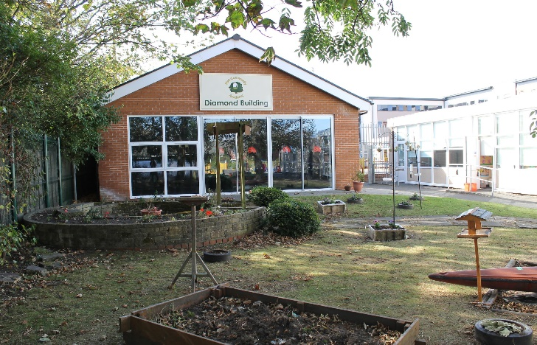**

**INTRODUCTION**

Park Community Academy is a Community Special Academy for pupils aged 2 - 19 years from Blackpool and surrounding areas. Blackpool Council’s Children and Young People’s Department have retained their statutory duties with regards to admitting children into the Academy and there are currently 322 pupils on roll.

From September 2015, the Local Authority commissioned Park Community Academy to deliver post-16 provision for pupils with Special Educational Needs. This is co-located provision with Woodlands School situated off site, based at Westbury Sixth Form Centre.

**LOCATION**

The Academy is situated in a pleasant area of the well-known seaside resort of Blackpool, approximately one-mile inland from the town centre and sea front. Nearby is the large open space and recreational and sports area of Stanley Park, and in close proximity to the Whitegate Drive Health Centre and Woodlands School for pupils with SLD/PMLD.

**WESTBURY SIXTH FORM CENTRE**

Westbury Sixth Form Centre provides a nurturing environment in a strong pastoral setting. It utilizes a holistic learning approach to maximize inclusivity and provides real opportunities for students to develop those all-important employability skills. WSFC’s mission is to provide students with outstanding teaching and learning that will prepare them for the start of their adult life.

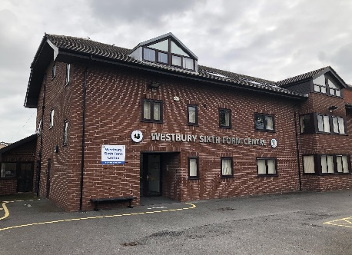

**THE PUPILS**

All pupils attending PCA have an Education, Health and Care Plan. The children and young people have a range of learning needs associated with moderate to severe learning difficulties, complex learning difficulties (including autistic spectrum disorders), sensory difficulties and associated social emotional and behavioral difficulties and challenging behaviours. Many are admitted from local mainstream Schools or Nurseries. However, because of the nature of Blackpool, there is a significant transient population and some pupils move into the area with only partly completed statements or EHCP’s. Children are regularly admitted at any time throughout the academy year.

 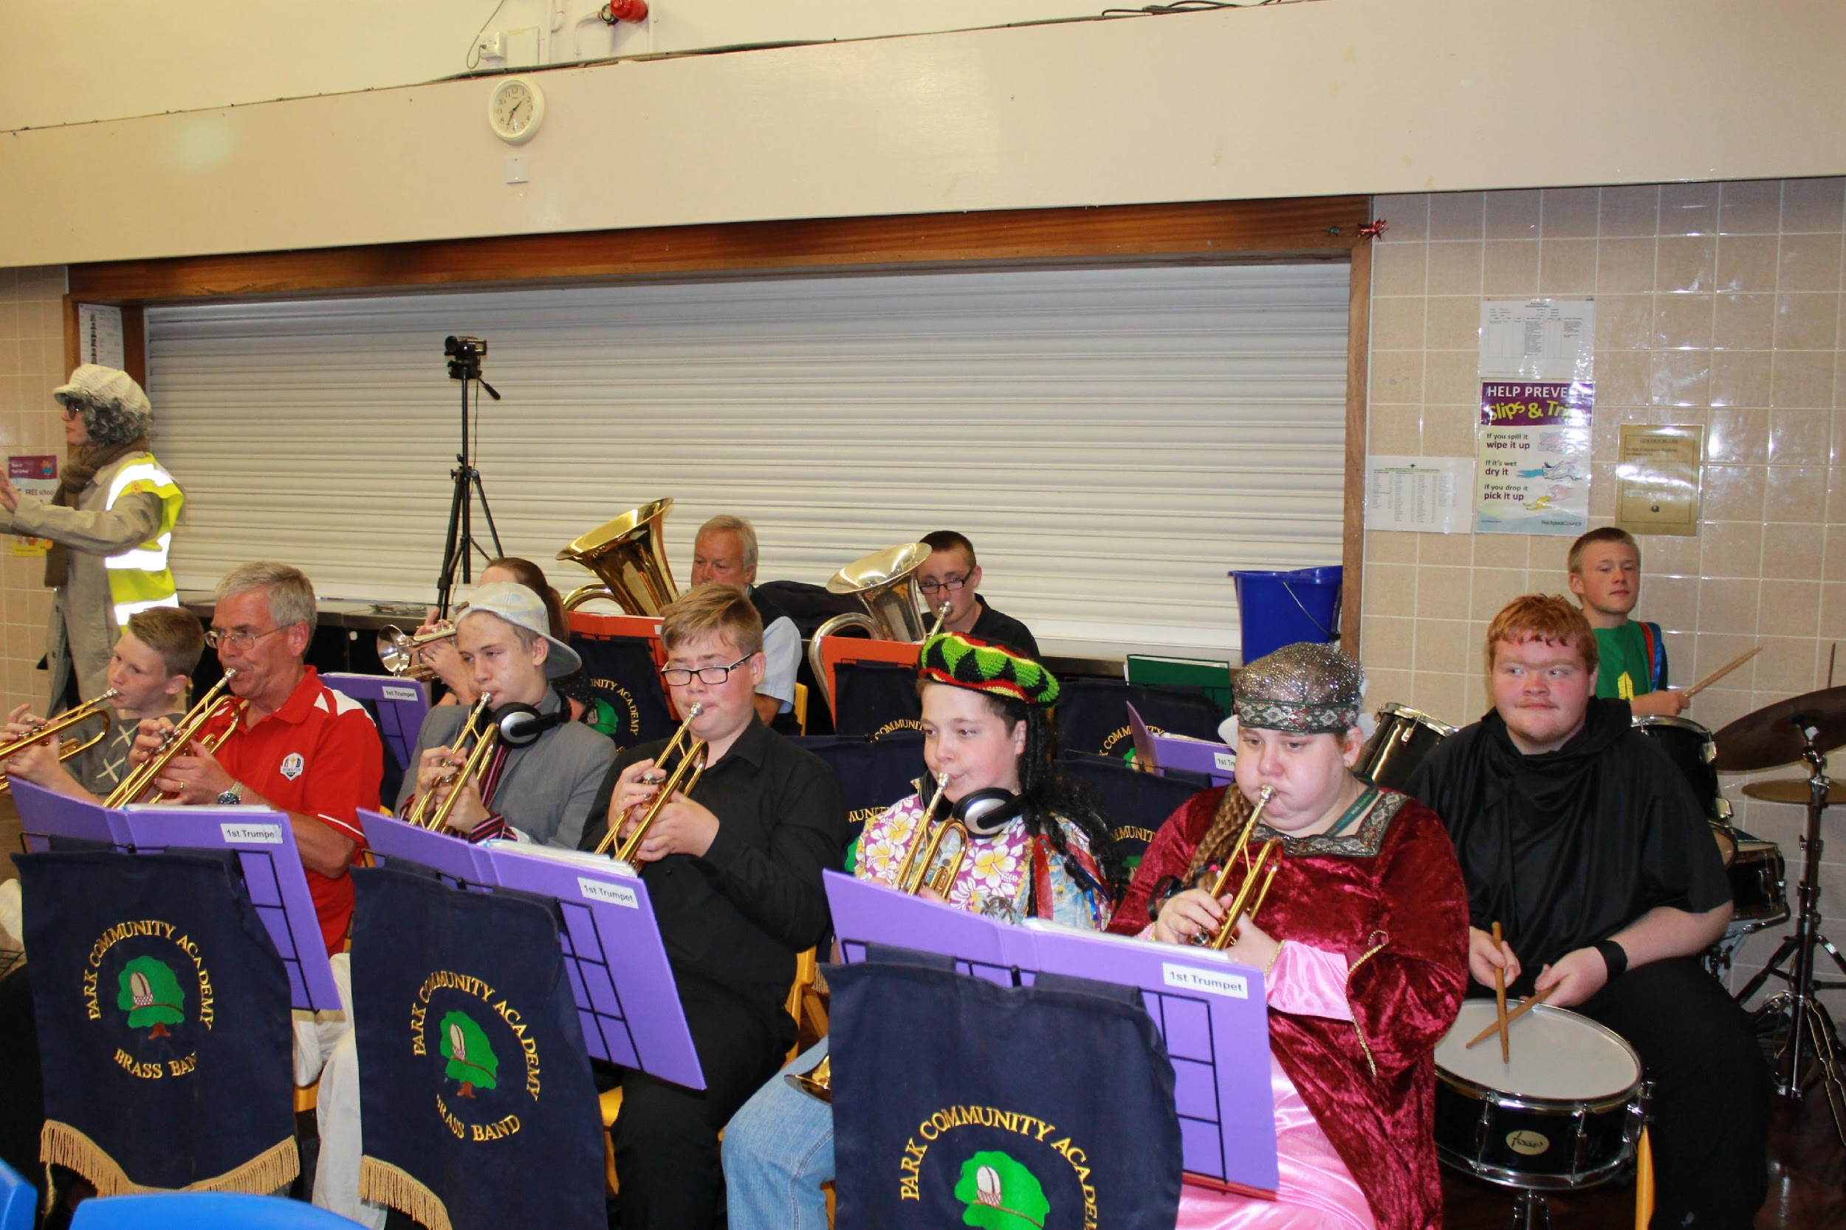

Our pupils have access to a broad and balanced curriculum, adapted to meet the needs of each individual. In addition to gaining language, mathematical, scientific, technological, artistic and physical skills, our aim is for children to build confidence, develop self-reliance, learn to make decisions and develop the ability to express feelings and ideas.

We attach great importance to the personal, social and moral development of pupils, seeking to enable them to build positive relationships with other pupils and adults, and to be sensitive to the feelings and needs of others. We work hard to ensure that all pupils feel good about themselves, acquiring a high level of self-esteem to promote self-confidence.

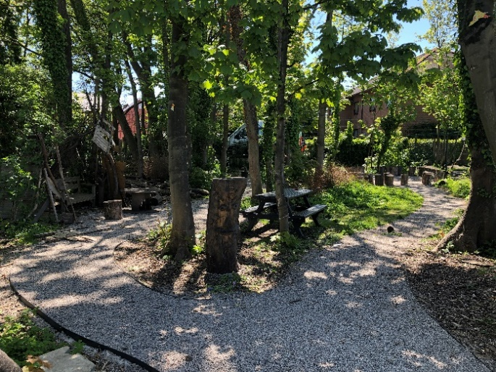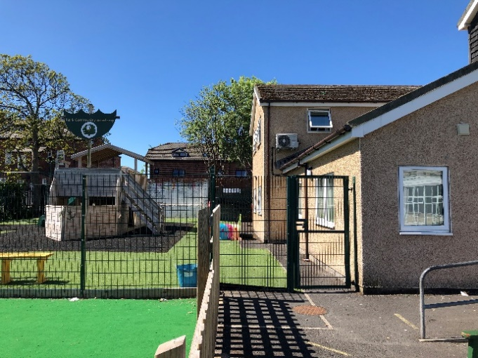

**THE BUILDINGS AND SITE**

The original school opened in September 1960, and the architecture reflects the style of that period. Since this time, there has been significant investment and development, resulting in a site that now has numerous specialist areas, located both in integrated and outlying teaching spaces.

Outside is a large playing field, a floodlit Multi Use Games Area (MUGA), a smaller MUGA for primary pupil use, a trim trail, a separate playgrounds for early years, primary and secondary pupils and 3 separate car parking areas.

Subject to availability and Covid restrictions permitting, interested candidates are invited to tour the academy site and buildings with the Headteacher who can further explain any recent developments.

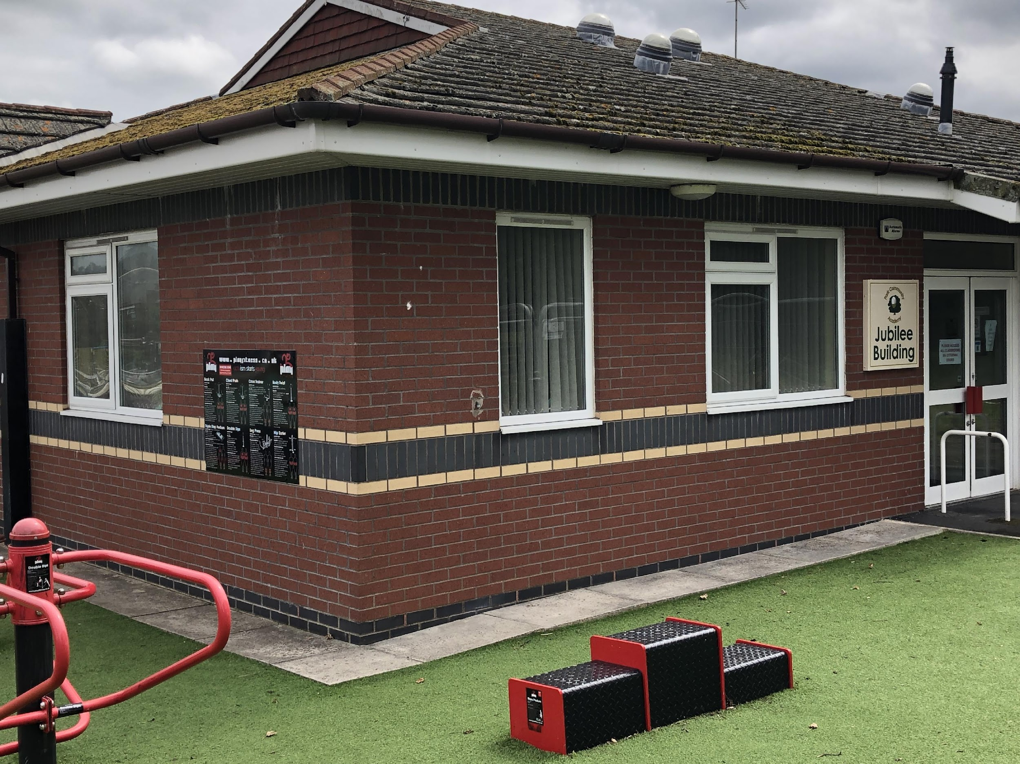 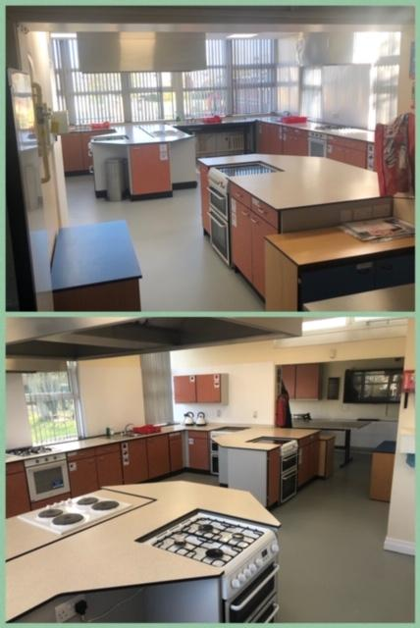

**OFSTED INSPECTION**

The academy was last inspected in May 2018 and was judged as **‘Outstanding’**. It was also judged as ‘Outstanding’ in its previous full Inspections in May 2015, October 2009 and May 2007.

For further information about the strengths of our academy, please visit the Ofsted website to read the full report: [www.ofsted.gov.uk](http://www.ofsted.gov.uk) – ‘schools’

**ACADEMY ACHIEVEMENTS**

Park Community Academy is proud to have received a number of accolades and more information about this can be found on the Park Community Academy website.

**TRUST CURRICULUM STATEMENT**

The Park Community Academy curriculum is driven by the curriculum statement of The Sea View Trust. This places emphasis on providing a formal developmental and additional curriculum, relevant to each learner’s needs.

Pupils will have access to the Foundation Stage and the full breadth of the National Curriculum, having due regard for the relevance to each pupil at their particular age and development level.

**ACADEMY ORGANISATION**

The Academy is organised into the five stages of education defined by the National Curriculum:

KEY STAGE 1: Yrs. R, 1 and 2 Lower Primary

KEY STAGE 2: Yrs. 3 to 6 Upper Primary

KEY STAGE 3: Yrs. 7 to 9 Lower Secondary.

KEY STAGE 4: Yrs. 10 and 11 Upper Secondary.

KEY STAGE 5 Years 12, 13 and 14 Sixth Form

**THE STAFF**

The teaching staff compliment is organised into five teams, one for each of the Key Stages. The teams also include Nursery Nurses or Special Support Assistants and Apprentice Teaching Assistants who work closely with the teachers. The work within each Key Stage is organised by a senior team member, a Team Leader.

All teaching staff have leadership responsibilities for curriculum areas across the whole academy, at either primary or secondary level. Class based support staff are integral members of the teaching teams and all are supported by dedicated groups of non-class based staff. The academy also promotes, in conjunction with a partner training agency, a highly successful apprentice Teaching Assistant training programme.

**Pupils**

The pupils are organised into tutor groups or “classes” with children of similar age and need The class teacher (or form tutor) has direct day to day responsibility for maintaining an overview of the pupil’s well-being, together with their progress and care. Older learners experience a number of subject specialists, in line with mainstream models.

*Every effort is made to promote the inclusion of our pupils within the mainstream sector where appropriate and this work is developing still further.*

**Break-times**

During break times, the pupils and students mix socially within their own age bands.

**College Link Courses** **and Accreditation**

Students in Years 11 to 14 access mainstream college link courses and the academy offers a range of accreditations.

**Parents and Carers Partnership**

PCA works in close partnership with families.

**Children and Family Support Team**

The Children and Family Support Team is a key team within the pastoral care system of the academy, comprising of a Children and Family Support Manager and a support worker. Both work with academy based colleagues, individual families and external agencies to further develop home school relations. This promotes a high quality educational provision for all pupils, in an environment that reflects care, happiness, enjoyment and success. The academy also has Lead Learning Mentors to further support the mental health and wellbeing of our learners.

**Other Multi Agency Staff**

PCA has access to a School Nurse Practitioner (SNP), for one day per week, who supports the academy in addressing health related issues. The SNP delivers health related programmes across the academy in order to promote healthy lifestyles and good health, conducts health assessment of individuals, maintains a ‘health surveillance’ and leads on health promotion; this ensures that both local and national Public Health initiatives are met.

**OUT OF SCHOOL CARE**

The academy is an OFSTED registered provider of Out of School Care and, in normal circumstances provides clubs three nights per week, completely free of charge. A variety of sessions are offered, including a range of sports, leisure, recreational, musical, art and technology based activities for pupils of primary and secondary age. In July 2007 the academy’s Summer Activity Scheme was also inspected by OFSTED. The overall quality and standards of care provided by the academy were judged as ‘Outstanding’ in all areas. The full report can be viewed at [www.ofsted.gov.uk](http://www.ofsted.gov.uk) – ‘out of school care’.

****

|  |  |
| --- | --- |
| **Job Description** | |
| **Job Title** | Class Teacher |
| **Pay Grade/ Scale/ Range** | Teacher’s Main/Upper Pay Scale (M1 – M6) (UPS1 – UPS 3) |
| **Working Hours** | 5 days per week - Hours in accordance with School Teachers’  Pay and Conditions Document 2020 2021 |
| **Location** | Park Community Academy |
| **Staff Responsible to:** | Headteacher |
| **Start Date** | September 2022 |
| **Key Skills and Responsibilities** | |
| The successful candidate will:-   * Be an outstanding classroom teacher * Be able to share and develop a vision for the school community * Be committed to all aspects of inclusion and to parent partnership * Be committed to the further development of the Maths curriculum at Park Community   Academy and ensuring pupils make good or better progress in this area. | |
| **Teacher Job Description** | |
| The post includes the professional duties of teachers as indicated in the Teachers Pay and Conditions Document 2021 and the school’s policy for the use of 1265 hours.  **Purpose of Job**  To offer a broad and balanced curriculum to the children and young people across the primary or secondary phase, delivered in a way which effectively meets their needs; physical, social and academic. To assess, record and report the progress and needs of these children to their parents/carers, school leaders and professional support agencies.  **Main Duties and Tasks**    A. Teaching & Learning  1.) Plan their teaching to achieve good or better pupil progression and with regard to all relevant school policies and schemes of work  2.) Be able to select and use a range of different teaching and learning styles for different purposes according to the needs of the pupils.  3.) Assessing, recording and reporting on the development, progress and attainment of pupils in all areas and communicate this effectively to all key stakeholders  4.) Employ a range of appropriate teaching and learning styles and monitor and evaluate their effectiveness.  5.) To ensure that there are relevant and meaningful displays relating to the areas of study being followed, in each case having regard to the curriculum for the school.  6.) Work in partnership with other adults in the classroom and manage their performance effectively.  7.) Mark and monitor pupil's class and homework appropriately  8.) Participate in a wide range of professional development activities.  9.) To lead a curriculum subject area across the school  B. Pastoral  1.) Promoting the general progress and wellbeing of pupils.  2.) To promote positive behaviour across PCA and to follow the PCA behaviour policy and procedures  3.) To adhere to the school safeguarding policy  4.) To use the school reporting and recording systems correctly  C. Assessments and Reports  1.) Provide, or contribute to, oral and / or written assessments and reports, relating to individual pupils on a regular basis or as required.  2.) To lead the annual review process for the pupils in the tutor group  3.) To follow schools’ data process, analyse progress and implement appropriate intervention.  D. Policy  a). Awareness of, and adherence to, school policy and procedure (see staff handbook).    E. School Improvement Plan  a.) To fulfil agreed commitments relating to the ongoing school improvement plan.  b.) To write action plans for agreed areas of responsibility.    F.) Generic Duties  1.) Comply with policies and procedures relating to child protection, health and safety, confidentiality and data protection, reporting all concerns to an appropriate person.  2.) Contribute to the overall work and ethos of the organisation, working harmoniously with colleagues and demonstrating loyalty to the Trust.  3.) Attend and participate in meetings as required.  4.) Improve own practice through training, observation, evaluation and discussion with colleagues.  5.) Recognise own strengths and areas of expertise and use them to support others.  6.) Work across The Sea View Trust and partner organisations if required.  7.) Understand the importance of inclusion, equality and diversity when working with pupils, students and colleagues, promoting equal opportunities for all.  8.) Take a pro-active approach to health and safety, working with others in the school to minimise and mitigate potential hazards and risks, and actively contribute to the security of the school.  9.) Participate and engage with workplace learning and development opportunities, subject to the school’s CPD plan, working to continually improve own performance and that of the team/school.  10.) To undertake any other additional duties commensurate with the grade of the post  **Additional responsibilities as subject leader**  Curriculum Design and Development  All work relating to curriculum development must support the school’s aims and objectives and be undertaken in liaison with the School Curriculum Leader (Deputy Headteacher).  1.)Formulation/updating of a written Maths Policy  2.)Development of a scheme of work throughout the school  3.)Ensuring curriculum coverage, continuity and progression  4.)Organise the integration of Information and Communication Technology  5.)Organise whole school activities to promote the subject area  6.)Prioritise, plan and organise a subject area contribution to the School Improvement Plan  Communication  2.)Support colleagues in their planning and development of the curriculum area of Maths  3.)Encourage commitment and positive attitudes toward the curriculum area of Maths  4.)Communicate with the wider community (e.g. parents, carers, Governors)  5.)Liaison with all phases in the school  6.)Working collaboratively as part of a faculty to ensure high quality teaching and learning  Assessment and Monitoring  1.)Assessment and evaluation of the curriculum area as part of the school system  2.)Monitoring the curriculum area for continuity, consistency and progression, through opportunities for observing the teaching of the agreed scheme of work, pupil voice and scrutiny of work throughout the school  3.)Development and monitoring of record keeping system(s) as part of an agreed school system  4.)Participation in moderating and levelling children’s work in Maths as part of the process of quality assurance  5.)Leading in the development of individual pupil and whole school portfolios in Maths using examples of pupil’s work to indicate progress  6.)Contribute to assessment and target setting in Maths and track pupil’s progress in Maths across the secondary and sixth form phase.  Resources  1.)Evaluating the relevance of existing resources, particularly with regard to the broad range of needs and diversity at Park Community Academy  2.)Managing the purchase and deployment of resources in liaison with colleagues throughout the school  3.)Management of the budget assigned to the subject/curriculum area, ensuring ‘best value’  4.)Ensuring resources are used efficiently, effectively and safely throughout the school  5.)Maintain inventory of non-expendable stock/resources  Professional Development  1.)Attending appropriate in CPD, reporting back and cascading training to staff as appropriate  2.)Personal reading research to keep up to date with current issues, development and new resources  3.)Arranging and organizing school based in service activities as part of the whole school INSET programme when appropriate.  **Special Conditions**  An enhanced Disclosure and Barring Service (DBS) check is required for this post  **Teacher Bureaucracy and Workload Statement**  It is the stated aim of the school to work together to reduce the level of bureaucracy and workload impacting upon teaching and non-teaching staff. Senior Leadership is committed to working with teaching staff to maintain a manageable and reasonable workload including paperwork without undermining the professional status of the teaching body. Where staff have concerns, these should be conveyed to senior staff by the usual channels | |

|  |  |  |
| --- | --- | --- |
| **Person Specification** | | |
| **PLEASE NOTE: Governors/Trustees will use the criteria below to shortlist. Only those applicants who demonstrate that they meet those criteria (to the Governors/Trustees satisfaction) will be invited to interview.**  **MPS/ UPS**  This post includes the professional duties of teachers as listed in the School Teachers Pay and Conditions document and is in line with the requirements of Teachers’ Standards.  **Method of Assessment**  (A) Application form  (S) Supplementary evidence (on application form)  (I) Interview  (Q) Evidence of qualifications to be presented if shortlisted for interview | | |
|  | **Essential Criteria** | **Method** |
| 1 | A recognised teaching qualification | **A, Q** |
| 2 | Experience in teaching and differentiating schemes of work including National Curriculum programmes of study / 14 – 19 Curriculum | **A, S, I** |
| 3 | A knowledge and understanding of a broad range of SEND | **A, S, I** |
| 4 | Experience, or awareness, of the duties and roles of a form tutor and or class teacher | **A, S, I** |
| 5 | Knowledge of statutory and non-statutory assessment | **A, S, I** |
| 6 | Experience of planning, recording and evaluating pupil learning | **S, I** |
| 7 | Ability to lead and manage a subject across key stages including managing a budget | **A, S, I** |
| 8 | A person with good communication skills (oral and written) and a high standard of presentation | **A, S, I** |
| 9 | A willingness to work as part of a team including working alongside and managing support staff | **S, I** |
| 10 | An interest and willingness to undertake further professional development and to contribute to the professional development of others | **S, I** |
| 11 | Specialist subject expertise in Maths | **S, I** |
| 12 | Competent in the use of ICT | **S** |
|  | **Desirable Criteria** | **Method** |
| 1 | A knowledge and understanding of the role of support staff employed by the school and contributing outside agencies | **S, I** |
| 2 | Experience working closely with parents | **S, I** |
| 3 | A commitment to inclusion across the school | **S, I** |
| 4 | A commitment to supporting the whole school community | **S, I** |