

Classroom Teacher (KS2)

Pennyman Primary Academy

Job Ref: PPA333

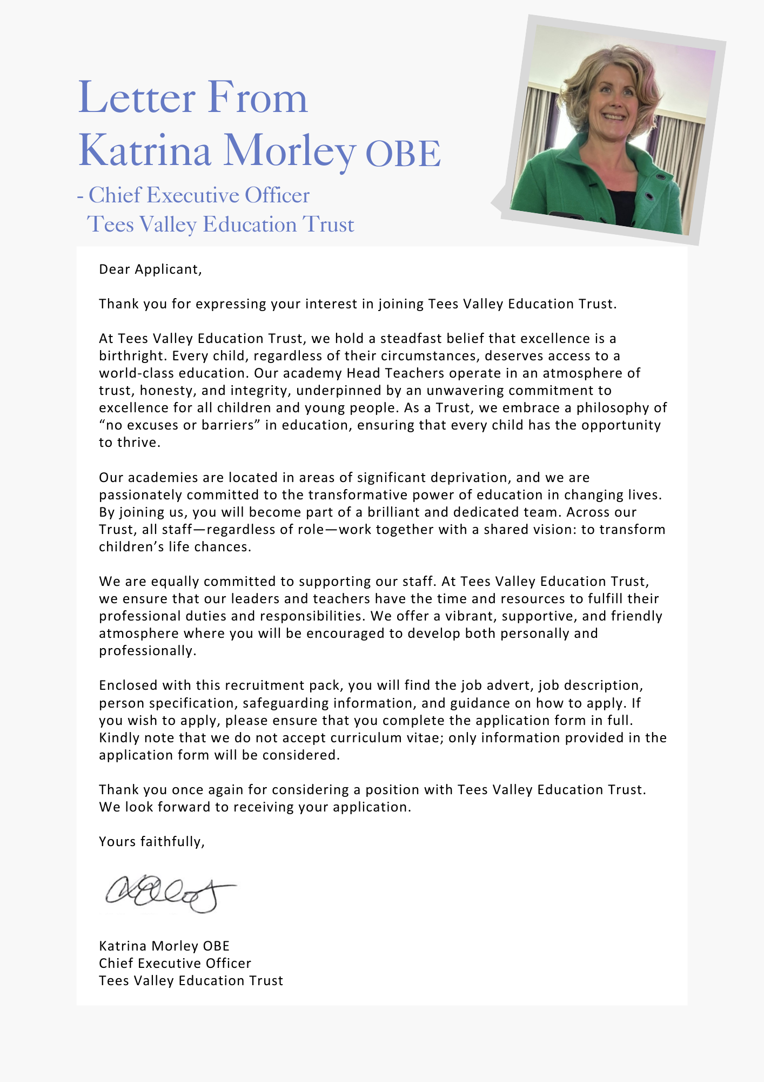



|  |
| --- |
| **ADVERTISEMENT** |

**Classroom Teacher (M1 – UPS3)**

**Status: Permanent**

**Required: September 2025**

**Salary: M1 to UPS3 (31,650 - £49,083)**

**Hours: Full Time**

**Location: Pennyman Primary Academy**

**Reporting to: Head Teacher**

**About the Trust**

The Trust was established in 2015 and provides education and enrichment activities to more than 1200 children across five Academies, located in Middlesbrough and Redcar and Cleveland local authority areas. Academies within the Trust are:

* Brambles Primary Academy (2 to 11 years),
* Discovery Special Academy (2 to 16 years),
* Dormanstown Primary Academy (3 to 11 years),
* Pennyman Primary Academy (2 to 11 years), and
* Wilton Primary Academy (3 to 11 years).

**About the role we are looking to appoint:**

**Pennyman Primary Academy is seeking to appoint an exceptional Key Stage 2 teacher, ideally with experience in Upper Key Stage 2, to join our thriving and inclusive learning community.** We are looking for an outstanding classroom practitioner with a passion for teaching and learning, someone who will model high expectations and inspire children to achieve their full potential. As a mainstream academy with a specialist designated unit for children with complex physical and medical needs, we are committed to inclusive practice and high-quality provision for all. The successful candidate will be a reflective and collaborative teacher with strong subject knowledge, who is eager to contribute to the continued development of teaching and learning across the academy. This is a fantastic opportunity for a teacher to contribute to an environment where every pupil can thrive- achieving their academic potential while developing curiosity, a lifelong love of learning, and the skills to succeed in the future- all within a dedicated and supportive team.

We are looking for teachers who demonstrate the aptitude to be excellent practitioners through embedding science of learning into pedagogical practices and provision. Please indicate on your application, your areas of strength/expertise e.g. Phase/ Subject/ area of specialism.

**Pennyman Primary Academy can offer you:**

* A committed senior leadership team that puts the child at the centre of school improvement
* A forward-thinking academy, which is committed to improvement through evidence-based research
* An excellent learning environment for children with a strong community ethos
* Hard working, committed and dedicated staff who strive to gain the best outcomes for all of our children
* Dedicated children who love coming to the academy and are encouraged to be the best they can be
* A passionate and high performing team of professionals across the trust to learn from and contribute to
* Career enhancement opportunities within areas of interest

**What the Trust will provide the successful candidate with:**

* A workplace where all staff are valued and treated with respect as outlined within the Trust’s Diamond Standards
* A passionate, enthusiastic and supportive Leadership Team
* A listening and learning organisation where all staff are encouraged to be curious and share ideas for the Trust/academies/team to improve
* Hard working, committed and dedicated staff who strive to gain the best outcomes for all children across the Trust’s academies
* Dedicated approach to children’s learning to encourage them all to be the best they can be
* Career enhancement opportunities within areas of interest as well as supporting ongoing professional development and training specific to job role
* Dedicated line manager to discuss work streams and capacity
* Free access to the Trust’s Wellbeing offer, which includes counselling, access to GP, Mindfulness and so much more.
* Auto Enrolment into the Teachers Pension scheme, employer contributing 28.68%
* Benefits of the Trust’s Staff Charter which can be found at [TVED Staff Charter](https://www.teesvalleyeducation.co.uk/wp-content/uploads/2022/01/STAFF-CHARTER_FINALISED.pdf).

**Safeguarding requirements for the role:**

Tees Valley Education Trust is committed to safeguarding and promoting the welfare of children. All appointments will be subject to a satisfactory enhanced DBS check.

This post is exempt from the Rehabilitation of Offenders Act 1974 and, therefore, all convictions, cautions and bind-overs, including those regarded as “spent” must be declared. The Trust’s Recruitment of Ex-Offender policy can be requested or visit the Trust’s website.

Applications are invited from prospective candidates who demonstrate that they are able to meet the essential criteria set out in the person specification and who have the vision, values and tenacity to join an outstanding team and help continue the journey towards excellence.

|  |
| --- |
| **JOB DESCRIPTION – TEACHER** |
| To carry out the duties of a school teacher as set out in the School Teachers Pay and Conditions Document. To meet the required standards for Qualified Teacher Status and having regard to the curriculum of the academy: to teach children within the primary age range according to their educational need. This includes all necessary professional duties of planning, preparing courses and lessons, assessing, recording and reporting on the development, progress and attainment of pupils assigned to you. To contribute and participate in the team working ethos of the academy and maintains the positive ethos and core values of the academy, both inside and outside of the classroom. |
| **PLANNING, TEACHING AND CLASS MANAGEMENT** |
| Teach allocated pupils by planning their teaching to achieve progression of learning through:   * Planning and delivering the teaching programme for all pupils within the class in relation to the Early Years or National Curriculum, PSHE and Citizenship and the Agreed Syllabus for Religious Education with regard for the academy’s aim statement, own policies and schemes of work. * Providing clear structures for lessons and for sequences of lessons, which maintain pace, motivation and challenge. * Setting tasks which challenge pupils and ensure high levels of interest. * Setting appropriate and demanding expectations. * Plan appropriately to meet the needs of all pupils * Setting clear targets and next steps in learning, building on prior achievements. * Making effective use of assessment information on pupil’s progress in lesson planning. * Ensuring effective teaching and best use of available time. * Maintaining positive behavior management in accordance with the academy’s procedures and encouraging positive learning dispositions. * Using a variety of teaching methods to:   + Keep all pupils purposefully engaged;   + Match approach to content, structure information, present a set of key ideas and use appropriate vocabulary;   + Use effective questioning and feedback addressing any errors and misconceptions in a timely manner * Evaluate own teaching critically to improve effectiveness. * Ensure the effective deployment of learning support assistants. * Encourage pupils to think and talk about their learning. * Provide a classroom environment and ethos that is supportive of learning for all pupils. |
| **MONITORING, ASSESSMENT, RECORDING, REPORTING** |
| * Assess how well learning objectives have been achieved and use this information to improve specific aspects of teaching. * Use assessment of and assessment for learning to support pupil learning. * Prepare and present information on the development, progress and attainment of pupils in the class to SLT through progress reviews. |
| **OTHER GENERAL PROFESSIONAL REQUIREMENTS** |
| * Have a working knowledge of teachers' professional duties and legal liabilities. * Operate at all times within the stated policies and practices of the academy and Trust. * Establish effective working relationships and set a good example through presentation, personal and professional conduct. * Endeavour to give every child the opportunity to reach their potential and meet high expectations. * Take responsibility for own professional development and duties in relation to academy and Trust policies and practices. |
| **SAFEGUARDING** |
| * All staff must adhere to the Trust’s safeguarding training (appropriate for job role) including policies, procedures, latest Keeping Children Safe in Education guidance and Working Together to Safeguard Children DfE 2023. |
| This job description will be reviewed annually and may be subject to amendment or modification at any time after consultation with the post holder. It is not a comprehensive statement of procedures and tasks, but sets out the main expectations of the Trust in relation to the post holder’s professional responsibilities and duties.  Elements of this job description and changes to it may be negotiated at the request of either the line manager or headteacher. |

|  |  |  |
| --- | --- | --- |
| Signed (Employee) |  | |
| Date: |  | |
| Signed (on behalf of employer): | | Name and Role: |
| Date: |  | |

|  |  |  |
| --- | --- | --- |
| **PERSON SPECIFICATION** | | |
| **QUALIFICATIONS & EXPERIENCE** | **AM** | **E/D** |
| Degree or relevant qualification and experience. | A | E |
| Qualified Teacher Status | A | E |
| Proven teaching experience | A, I, R | E |
| **KNOWLEDGE, ABILITIES AND SKILLS** |  |  |
| An understanding of the current National Curriculum | A, I | E |
| Knowledge of the characteristics of high-quality teaching in primary education | A, I, R | E |
| A sound understanding of strategies to support all children’s learning | A, I, R | E |
| Ability to plan effectively to meet the needs of a range of learners | A, I, R | E |
| The use of a variety of techniques for assessment for learning in order to impact positively on children’s progress | A, I, R | E |
| Ability to inspire and motivate all children to learn and realise their potential | I, R | E |
| Understanding of positive behaviour management strategies | I, R | E |
| Evidence of good classroom management skills. | I, R | E |
| Outstanding organisational skills with the ability to self-direct as well as work successfully within a team. | A, I, R | E |
| Excellent communication and interpersonal skills at all levels. | I, R | E |
| A commitment to further professional development. | A, I | E |
| Commitment to the protection and safeguarding of children and young people | I, R | E |
| Understanding of the science of learning teaching principles | A, I, | D |
| Understanding of how to use comparative data, together with information about pupils’ prior attainment to set targets for improvement. | A, I, R | D |
| Understanding of meeting the needs of vulnerable pupils including those with SEND and in receipt of PPG. | A, I, R | D |
| Ability to be proactive, use initiative and show a creative approach | I, R | D |
| **PROFESSIONAL CHARACTERISTICS** |  |  |
| Clear and articulate vision for the development of primary education | A,I | E |
| Commitment to meeting the educational, social and emotional needs of all children | A.I | E |
| Commitment to high standards and continuous improvement | A,I | E |
| Lead by example, with integrity, creativity, resilience and clarity and demonstrate the ability to positively empower, influence and encourage others | A,I | E |
| Excellent interpersonal skills and emotional intelligence | A,I | E |
| Ability to demonstrate the Trust Diamond Standards of Commitment, Curiosity, Courage, Creativity and Care | A,I | E |

AM (Assessment Method) - A - Application Form, I - Interview, R – Reference E – Essential D – Desirable

**Important:** In the first instance, applications are assessed against the criteria listed above, in addition to overall presentation, use of standard English and grammatical accuracy.

Where applications do not meet the expected standard, they will be rejected before being matched to the person specification.

|  |
| --- |
| **HOW TO APPLY AND EXPLANATORY NOTES OF THE PROCESS** |

Application packs can be downloaded or printed directly from the Trust website **www.teesvalleyeducation.co.uk** or requested from the academy. Only applications via the Trust’s official application form will be accepted. Please do not submit a CV as substitute for part or full application form, the information will not be accepted or considered.

If you are submitting your completed application form by e-mail to pennyman@tved.org.uk - please be aware the academy cannot be responsible for any formatting anomalies when printing. If you are unable to submit an electronic application form, handwritten or electronic printed copies should be posted or hand delivered to the following address for the attention of **Mrs Louise Stogdale, Head Teacher**. Please add Pennyman Teacher as the subject.

**Pennyman Primary Academy**

**Fulbeck Road**

**Netherfields**

**Middlesbrough**

**TS3 0QS**

##### **Shortlisting Process**

After the closing date, short listing will be conducted by a panel, who will match your skills/experience against the criteria in the Person Specification. You will be selected for interview entirely on the contents of your application form, so please read the Job Description and Person Specification carefully before you complete your form.

**Shortlisted candidates will receive:**

* Letter confirming interview details.
* Details of original ID documentation required to confirm candidates. Photocopies or certified copies are not accepted.
* Criminal Record Self-Declaration Form, which must be brought on the day of the interview in the sealed envelope provided.

##### **References for successful Candidate/s**

We may seek references for shortlisted candidate/s and we may also approach previous employers for information to verify particular experience or qualifications before the interview. Any relevant issues arising from references will be taken up post interview.

**Interview process**

In addition to candidates’ ability to perform the duties of the post, the interview will also explore issues relating to safeguarding and promoting the welfare of children, including:

* Motivation to work with children and young people
* Ability to form and maintain appropriate relationships and personal boundaries with children and young people
* Emotional resilience in working with challenging behaviours
* Attitudes to use of authority and maintaining discipline

##### **Conditional Offer: Pre-Employment Checks**

Any offer to a successful candidate will be conditional upon:

* Verification of right to work in the UK
* Receipt of at least two satisfactory references (if these have not already been received)
* Verification of identity checks and qualifications
* Satisfactory enhanced DBS check
* Verification of professional status such e.g. QTS Status, NPQH (where required)
* Satisfactory completion of a Health Assessment
* Satisfactory completion of the probationary period (where relevant)
* Where the successful candidate has worked or been resident overseas in the previous five years, such checks and confirmations as may be required in accordance with statutory guidance.

Visits to the academy are actively encouraged and should be arranged by contacting the academy **office on 01642 314750.**

**Visit dates are:**

* Thursday 8th May at 9am and 3pm and
* Friday 9th May at 1pm and 3pm

For your information, the recruitment timetable is detailed below:

**Closing Date:** Wednesday 14th May 12 noon.

**Shortlisting Date:** Wednesday 14th May

**Teaching Task and Interviews:** Monday 19th May

|  |
| --- |
| **EQUALITIES INFORMATION AND OBJECTIVES STATEMENT** |

As an academy we ensure that our vision, values and ethos meet the expectations of the equality and diversity guidelines, and legislation set out by the Equality and Human Rights Commission. This includes the following 9 protected characteristics:

1. Age
2. Disability
3. Gender Reassignment
4. Marriage and Civil Partnerships
5. Pregnancy and Maternity
6. Race
7. Religion or belief
8. Sex
9. Sexual Orientation

**Objectives Statement**

1. To support children’s sensory, academic and communication skills to enable them to develop holistically.
2. To ensure high expectations across all aspects of the academy (as outlined in objective 1) to ensure children make the best progress according to their individual starting points.
3. To continue to monitor attendance of all groups of children in the academy.
4. To review levels of parental and pupil engagement in learning and academy life, across all activities and ensure equality and fairness in access and engagement.
5. To ensure the academy environment is as accessible as possible to pupils, staff and visitors.

