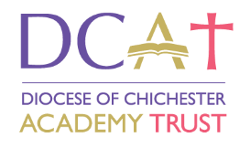
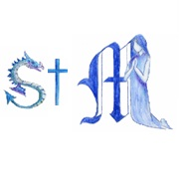
St. Margaret’s C of E Primary School

The Mardens, Ifield, Crawley, West Sussex RH11 0AQ

Telephone 01293 521077

Headteacher: Mrs Jill Hine B.Ed. (Hons), NPQH

Loving God~Serving others~Fulfilling our potential

Key Stage 1 or 2 Class Teacher
Required from 1st September 2026

Applications welcome from ECT/TMS
NOR 418 Age Range 4 - 11

An exciting opportunity has arisen at our school for a permanent full-time Class Teacher. We are looking for an enthusiastic, committed and caring teacher to join our team.

We are looking for a teacher who:
- Has high expectations of children
- Is committed to self/professional development
- Has excellent organisational and communication skills
- Enjoys working as part of a team
- Has well-developed, effective teaching strategies
- Can be flexible
- Wants to be part of our journey of improvement
- Is supportive of our Christian ethos

We can offer:
- Well-behaved, enthusiastic children
- The chance to work with a team of dedicated, hardworking staff who are passionate about their work with the children
- An exciting learning environment with wonderful outside learning facilities
- Supportive governors and parents

Visits to the school are welcomed and encouraged. Please contact us on 01293 521077 if you would like to make an appointment.

Our school is committed to safeguarding and promoting the welfare of children and all appointments are subject to an enhanced DBS clearance, satisfactory references and health clearance.

Closing Date: 12:00 pm Friday 5th June 2026

NB: We intend to review applications as they are received and call those shortlisted for immediate interview. An early application is advised, as once we have appointed, we will close the recruitment process.

