Part-time class teacher Year1
RECRUITMENT PACk
trewirgie infants

CONTENTS
Advert | Page
Information about Trewirgie Infants School | Page
Job Description | Page
Person Specification | Page
Application Form | Page
Equal Opportunities Form | Page
Safeguarding Self-Declaration Form | Page
Letter from Chair of Board of Trustees | Page
Useful Information | Page

Truro and Penwith Academy Trust is a charitable Company registered in England and Wales, Company number 08880841. Registered office: Academy House, Truro Business Park, Threemilestone, TR4 9LD

I
Trewirgie Infants Information for Applicants
Advert
We are looking for a 0.76 FTE KS1 teacher to work in a Year 1 class to start from September 2023. ECT welcome to apply.

This is an exciting opportunity to work with a forward thinking staff and wonderful children.

Applications are welcome from all teachers whether experienced or newly qualified.

We are looking for a dynamic, creative and hardworking teacher who will deliver the very best learning experiences for our children.

Successful applicants must:
- Work hard to ensure that all gaps in learning are closed between groups within the class.
- Be willing to support our school within the wider community.
- Work with members of the school team and our parents.
- Be a positive role model for all pupils.

To discuss the position please contact the School via email trewirgieinf@tpacademytrust.org
or call 01209 216111 and ask for Sarah Howe

Closing date: 27th March 2023
Interviews will be held on 20th April 2023
Please email completed applications to trewirgieinf@tpacademytrust.org

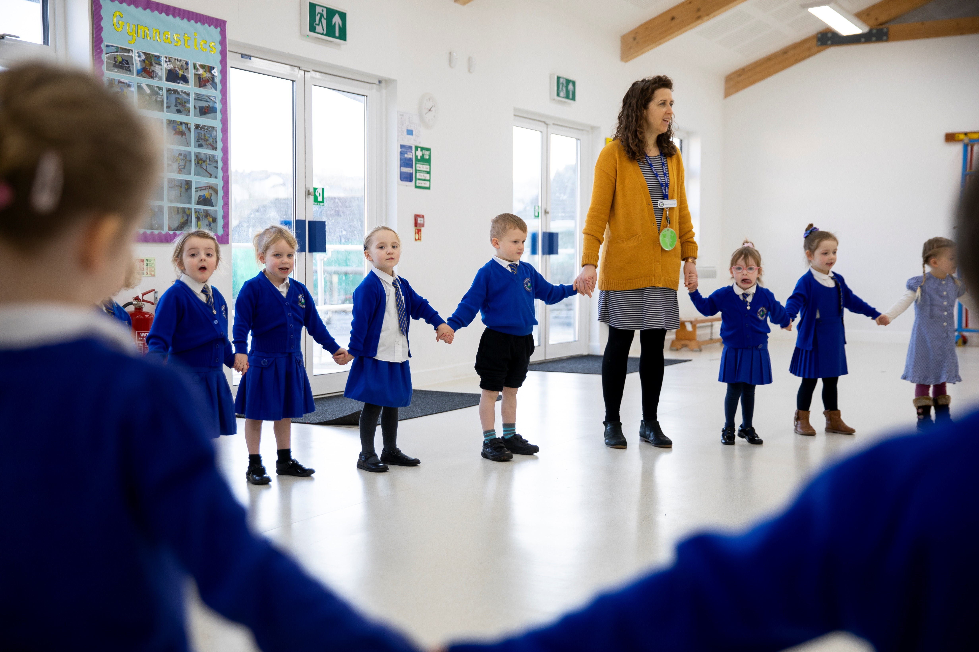

Trewirgie Road, Redruth, TR15 2SZ
trewirgieinf@tpacademytrust.org www.trewirgie-inf.cornwall.sch.uk
Headteacher: Mrs Cath Callow
Welcome to Trewirgie Infants School
This information pack will provide you with an insight into our school and offer some practical information which will be of use to you as a prospective member of our school community.
Trewirgie Infants is a vibrant school where children are enthusiastic and motivated to achieve endless possibilities. The children are at the heart of every decision we make to ensure that they are happy, confident and that the opportunities that are provided for them are relevant to their needs both now and in the future.
At Trewirgie Infants School, we believe that children should be curious about their learning. Through our engaging curriculum, we ensure that children can foster a passion for learning that will help to develop high aspirations and a lifetime of memories. We believe in ensuring that children receive a well-rounded curriculum; where individual talents can be spotted and nurtured to ensure that all children experience success and reach their full potential.
The school has a dedicated team that works hard to reach high standards in everything we do and this is further embedded through our relationships with parents, the local community and the other schools. We firmly believe that education is a partnership between home and school and regard you as an active partner in your child’s education and value your interest and support.
Mrs Cath Callow - Headteacher

General Background
The school caters for children between the ages of 3 - 7. We have a Nursery within the school grounds, providing opportunities for younger children.
We currently have 280 pupils on roll and offer a rich & diverse curriculum, as well as a full programme of before & after-school activities.
In June 2021 we joined Truro and Penwith Academy Trust and will be working collaboratively with our partner schools as well as having excellent links with the Redruth Learning group of schools.

Class Organisation

The school currently has 280 children on roll consisting of 3 form entry ranging from Reception to Year 2 and a 60 place Nursery.

Staff Organisation

The staff organisation can be located on our website
https://www.trewirgie-inf.cornwall.sch.uk/about/staff/
We are strongly committed to staff development and learning.

Our Curriculum
At Trewirgie Infants and Nursery school, we inspire children to engage in learning, and to be proud members of a caring, supportive and successful school. We support our children to develop life- long learning skills; to be independent and creative thinkers and to be socially confident. To enable our children to be successful, we have developed a curriculum that captures their interests, stimulates their ideas and encourages inquisitiveness and critical thinking which meets their needs and reflects our locality and heritage.
At our school, we teach the children to care about themselves and others. We encourage our children to share their thoughts, ideas and feelings so we can support them to succeed to be healthy lifelong learners who are emotionally and mentally strong. Our aim is to inspire and educate our children in a happy, safe and enjoyable environment. We want our children to develop life skills, to be independent and creative thinkers and to be socially confident throughout their education and into their adult lives. Helping our children to develop respect, self-esteem and an ability to value themselves and others in order to make positive life choices for themselves.
Our curriculum is planned carefully to follow the National Curriculum objectives but always with our children and our school’s locality at its heart. We provide a creative curriculum framework in which children can develop an understanding of their own skills, expertise and knowledge allowing them to explore and build upon these as a process of self-development. It is designed to be broad, balanced and relevant to the experiences and needs of our children. It is structured to allow a progression in the acquisition of skills, knowledge and understanding for our children to succeed in a changing world. All children will have opportunities to experience all areas of the curriculum. Building upon the knowledge and skills learnt and developed in Early Years throughout their journey into Key Stage 1.
Our children and community shape the way we have decided to create our curriculum. We recognised that our children needed a curriculum that is interesting, creative, intriguing and fun experience. Each year group and class adapt their own planning to meet our children’s real life needs and their starting points. All staff set high expectations for all children. They use appropriate assessments to set ambitious but achievable targets and plan challenging work to inspire and extend children’s knowledge and skills.
Teachers plan lessons so that Pupil Premium and SEND children can study every National Curriculum subject, ensuring that there are no barriers to learning and every child can achieve at their level. Teachers take account of the needs of children whose first language is not English. Lessons are planned so that teaching opportunities are there to help those children to develop their English, and to support them to take part in all subjects.

Insert JD

Job Description

Job Title: | Teacher (Key Stage 1)
Salary Range: | Main Scale dependent on experience
Base: | Trewirgie Infants School
Responsible to: | Head Teacher/Assistant Head Teacher/Governing Body
Direct Supervisory Responsibility for: | The post holder may be responsible for the deployment and supervision of the work of teaching assistants relevant to their responsibilities
Important Functional Relationships: Internal/External | Other Teaching Staff, Support Staff, Pupils, Parents

Main Purpose of Job:
- Be responsible for the learning and achievement of all pupils in the class/es ensuring equality of opportunity for all
- Be responsible and accountable for achieving the highest possible standards in work and conduct
- Treat pupils with dignity, building relationships rooted in mutual respect, and at all times observing proper boundaries appropriate to a teacher’s professional position
- Work proactively and effectively in collaboration and partnership with learners, parents/carers, governors, other staff and external agencies in the best interests of pupils
- Act within the statutory frameworks, which set out their professional duties and responsibilities and in line with the duties outlined in the current School Teachers Pay and Conditions Document and Teacher Standards
- Take responsibility for promoting and safeguarding the welfare of children and young people within the school

Main Duties and Responsibilities:
All teachers are required to carry out the duties of a schoolteacher as set out in the current School Teachers Pay and Conditions Document. Teachers should also have due regard to the Teacher Standards. Teachers’ performance will be assessed against the teacher standards as part of the performance management process as relevant to their role in the school.

Teaching

- Deliver the curriculum as relevant to the age and ability group/subject/s that you teach;
- Be responsible for the preparation and development of teaching materials, teaching programmes and pastoral arrangements as appropriate;
- Be accountable for the attainment, progress and outcomes of pupils you teach;
- Be aware of pupils’ capabilities and their prior knowledge - plan teaching and differentiate appropriately to build on these demonstrating knowledge and understanding of how pupils learn;
- Have a clear understanding of the needs of all pupils, including those with special educational needs; gifted and talented; EAL; disabilities; and be able to use and evaluate distinctive teaching approaches to engage and support them;
- Demonstrate an understanding of and take responsibility for promoting high standards of literacy including the correct use of spoken English (whatever your specialist subject);
- If teaching early reading, demonstrate a clear understanding of appropriate teaching strategies e.g. systematic synthetic phonics;
- Use an appropriate range of observation, assessment, monitoring and recording strategies as a basis for setting challenging learning objectives for pupils of all backgrounds, abilities and dispositions, monitoring learners’ progress and levels of attainment;
- Make accurate and productive use of assessment to secure pupils’ progress;
- Give pupils regular feedback, both orally and through accurate marking, and encourage pupils to respond to the feedback, reflect on progress, their emerging needs and to take a responsible and conscientious attitude to their own work and study;
- Use relevant data to monitor progress, set targets, and plan subsequent lessons;
- Set homework and plan other out-of-class activities to consolidate and extend the knowledge and understanding pupils have acquired as appropriate;
- Participate in arrangements for examinations and assessments within the remit of the School Teachers’ Pay and Conditions Document.

Behaviour and Safety

- Establish a safe, purposeful and stimulating environment for pupils, rooted in mutual respect and establish a framework for discipline with a range of strategies, using praise, sanctions and rewards consistently and fairly;
- Manage classes effectively, using approaches which are appropriate to pupils’ needs in order to inspire, motivate and challenge pupils;
- Maintain good relationships with pupils, exercise appropriate authority, and act decisively when necessary;
- Be a positive role model and demonstrate consistently the positive attitudes, values and behaviour, which are expected of pupils;
- Have high expectations of behaviour, promoting self-control and independence of all learners;
- Carry out playground and other duties as directed and within the remit of the current School Teachers’ Pay and Conditions Document;
- Be responsible for promoting and safeguarding the welfare of children and young people within the school, raising any concerns following school protocol/procedures.

Team Working and Collaboration

- Participate in any relevant meetings/professional development opportunities at the school, which relate to the learners, curriculum or organisation of the school, including pastoral arrangements and assemblies;
- Work as a team member and identify opportunities for working with colleagues and sharing the development of effective practice with them;
- Contribute to the selection and professional development of other teachers and support staff including the induction and assessment of new teachers, teachers serving induction periods and where appropriate threshold assessments;
- Ensure that colleagues working with you are appropriately involved in supporting learning and understand the roles they are expected to fulfil;
- Take part as required in the review, development and management of the activities relating to the curriculum, organisation and pastoral functions of the school;
- Cover for absent colleagues within the remit of the current School Teachers’ Pay and Conditions document.

Administration

- Register the attendance of and supervise learners, before, during or after school sessions as appropriate;
- Participate in and carry out any administrative and organisational tasks within the remit of the current School Teachers’ Pay and Conditions Document.

Professional Development

- Regularly review the effectiveness of your teaching and assessment procedures and its impact on pupils’ progress, attainment and well-being, refining your approaches where necessary, and responding to advice and feedback from colleagues;
- Be responsible for improving your teaching through participating fully in training and development opportunities identified by the school or as developed as an outcome of your performance management review.

General/Other:
- To ensure that pupils needs are prioritised and to have a clear sight of how this role impacts on the school’s and the trust’s pupils at all times
- To act as a Trust team member and provide support and cover for other staff where needs arise inclusive of occasional work at other sites within a reasonable travel distance
- To be aware of and adhere to all Trust policies and procedures
- To be responsible for your own continuing self-development and attend meetings as appropriate
- Regularly review the effectiveness of your teaching and assessment procedures and its impact on pupils’ progress, attainment and well-being, refining your approaches where necessary, and responding to advice and feedback from colleagues;
- Be responsible for improving your teaching through participating fully in training and development opportunities identified by the school or as developed as an outcome of your performance management review
- To undertake other duties appropriate to the post as required

Person Specification: | Essential | Desirable | Recruiting method
Education and Training | NQT or Qualified Teacher Status |  | Application/ certificates
Skills and Experience | Ability to create a stimulating and safe learning environment  Ability to plan, prepare and deliver the curriculum as relevant to the age and ability group/subject that you teach  Ability to assess and record the progress of pupils’ learning to inform next steps and monitor progress  To teach using a wide variety of strategies to maximise achievement for all children, including those with special educational needs and high achievers  Ability to successfully deploy a wide range of effective behaviour management strategies  High level of oral and written communication skills and an ability to work in partnership with other staff | Knowledge of current education and professional  developments and an understanding of their  application in a whole school context | Application/Interview/Assessment
Specialist Knowledge and Skills | Extensive knowledge and understanding of how to use and adapt a range of teaching, learning and behaviour management strategies, including how to personalise learning to provide opportunities for all learners  Extensive knowledge and well-informed understanding of the assessment requirements and arrangements for the curriculum areas being taught  Demonstrates an awareness, understanding and commitment to the protection and safeguarding of children and young people  Demonstrates an awareness, understanding and commitment to equal opportunities |  | Application/Interview/Assessment
Behaviours and Values | Strong professional relationships with parents and pupils.  Ability to be cheerful, flexible and have a good sense of humour. ▪ Evidence of being a team player.  Two fully supportive references from appropriate sources.  Display an understanding and commitment to the safeguarding of children; successful completion of an enhanced DBS and safeguarding checks. |  | Application/Interview/Assessment/Enhanced DBS Check

Special Conditions related to the post
- To run extra-curricular clubs

The Trust is committed to safeguarding, promoting the welfare of children and to ensuring a culture of valuing diversity and ensuring equality of opportunities.

Successful applicants must be suitable to work with children and will need to undertake the following before commencing employment:

- Enhanced Disclosure & Barring Service (DBS) Certificate with barred list information
- Receipt of two satisfactory employer references one of which must be from your current or most recent employer
- Satisfactory verification of relevant qualifications
- Satisfactory health check

All new employees will be required to undertake mandatory training required by the Trust.

How to apply: | To download an application pack please visit: Cornwall Council Website  Please complete an application form in full and by post/email return to  Please note that we do not accept CVs.
Contact details: | Address: Trewirgie Infants School, Trewirgie Rd, Redruth, TR15 2SZ  Tel: 01209 216111  E-mail: trewirgieinf@tpacademytrust.org
Closing date: | 27th March 2023  Please note that if you have not received a reply within 28 days of the closing date you must assume that, on this occasion your application has been unsuccessful.

We hope you find this pack provides all the information you need in order to consider your application for this post.
Any questions or matters you would like to discuss informally, please email
trewirgieinf@tpacademytrust.org

Please note that CVs will not be accepted.

Application packs can be downloaded from
www.tpacademytrust.org
www.trewirgie-inf.cornwall.sch.uk

Closing Date: 09th December 2022
Completed applications to be returned to trewirgieinf@tpacademytrust.org
Shortlisting
To ensure the fairness of the selection process, shortlisting will be based upon the information which you provide in your application, and assumptions will not be made about your experience or skills. We will look for demonstrable evidence that you meet the criteria set out in the person specification.
Interviews will be held on 13th December 2022

Useful Information

Truro and Penwith Academy Trust is committed to safeguarding and promoting the welfare of children and young people and expects all staff and volunteers to share this commitment. If successful in being appointed to a post you will be expected to apply for a disclosure from the Disclosure and Barring Service as well as other employment checks before your appointment is confirmed.

