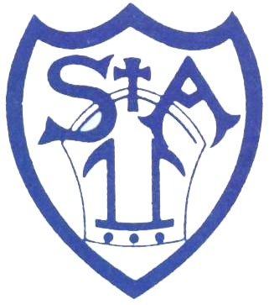

St. Augustine’s Catholic Primary School
Safer Recruitment

At St. Augustine’s Catholic Primary School, we are vigilant in maintaining a culture of safe recruitment. We have robust recruitment and vetting procedures that help deter, reject or identify people working in any capacity at, or visiting our school, who might abuse children.

CHECKS & VERIFICATIONS
- The Governing Body will reach a clear and reasonable rationale for its decisions about the suitability of each prospective employee based on statutory checks and evidence including: criminal record checks (DBS checks), barred list checks, prohibition checks, under the Childcare (Disqualification) Regulations 2009, Prohibitions, directions, sanctions and restrictions.
- We will also obtain verification of identity, of mental and physical fitness to carry out work responsibilities and of professional qualifications, as appropriate.
- We will seek confirmation of the applicant’s suitability and capacity through interview and her/his experience and history through references (x2), which are requested prior to interview. All job offers are made subject to:
- Completion of Enhanced DBS
- Verification of identity and right to work in the UK (e.g. Passport)
- Confirmation of teaching qualification (PGCE)
- Confirmation of QTS
- Receipt of satisfactory references x 2
- Completion of a self-declaration under the Childcare (Disqualification) and Childcare (Early Years Provision Free of Charge) (Extended Entitlement) (Amendment) Regulation 2018.
- Staff who were employed prior to statutory requirement of two references have undergone a risk assessment and a letter has been signed and filed in their Personnel records.
- Checks are carried out on all staff via the DfE Employer Access to ensure the candidate :
- Is not prohibited from teaching
- Has successfully completed their induction and probation period
- Is not subject of a suspension or conditional order imposed by the General Teaching Council for England that is still current
- At interview, candidates are asked if they have spent time overseas in the last 5 years. If so, written evidence will be requested to confirm that there is no overseas criminality recorded.
- Individuals who have lived or worked outside the UK will undergo the same checks as all other staff. We will make further checks we consider appropriate, so that any relevant checks that occurred outside the UK can be considered, including a check for information about any teacher sanction or restriction that an EEA professional regulating authority has imposed, using the NCTL Teacher Services system.
- We will take proportionate decisions on whether to ask for any checks beyond what is required and ensuring volunteers are appropriately supervised.
- We adhere strictly to safer recruitment practice as outlines in part 3 of the ‘Keeping Children Safe In Education (2019)’ and General Data Protection Regulation (May 2018)
- At least one member of every short listing and interview panel will have completed safer recruitment training. The Headteacher is responsible for ensuring that safer recruitment training is up to date.
- Unsuccessful applications will be kept on file for 6 months and will not be disclosed to any third party without the applicants consent.
- Staff personal files will be retained for a period of 6 years from notice of termination of employment.

GOVERNANCE
- All Governors have an enhanced criminal records certificate from the DBS. The governors who engage in regulated activity in the school will also undergo a barred list check.
- The recruitment panel consist of a governor who has undergone the ‘Safer Recruitment’ training.

SINGLE CENTRAL REGISTER (SCR)
- We keep an electronic single central record, which covers all staff (including supply staff and teacher trainees on salaried routes), volunteers, governors and contractors. The Headteacher and Chair of Governors or designated governor for safeguarding and child protection regularly monitor the single central record and complete a record of their scrutiny and recommendations.

