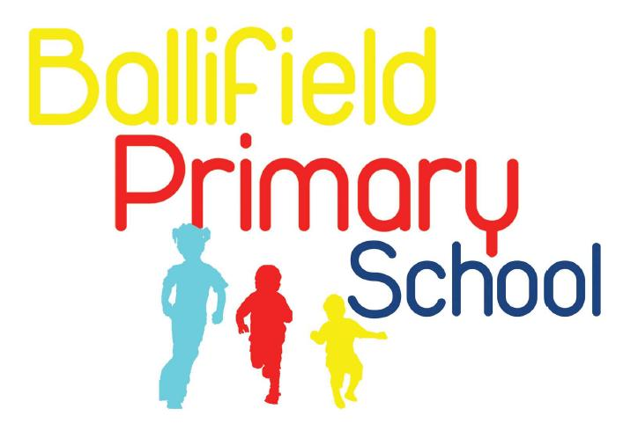
Handsworth Grange Road
Sheffield
S13 9HH

Tel/Fax: (0114) 269 7557 www.ballifield.co.uk

Headteacher: R Binns, BA Hons, NPQH

Advert - Cleaner

Ballifield Primary School are looking for an enthusiastic part-time cleaner to join our premises team. This is a permanent position, starting date to be confirmed.

Hours are 10 hours per week (3.15pm – 5.15pm Monday to Friday with flexibility) for 52 weeks per year. Salary: Grade 1 SCP 2 (£23656 pro rata)

Closing date: Thursday 6th February.

You will join a friendly team of cleaners and will be responsible for maintaining a high standard of cleanliness and hygiene throughout the school. Duties will include vacuuming, sanitising, mopping, dusting and any other appropriate tasks including deep cleaning of areas where necessary.
You should be reliable, punctual and able to use your own initiative. An understanding of Health & Safety at work and or COSHH regulations would be desirable, as is experience of working in a similar role, ideally in a school or similar establishment. However, full training will be provided for the successful candidate.

How to apply

For more information or to request a recruitment pack including full job description, please email recruitment@ballifield.sheffield.sch.uk or phone the school office on 0114 2697557.

If you have any questions regarding this role please contact Rachael Binns (Headteacher) on 0114 2697557.

Completed application forms can be returned by email to recruitment@ballifield.sheffield.sch.uk by the closing date.

Ballifield Primary is committed to safeguarding and promoting the welfare and safety of all our children. We expect all our staff and volunteers to share this commitment. This post is exempt from the Rehabilitation of Offenders Act (ROA) 1974. All shortlisted candidates will be asked to disclose any cautions or convictions prior to interview. The amendments to the ROA 1974 (Exceptions Order 1975, (amended 2013 and 2020)) provide that when applying for certain jobs and activities, certain spent convictions and cautions are ‘protected’, so do not need to be disclosed to employers, and if they are disclosed, employers cannot take them into account. Guidance and criteria on the filtering of these cautions and convictions can be found on the Ministry of Justice website:

https://www.gov.uk/government/publications/dbs-filtering-guidance/dbs-filtering-guide.

In addition, an online search will also be conducted for all shortlisted candidates prior to interview. If appointed, the successful candidate will be required to complete various vetting checks, including an enhanced DBS criminal records check, a Children’s Barred List check and a prohibition from teaching check. Please note that it is a criminal offence to apply for this post if you have been placed on the Children’s Barred List. Before applying, candidates are asked to read the school’s safeguarding policy which can be found through this link https://ballifield.co.uk/wp-content/uploads/2024/09/Child-Protection-and-Safeguarding-Policy-September-2024.pdf and the recruitment of ex-offenders policy, which we will send with the application pack.

We value our diverse workforce and aim to work together to make the most of our differences. We welcome applications from everyone. Under the Disability Confident employer scheme, disabled applicants who meet the essential criteria of this job are guaranteed an interview.

