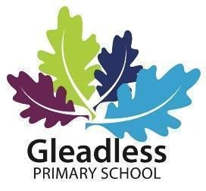

Cleaner (Grade 1 SCP 3, £24796 - £9439 actual)
15hrs a week (3:00pm-6:00pm Monday to Friday, 42 weeks per year – paid 48.3)
Required to start September 2026

The governors of Gleadless Primary School are seeking a cleaner to join our team.
You will join a friendly team of cleaners and will be responsible for maintaining a high standard of cleanliness and hygiene throughout the school.
Gleadless Primary School is a two-form entry school with approximately 400 pupils on roll, situated to the south east of the city. This position offers a fantastic opportunity to work as part of a friendly and supportive staff team. Our children love to learn and enjoy school and we build strong relationships with our families and community. We are looking for someone who is well motivated and passionate, a team player who is also able to work independently using their own initiative.

On 1st February 2024, Gleadless became a part of Sheffield South East Trust (SSET). SSET unites six other local schools (Manor Lodge Primary, Wybourn Primary, Norfolk Primary, Phillimore Primary, Woodhouse West Primary and Acres Hill Primary). These schools work closely together for the benefit of the children and communities they serve. There are many opportunities for support, training and networking between the schools. The Trust aims for schools to grow and flourish, by being individual and closely aligned with their community, whilst having strong capacity with other similar local schools.

As an organisation we are committed to the safeguarding of all children in our care. The successful candidate will be required to complete a DBS Disclosure in line with Section 115 of the Police Act 1997.

If you wish to apply for this post, application forms and further information can be found on the school website http://www.gleadless.sheffield.sch.uk. Please email completed application forms to:
recruitment@gleadless.sheffield.sch.uk

Closing Date: Tuesday 7th July 2026 – 9am
Interviews: Tuesday 14th July 2026

