ROCHDALE BOROUGH COUNCIL

SCHOOL: HEYBROOK PRIMARY AND NURSERY

JOB DESCRIPTION

Job Title: | Cleaner
Grade: | Grade 1 (SCP) 1-3
Responsible to: | Cleaner in Charge, Premises Manager, Headteacher
Responsible for: | Please insert as appropriate
Hours of Duty: | 20hrs per week. Split shift 6.30am-8.30am and 3.15pm-5.15pm Monday to Thursday. Fridays 6.30am-8.30am and 3.00pm-5pm.
Any Special Conditions of Service: | - The Postholder may be required to attend evening and weekend meetings.  - The School operates a Smoke Free Policy for all its employees and applies to any building and associated grounds within the immediate vicinity of the school.  - Annual Leave – All Year Round – Annual leave will be approved in accordance with the needs of the school.  - The ability to converse at ease with customers and service users and provide advice in accurate spoken English.
Values and Behaviours | Approach the job at all times using the Rochdale values:  - Proud  - Passionate  - Pioneering and Open  Be aware of and apply the Rochdale Values and Behaviours at all times.
DBS Disclosure Level: | Enhanced

This school is committed to safeguarding and promoting the welfare of children and young people and expects all staff to share this commitment.

Organisational Chart:

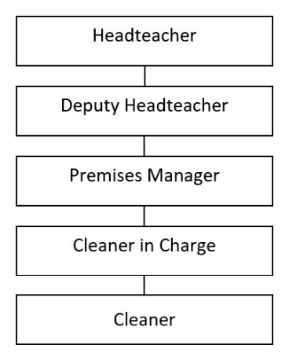

PURPOSE AND OBJECTIVES OF THE JOB

To undertake, individually or as part of a team, the cleaning of designation premises and associated accommodation to ensure that they are kept in a clean and hygienic condition.

CONTROL OF RESOURCES

Personnel
To be responsible for the direction, support and motivation of self and any staff under postholder’s control.

Financial
To work in accordance with Financial Regulations and procedures of the School.

Equipment/Materials
Cleaning materials, electrical and non-electrical equipment and reporting faults and defects to your immediate supervisor.

Health/Safety/Welfare
Responsible for the health, safety and welfare of self and colleagues in accordance with the school’s Health & Safety policies and procedures and current legislation.

Equality and Diversity
To work in accordance with the school’s policy relating to the promotion of Equality and Diversity.

Training and Development

The post holder will be responsible for assisting in the identification and undertaking of his/her own training and development requirements in accordance with the school’s arrangement.

Relationships (Internal and External)

Communicating with all staff (both of the school in particular and the Authority in general), students, contractors and other work persons on the premises and generally with members of the public as necessary.

RESPONSIBILITIES:
The postholder must:

- Perform his/her duties in accordance with the School’s Equal Opportunities Policy.

- Ensure that the School’s commitment to public service orientation and care of our customers is provided.

- Be able to render regular and efficient service to undertake the duties of this post.

PRINCIPAL DUTIES

- Cleaning.

- Washing.

- Sweeping.

- Vacuum Cleaning.

- Emptying of litter bins.

- Polishing and dusting of designated areas (which may include toilets and shower areas) and fixtures and fittings using, where appropriate, powered equipment.

SECONDARY DUTIES

- To participate in relevant training as required

- To undertake such other duties and responsibilities, of an equivalent nature, as may be determined by the Headteacher (or nominated representative) in consultation with the post-holder and if she/he wishes with her/his trade union representative.

Job Description prepared by: _____________________ Date: ___________________

Agreed by Postholder: ___________________________ Date: ___________________

