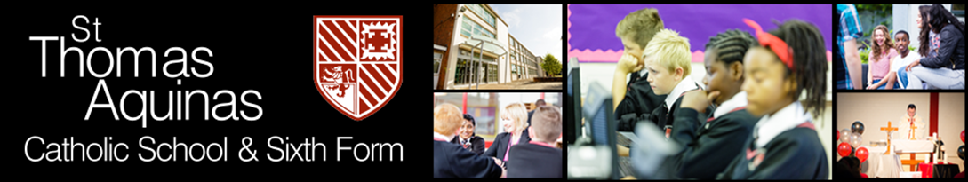
Cleaner
Job Description
Grade: GR1 £13.03 per hour
- Job Purpose
  - To provide a clean and pleasant environment in order to facilitate the effective teaching of pupils and its full use by those staff and pupils who occupy it. To help maintain the fabric of school building
  - To maintain cleanliness in order to prevent any health risk from occurring in schools
- Key Responsibilities
  - To clean a specified area of the school to the required standard as instructed by the Supervisor
  - Wash floors, surfaces, fixtures and fittings and walls up to a specified height
  - Cleaning inside windows up to a specified height
  - Sweeping and vacuuming floors
  - Polishing and dusting surfaces and furniture
  - Cleaning toilets and shower areas
  - Use cleaning materials as appropriate, and according to their instructions for use
  - To empty bins and remove rubbish from the premises
  - To report any damages to school property or other relevant matters to the Supervisor
  - To use power cleaning equipment as directed
  - To undertake relevant Non-Routine cleaning as instructed by the Supervisor
  - To undertake any relevant training as required
  - To comply with the requirements of the health and safety at work regulations
  - To take reasonable care for the Health and Safety of themselves and for others
  - To co-operate with the employer in ensuring that health and safety responsibilities are carried out
  - Individuals have a responsibility for promoting and safeguarding the welfare of children and young people he/she is responsible for or comes into contact with.
  - To ensure all tasks are carried out with due regard to Health and Safety
  - To undertake appropriate professional development including adhering to the principle of performance management.
  - To adhere to the ethos of the school
    - To promote the agreed vision and aims of the school
    - To set an example of personal integrity and professionalism
    - Attendance at appropriate staff meetings and parents evenings
- Supervision Received
  - Level of supervision:
2. Left to work within establishment guidelines subject to scrutiny by Cleaning Supervisor who will also provide support and training.
This job description will be reviewed annually and may be subject to amendment or modification at any time after consultation with the post holder. It is not a comprehensive statement of procedures and tasks but sets out the main expectations of the school in relation to the post holder’s professional responsibilities and duties.
Elements of this job description and changes to it may be negotiated at the request of either the principal or the post holder.
Whilst every effort has been made to outline the key duties and responsibilities of the role, it is not an exhaustive list. The duties and responsibilities of the role may vary from time to time,
commensurate with and without changing the general character of the duties or the level of responsibility entailed and would not in itself justify a reconsideration of the grading of the post.
The Multi-academy will endeavour to make any necessary reasonable adjustments to the job and the working environment to enable access to employment opportunities for disabled applicants or continued employment for any employee who develops a disabling condition.

For further information please see the Link to Candidate brochure
Safer recruitment Policy https://www.lumenchristi.org.uk/docs/0022_Policies/Safer_Recruitment_Policy_23.pdf
Whistle Blowing Policy
https://www.lumenchristi.org.uk/docs/0023_Policies/Whistleblowing_2023.pdf
Staff Code of conduct
https://www.lumenchristi.org.uk/docs/0023_Policies/Staff_Code_of_Conduct_2023.pdf

