January 2022

Dear Applicant,

Thank you for enquiring about the post of Cleaning Assistant. Please find enclosed the following information:-

- Job Description and Person Specification
- College Prospectus
- College Newsletter
- An application form
- RO1 form

Minsthorpe Community College is a large, vibrant and inclusive community college with a student body of over 1500 students ranging from 11 to 19 years. We have six primary schools in our pyramid and are pleased to welcome children from neighbouring areas.

We have a highly skilled team of teachers and associate staff that always act in the best interest of the students. We offer excellent facilities for learning and teaching with dedicated blocks for each subject area as well as community dimensions including a sports & fitness centre and a children’s centre;

Students enjoy a range of extra-curricular and enrichment opportunities which complement their learning. Minsthorpe Community College secures great GCSE and Post 16 results year on year allowing students to progress into higher education and employment.

Minsthorpe Community College: A place where everyone plays a part in strengthening our learning community through Motivation, Commitment and Care.

If you are appointed to the staff of this College, you will be given the opportunity to work in an exciting and rewarding environment which can only help you in terms of your own personal and professional development.

The closing date for this post is Friday 28th January.

Please return your completed application to the Director of HR & Associate Teams at the College by midday on 28th January.

Thank you, in advance, for your application.

Yours sincerely
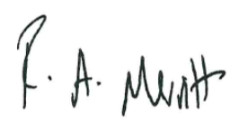
Mark Gilmore Rachael Merritt
Principal Principal

