**Founded in hope St. Mary’s CE (VA) Primary School is a place where all can find their voice, grow in wisdom and live well in community and service.**

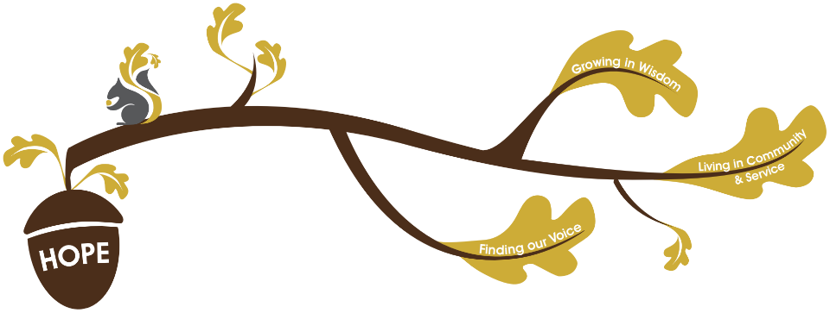Leaders at St. Mary’s School have a clear vision for our school that has three key branches. The three key branches of our vision grow from the core value of **HOPE**. We believe that hope gives us optimism for a better future. No matter where you are on your journey that through the grace of God we have the hope of a new and better start.



**Finding Our Voice** – We belief that all people are made in God’s image (Genesis 1:27) and are, therefore, of infinite worth. That the first word that is said about us is that we are ‘good’ (Genesis 1:31). We believe that all our children need to have the skills to communicate effectively with the world around them, growing in self-confidence, esteem and emotional wellbeing.

**Live in Community and Service** – We believe in a God who sent his Son, Jesus, not to be served but to serve (Matthew 20:28) and calls us to serve each other (John 13:14-15). We believe in a God who created us to do ‘good works’ (Ephesians 2:10). Through service, we seek to support help and nurture each other so that we have a shared responsibility to ensure that everyone can flourish. We believe that human beings are not made to be alone (Genesis 2:18) but are meant to be part of a ‘body’ (1 Corinthians 12:12-27) where each contributes and cares for the other. Through living as a community, we seek to grow in our understanding of each other, valuing our self and others locally nationally and globally.

**Grow in Wisdom** – We believe that through a deep and broad understanding of all aspects of the world we live in we can best develop the skills, understanding and resilience required to be able to flourish. We believe that each one of us is an individual whose unique skills set needs to be nurtured, developed and celebrated. ‘We believe in a God who has called us to grow in wisdom (James 1:5, Proverbs 4:7).  A God who proclaims that wisdom is a blessing (Proverbs 3:13) and calls us to love God not only with our hearts, but with our minds and understanding (Matt 22:37).