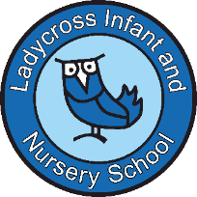

**Clerk to the Governors Person Specification**

* Essential:
  + Excellent organizational skills, with the ability to manage multiple tasks and prioritize effectively.
  + Strong communication skills, both written and verbal, with an ability to present information clearly.
  + Ability to work independently and as part of a team.
  + High level of attention to detail and accuracy in all aspects of work.
  + Good understanding of school governance, or willingness to develop this knowledge.
  + Discretion and professionalism in dealing with confidential matters.
  + Proficiency in using office software, including word processing, spreadsheets, and email.
* Desirable:
  + Previous experience as a Clerk to a Governing Body or in a similar administrative support role.
  + Knowledge of current educational legislation and governance frameworks.
  + Understanding of the school’s local context and community.