# 

**Computing Teacher**

# 

**Computing Teacher**

**St Crispin’s School**

Headteacher:

Ginny Rhodes

NOR 1274, 11-18

Mixed Comprehensive, London Road, Wokingham, Berkshire RG40 1SS

Tel: 0118 978 1144

www.crispins.co.uk

**Full-time for September 2022, Main Pay scale** £25,714-£41,604 (depending on experience)

**Permanent**

**Suitable for Early Career Teachers**

**Rare opportunity to join a growing popular school**

As a dedicated, ambitious teacher, you want to enjoy coming to work, be supported and valued.

At St. Crispin’s you will be part of a happy, friendly team. We are a high-attaining school with student behaviour that is described as exemplary.

As a result of a significant increase in student numbers and growth in our popular school, a rare opportunity for an enthusiastic Computing Teacher to join our Maths and Computing Department has arisen.

Our ethos of “Excellence for All”encapsulates our commitment to do the very best for both students and staff. If you are looking for a vibrant learning environment with many opportunities to maximise your potential, be motivated and inspired, we would love to hear from you.

Visits to the school highly recommended!

Applications from new entrants to the profession welcomed.

**To apply: TES QUICK APPLY** or **via our school website** [www.crispins.co.uk/vacancies](https://www.crispins.co.uk/vacancies/).

Application form also below.

To find out more contact Mel Knight, PA to Headteacher - 0118 978 1144 [knightm@crispins.co.uk](mailto:knightm@crispins.co.uk)

**Closing date:** 9 am, Tuesday 25st January

**Interviews:** Monday 31st January

**For more information:**Mel Knight on 0118 978 1144 or email: [knightm@crispins.co.uk](mailto:knightm@crispins.co.uk)

This school is committed to safeguarding and promoting the welfare of children and young people and expects all staff and volunteers to share this commitment. Appointments are subject to enhanced CRB clearance and satisfactory employment references.



**Job Description**

**Salary**  St Crispin’s main point scale (please refer to Pay Policy for detailed scale; this policy can be accessed via The Circle Trust website.)

# Aim and main purpose of the job:

**Knowledge**

* Demonstrate subject competence and to keep up-to-date his/her knowledge of the National Curriculum for 11-16 year olds in relation to their subject; and where relevant to the post, other examination courses at KS4 and Post 16.
* To attend continuous professional development activities when required to update his/her knowledge of the National Curriculum, syllabus changes and national initiatives which impinge directly on teaching, pastoral or other responsibilities.
* To keep informed about the key priorities identified in the School Improvement Plan, associated department development plans and his/her responsibilities agreed upon within it.

**Planning, Teaching and Classroom Management**

* To teach across a range of abilities and ages commensurate with his/her experience and skills and as agreed in consultation with the Headteacher and Head of Department.
* To plan lessons in accordance with the agreed departmental scheme of work and in line with the departmental teaching and learning policy.
* To plan lessons carefully with specific learning objectives and with special regard to prior attainment data, gender and race, fluency in English, DSEN (including IEPs).
* Use a variety of teaching approaches that identify, build upon and develop pupil learning styles, and the ability to learn independently.
* To set clear targets for pupil improvement and monitor progress towards these.
* To work effectively with Learning Support Assistants to plan lessons and individual support for pupils with specific learning difficulties.
* To set appropriate homework in line with school and departmental policies.
* Establish and maintain good standards of pupil behaviour in the classroom by implementing consistently and fairly the School Behaviour Policy.

|  |
| --- |
| Monitoring, Assessment, Recording and Reporting  * To assess how well learning objectives have been achieved and use this assessment to improve aspects of teaching. * To develop the expertise to be able to recognise the level at which a pupil is achieving, and make accurate and valid assessments using school and departmental policies and procedures. * To mark work on a regular basis in line with school and departmental policies and guidelines. * To make careful records of attendance and pupil progress following carefully the departmental guidelines; mark books and pupil work should be available for scrutiny as required from time to time. * To liaise effectively with pupils’ parents/carers through informative oral and written reports on pupils’ progress and achievements according to the school’s assessment and reporting schedule. * To discuss with parents/carers appropriate next steps in learning for their child, and encourage them to support their child’s learning.  Other Professional Responsibilities  * To undertake the role of form tutor, if required to do so, and follow the guidance given by the Head of Year in relation to carrying out this role. * To undertake supervisory duties before school, at break or after school as required. * To attend department, year and other school meetings as required. * To contribute to the work of the department. * To support colleagues in maintaining the school’s behaviour policy. * To maintain appropriate standards of professional appearance and conduct. * To raise issues of concern with his/her line manager or with the appropriate member of SLT. * To maintain the Professional Standards for teachers. * To follow the school performance management system. * The post holder is responsible for ensuring that the school safeguarding/child protection policy is adhered to and concerns are raised in accordance with this policy. * To carry out tasks as reasonably required by the Headteacher. |

# Details of Line Management

Teachers are line managed by Heads of Department (and Heads of Year in respect to their work as a tutor.)

# Notes:

Whilst every effort has been made to explain the accountabilities of this post, each individual task undertaken may not be identified.

This job description is current, but following consultation with you, may be changed by the Headteacher to reflect or anticipate changes in the job, which are commensurate with the salary and job title.



**Maths and Computing Department Information**

**Introduction and welcome by Head of Department including departmental vision**

The school motto is “Excellence for all” and this drives everything that we do in the maths and computing department. We strive to have excellent learning experiences and outcomes for students and an excellent working environment for our staff. I strongly recommend all applicants visit the department before applying to see first-hand what a warm, welcoming and experienced team of maths and computer science teachers we have and the supportive team you would be joining. We are very fortunate in having the two departments together as it gives us a greater team, with a wealth of experience and can map students learning across both curriculums, allowing us the opportunity to make logical links between the mathematical processes and the computational algorithms needed to apply them. By combining the two departments, students benefit from having computing and computational thinking taught in ability set classes explicitly as a separate subject from IT which is delivered as part of the science department.

**Curriculum overview**

At key stage 3, we strongly believe in getting the basics right and focus heavily on developing numeracy and algebraic skills in year 7. We are moving over to a mastery scheme of work and are in the process of developing and delivering this to year 7 with the plan to roll it up each year going forwards. We have developed our own schemes of work, department wide resources, that include rich tasks and activities that develop problem-solving strategies, with an aim to foster a love of subject in the lower school. In years 8 and 9 we are currently delivering the Oxford University Press MyMaths series.

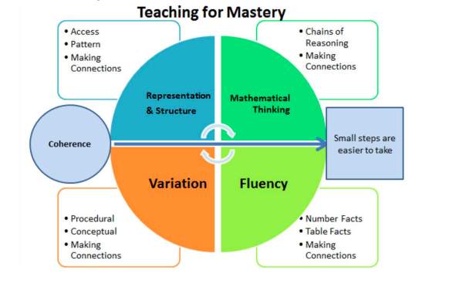

At key stage 3 all students receive one hour a fortnight of computing with a specialist computing teacher. Our computing curriculum in key stage 3 ranges from cyber security to developing programming skills, which from year 7 onwards includes using micro-bit and scratch and advances to using python from year 8. More details of both our maths and computing schemes of work can be found on our school website.

At key stage 4, we follow the new 9-1 AQA GCSE. We always have excellent GCSE results for maths and run intervention programmes to ensure all pupils make the best possible progress. Our 9-4/A*-C pass rate has been consistently between 84% and 87% for many years and we have been ranked in the top quintile for progress 8 for maths since the measure came in. Students’ progress is monitored carefully by classroom teachers and key stage coordinators using end of half term tests for the lower school and chapter tests for key stages 4. Specialist maths intervention staff then use these results to support classroom teachers and students as necessary.

In computing at key stage 4 we currently follow the 9-1 AQA GCSE Computer science course. It is the fastest growing option subject at St Crispin’s for GCSE and we now have 3 classes in each year group taking the course, out of a 7-form entry year group. This reflects the strength and love of subject that is being developed during the specialist computing lessons at key stage 3. To be eligible to take this course we require students to be taking higher tier GCSE Maths and monitor students’ progress closely using tracking tasks and run timetabled intervention classes with year 11 groups to ensure pupils have the best chance of success in this subject.

At key stage 5, we continue using the mymaths textbooks and systems for both the new AQA A-level Maths and Further Maths. At A-level, we have several maths classes and one class for further maths in each year group, and are always one of the most popular A-level subjects in the school. This reflects the quality of the department, its leadership and the supportive environment and enjoyment of subject we create in the lower years. We introduced the OCR A-level Computer science in September 2021 and it has been immediately popular and successful and we are looking forward to watching computer science grow as a subject at St Crispin’s even more in the future.

**Examination results**

We are incredibly proud of our examination results at St Crispin’s. At GCSE, for many years we have consistently achieved 84%, or above, of year 11 students achieving grades A*-C or 9-4 in maths. Our excellence for all philosophy means that we want the best for all students and successfully offer the ELC for lower ability students for whom GCSE Maths is a challenge. Our computer science results are more varied, depending upon the cohort we have each year but progress measures are always positive.

**Resources and rooming**

At all key stages we use the mymaths textbooks for maths and students have access to their own books in class and via the online platform at home. We use teams effectively with all classes across maths and computing to share resources and assignments with students. The department is split across two blocks, the main maths block with maths classrooms and the maths and computing department office and tea room. Then a separate Computing block with two computer rooms, which are being refitted this summer, and two further maths classrooms. The department also has a set of 35 laptops for use with students. Classrooms have interactive whiteboards and all the resources we would wish to create engaging environments in which students can learn.

The department is well resourced and we have developed excellent practises in creating and sharing our own resources. We also subscribe to Craig and Dave, mathspad, mathsbox, kerboodle and mymaths to ensure teachers have a wealth of resources for use in the classroom and for setting regular personal study tasks for students to complete at home.

I am very proud of the Maths and Computing department at St Crispin’s

Katy Prince, Head of Maths and Computing

**About us**



St Crispin’s is a mixed comprehensive secondary school. We offer students of all abilities and interests the opportunity to be the best they can be. Ofsted describe us as a good school with outstanding leadership and exemplary student behaviour.

We believe in promoting excellence, while providing an atmosphere in which our students can learn, enjoy, grow and show support to others. We have a strong focus on the basics: excellent learning and teaching, a safe disciplined environment and an ethos, which promotes the highest aspirations. Good qualifications are the key to a young person’s future success and for this reason, they are our main priority. Nevertheless, developing young people to become well rounded, articulate, confident and happy is of equal importance.

We have a team of committed staff that provides support, challenge and expertise, enabling every student to achieve.

On 1st February 2018, St Crispin’s converted to an academy and became part of [www.thecircletrust.co.uk](http://www.thecircletrust.co.uk).

Our trust was created to serve the local area and be geographically committed to surrounding counties. It was borne out of a desire that all children and young people have an excellent well-rounded education and flourish in first-rate schools where the best teaching, the best facilities and the most up-to-date resources are made available to them.

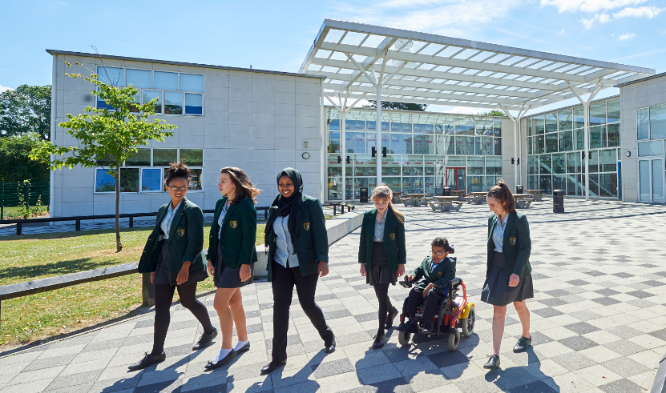

Policy Statement

To view our Recruitment Privacy Policy please see link below:

[St Crispin's School Recruitment Privacy Policy](https://www.crispins.co.uk/wp-content/uploads/2020/11/St-Crispins-School-Recruitment-Privacy-Notice.docx.pdf)