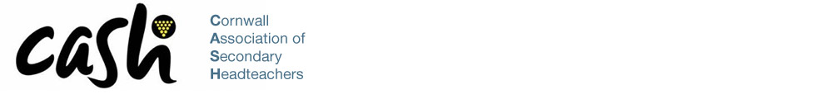

October 2024

Dear Applicant,

Thank you for your interest in the position of Consultant Executive Officer for Cornwall Association of Secondary Headteachers (CASH) – two year contract.

Following the retirement of our previous Executive Officer in the summer of 2024, we are seeking to secure a new self-employed or company consultant to provide the services of CASH Executive Officer. These include responsibility for the coordination and day-to-day running the association, supporting its members, sourcing and coordinating continued professional development for all CASH members, and ensuring school leaders are kept abreast of the latest changes and decisions across the educational landscape.

Cornwall Association of Secondary Headteachers (CASH):

Cornwall Association of Secondary Headteachers is a membership organisation that represents publicly funded secondary schools in Cornwall and the Isles of Scilly, teaching Key Stages 3 and 4 (11 -16 year old children) and post 16 where those schools have a Sixth Form. The Duchy's four special schools, Local Authority Virtual School and the Alternative Provision Academies across the county are also members.

CASH is run by heads for heads. We provide professional support to Headteachers and school leaders with the aim of improving school outcomes for all young people in Cornwall. CASH also runs a number of subject leaders’ networks, coordinated by the Executive Officer.

Effective communication, dialogue and trust between colleagues lies at the heart of CASH.  We act as an organisation to represent the views of Headteachers in discussing issues of mutual interest with the officers and elected members of Cornwall Council, the county's six MPs and other groups including the media.

Please visit the CASH website for further information. If after reading the information, you have any further questions, please contact me via my school email address [head@budehaven.cornwall.sch.uk](mailto:head@budehaven.cornwall.sch.uk), and we can arrange a telephone call. The closing date for applications is 9am on Monday 18th November 2024.

We very much look forward to receiving an application from you.

Yours faithfully,

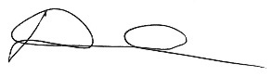

Mr Dominic Wilkes

Chair of CASH/Headteacher of Budehaven Community School