

Queen Elizabeth’s High School

An 11-18 Grammar School. Original Charter 1589.

Vacancy Information Booklet
Cover and Operations Administrator
37 hours per week
39 weeks per year
To commence ASAP, with flexibility for candidates currently serving a notice period.
Grade 4 (12-15) Actual salary £22,290 - £23,831 (FTE £25,989 - £27,254)
Queen Elizabeth’s High School is entirely committed to safeguarding and promoting the well-being of all of its students. Each student’s welfare is of paramount importance. Successful candidates are therefore required to reveal information concerning all convictions and offers of employment will be subject to an enhanced background check by the Disclosure and Barring Service (DBS).
Closing Date: 08.00 on 25th September 2026
Interviews to be held week commencing 5th October 2026
The school reserves the right to end the recruitment process early in response to applications received.

School Vision

At Queen Elizabeth’s High School, we aim to offer an outstanding education and to be the destination of choice for academic excellence. This is achieved by providing an environment in which students are academically challenged, well cared for, and are afforded access to a broad range of fulfilling and enriching co-curricular activities.

School Motto and Values
Tradition Achievement Opportunity
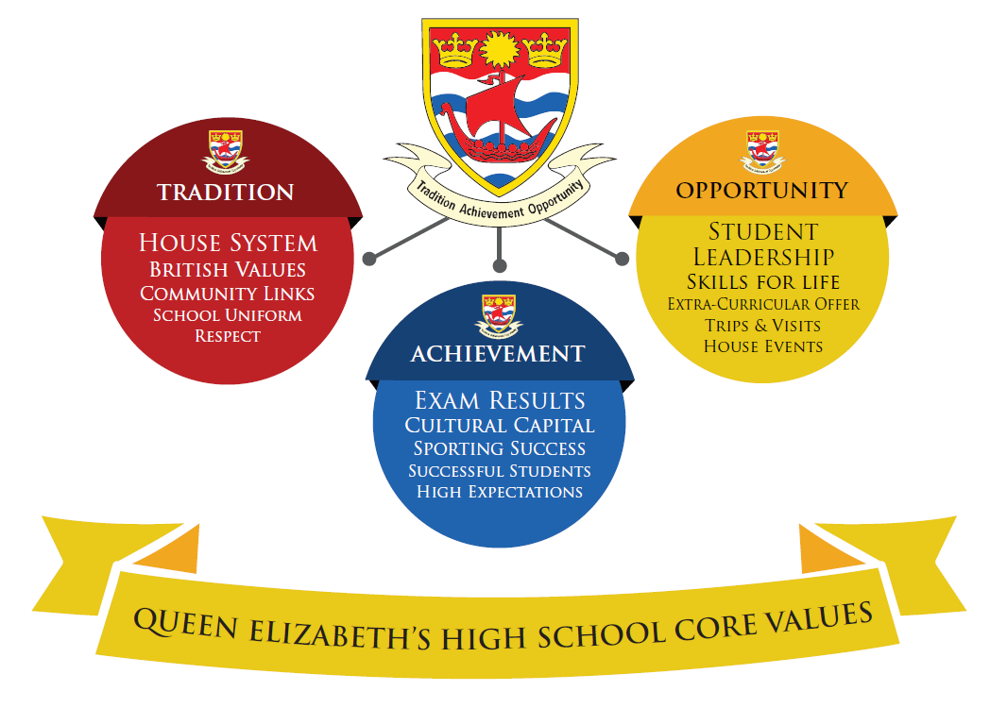
At Queen Elizabeth's High School we aim for high standards in all we do.
- We strive to fulfil the potential of each student.
- We aim to achieve this through a carefully planned, broad education in which enthusiastic teachers use a variety of teaching styles in activities inside and outside the classroom.
- We aim to maintain a friendly and caring atmosphere in which students and staff share a mutual respect.
- When they leave Queen Elizabeth's High School we want students to be well-balanced adults, inspired to continue their learning and able to contribute positively to society.
- Queen Elizabeth’s High School is committed to the highest possible standards of child protection.

The selection criteria for student admission to QEHS in Years 7-11 benefits children of staff who have worked at our school for more than two years, or who are recruited to fill certain key posts. See the full Admissions Policy on our school website (www.qehs.lincs.sch.uk).

What Ofsted said…….
In December 2023, the school was inspected by Ofsted. QEHS has been graded as ‘Good’ in all five of the inspection categories: The Quality of Education, Behaviour & Attitudes, Personal Development, Leadership & Management, and Sixth Form Provision. Therefore, the overall effectiveness of the school is a strong ‘Good’.

The inspection team rightly noted that QEHS is a school where expectations around what students can achieve are high, and that students thrive on this challenge and are successful in their academic studies. Just as importantly, it is recorded that students ‘…get on well together and enjoy each other’s company’ and that interactions with their teachers are similarly positive and productive. Above all, students attending QEHS were seen to be benefitting from an ambitious curriculum and ‘…a rich educational experience’ that serves to develop their confidence, character and to broaden horizons.
Following on from two consecutive years of outstanding examination results and a top ten regional placing in The Sunday Times Parent Power Survey, the findings of this Ofsted inspection serve to demonstrate just how amazing the students of QEHS truly are and the extent to which they thrive and blossom by committing wholeheartedly to the utterly unique Queenies offer.

The QEHS Learner Standards
We are committed to working together as a school to ensure that students enjoy and achieve in all of their endeavours. Learning is at the heart of our thinking as a community and we encourage students to grasp opportunities in order to broaden their knowledge, skills and understanding. To support this, we have developed the QEHS Learner Standards. These standards set out to identify three key areas of focus for learning and are used as a framework for all that we do.

The Learner Standards are as follows:

1. Behaviour for Learning
2. Learning to Learn
3. Leadership for Learning


The Vacancy
This vacancy at Queen Elizabeth’s High School will require the successful candidate to be responsible for the effective administration and coordination of staff cover, ensuring continuity of teaching and minimal disruption to learning.

To monitor, analyse and report on staff attendance, supporting compliance with school policies and procedures.

To manage and maintain accurate, secure and accessible records, including archive systems and confidential staff information.

A strong team of support staff fulfil various roles within the school. The post holder must be able to work with initiative and foresight to a very high standard and contribute to the smooth running of covering the school’s teaching staff absences. The successful candidate will be the point of contact between varying stakeholders and should therefore possess excellent communication skills. The post holder will also be required to have excellent organisational skills and the ability to multi-task.

We seek to appoint an individual with high educational standards and excellent computer skills. Previous experience as an administrator is essential and experience of working within a school environment would be desirable, along with knowledge and experience of using Microsoft Office package and database systems.

Due to the nature of the administrative role, there will be a need for flexibility around working hours on occasions.

The Cover and Operations Administrator will report and be accountable to the Office and Admissions Manager/ Assistant Headteacher Teaching and Learning and Operations.

KEY RESPONSIBILITIES
MAIN DUTIES:
Cover Management & Coordination
1. | Ensure effective daily organisation and deployment of staff cover for both planned and unplanned  teaching staff absences.
2. | Liaise with teaching staff, Cover Supervisors, Heads of Department, external agencies, and supply  teachers to secure appropriate cover.
3. | Manage and coordinate cover requirements during whole-school events, including trips, exams and  other calendar activities.
4. | Plan staff absence proactively, where possible, to minimise disruption and reduce reliance on external  cover.
5. | Allocate cover ensuring the best possible match between staff expertise and student needs.
6. | Provide cover staff with clear, personalised timetables and relevant lesson information.
7. | Communicate daily cover arrangements effectively to all staff, ensuring clarity and timeliness.
Timetabling, Rooming & Exam Support
8. | Coordinate and manage room changes to ensure minimal disruption to teaching and learning.
9. | Support the organisation and smooth running of internal and external examinations, including  room allocation and staffing requirements.
10. | Work closely with curriculum and leadership teams to ensure alignment between cover, timetabling,  and school priorities.
11. | Contribute to forward planning of school operations to ensure efficient use of resources and spaces
HR Administrative Support
12. | Provide administrative support for HR processes, particularly in relation to staff absence management  and recruitment.
13. | Record and monitor staff absence accurately using the school MIS and school systems.
14. | Issue Return to Work documentation and alert Leadership Team members when absence triggers  are reached in line with policy.
15. | Support recruitment processes, including coordination of candidate visits, interview scheduling,  and onboarding logistics.
16. | Maintain accurate and confidential staff records in line with data protection requirements.
General Responsibilities
17. | The postholder is expected to be flexible in undertaking duties and responsibilities attached to their  post and may be asked to perform other duties, which reasonably correspond to the general character  of the post and are commensurate with its level of responsibility
18. | Contribute to continuous improvement of systems, processes, and practices within the role.

PERSON SPECIFICATION
Requirements | Where identified* | Essential | Desirable
Experience of working with SIMS | A, T, I
Experience working in a school environment | A, I
Strong ICT skills are essential, particularly in terms of spreadsheets, data handling, manipulation and output | A, T, I
An ability to communicate effectively both verbally, electronically and on paper with all stakeholders | A, T, I
Ability to work quickly and accurately on their own initiative | A, T, I
Preferably 2-3 years’ experience of a similar senior administrative role | A, I
A Levels or NVQ Level 3 (or equivalent qualification). | A, I
Excellent inter-personal and organisational skills | A, T, I
Knowledge of the education system | A, T, I
Self-starter and decision maker | A, I
Ability to handle sensitive and confidential information with complete discretion | A, I

*A = Application form T = Test/Assessment I = Interview P = Presentation

GENERAL

The postholder is required to take personal responsibility for contributing to organisational transformation and changes in ways of working, maximising the benefits and efficiencies for both internal and external customers, including the promotion and use of self–service to achieve maximum cost effectiveness.

The postholder is expected to work to the Lincolnshire County Council Core Values and Behaviours and to carry out the duties in accordance with Lincolnshire County Council policies.

Other Duties - The duties and responsibilities in this job description are not exhaustive. The post holder may be required to undertake other duties within the general scope of the post. Any such duties should not substantially change the general character of the post. Duties and responsibilities outside of the general scope of this grade of post will be with the consent of the post holder.

Safeguarding -. All employees need to be aware of the possible abuse of children and vulnerable adults and if you are concerned you need to follow the Lincolnshire County Council Safeguarding Policy. In addition, employees working with children and vulnerable adults have a responsibility to safeguard and promote the welfare of children and vulnerable adults during the course of their work.

HOW TO APPLY
We believe that QEHS is a great place to work. Please read the information in this booklet, the relevant job description and have a look at our website. Should you wish to apply, application details are available on our school website (www.qehs.lincs.sch.uk) or by emailing a request to recruitment@qehs.lincs.sch.uk.

A letter of application is required to accompany the formal application form. This letter must be limited to two sides of A4 paper and is an opportunity for you to explain how you believe your own experience equips you for the post and for you to outline how you would approach this role at QEHS.

You are also welcome to telephone 01427 612354 if you have any questions about the post / and or you would like to arrange a visit to the school.

Completed applications should be submitted by email to recruitment@qehs.lincs.sch.uk by 08.00am on Friday 25th September 2026. We will contact your referees for a reference before the interviews and, for shortlisted candidates, the references will be taken into account in deliberations at the conclusion of the final panel interviews. Interviews will be held on week commencing Monday 5th October 2026.

Candidates are required to bring to interview evidence of all relevant qualifications listed on their application as well as certificates for A Level, degree, teaching and other qualifications acquired. Please also bring proof of identity, including at least one item of government issued photographic evidence (current passport or new style UK driving license). A list will be provided detailing which documents can support your application. Please be aware that at least one document should include your National Insurance number. Candidates will also be provided with a self-disclosure form. This will allow them the opportunity to disclose and fully explain any information with regard to disciplinary sanctions, and/or anything they are concerned might appear on their DBS, etc.

Queen Elizabeth’s High School is committed to safeguarding and promoting the welfare of children and young people and expects all staff and volunteers to share this commitment. The successful candidate will be subject to an enhanced DBS check.

Queen Elizabeth’s High School is committed to equal opportunities and staff development. We aim to ensure that no job applicant or employee receives less favourable treatment because of race, colour or nationality, gender, marital status, religion, disablement or criminal record. Members of staff are expected to set a good example in their appearance and smart office dress is a good guide for all staff.

QEHS and Lincolnshire Children Services are committed to
the highest standards of child protection and staff development.


Queen Elizabeth’s High School
Morton Terrace ∙ Gainsborough ∙ Lincs DN21 2ST ∙ Tel (01427) 612354
Website: www.qehs.lincs.sch.uk Email: office@qehs.lincs.sch.uk
HEADTEACHER: Mr R M Eastham, BSc (Hons), MEd, NPQH

Original Charter 1589




