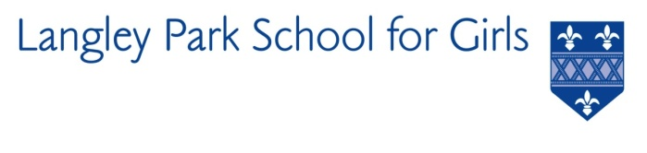

Langley Park School for Girls

Hawksbrook Lane

Beckenham

Kent BR3 3BE

Headteacher: Ms Katie Scott

COVER COACH

(Fixed-term Contract)

Immediate Start – Contract to July 2022

Salary: NJC Scale 4, Point 7 (£22,377)

Equivalent of working : 36 hours per week, 52 weeks per year

Langley Park School for Girls is seeking to appoint a talented and confident individual with natural authority, excellent communication and organisational skills to provide cover for lessons including PE, assist in the running of our extra-curricular programme; as well as high level administrative support within the PE department. This post has come about in response to the need for students returning to school to increase levels of activity. No formal teaching qualifications are required, but sporting experience in either netball, football, hockey or basketball is essential. There is the possibility that the successful candidate (if a graduate) could subsequently become part of a GTP programme. This is a 36 hours per week contract, however, the successful candidate will need to be flexible around their working hours and commit to supporting the broad fixtures programme offered by the school.
A job description, person specification and application form are available on our website at www.lpgs.bromley.sch.uk

Please note that whilst you are also welcome to submit a CV, shortlisting will be based solely on our application form and covering letter. All applicants must complete the LPGS Application Form. Applications should be emailed to Helen Partridge, hpa@lpgs.bromley.sch.uk.

The closing date for applications is Thursday 22nd April. It is anticipated that interviews will be held during the week commencing Monday 26th April.

This school is committed to safeguarding and promoting the welfare of children and young people and expects all staff and volunteers to share this commitment. The successful applicant will be subject to an Enhanced Disclosure & Barring Service check.

