

**Recruitment**

**Information**

**Caring | Inclusive | Ambitious**

**Company Registration Number: 7703800**

**Name of the Academy Trust: Testwood School**

**Data Protection Registration No. Z5506335**

**Registered Address: Testwood School, Testwood Lane,**

**Totton,**

**Southampton, Hampshire, SO40 3ZW**

**For more details, visit www.testwoodschool.co.uk**

**Cover Supervisor**

Part-time 27.5 hours per week, term time only (39

weeks)

Permanent

Required From: ASAP

Application Deadline: 17th October at Midday

Grade D post £27,780 FTE (actual £17,709)

**Testwood School has been educating the young people of our community since 1946.**

We are a mid-size 11-16 comprehensive school located in Totton. We aim to nurture our young people to become respectful, resilient and proud to take responsibility in our community. We aim to do this by aiming to consistently act in accordance with our core values of being **Caring, Inclusive and Ambitious.**

We are proud of our good reputation in the community and many of our students are not the first generation to attend Testwood. Some even claim to be fourth generation Testwood!

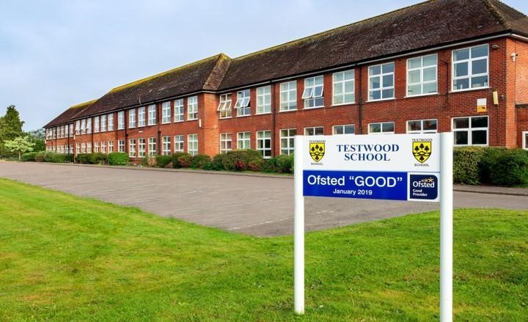

**Welcome**

**To Testwood School**



We are proud of our traditions, such as our House system, but we also embrace change, seek to learn from best practice elsewhere, and prioritise the professional development of our staff. We do this not just to improve our effectiveness as a school, but also because we recognise that learning and development are as important to staff as they are to our students here at Testwood School.

We are proud that our staff culture is open, collaborative and supportive. If you too want the very best for young people, recognise that this can be challenging at times, are prepared to work hard, and would like to be a part of our school community then I would encourage you to apply to join us.

**Tim Webber**

Headteacher, Testwood School

**Cover Supervisor - Job Description**

**“Testwood School is a great place to work and develop as a teacher. It has a strong sense of community where students are at the heart of what we do.”**

We are delighted to be seeking an enthusiastic cover supervisor to join our team.You will join a small but enthusiastic team of dedicated cover teachers to support absent colleagues across the school.

The applicant will be expected to supervise whole single classes of students under the direction of a teacher during the short-term absence of a class teacher.

This is an ideal opportunity for a confident, flexible, well-organised person who is considering a career in teaching. The role may suit someone looking to gain classroom experience before applying for a PGCE or SCITT placement.

The ideal candidate will have good communication skills, as you will have to liaise between the school office, class teachers and students. You will be required to ensure all work set is completed to a high standard.

The successful candidate will:

* Have the ability to work on their own initiative.
* Educated to GCSE level in English & Maths.
* Good communication skills and ability to clarify and explain instructions clearly.
* Keen to learn and develop professionally.

Previous experience of work in a similar role would be an advantage, but not essential.





**Please send your completed application form to Jayne Baker, Headteacher’s PA at: jbaker@testwoodschool.co.uk**

**“Testwood School have a wealth of wellbeing and welfare initiatives to ensure our staff thrive and enjoy the working life”**

**“I consider myself lucky to have worked at Testwood since 2005. No two days are the same and it is a real pleasure to come to work every day. Working with young people is a privilege and we are lucky to be in the position to be able to make a difference.”**

**Testwood School Senior Team:**

**Why work with us?**

**“I have worked in 8 schools during my career, and this is my**

**favourite by some distance. We are indebted to those who**

**have worked at Testwood before us for creating such a good**

**reputation and solid foundations on which to build. We have high standards to live up to and we expect everyone at Testwood to improve the school so that we had it over to our successors as an even stronger school than we found it”**

**Tim Webber**

Headteacher



**Phil Ward**



Deputy Headteacher for

Student Welfare

**I joined Testwood in 2023, I am**

**excited to be part of the changes that we are making with our curriculum and offer at KS4, with both academic and vocational qualifications. We want to ensure that our students leave us well prepared to meet the challenges of their next steps and become valuable members of the Totton community.”**

**Becky Magee**



Deputy Headteacher for

Student Learning and

# Performance



**Jackie Barker**

Finance Director



**No two days are the same. Ever.**

**That's probably why when I**

**joined in 1996, I am still a member**

**of the staff. Considered to be**

**back office staff you still feel the**

**energy, commitment and the**

**inclusivity from colleagues who**

**make Testwood a brilliant place**

**to work.”**

**Nick Gilbert**

Assistant Headteacher

for Staff Learning and

Performance



**Testwood School is a community**

**with a strong bond between staff,**

**students and parents. This has**

**made it a special place to work**

**since I joined in 2009. I feel**

**privileged to be part of such a**

**supportive environment where I**

**have had the opportunity to work**

**with so many talented teachers.”**

**Dermot Murphy**

Assistant Headteacher

for Student Belonging



**Testwood School has a positive,**

**supportive and collaborative**

**environment. We aim to build**

**strong, lasting relationships with**

**students, colleagues, and the wider**

**school community, which makes**

**working here so enjoyable and**

**rewarding. Testwood School is**

**such a special place and I am**

**grateful and proud to have been**

**part of its community for so many**

**years.”**

**Jools Housham**

Assistant Headteacher

for Staff Welfare and

Belonging



**Having worked here for 15 years, I**

**feel that Testwood is the place for**

**me. The staff are brilliant;**

**committed, hardworking and with a**

**great sense of humour. We are a**

**collaborative team, working so**

**closely together and always**

**supporting each other and we**

**would be delighted for you to join**

**our Testwood Family.”**

**Testwood School: What Our Staff Say**

**Testwood is an incredibly inclusive, welcoming and inspiring school to work in. I feel incredibly privileged to be part of a community that holds children and education at its core. Staff are treated with the utmost respect and I value the support and guidance given from my colleagues. We take huge pride in what we do for our students and the sense of community can be felt throughout the school. I come to work in the morning knowing that I am going to make a difference today.”**

**Rachel White**



Curriculum Leader for

Media & Head of Year 7

**I really do love my school and fully enjoy teaching Mathematics to my students. I find my colleagues to be very approachable, having an ‘open door policy’, and committed to doing the best for our students. I feel safe in the guidance and decision-making of our Senior Leadership Team and I am comfortable to approach them with concerns or raising alternative opinions. Our staff are very welcoming and open and I am privileged being part of a growing team making those marginal gains for all our students.”**

**Ashley Terblanche**



KS3 Coordinator for

Maths

**I thoroughly enjoy working at Testwood School and that is due to the brilliant staff and students. I feel very supported and work so closely with my team, it makes the day so much brighter. I know that our senior staff will always be there to support me and if I have any concern, they will always listen.”**

**Libby Pope**



Attendance Officer



**Testwood School: What Our Students**

**Say**

**“**

**At Testwood, there are so**

**many opportunities and so**

**many subjects that I love.**

**There are so many great**

**things about the school**

**and all the teachers are**

**really nice.”**

Year 7 Student

**“**

**It is such a caring and**

**positive environment. The**

**teachers are encouraging and**

**help you, whilst still letting**

**your work be authentic and**

**genuine to my visions.”**

Year 10 Student

**“**

**The staff find so many**

**incredible opportunities for**

**us to learn. They really care**

**about us and our futures.”**

Year 10 Student



**Additional Application Information**

**Safer Recruitment**

Testwood School are committed to

safeguarding and promoting the welfare of all

children and preventing extremism. The

Trust is required to conduct a variety of

checks and online searches about you as

part of their recruitment process in

accordance with Keeping Children Safe in

Education guidance. It is an offence to apply

for certain roles within schools if you are

barred from engaging in regulated activity

relevant to children.

**Data Protection Act 1998**

You should be aware that the information you

have provided will be stored on our Testwood

Secure Database and will only be used to

process your application. It will not be passed

on to any other person or organisation.

**Privacy Notice**

The School collects information about you in

order to provide you with recruitment and

employment services. We will use the

information for the recruitment and selection

process and, if successful, to activate

employment with the School.

The legal basis for processing your personal

data is that it is necessary for the

performance of the employment contract or in

order to take steps before entering into a

contract and is necessary for the County

Council to comply with a legal obligation.

The legal basis for processing special

category data is that processing is necessary

for the purposes of carrying out the rights and

obligations in the field of employment, that it

is necessary for the reasons of substantial

public interest and that it is necessary for the

purposes of the assessment of the working

capacity of the employee.

We will keep your personal information for

one year following the interview date if you

are not successful, and for the duration of

your employment plus 7 years if you are

successfully appointed.

You have some legal rights in respect of the

personal information we collect from you.

Please see the School’s website for further

details on their privacy notice and data

protection policy. You can contact the

School’s Data Protection Officer if you have a

concern about the way they collect or use

your data.

All successful candidates are subject to

Disclosure and Barring Service (DBS) checks

along with other relevant employment checks.

Please visit our website

www.testwoodschool.co.uk for further

information

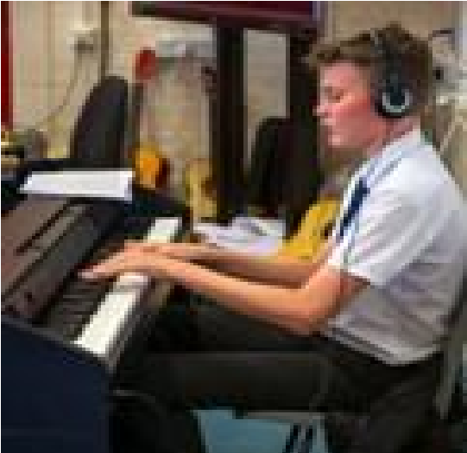

**address: Testwood School, Testwood Lane, Totton,**



**Caring | Inclusive | Ambitious**

**Company Registration Number: 7703800**

**Name of the Academy Trust: Testwood School**

**Data Protection Registration No. Z5506335**

**Registered Address: Testwood School, Testwood Lane,**

**Totton,**

**Southampton, Hampshire, SO40 3ZW**

**For more details, visit www.testwoodschool.co.uk**

