St Philip Howard

Catholic Voluntary Academy

Part of the St Ralph Sherwin Catholic Multi Academy Trust

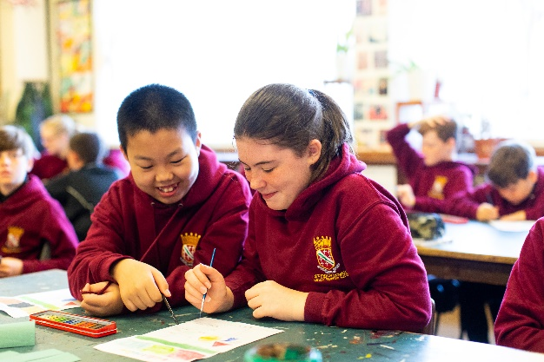
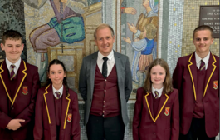
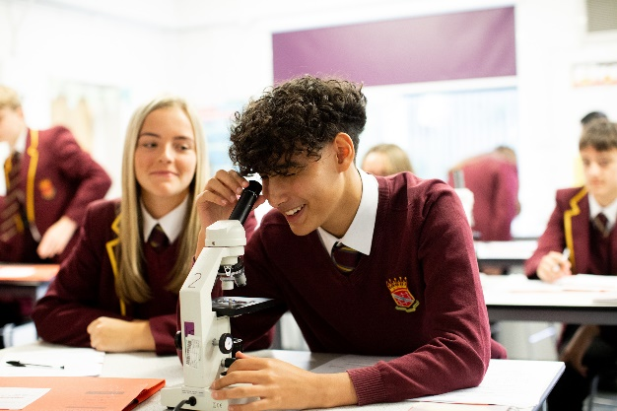

Cover Supervisor

Start Date: February 2024

Salary: SCP 6-9
Line-manager: Associate Assistant Head-teacher

Headteacher’s Welcome

Through a three – way partnership between home, school and parish we aim to work as a team to ensure our children achieve their potential. We believe that a happy child is a fulfilled child and therefore our strong pastoral system is of key importance to us. Our Catholic faith underpins everything that we do and ensures that our pupils are well rounded, confident young people with increasingly high aspirations. We are on an exciting journey at SPH and we firmly believe that by working together all our pupils will have a bright future ahead.

St Philip Howard Catholic Voluntary Academy is an exciting place for our students to grow and develop, building an enriching love of learning and a spiritual outlook that they will carry with them through life. We are an oversubscribed smaller than average Catholic Secondary school with 585 pupils located in Glossop, Derbyshire.

The successful applicant for this position will be joining a school where we care about our students and we care about our staff. We are delighted with our recent Ofsted inspection where we secured a ‘good’ judgement in all areas.

If you are excited by the opportunity to be part of #TeamSPH then we would welcome a discussion regarding this important position.

Mr M Kays Headteacher

About this post

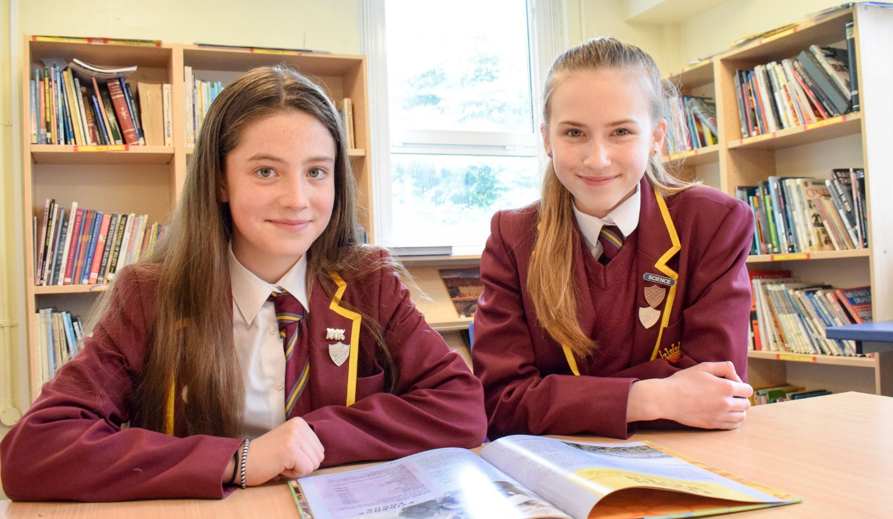
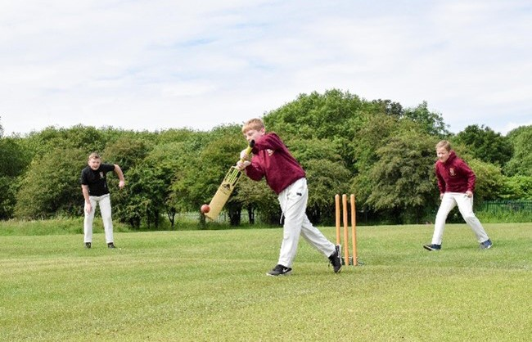

The Post
We are looking for a highly skilled and passionate Cover Supervisor to join our busy, hardworking team from February 2024 at Saint Philip Howard Catholic Voluntary Academy.

The Role
The successful candidate will be required to supervise whole classes during the short-term absence of the teacher, assist with the supervision of pupils out of lesson time and provide administrative support for the school when not required for cover. A full list of duties can be found in the Job Description.

#TeamSPH: Together on the Journey
Together, we will make the SPH journey: safely, respectfully and with kindness as part of a united Catholic family.

God will be at the heart of our journey, supporting us to realise the potential of our God given talents.

Our Gospel Values will guide us on our journey, helping us to make brave choices along the way.

Respect for all will be at the spirit of our journey and we will
embrace the uniqueness of everyone we greet.

Inspiration and passion for learning will lead us all to have a
memorable and successful journey.

Person Specification

 | Essential Criteria | Desirable Criteria
Education &  Qualifications | - A good general education. | - No specific formal qualification required but expected NVQ Level 3 or equivalent as a minimum.  - Excellent numeracy/literacy skills.
Competence Summary (knowledge, abilities, skills, experience) | - Understanding of principles of child development and learning processes.  - Knowledge of, and ability to use a range of strategies to deal with classroom behaviour as a whole and also individual behavioural needs.  - Evidence of having worked with children in some capacity.  - A positive interest in working with children.  - Ability to get the best out of children.  - Ability to build good working relationships with a range of colleagues.  - A clear communicator.  - Ability to work calmly and with patience.  - A good attendance record.  - Evidence of the stamina required to cope with the demands of the post.  - Knowledge of relevant policies/codes of practice and awareness of relevant legislation. | - Relevant work experience in a similar environment.  - A good knowledge of ICT.

 | Essential Criteria | Desirable Criteria
Work related personal requirements | - Strong interpersonal, written and oral communication skills  - Genuine passion and a belief in the potential of every student, regardless of need – and the ability to raise the self-esteem and expectations of children and young people.  - Ability to identify own training and development needs and participate in on-going training.  - Ability to manage classroom activities and the physical learning space safely.  - Ability to deal calmly with different situations as they arise.  - Understand and respect the principles of confidentiality  - Adaptability.
Other requirements | - Ability to form and maintain appropriate relationships with colleagues, students and parents  - Ability to work both autonomously and as a member of a team.  - Empathetic and approachable manner  - Highly motivated and pro-active  - Flexible.  - Sense of humour.  - This post is subject to an enhanced DBS disclosure.  - Must be committed to safeguarding the welfare of children.  - Where appropriate, to attend events and meetings outside normal school hours. | - Willingness to contribute to the wider life of the school

Job Description

Job Purpose

- To work under the guidance of Heads of Department, Class teachers and/or members of the Senior Leadership Team- within an agreed system of supervision.
- To support individuals and groups of pupils to enable access to learning. This could
include those requiring detailed and specialist knowledge in particular areas.
- To supervise whole classes during the short-term absence of the teacher. The main focus
of such cover will be to respond to questions, assist pupils to undertake set activities and
stay on task and maintain order.
- To act as an examination invigilator, when required. To provide administrative support for
the school when not required for cover invigilation.

Support for pupils when supervising classes in the absence of the teacher

- To invigilate internal and external examinations when required.
- To register and record student attendance.
- To instruct students regarding the work left by their teacher.
- To provide students with the necessary resources for their learning.
- To enable orderly entrance and exit of classrooms.
- To promote the inclusion and acceptance of all pupils within the classroom.
- To create a calm and purposeful environment in which pupils can complete work set by the classroom teacher and engender high expectations.
- To follow school systems and procedures on behaviour management.
- To report back as appropriate using the school’s referral procedures on the behaviour of
pupils during the class and any issues arising.
- To manage resources effectively and ensure classrooms are left tidy and ready for the next
lesson.
- To collect any completed work after the lesson and return it to the appropriate teacher.
- To liaise with teacher(s) about cover work.
- To be aware of particular pupils’ specific needs as identified in IEP’s.
- To support pupils in using basic ICT as directed.
- To ensure Homework is recorded effectively.

Support for the School

- Support for the Curriculum when supervising classes in the absence of a teacher.
- To collate a bank of supervision work in liaison with the relevant members of the teaching
staff.
- Be aware of and comply with policies and procedures relating to inclusion, child protection, assertive discipline, health, safety and security, equal opportunities and SEN, confidentially and data protection, reporting all concerns to an appropriate person.
- Contribute to the overall ethos/work/aims of the school.
- Establish purposeful relationships and communicate with other agencies/professionals, in
liaison with the teacher, to support achievement and progress for pupils.
- Attend and participate in regular meetings, including staff meetings.
- Participate in training and other learning activities and an annual performance review as
required.

- Recognise own strengths and areas of expertise and use these to advise and support
others.
- Provide appropriate guidance and supervision and assist in the training and development of other support staff as appropriate.
- Undertake planned supervision of pupils’ out-of-school-hours learning activities.
- Assist with the supervision of pupils out of lesson time, including before and after school
and at breaktimes.
- Supervise pupils on visits, trips and out-of-school activities as required.
- Provide clerical/admin support, eg, photocopying, typing, filing, collecting money etc

Plus, any other duties which may arise during the course of work and as authorised by the Headteacher or membership of the Senior Leadership Team. Such duties will be commensurate with the general level of this post and will be subject to the skills and abilities of the post holder.

St Philip Howard CVA, Sunlaws Street, Glossop,
Derbyshire, SK13 8DR.

Email: vparker@sph.srscmat.co.uk

Web: https://www.stphiliphowardglossop.srscmat.co.uk/

Twitter: @StPhilipHoward1 Tel: 01457 853 611

