INFORMATION PACK
Altrincham Grammar School for girls
Cover Supervisor
Three days a week, Permanent
Required as soon as possible

Overview of the Role
We require a well- qualified and confident Cover Supervisor to supervise classes in the absence of a teacher and ensure that students complete the work set. The successful candidate will need to ensure that students remain fully engaged and will expect high standards of behaviour at all times. When not involved in supervising classes, the cover supervisor will be actively involved in many other aspects of school life such as: lunchtime supervision; examination invigilation; supporting students in a one to one or small group situation; assisting with trips or visits; supporting departments; supporting the school archives; supporting the Charity Committee.

The full job description and person specification are at the end of this pack.

Contents of this pack
Bright Futures Educational Trust | Page 1-2
Altrincham Grammar School for Girls | Pages 3
Why work for us? Terms and conditions and how to apply | Page 4
Job Description | Pages 5
Person Specification | Pages 6-7

Bright Futures Educational Trust

Bright Futures Educational Trust (The Trust) is a multi-academy trust (MAT) set up in 2011. The Trust is made up of a richly diverse group of schools in Greater Manchester and Blackpool. We are passionate about working together within and beyond the Trust to achieve our aspirational vision: the best for everyone, the best from everyone. We are an organisation that is underpinned by values of: community, integrity, and passion. In everything we do, we remember that we are accountable to the children, families, and communities that we serve.
Our schools have their own identities and form one organisation and one employer, Bright Futures Educational Trust. Bright Futures’ Board of Trustees maintains strategic oversight of the Trust and delegates some of its responsibilities to the Executive Team, Principals, and local governing bodies. We place a high value on integrity and probity and take seriously our accountabilities for making the best use of public money. How decisions are made is described in our delegation framework. You can find out more about the Trustees and the Executive Team on our website: About Us

The central team comprises the Executive Team: John Stephens, CEO; Edward Vitalis, Chief Operating Officer; Gary Handforth, Director of Education; Lisa Fathers, Director of Development, Partnerships and Teaching School Hubs; Lynette Beckett, Director of HR & Strategy. The focus of these roles is to work with schools, providing high quality and timely guidance, leadership, challenge, and support. In addition to the Executive Team, we have central operations for Finance, HR, Educational Psychology, Marketing and Communications, and Digital Technologies. Please see our website brochure which explains our central operations: Working together for a Bright Future.

Bright Futures Development Network is another important outward facing component of our organisation made up of a number of hubs and networks at the heart the Trust. In January 2021, after significant national reforms to the teaching school policy Bright Futures was designated with two new large-scale Teaching School Hubs, which replace the Alliance for Learning Teaching School. This growth and expansion in our outward facing work brings about a significant increase in accountability and reach. The two Bright Futures Teaching School Hubs are designed to provide strong strategic regional leadership to build robust partnerships to support teachers and leaders in every phase and type of school, at each stage of their development. A crucial part of the hub remit is carefully ensuring structured collaboration. The Teaching School Hubs are at the forefront of providing high quality professional development, playing a significant role in the implementation and delivery of: The Early Career Framework, National Professional Qualifications (NPQ), Initial Teacher Training and Continuous Professional Development (CPD). The Hubs work directly with the Department for Education and national NPQ/ECT providers. In addition to this, the Hubs enhance the professional development needs of Bright Futures schools and academies. Within this outward facing area of Bright Futures Educational Trust, we have a commercial offer run through the Alliance for Learning which provides first-class school improvement services and CPD to over 700 schools, further complementing the work of our Teaching School Hubs. Our School-Centred Initial Teacher Training (SCITT) Bright Futures SCITT is also an integral part of the Teaching School Hubs, with over 10 years’ experience and judged Good by Ofsted, we offer Early Years, Primary and Secondary teacher training programmes. Within the Bright Futures Development Network, we are also proud to have a Maths Hub: NW1 Maths Hub offering a wide range of maths specific high-quality professional development opportunities and training/coaching to 500 schools.

Collaboration and strong relationships form one of the ‘commitments’ in our Strategy and all components of the Bright Futures’ family work closely together. Our Strategy was developed collaboratively and can be found on our website: Our Strategy

Altrincham Grammar School for Girls
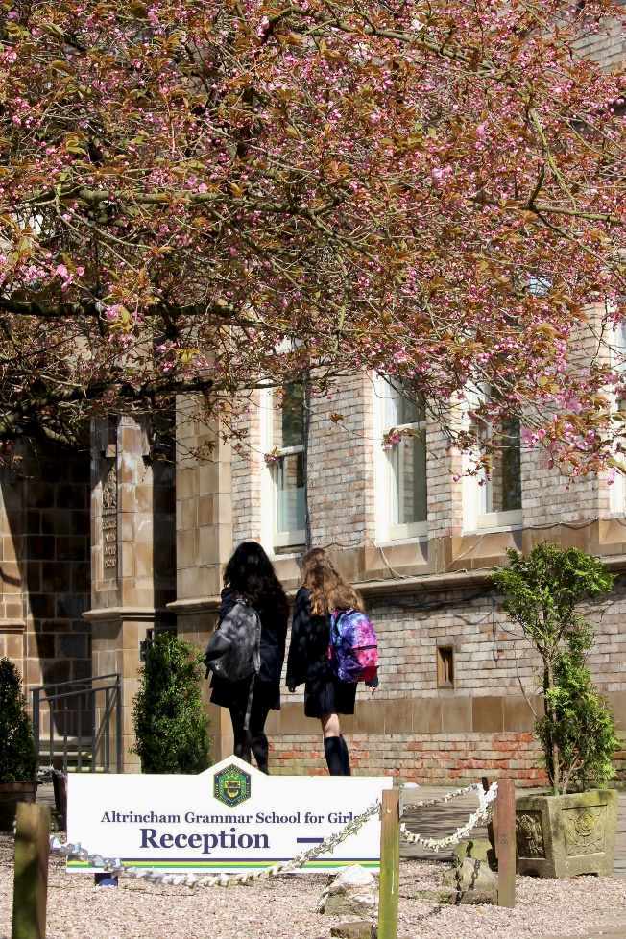
Altrincham Grammar School for Girls (AGGS) is a highly successful single sex 11 -18 academy in the South Trafford area. AGGS was in the first cohort of schools to be designated a national teaching school in 2011. AGGS is the lead school in ‘The Alliance for Learning’, which comprised schools of every type and phase, plus universities, throughout a wide geographical area. The impact of teaching school activities has been felt within the Trust and far beyond. We have a reputation for excellence regionally and nationally, of which we are very proud.

AGGS is committed to providing equal opportunity in recruitment and employment to all individuals. We will consider candidates without regard to race, ethnicity, gender, religion, sexual orientation and identity, national origin, age, military or veteran status, disability or any other legally protected status; and without discrimination based on socioeconomic, marital, parental or caregiving status, or any of the previously listed characteristics or statuses.

We value the diversity of our staff and reject any form of harassment, discrimination or victimisation. The Bright Futures Educational Trust vision is: ‘the best for everyone, the best from everyone’. To achieve this, we create and maintain a work environment and culture where people from different backgrounds, and with varying lifestyles, interests, opinions and responsibilities, treat each other with dignity and respect. It is a climate in which our staff feel safe and are inspired and motivated to be their best.

Our school is dedicated to sustaining and promoting diversity with respect to recruitment, promotion, training and general treatment during employment. We are actively seeking to extend the diversity of our staff. Furthermore, we welcome candidates who have not had previous experience of working in a grammar school.

We aim to ensure that our recruitment processes set up all candidates for success. At interview our aim is to provide a positive experience. We don’t want to catch anyone out, but rather to provide the opportunity for all candidates to be themselves and show us what they are capable of.

WHY WORK FOR US?
We offer a great opportunity to join an organisation which really lives its values. Our working environment is very inclusive and whilst you can expect to be challenged in your role, you will be supported through professional learning, treated fairly and with dignity and respect. Please see the Equality,
Diversity, an Inclusion statement on our website.

Terms and Conditions
Salary: NJC scale points 12 to 19 (Bright Futures scale Grade 5). The full-time equivalent pay is £24,496 rising to £27,852 per annum. The actual pay based on the below working pattern commencing £11,283.59 rising to £12,829.46, per annum actual pay. Pay progression is linked to performance.

Working weeks: This is a great opportunity for flexible working as the role will work 38 weeks during school term time and an additional 1 week to be agreed. A total of 39 weeks.

Hours: 19.5 per week over 3 days, which would be Wednesday, Thursday and Friday in the first instance.
Holidays: You will be paid for the prorate equivalent of 25 days, plus 8 public holidays. This increases to 30 days plus 8 public holidays after 5 years’ service.
Pension: Local government pension scheme. Please take a look at the website: https://www.gmpf.org.uk/.

Other: We offer salary sacrifice schemes for purchasing bikes used for travel to work and technology for personal use, through monthly interest free salary deductions.
We also offer opportunities for professional development.

How to Apply
We can only accept completed application forms, rather than CVs. This is because the regulatory guidelines of
Keeping Children Safe in Education (2021), require us to check various details of job applicants and an identical
application format for each candidate enables us to do this. We use a process that does not identify personal
characteristics to the shortlisting panel. This is part of our commitment to equalities and diversity.
NO AGENCIES PLEASE.
Our application form is available online, along with the disclosure of criminal background form. The portal link is HERE. Alternatively, you can click Apply Now on this role via the current vacancies page of our website. Please upload the forms by 9 am Monday 20 February 2023.
The selection will take place on Friday 24 February 2023. You will be notified after the closing date whether you have been shortlisted.

Keeping Children Safe in Education
Bright Futures Educational Trust is committed to safeguarding and promoting the welfare of children and young people and we expect all staff and volunteers to share this commitment. This post is exempt from the Rehabilitation of Offenders Act 1974; pre-employment checks will be carried out and references will be sought for shortlisted candidates and successful candidates will be subject to an enhanced DBS check and other relevant checks with statutory bodies.

Data Privacy
You can read the details of how we use the personal data that you provide us with in our Job Applicants’ privacy notice on our website: Applicant Privacy Notice
JOB DESCRIPTION
Cover Supervisor
We require a well- qualified and confident Cover Supervisor to supervise classes in the absence of a teacher and ensure that students complete the work set. The successful candidate will need to ensure that students remain fully engaged and will expect high standards of behaviour at all times.
When not involved in supervising classes, the cover supervisor will be actively involved in many other aspects of school life such as: lunchtime supervision; examination invigilation; supporting students in a one to one or small group situation; assisting with trips or visits; supporting departments; supporting the school archives; supporting the Charity Committee.
Principal Responsibilities
- Ensuring the health and safety of students being supervised.
- Responsibility for the supervision of students completing work in the teacher’s absence.
- Ensuring that the students complete the work set and that high standards of behaviour are maintained.
- Responding appropriately to students’ needs and requests for assistance.
- Liaising with subject staff and providing any relevant feedback to departments.
- Registering students in each session and reporting on any absences or lateness.
- Carrying out the school’s policies.
- Encouraging students to interact with each other in a purposeful way e.g. overseeing group work or practical activities.
- Conducting form time and contributing to form activities.

Additional Responsibilities
- Supporting the Charity Committee with charity events where appropriate.
- Undertaking lunchtime supervision at the sixth form, as required.
- Acting as an examination invigilator for both internal and external examinations.
- Supporting subject departments by carrying out a range of duties as specified by the Head of Department.
- Assisting with open evenings and other functions.
- Supervising students on trips and visits outside school.
- Assisting and mentoring individual students who require additional support.
- Undertaking any other relevant duties commensurate with the role to assist in the wider life of the school.

School-wide Responsibilities
- Being aware of and acting upon relevant school policies and in particular those associated with Child Protection/Safeguarding Children and Health & Safety issues.
- Being responsible for maintaining a clean and tidy environment.
- Attending relevant meetings as required.
- Acting as a role model for the students in school.
- Acting as an ambassador for school and ensuring that the school’s high standards are promoted at all times.

Flexibility
Although the cover supervisor will normally work during term time only and during the core working hours of 8.30 – 3.30, it is essential that the successful candidate be prepared to work outside these times on occasion. Such hours will be agreed in advance.
PERSON SPECIFICATION
Cover Supervisor

 | Essential | Desirable | Method of Assessment
Qualifications, Educational, Training | Qualification post GCSE level.  Good educational background with strong literacy and numeracy skills.  English and mathematics at least GCSE level grade C. | QTS | Application form  Interview
Relevant Experience | Successful experience in the world of work.  Contribution to the work of a department or team in the workplace.  Experience of working with school age students in a paid or voluntary capacity. | Experience of responsibility within the workplace.  Experience of working in a school. | Application form  Interview
Safeguarding | Commitment to demonstrating a responsibility for safeguarding and promoting the welfare of young people. |  | Application form Interview  Task  Pre employment screening
Knowledge, skills, abilities | Very good oral and written communication skills.  Ability to exercise control in the classroom and encourage good behaviour.  Confidence in delivery of materials to students.  Ability to show tact and discretion and the ability to maintain confidentiality.  Ability to generate enthusiasm for teaching and learning.  Ability to work effectively as part of a team.  Ability to manage and motivate others.  Ability to plan, organise, review and adapt.  ICT competency. | Knowledge of recent educational issues and of current resources for teaching. | Application form  Task  Interview
Our values | Authentic commitment to the Trust’s values of community, integrity, and passion.  Community: Evidence of working together for a common purpose and encouraging diversity  Passion: Evidence of taking personal responsibility, working hard and having high aspirations |  | Application form  Interview  Task
Others | Flexibility, adaptability and a willingness to be involved in change.  Commitment to further training and development.  Willingness to participate in all aspects of school life and assist others with their roles.  Self-confidence and initiative.  A positive approach to challenges, which seeks solutions to problems and addresses difficulties with cheerfulness and good humor.  A genuine commitment to improving the quality of provision for students in our school.  Smart, professional appearance.  DBS clearance. |  | Application form  Interview  Task

Bright Futures Educational Trust is committed to safeguarding and promoting the welfare of children and young people and we expect all staff and volunteers to share this commitment. This post is exempt from the Rehabilitation of Offenders Act 1974; pre-employment checks will be carried out and references will be sought for shortlisted candidates and successful candidates will be subject to an enhanced DBS check and other relevant checks with statutory bodies.

