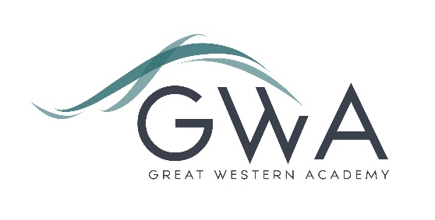

Information for Applicants

Cover Supervisor
Great Western Academy opened in brand new, state-of-the -art facilities in North Swindon in September 2018 with just 150 Year 7 students. The Academy has grown year by year and now accommodates over 900 students in years 7 to 11 and the Sixth Form.
The post would particularly suit someone who is considering a career in secondary teaching. It will provide significant experience of classroom management and building a positive learning environment within a very supportive and successful school. As the school grows in future years there is an excellent opportunity for existing staff to shape and develop their roles.
Application process

Please complete the application form and equalities form supplied and enclose a supporting letter, either in the space provided on the application form or as a separate document. The application form should be completed in full in black ink or type. A CV is not required and should not be submitted as part of the application.

Your supporting letter should be no more than 2 sides of A4 (with a font size no smaller than 11) and should enhance your application by providing further information, matched to the person specification, about your suitability for the post. This should include evidence of the impact of any previous work you have undertaken.

Electronic applications should be completed on Eteach or returned via email to recruitment@gwacademy.co.uk

References: References will be taken up prior to interview.

Closing Date: 9am Monday 1st July 2024. However, we will review applications as they come in and may close this vacancy early, so please don’t delay your application.
Interviews: week commencing 8th July 2024

Great Western Academy is committed to safeguarding and promoting the welfare of children, young people and vulnerable adults and we expect all staff to share this commitment and undergo appropriate checks. All posts within the Trust are therefore subject to an Enhanced DBS and barred list check.

