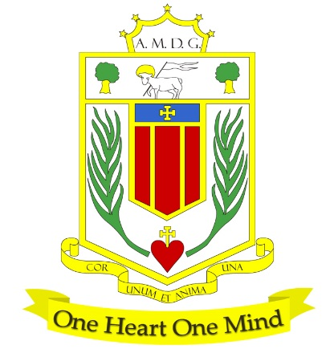
BROUGHTON HALL CATHOLIC HIGH SCHOOL
Yew Tree Lane

Liverpool, L12 9HJ

Telephone 0151 541 9440
E.mail: igglesd@broughtonhall.com
Head Teacher: Mr G M Preston, B.A. (Hons), NPQH, PGCE

COVER SUPERVISOR
FULL TIME OR PART TIME (term time)

SALARY: NJC 4 SCP 7 TO 11 £24,294 to £25,979 (full time equivalent)
£13.31 TO £14.24 per hour
CONTRACT TYPE: Permanent
CLOSING DATE: Tuesday, 10th September at 10.00 am
INTERVIEWS TO BE HELD: As soon as possible after closing date
START DATE: As soon as possible

The Governing Body of Broughton Hall Catholic High School are seeking to appoint an enthusiastic, well organised person with the ability to supervise classes of KS3 and KS4 pupils in the absence of the class teacher.

The successful candidate will have excellent communication skills and the ability to relate well to both adults and students whilst adopting a flexible approach to work. Induction, support and training will be offered to the successful candidate.

Duties to include:-
- Supervising students in the classroom and ensure good order and discipline are maintained
- Supervising pre-prepared activities and self-directed learning in the short-term planned/ unplanned absence of teachers to provide continuity of learning for students
- Promoting high standards of behaviour, using rewards and sanctions where appropriate

Induction, support and training will be offered to the successful candidate.

Our Trustees are the Sisters of Mercy.

How to Apply:- Please complete the school’s Application Pack and email to smithg@broughtonhall.com

Broughton Hall Catholic High School will undertake all of the DfE pre-employment checks outlined in the statutory guidance, Keeping Children Safe in Education.

This post exempt from the Rehabilitation of Offenders Act 1974. The amendments to the Rehabilitation of Offenders Act 1974 (Exceptions) Order 1975 (2013 and 2020) provides that when applying for certain jobs and activities, certain convictions and cautions are considered ‘protected’.

This post is subject to satisfactory references being received and a satisfactory Enhanced Disclosure, with Barred List Check, being obtained from the Disclosure and Barring Service (DBS).

Broughton Hall Catholic High School is committed to safeguarding and promoting the welfare of children and young people and expects all staff and volunteers to share this commitment.

