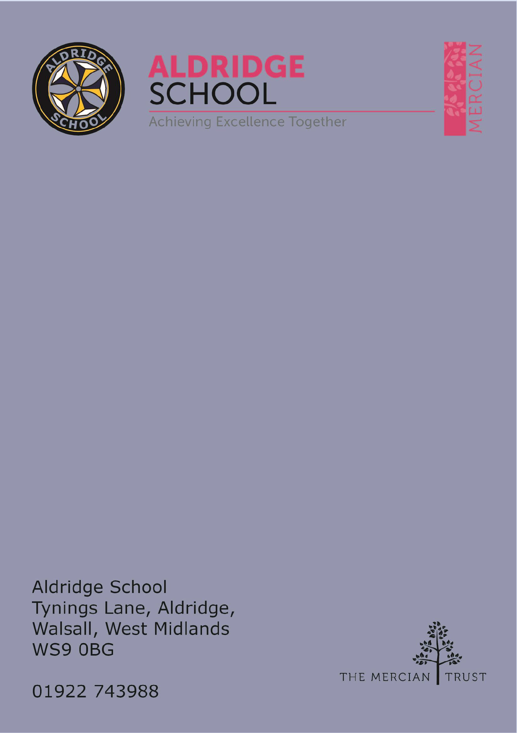

Application Pack

Cover Supervisor



About Aldridge School – a Founder Academy of the Mercian Trust

About The Mercian Trust

Job Description

Job Advert

How to Apply

# About Aldridge School

Thank you for taking the time to find out more about Aldridge School. This pack is intended to give you information about this role and our school's broader vision and ethos. Further background information is available in our Prospectus and Sixth Form Prospectus on our website.

We are a comprehensive school of over 1500 students situated near the centre of Aldridge village. We believe that it is our responsibility to work to meet the needs of every individual student, challenging them to achieve their best, supporting them to become responsible young adults and preparing them for their next steps into the world of work or further education.

Aldridge School is a good school (Ofsted 2022). It is a school which is proud of its traditions and successes which have been achieved through hard work and high expectations. particular, we encourage our students to be **R**espectful, **R**esponsible, **R**esilient and **R**eady to learn in order that they will be happy and successful at school and in the wider world beyond.

Aldridge School has a dedicated, talented and conscientious team of staff who work together to provide a high standard of teaching, excellent pastoral care and professional support services. Our broad curriculum is designed to meet national expectations, be relevant and interesting, support our students in achieving the best possible standards in external examinations and to equip them with the skills they need to be successful in adult life.

At Aldridge School we have a popular and thriving Sixth Form. We are very proud of our students' success with over 80% securing places at some of the top Universities and on Higher Apprenticeships last year. We offer a very broad range of both academic and vocational courses at level 3, ensuring that Aldridge School Sixth Form is an option for a wide range of students.

We also enjoy strong links with surrounding primary schools, working with students in Years 5 and 6 including work in Science, Maths, English, Performing Arts and Enterprise. We are proud of our community and we work hard to promote this pride in all our partnerships, so that we can make sure that future students from these schools enjoy an easy, enjoyable transition to Aldridge School.

Students at Aldridge School are friendly, polite and respectful. Strong relationships between staff and students contribute significantly to ensuring that students are happy and feel safe.

If you would like to find out more, please contact us to arrange a visit to see our school at work. We look forward to meeting you.

# Benefits of Working at Aldridge School

* Everyone has the highest expectations of behaviour, with all staff reinforcing those expectations
* A clear system of sanctions which is applied consistently so staff don't have battles with students
* Senior Leadership are very visible
* Excellent pastoral support offered through Head of Year staff
* CPD tailored specifically to staff needs, based off their feedback
* Time for staff to put new things into action
* Non-hierarchical approach to professional development - there are things a senior leader can learn from an ECT and vice versa
* Regular Staff, Faculty and Pastoral briefings to support good communication
* Performance Management is tailored to faculty and individual needs. Data targets are not used punitively but aspirationally. We begin from the assumption that everyone will get the pay rise unless they haven't done all they can to improve student outcomes
* We are constantly streamlining all systems and processes so they take less time
* Open door Senior Leadership Team - no concern is ever too small
* Countless opportunities to get involved with the wider life of the school - Duke of Edinburgh, school performances, sports teams, music
* Contributions of staff recognised through 'Above and Beyond' draws each half term
* MAT ‘Employer of Choice’ opportunities such as Simply Health Healthcare plan and access to mylifestyle with a wide range of employee perks.

# The Mercian Trust

Aldridge School is an academy in The Mercian Trust.

The Mercian Trust brings ten very different and individual schools together as a single Multi-Academy Trust or MAT.

The ten schools are unique in their identity and united by their ambition to offer the best possible future for their students.

**The ten schools are:**

* Aldridge School
* Queen Mary's Grammar School
* Queen Mary's High School
* Shire Oak Academy
* The Ladder School
* Walsall Studio School
* Q3 Academy Great Barr
* Q3 Academy Langley
* Q3 Academy Tipton
* New Leaf School



Each School has its own distinct ethos and approach, but we have this over-arching aim in common: we prepare all our students to enjoy life to the full by inspiring them to:

* + Realise their potential as learners
  + Thrive in the world of work
  + Make a positive contribution to the local, national and international community

The Mercian Trust respects the autonomy of its member schools but, through collaboration, fosters strengths that are greater than the sum of its parts. Working together as a Multi Academy Trust provides a framework for sharing expertise and enthusiasm, resources and ideas.

# Job Description

## Post: Cover supervisor

## Responsible to: Cover Manager

**Salary Scale:** Grade 4 SCP 6-11 pro-rata

39 weeks per year (Term Time plus 5 additional training days)

**Purpose**

To cover for both planned and unplanned staff absences as deployed by the cover supervisors.

To supervise whole classes during the short-term absence of the class teacher under the guidance of teaching/senior staff, including implementing work programmes, managing pupil behaviour and assisting pupils in relevant activities in line with the school’s policies and procedures.

**Principal Duties and Responsibilities**

* To supervise classes and provide classroom cover for absent staff as part of the cover team.
* To support with

**Standards and Quality Assurance**

* Support the aims and ethos of the school.
* Set a good example in terms of dress, punctuality and attendance.
* Attend team and staff meetings.
* Undertake professional duties that may be reasonably assigned by the Headteacher.
* Be proactive in matters relating to health and safety.
* Be committed to safeguarding and promoting the welfare of children and young people.

**The duties and responsibilities in this job description are not exhaustive. The post- holder may be required to undertake other duties from time to time within the general scope of the post. Any such duties should not substantially change the general character of the post. Duties and responsibilities outside of the general scope of this grade of post will be with the consent of the post-holder.**



# Person Specification

Th. e employee will need to demonstrate the following requirements in order to perform each of the main activities of the job safely and effectively.

|  |  |  |
| --- | --- | --- |
|  | Essential | Desirable |
| **Qualifications** |  |  |
| Good general standard of education | X |  |
| Good ICT and word processing skills | X |  |
|  |  |  |
| **Knowledge** |  |  |
| Understanding the importance of  confidentiality and appreciation of the implications of GDPR | X |  |
| Understanding of safeguarding and child protection requirements | X |  |
|  |  |  |
| **Skills/Attributes** |  |  |
| Excellent interpersonal skills – able to deal with a variety of people, including students, staff and visitors, showing  empathy, sensitivity and assertiveness when necessary | X |  |
| Able to make sound judgements when dealing with stakeholders | X |  |
| Good communication skills both oral and written | X |  |
| Good time management skills | X |  |
| Able to prioritise workload | X |  |
| Able to keep calm in difficult situations | X |  |
| Able to operate effectively as part of team, as well as independently | X |  |
| Self-motivated | X |  |
| Flexibility | X |  |
| Willingness to undertake training | X |  |

# How to Apply

## Closing Date

Monday 9th June 2025

You are advised to apply early as we reserve the right to close vacancies before the advertised date if a large number of applications have been received.

## Start Date

As soon as possible

## Visits to School

For further information, please contact the school either by email [info@aldridgeschool.org](mailto:info@aldridgeschool.org) or by telephoning 01922 743988

## Applying

Applications via the Mercian Trust portal.

