Job Description

Title of Post Cover Supervisor

Scale/Grade Grade 5, Points 12 to 17 (pro rata)

Hours Full or part time for 39 weeks per year (term time)

Terms and Conditions To work across Key Stages 3 & 4 providing cover supervision for classes

Responsible to Line Manager

Purpose of the Job
To support students and teachers to implement the School’s Curriculum Mission Statement and contribute to maintaining standards.

Key Purpose
- Students will have high quality learning at all times at All Saints Catholic High School
- Students will be able to access learning opportunities in the absence of their regular teacher
- Safety and welfare of students is maintained at all times

Key Tasks to Achieve Outcomes
To cover class groups of pupils for absent teachers. This will include:

- Collecting cover work
- Setting prepared work for groups and classes where the teacher is absent
- Supervising pupils working on the work set
- Ensuring completion of work to a high standard
- Maintaining good discipline and a positive working atmosphere
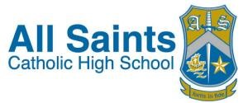
- Supervising classes using ICT and online working
- Working with small groups as appropriate, when not required for whole groups
- Feeding back to class teacher on work completed if appropriate
- Liaising with Subject Leaders and other staff as appropriate in connection with work for students
- Carrying out administrative work linked to a pastoral area while classes are working or in time when no cover is required
- Within the designated areas of responsibilities, to implement the school’s Health and Safety Policy
- To undertake other duties as requested which are an extension of or an amendment to the particular responsibilities stated above

Indicators of Performance
- Classes are conducted in an orderly manner
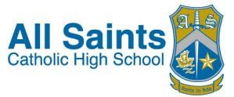
- Students make progress in cover lessons

