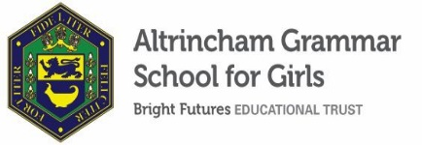

Cover Supervisor
Required from 9 January 2023
Part-time 19.5 hours (3 days), 38 plus 1 week; Permanent
GRADE 5 points 12 –19; Actual Pay £11,283.59 - £12,829.46

The Bright Futures Educational Trust is a partnership of schools based in the North West. The Trust’s vision is the best for everyone, the best from everyone. Our values of community, passion and integrity are at the heart of everything we do. There are currently twelve schools within the Trust. The Trust is committed to providing all staff with the training and support they need to be the best in their profession. Benefits include: working cross-phase, knowledge exchange between our schools and the opportunity to work with some of the most inspiring colleagues in their profession.

We require a well- qualified and confident Cover Supervisor to supervise classes in the absence of a teacher and ensure that students complete the work set. The successful candidate will need to ensure that students remain fully engaged and will expect high standards of behaviour at all times. When not involved in supervising classes, the cover supervisor will be actively involved in many other aspects of school life such as: lunchtime supervision; examination invigilation; supporting students in a one to one or small group situation; assisting with trips or visits; supporting departments; supporting the school archives; supporting the Charity Committee.

Further information on the role can be found on the school website.

Our new portal contains our on-line application form and disclosure of criminal background form. Please click on the link HERE, or find it on our website. Please complete the forms by 9 a.m. Monday 12 December 2022.

Closing date for applications is 12 December 2022 at 9 a.m.
Interview date is Thursday 15 December 2022.

ADDITIONAL INFORMATION
Further information about the school, a copy of the school’s prospectus and the most recent OFSTED inspection are available from the school’s website.

Bright Futures Educational Trust is committed to safeguarding and promoting the welfare of children and young people and expects all staff to share this commitment. Any successful applicant will be required to undertake an Enhanced Disclosure check by the DBS. This post is exempt from the Rehabilitation of Offenders Act 1974.

