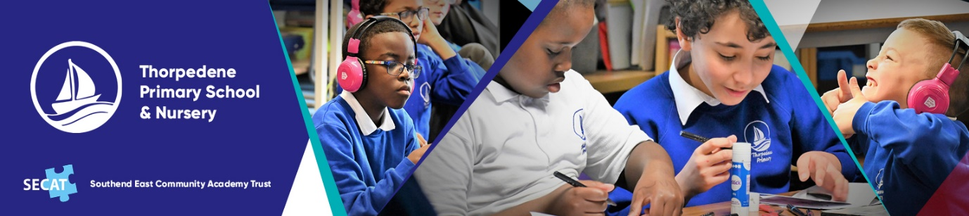
At Thorpedene we strive to provide a welcoming, friendly and happy learning environment for all our children. This is achieved through our hardworking whole school community including parents, Governors, Trustees and our dedicated team of staff and not forgetting the vital part – our children! We work collaboratively with a clear focus on our school vision and values.
Our aim at Thorpedene is to provide a purposeful, well-balanced curriculum which stimulates learning, encouraging reflective children to have the independence and self-confidence to live and learn, now and in the future.
We are determined to ensure that every child who attends Thorpedene continues to succeed in a supportive learning environment based on the school core values of Achieving, Caring, Respecting with Confidence. We know that children learn better when they are happy. Here at Thorpedene Primary School & Nursery we continue to put the best interests of every child at the heart of our school and ensure that every child is nurtured and challenged to achieve their true potential and pursue their dreams.
We are proud to be a part of the Southend East Community Academy Trust (SECAT) along with Bournes Green Infant School, Bournes Green Junior School, Hinguar Primary School, Richmond Avenue Primary School and Shoeburyness High School.

