**Role:** Cover Supervisor

Birley Spa Primary Academy

Cover Supervisor – Fixed Term

Candidate

Information Pack:

## Salary: NJC 12-17 (£26, 421 - £28,770)

## Location: Birley Spa Primary Academy, Jermyn Crescent, Sheffield, S12 4QE

## Contract Type: 37 hours per week, 39 weeks per year

## Contract Term: 1 Year Fixed Term with opportunity to become permanent

## Closing Date: Monday 21st October 2024

## Interview Date: Thursday 24th October 2024

Birley Spa Primary Academy is looking to appoint a highly motivated and capable Cover Supervisor with well-developed interpersonal skills to support teachers and students as directed and ensure that classes are appropriately managed during times of teacher absence.

We view the role of Cover Supervisor as essential to the running of the school and the continuity of learning for young people. The successful candidate will have a flexible approach and the confidence and presence to manage whole classes in a professional manner. Applicants should have very good literacy and numeracy skills and the ability and desire to work with young people. In return, you will join a friendly and welcoming school community prepared to develop you as a professional through training and support.

The successful candidate would be required to:

* Undertake classroom activities as directed by teachers to support teaching and learning process
* Assist in the preparation of resources and display
* Mark students’ work in accordance with Academy policies and teacher instructions
* Undertake administrative duties as requested by teachers
* Cover tutor groups as and when needed
* Input data to support Academy policies in Assessment, Recording and Reporting
* Maintain student records in accordance with statutory procedures, Academy policies and as directed by the Head of School/Executive Headteacher
* Liaise with Learning Resource staff and ICT staff to ensure teachers requirements are met to ensure high quality teaching and learning
* Manage the behaviour of pupils to ensure a constructive environment is maintained, by using a range of strategies
* Assist the teacher in the classroom as timetabled/requested
* Respond to student needs as they arise in the classroom
* Undertake break and lunchtime activities
* Undertake examination invigilation duties where required
* Work with teachers to prepare appropriate lessons/resources when absence is known in advance
* Compile appropriate lesson activities/resources in liaison with other teachers when absence is not known in advance
* Ensure that all communications with parents demonstrate the values of the academy and the L.E.A.D. Academy Trust
* Attend all meetings and functions necessary to support the work in this job description
* Support the efficient running of breakfast and after school club
* Add to the extra-curricular offer for children

# How to Apply

Please send a completed application form and covering letter, with a supporting CV if you wish to:

Cathy Gibson, Head of School, at enquiries@birleyspaacademy.co.uk

Closing Date: 21st October 2024 at 12:00pm

Applications will be reviewed upon receipt therefore shortlisted candidates may be contracted in advance of the closing date.

The L.E.A.D. Academy Trust is committed to safeguarding and promoting the welfare of children and young people and we can expect all staff and volunteers to share this commitment. This post is subject to an enhanced DBS check.

## Application Forms/Further Information:

If you would like an application form, or for more information about our Academy, please visit our website: <https://www.birleyspaacademy.co.uk/about-us/vacancies/>

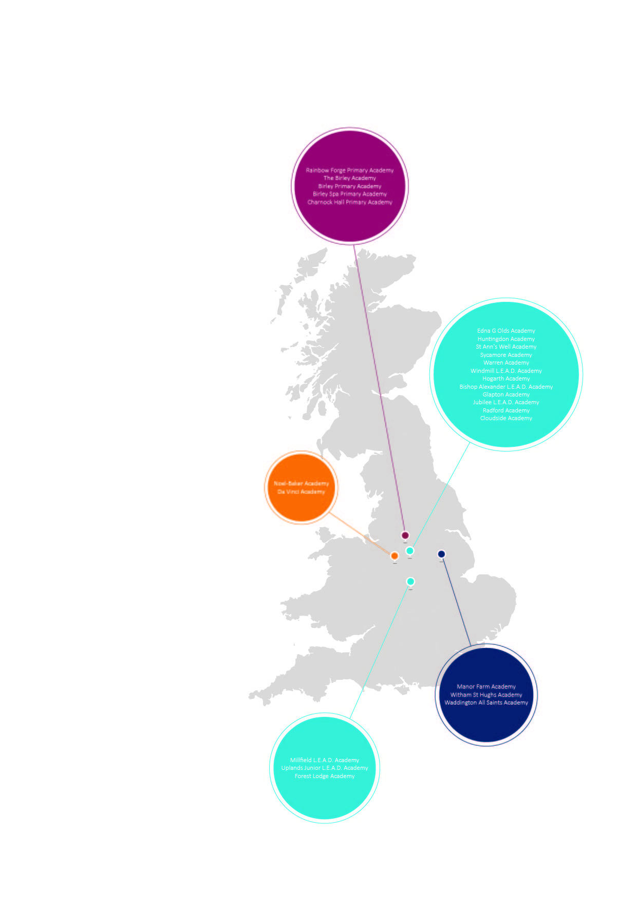

# L.E.A.D. Academy Trust

L.E.A.D. Academy Trust comprises of twenty five academies across Nottingham, Leicester, Derby, Lincoln and Sheffield. Our philosophy is to; lead, empower, achieve and drive.

At the heart of our Trust is the development of outstanding leaders. We empower individuals in our schools to provide the highest quality education, enabling every pupil to realise their full potential. We have also been recognised by Ofsted as a leading academy sponsor, securing rapid and sustainable improvement through the research and application of best practice across operational areas.

The combination of autonomy and collaboration across key areas of leadership and management underpinned by shared vision, values and best practice positions L.E.A.D. as a truly unique Academy Trust.

To view our ‘L.E.A.D. Family Brochure’ please visit:

www.leadacademytrust.co.uk

To see the wonderful achievements, proud moments and diverse events happening across our Trust please follow our twitter account: @LEADAcadTrust

# Our Leaders

One of the core priorities for the L.E.A.D. Academy Trust is the development of outstanding school leaders. We are dedicated to providing an organisation which will:

• develop inspirational school leaders for the future through high quality recruitment, professional development and coaching;

• invest in joint training, peer coaching, sharing good practice and professional dialogue in a climate of trust;

• continually improve, exploring new ways of working, alternative curriculums and innovation;

• strategically plan to produce the next generation of high quality school leaders.

### The L.E.A.D. Teaching School Alliance

The L.E.A.D. Teaching School Alliance is a dynamic, cross-phase collaboration of schools committed to harnessing, nurturing and sharing the specific skills and attributes required to teach and lead in areas with diverse pupil populations. Everything we do in our schools is about providing children with an outstanding, broad and balanced education.

Our innovative Initial Teaching Training (ITT) route aims to increase the number of quality teachers in our schools. In addition, we offer a range of high quality Continuing Professional Development (CPD) for staff at all levels and tailored school-to-school support. We are keen to nurture and grow staff across our alliance and offer a range of opportunities to develop the leaders of tomorrow. By working in partnership with The University of Nottingham and other regional Universities, we are also creating a research culture within our alliance that will impact positively on teaching, learning and the achievement of young people.

**Cover Supervisor Person Specification**

# Our Support

We provide a range of high quality, professional services to schools in nine core areas:

**Financial Management**

**Project Management**

**Procurement**

**ICT Management**

**Human Resources**

**Leadership Development**

**Legal Support**

**Governor Support**

**Education**

This job description lists the competencies expected of an experienced/fully trained post-holder. The two right hand columns provide guidance for the appointment of new staff. (E = Essential criteria, D + Desirable criteria)

|  |  |  |  |
| --- | --- | --- | --- |
|  | | **E** | **D** |
| **Qualifications and Attainments** | * Studied to a minimum standard of GCSE (grade A* - C), or equivalent, in English and Maths * Level 3 qualification * A degree or post graduate qualification | E  E | D |
| **Skills and**  **knowledge** | * Ability to contribute to the delivery of lessons. * High level of oral and written communication skills * Ability to work as part of a team * Able to work to tight deadlines, managing and prioritising time effectively * Self-starter, with and ability to work independently & use own initiative to overcome obstacles | E  E  E E  E |  |
| **Experience** | * Previous paid or voluntary work with young people * An understanding of Keeping children safe in education * An understanding basic school organisation * A basic knowledge of the work of a school * Experience working with children with Special Educational Needs | E  E E  E | D |
| **Personal Attributes** | * Have an openness to learning and change * Have a positive attitude to personal development and training * Be able to work in ways that promote equality of opportunity, participation, diversity and responsibility | E  E E |  |
| **Additional Requirements** | * This role is subject to an enhanced DBS * May be required to work out of school hours to support the academy | E  E |  |



L.E.A.D. Academy Trust

5a The Ropewalk

Nottingham

NG1 5DU

**Email:** admin@leadacademytrust.co.uk

**Telephone:** 0115 822 5440