16th July 2024 – 10.00 am



Broughton Hall Catholic

High School



Information Pack

**Full Time (term time) or**

**Part Time**

**Cover Supervisor**

Start Date:

As soon as possible

Closing Date:

Proposed interview Date:

As soon as

possible

Salary Scale:

NJC SCP

7

to

11

£

24,294

to

£

25,979

(

full time equivalent

)

£

13.31

to £

14.24

per hour

Contract Term:

Permanent

http://www.broughtonhall.com/information/vacancies.php

# Broughton Hall Catholic High School

Founded in 1928 under the trusteeship of the Sisters of Mercy, Broughton Hall Catholic High School, an all-girls Catholic secondary school in Liverpool, provides the very best in modern education based on the Gospel values of mutual respect and care.

The central aim of our school is to provide excellent educational opportunities enabling each pupil to develop their God given talents, to grow in confidence and self-esteem and to fulfil their potential.

As a Catholic school Broughton Hall centres its mission on the person of Jesus Christ, and promotes the Gospel values throughout the school community and in all aspects of school life: spiritual, academic, pastoral, and personal. By proclaiming and living out the faith of the Catholic Church, we support each other in shared experiences of teaching and learning, prayer, worship and charity. Our mercy values permeate throughout our community.

Our facilities are bright, spacious, high tech and designed to meet the needs of all our pupils. We have a separate 6th Form facility, which is shared with our neighbouring boys school Cardinal Heenan Catholic High School. A full range of extra-curricular activities are provided to further the creative, sporting and academic talents of each pupil and offer Outward Bound and Duke of Edinburgh Award schemes as well as the opportunity to attend educational visits and residential trips.

We pride ourselves on our high expectations of all pupils and have an **‘Ambition for All’** policy. Whatever your role within the school, you will share these values and be able to encourage and motivate pupils with your passion, presence and personality. We were delighted to be rated as a Good provider by Ofsted in November 2022.

Our school motto ‘**Cor Unum et Anima Una’** - One Heart and One Mind, reflects the strong sense of community amongst pupils, staff, parents and Governors.

# We Offer

* Pensions Scheme – Teacher Pension Scheme for teaching staff or Merseyside Pension Fund for support staff
* Regular training and development programme
* Access to occupational health and well-being services
* Well being App
* Cycle2Work Scheme
* Tax Free Childcare Vouchers
* Supportive work environment where all staff are valued

And that’s not all, we place the outcomes of the children in our school at the heart of everything we do, so you’ll wake every day in the knowledge that your role will have a significant positive impact on the lives of others.

# Equal Opportunities

Broughton Hall Catholic High school is an equal opportunities employer.

We welcome applicants from all backgrounds and value everyone as an individual. We are committed to organisational practices, which promote diversity and inclusion for all employees and volunteers regardless of age, gender reassignment, marriage or civil partnership status, pregnancy and maternity status, disability, race (including colour, nationality, ethnic or national origin), religion or belief, sex, or sexual orientation. Connecting these differences creates a productive environment in which everyone feels valued.

Monitoring information in relation to job applicants will be to assist us in equality monitoring. The recruitment panel will not have access to job applicant’s monitoring information.

To assist us in monitoring the operation of equal opportunities policy, and for no other reason, please ensure you complete and submit the Equal Opportunities Monitoring Form with your application form.

# Safeguarding & Enhanced DBS Checks

Broughton Hall Catholic High School is committed to safeguarding and promoting the welfare of young people and expect all pupils, staff, volunteers and visitors to share this commitment

All posts are subject to an enhanced DBS check and full pre-employment checks to comply with the current Keeping Children Safe in Education statutory guidance for schools.

All staff will be expected to follow Broughton Hall Catholic High School’s child protection policies, code of conducts and managing allegations against staff procedures.

All roles in school, including this post, are exempt from the Rehabilitation of Offenders Act (ROA)

1974. The Ministry of Justice’s guidance on Rehabilitation of Offenders Act 1974 and the

Exceptions Order 1975 provides information about which convictions must be declared during job applications and can be accessed [here.](https://www.gov.uk/government/publications/new-guidance-on-the-rehabilitation-of-offenders-act-1974)

All applicants must therefore declare all previous convictions and cautions, including those which would normally be considered ‘spent’ except those received for an offence committed in the United Kingdom if it has been filtered in accordance with the DBS filtering rules. Information about filtering offences can be found in the DBC Filtering Guide, which can be accessed [here.](https://www.gov.uk/government/publications/dbs-filtering-guidance)

By engaging in this recruitment process, shortlisted candidates consent to an online search in line with the Keeping Children Safe in Education Statutory Guidance 2022.

# Welcome

Thank you for your interest in the position of Cover Supervisor. This pack has been designed to help you should you choose to apply, which we sincerely hope you do. We hope it answers your initial questions, but if not, please do not hesitate to contact us and we will endeavour to help you through your application process.

Broughton Hall Catholic High School is the largest all-girls school in Liverpool and serves many different areas making us a vibrant a diverse school. In November 2022 Ofsted inspectors acknowledged the work taking place at Broughton Hall. Pupils are proud to be part of Broughton Hall Catholic High School and enjoy strong relationships with their teachers and pastoral staff.

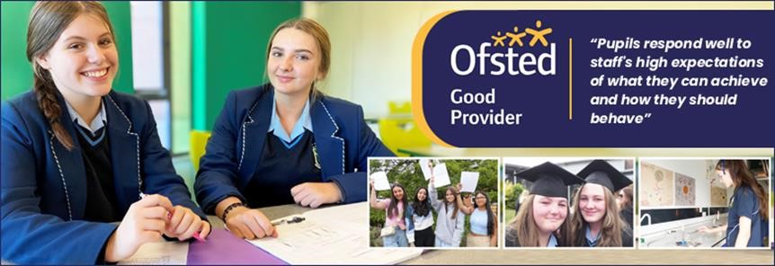

We work hard to ensure Broughton Hall Catholic High School remains a friendly and welcoming environment for all those who work, study or visit here and hope that you are the person we are looking for to bring creativity and innovation to the role.

Our Governors are seeking to appoint an enthusiastic, well organised person with the ability to supervise classes of KS3 and KS4 pupils in the absence of the class teacher.

The successful candidate will have excellent communication skills and the ability to relate well to both adults and students whilst adopting a flexible approach to work. Induction, support and training will be offered to the successful candidate.

We look forward to hearing from you.

Gerard Preston

Headteacher

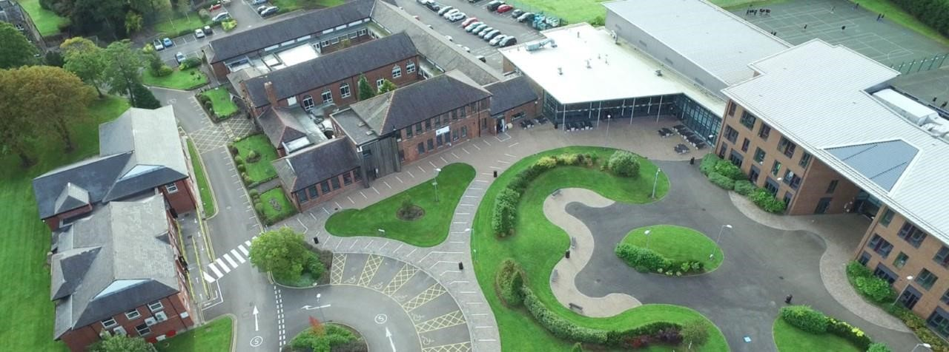

**Job Description**

# Cover Supervisor

|  |  |
| --- | --- |
| **Reporting to:** | Cover Manager, Assistant Head Teacher, Heads of Departments |
|  |  |
| **Purpose:** | To supervise groups and whole classes during the short-term absence of the class teacher under the guidance of teaching/ senior staff. This will include implementing work programmes, managing pupil behaviour and assisting pupils in relevant activities in line with the school’s policies and procedures.    The primary focus is to maintain order and keep pupils on task. |
|  |  |
| **Areas of**  **Responsibility:** | **Main Duties:**  The following list is typical of the level of duties which the post holder will be expected to perform. It is not necessarily exhaustive and other duties of a similar type and level may be required from time to time.    **Key Tasks:**   * Supervise students in the classroom and intervention rooms and ensure good order and discipline are maintained * Supervise pre-prepared activities and self-directed learning in the short-term planned/ unplanned absence of teachers to provide continuity of learning for students * Prepare the classroom/ outside areas for lessons, ensuring that resources are available and cleared away at the end of the lessons as appropriate * Manage the behaviour of pupils whilst they are undertaking work * Collect any completed work after the lesson and return it to the appropriate teacher * Report back as appropriate using agreed referral procedures on the behaviour of students during the class, and any issues arising * Assist with break-time supervision including facilitating games and activities     **Individuals in this role may also:**   * Undertake exam invigilation * Assist with student first aid and welfare duties, looking after sick students, liaising with parents/ carers and staff, etc.     **Professional Values:**   * Having high expectations of all pupils; respecting their social, cultural, linguistic, religious and ethnic backgrounds |
|  | * Treating pupils consistently with respect and consideration * Recognising equal opportunities issues as they arise in the schools and responding effectively, following schools’ policies and procedures * Working collaboratively with colleagues as part of a professional team; and carrying out roles effectively, knowing when to seek help and advice from colleagues * Working within schools’ policies and procedures and being aware of legislation relevant to personal role and responsibility in the school   **Supporting School:**   * To play a full part in the life of the school community, to support and contribute to its Catholic mission and ethos * Safeguard the confidentiality of information relating to students and staff always * Work within the school’s health and safety policy to ensure a safe working environment for staff, students and visitors * To attend relevant in-service training * Actively promote, comply and adhere to all school policies * Maintain high professional standards of attendance, punctuality, appearance, conduct and positive, courteous relations with students, parents and colleagues * Demonstrate willingness to support new initiatives within the school * Participate fully in training, learning development and the school’s performance management system for support staff   The post holder must promote and safeguard the welfare of the children and young people that they are responsible for, or come into contact with.  The post holder must act in compliance with data protection principles in respecting the privacy of personal information held by the school. |
|  |  |
| **Disclosure level:** | Enhanced |
|  |  |
| Whilst every effort has been made to explain the main duties and responsibilities of the post, each individual task undertaken may not be identified. | |

This job description is current at the date shown, but, in consultation with you, may be changed by the Headteacher to reflect or anticipate changes in the job commensurate with the grade and job title.

**Person Specification**

# Cover Supervisor

|  |  |  |
| --- | --- | --- |
| **Qualifications** | **Essential** | **Desirable** |
| Hold a First Aid certificate or be prepared to train for a qualification |  |  |
| Appropriate IT skills to support learning |  |  |
| Good numeracy and literacy skills |  |  |
| Desire to enhance and develop skills and knowledge through CPD |  |  |
| **Experience** | **Essential** | **Desirable** |
| Experience of working with or caring for children of relevant age (11 – 16) |  |  |
| Experience of working as a Teaching Assistant |  |  |
| Working in a secondary school environment |  |  |
| Managing pupil behaviour |  |  |
| Liaising with other professional colleagues |  |  |
| **Knowledge & Skills** | **Essential** | **Desirable** |
| Excellent organisational skills |  |  |
| Excellent interpersonal skills |  |  |
| Excellent communication skills |  |  |
| Excellent time management skill |  |  |
| Excellent written and oral communication skills |  |  |
| **Personal Qualities** | **Essential** | **Desirable** |
| Ability to promote a positive ethos and model positive attributes |  |  |
| Ability to work effectively within a team environment, understanding classroom roles and responsibilities |  |  |
| Commitment to the highest standards of child protection and safeguarding |  |  |
| Suitable to work with children. An Enhanced Disclosure with Children’s Barred List check will be completed on the successful applicant |  |  |
| Good team player and a flexible approach to work |  |  |
| Ability to build and maintain successful relationships with young people, treating them consistently, sensitively, with respect and consideration. |  |  |
| Able to work with minimal supervision |  |  |
| Willingness to take part in out of school activities |  |  |

