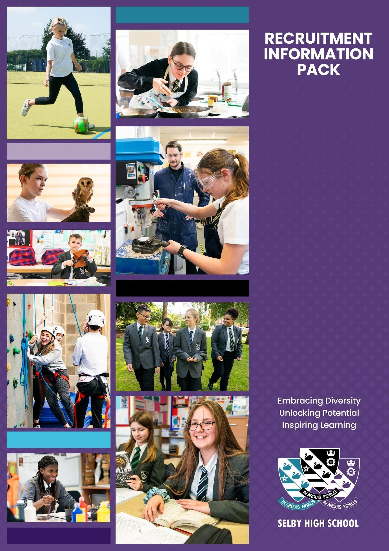

**Cover Supervisor**

**October, 2024**

**WELCOME**

Dear Candidate,

Thank you for your interest in the post of Cover Supervisor at Selby High School. We are looking for somebody to join our experienced team, to cover short term absences, and where possible, provide in-class support, as well as small group and one to one support for students. This is a key role within our school, which allows the successful candidate to make a real difference to the school experience of our young people. We are very interested in candidates who have an interest in developing their career in education, and are looking for experience in a high quality school environment.

Selby High School is an ambitious, forward looking, and successful 11-16 secondary school located in North Yorkshire and rated ‘good’ in our last inspection. We are proud of our school and the opportunities it provides for both students and staff. Our ambition is success for everyone through encouragement, teamwork, and mutual respect, combined with an enjoyment of learning. We are a learning community who embrace opportunities for all our learners by securing high quality learning and teaching. We aim for all our students to achieve their full potential, both as students at Selby High School, and as considerate global citizens of the future.

We are looking for a determined, enthusiastic professional, who wants to work with our young people, to ensure that, regardless of starting points or barriers to learning, they make progress in school. We are looking for somebody who is at HLTA or QTS level, or willing to work towards this. In return, we offer a comprehensive induction programme and continual professional development. As a staff member at Selby High School, we will provide you with excellent training opportunities, and encourage you to have high aspirations for your future career. All classroom-based staff at Selby High receive a school laptop.

Selby High School is a great place to work. Please, just take a little time to look at the whole school twitter feed [https://twitter.com/SelbyHigh](https://twitter.com/SelbyHigh%20) and the PE twitter feed <https://twitter.com/SelbyHighPE> to see some of the opportunities of the school. If you have a little longer to spend, our school website at <https://www.selby-high.org.uk/> gives a real insight into the character of our school.

This information pack contains the Job Description and Person Specification, together with some background information about the faculty and the school. We hope this gives you a feel for Selby High School. If you wish to visit prior to putting in your application, then you would be most welcome. I look forward to receiving your application.

With all best wishes.

Yours faithfully



Nick Hinchliffe

Principal

**ABOUT SELBY**

Selby is a small market town situated 14 miles (22.5 km) south of the city of York, along the course of the River Ouse. It is dominated by the superb Abbey, founded in AD1069 by Benedict when he saw three swans on a lake in Selby which he interpreted as a sign of the Father, Son and Holy Ghost, resulting in the official crest of Selby Abbey, and subsequently, Selby High School.

Selby local government district has a population of 82,900. It is a fairly rural district with a population density well below the national average. Selby town, with a population of 24,680 is its only major settlement, with a population of more than 15,000.

Selby has a growing local economy with new housing and shops being built on the town's outskirts. The riverfront area is also being revamped with modern housing and flats. This is anticipated to bring population growth and enhanced demand for high quality educational places into the future. Selby is ideally located to a whole variety of places, facilities and activities for culture, leisure, commerce and learning. There is a wide range and variety of housing and prices are below the national average.

|  |  |
| --- | --- |
| The district of Selby is contained within both the Leeds City Region and the York, North Yorkshire and East Riding Enterprise Partnerships. The Leeds E.P. Strategic Economic Plan (2016-2036) describes Selby as follows:  “The district of Selby sits on the eastern boundary of Leeds City Region within the county of North Yorkshire. Both the market town of Selby and the wider district are home to many highly skilled and paid employees, many of whom travel each day to Leeds, York and beyond. Its economy is characterised by manufacturing, distribution, construction and energy production; drawing its employees from the district’s market towns and villages, as well as neighbours including the East Riding, Wakefield and Doncaster.”  Looking ahead, the district has a key role to play in providing space for business growth in the Leeds City Region. The unemployment claimant count rate in Selby is around 1.3% (Sept 2016) which is well below the national average.  In terms of further education, Selby College is graded ‘good’ in all areas by Ofsted. It is a tertiary college providing the town`s sixth form as well as a small range of Higher Education courses, apprenticeship programmes and courses for adults. There is easy access to Leeds, Hull and York for Universities and it is to these centres that the majority of local, young HE entrants progress.  In short, Selby is a hidden gem, with both its own delights and very easy access to a diverse range of activities and experiences, for individuals and families of all ages. | **Selby Abbey has been at the heart of the community since 1069.** |

**LIVING IN NORTH YORKSHIRE**

**Knaresborough**

North Yorkshire is England's largest county and one of the most rural. The area comprises the Yorkshire Dales and North York Moors, three Areas of Outstanding Natural Beauty, the Pennines and a stunning coastline around Scarborough and Whitby. The area hosted the phenomenal Tour de France in 2014, and due to its success has created the Tour de Yorkshire with global recognition. There are ruined castles and abbeys, serene gardens, unique breweries, thrilling rides and industrial heritage. Something for everyone!

North Yorkshire has plenty to offer the outdoor enthusiast. From the hard gritstone of Almscliff and Brimham Rocks to the limestone of Malham, Gordale and Kilnsey, climbing venues are in abundance. The Yorkshire Dales is the premier area for caving and for mountain biking; there are the bridleways of the Dales and North York Moors as well as the renowned trail centre at Dalby Forest. The Sustrans trail centres are all easily accessible for days and weekends away, as is the Lake District and the fells, crags and coast of Northumberland. There are a small number of sailing clubs on reservoirs around the county and fantastic surf sport venues and sea kayaking on the east coast.

While the county is rightly known for its wide-open spaces, it also incorporates attractive market towns including Pickering and Helmsley, traditional seaside towns, the Spa town of Harrogate and the ancient city of York - the most visited city outside of London. There are a wide range of shopping, leisure and cultural facilities as well as excellent schools, universities, road and rail links; there really is everything to offer you and your family as a place to work, live and enjoy!

Travelling further afield we have convenient connectivity, with close proximity to metropolitan cities of Leeds and Newcastle, with little over two hours commute on the main train line to London. We border the Lake District, Lancashire, County Durham, and Yorkshire & Humber regions with all they have to offer.



**Whitby**

**SELBY HIGH SCHOOL**

|  |  |
| --- | --- |
|  | Selby High School is a thriving, successful, and popular school. The ‘can do’ ethos at the school ensures the very best for each and every one of its students. Following our successful OfSTED inspection, everyone at the school is eager to move towards outstanding in every area. Selby, located in North Yorkshire, benefits from good commuter links with York and Leeds.  Selby High School is an equal opportunities employer. We have a robust child protection policy and are committed to safeguarding the welfare of our children and young people. It is our objective to ensure that job applicants and staff are treated solely on the basis of their merits, abilities and potential. We do not discriminate against any applicants on the basis of any protected characteristics, and welcome applications from all sections of the community. |

As a school we work in a positive and supportive environment with learning and teaching at the heart of all that we do. We have committed and talented staff who aim to inspire everyone in our school community with a love of learning and, by doing so, maximising students’ life chances. We provide all our staff with a laptop computer and a full professional development and induction programme, both of which have been judged to be outstanding.

Please visit our [Policies page](https://www.selby-high.org.uk/Policies/) for the most up to date policies including Safeguarding & Child Protection and the Equalities Scheme which are part of the interview process.

|  |  |  |  |
| --- | --- | --- | --- |
|  | **Community and Culture** – Our school is a community, in which we provide help and support for one another, in line with our values. |  | **Prioritising high quality planning** – Effective  teaching and learning is underpinned by sensible, appropriate planning that is focused on the needs of all learners. |
|  | **High quality recruitment, retention and**  **development** – Our commitment to Career Pathways ensures that our staff team is always of the highest quality. |  | **Developmental teaching and learning** – We know that teaching time is like ‘gold dust’ and all staff need to be supported to deliver consistently good or better lessons. |
|  | **Supportive staff appraisal** – Aspirational targets that foster the improvement and development of all our colleagues, across the school. |  | **Communication commitment** – We strive to ensure that whole school communication is clear, timely, useful and manageable for all. |
|  | **Streamlined data and report management** – A  sensible approach that avoids duplication and leads to meaningful improvements for students. |  | **Wellbeing – A welcoming place to work** – We are an inclusive school community, committed to equality and diversity and a place where staff are happy in their work. |
|  | **Marking that is manageable and meaningful** – Time invested in marking and feedback should be proportional to the impact on student progress. |  | **Managing workload** – We believe that time well  spent is that which has the highest impact on raising standards, rejecting things that create unnecessary burden for little gain. |

**STAFF BENEFITS**

|  |  |
| --- | --- |
|  | Vivup is a provider of employee benefits in partnership with North Yorkshire County Council  North Yorkshire County Council recognise there is more to pay than just salary and they offer access to a wide range of competitive benefits.  The Vivup website provides colleagues with access to a host of voluntary benefits including discounts on goods and services such as your day to day shopping, days out, travel, electrical goods, leisure activities as well as links to salary sacrifice schemes. |
|  |  |

**Lifestyle Savings**

Explore a huge range of discounts to help you save money across hundreds of the UK’s favourite high-street and online retailers.

**Support & Wellbeing**

Access expert help and support for life’s ups and downs 24/7, 365 days a year. Make the most of the schemes available to help your money go further.

**DISCLOSURE**

All successful applicants are required to complete an enhanced DBS check and any offer of employment will be subject to satisfactory references and checks.

**HOW TO APPLY**

If you decide to apply, and we do hope you will, please complete the application form. This should be returned by e-mail to Caroline Airth at [admin@selbyhigh.co.uk](mailto:admin@selbyhigh.co.uk)

**Closing date:** The closing date for this role is 3pm on Monday 11th November, 2024, although we may interview candidates who put in a good application before this date.

**JOB DESCRIPTION**

**POSITION:** Cover Supervisor

**SALARY: Grade G** £26,873 to £29,269 (Pro Rata) £23,296 to £25,373 (Actual)

**REPORTS TO:** Vice Principal

**HOURS:** 37 Hours per week.  Term Time Only.

**Job Purpose**

To cover short term absence when the assigned teacher is not present.  To provide in-class support and assist students in small groups as required.

**Cover Supervisor Responsibilities**

* Cover for classes when a teacher is absent and deliver the work set and agreed with the teacher.
* Be proactive in the classroom, checking understanding, circulating, responding to questions, supporting students with their work and staying on task, and managing behaviour.
* Create a calm and purposeful environment in which students can complete work set by the class teacher, engender high expectations and promote self-control and independence.
* Monitor, record and evaluate pupil responses to learning activities through a range of assessment and monitoring strategies
* Interact with pupils in ways that support the development of their ability to think and learn, and work independently
* Support the development and implementation of appropriate behaviour management strategies, to anticipate and manage behaviour constructively,
* Support pupils in their social and emotional wellbeing, and develop and implement related social, health and physical programmes.
* Encourage and motivate pupils to promote independence and resilience and increase self-esteem.
* Provide feedback to students in relation to progress, achievement, behaviour and attendance.
* Support students' access to learning using appropriate strategies and resources.
* Establish constructive and respectful relationships with parents/carers, exchange appropriate information, facilitate their support for their child’s attendance, access and learning and support home to school and community links.
* Play an appropriate part in establishing effective relationships and communicate with other agencies/professionals, in liaison with the teacher, to support achievement and progress of students.

**In-class and small group support**

* Support teachers in the provision of support for students with special educational needs and/or disabilities.
* Plan and implement small group learning activities.
* Support the progress of who are on an alternative pathway.
* Provide information and advice to enable students to make choices about their own learning/behaviour/attendance, using appropriate behaviour management strategies as necessary.
* Work with other staff in planning, evaluating and adjusting learning activities as appropriate.
* Take a lead role in the development and implementation of appropriate behaviour management strategies.

**Other Duties**

* Organise and manage an appropriate learning environment and resources.
* Support the use of ICT to advance pupils’ learning and use common ICT tools for own and pupils’ learning.
* Accompany or act as a group leader on educational visits, and other activities outside of the classroom, supervising the pupils.
* Assist with administrative support e.g. dealing with correspondence, compilation/ analysis, reporting on attendance, making phone calls.
* Supervise and provide access arrangements for pupils sitting internal and external examinations, ensuring that examinations comply with Examination Board Regulations
* Supervise students at break times.
* Lead or cover a Personal Development group as required.
* Participate in meetings, training and appraisal as required.
* Pay due regard to professional boundaries, maintaining appropriate levels of confidentiality
* Share information about pupils with teachers and other professionals as required

**Safeguarding**

* Be responsible for promoting and safeguarding the welfare of children and young people that you are responsible for and come into contact with, following all relevant policies.
* Assist pupils with personal hygiene, and welfare, including physical and medical needs, whilst encouraging independence
* Undertake annual training in the most recent legislation.
* Be able to recognise when a child or young person is in danger or at risk of harm and take action to protect them.
* Make considered judgements about how to act to safeguard and promote a child or young person’s welfare

**Data Protection**

* Comply with the County Council’s policies and supporting documentation in relation to Information Governance this includes Data Protection, Information Security and Confidentiality.

**Development**

* Ensure continued personal professional development through attendance at relevant training.
* Undertake appropriate training in the use of ICT software programs to ensure the most effective and efficient processes support your work.

**General**

* Undertake any other duties as reasonably required by the Principal.
* Contribute to the life of the school community and to support its ethos and policies.

**Equalities**

* Promote inclusion and acceptance of all pupils
* Ensure services are delivered in accordance with the aims of the equality Policy Statement

**Health & Safety**

* Be aware of the responsibility for personal health, safety and welfare and that of others who may be affected by your actions or inactions.
* Be aware of the specific issues relating to health and safety in your area and make appropriate assessments of any risk.
* Co-operate with the employer on all issues to do with health, safety and welfare.

# Person Specification

|  |  |
| --- | --- |
| **Essential on appointment** | **Desirable on appointment** |
| **Knowledge**   * Good understanding of child/young people’s development and learning processes * Understanding of individual children and young peoples’ needs * An understanding that children/Young people have differing needs and knowledge of inclusive practice | * Knowledge of Behaviour Management techniques * Knowledge of Child Protection and Health & Safety legislations and procedures |
| **Experience**   * Significant experience of working with children in an education setting. | * Experience of delivering evidence based interventions that accelerate learning * Experience in a relevant specialism e.g. Art/Music/Sport |
| **Occupational Skills**   * Demonstrable ICT skills and ability to use them as part of the learning process, or, the ability to develop ICT skills in a reasonable timeframe * Good written and verbal communication skills: able to communicate effectively and build good relationships with all teachers, children, young people, families and carers |  |
| **Qualifications**   * Level 2 numeracy & literacy qualification or equivalent * HLTA status or QTS or willing to work towards these standards. | * Relevant NVQ level 4 or foundation degree * Appropriate first aid training |
| **Personal Qualities**   * Demonstrable interpersonal skills * Ability to work successfully in a team * Able to exercise judgement * Confidentiality * Flexibility | * Creativity |
| **Other Requirements**   * Enhanced DBS clearance * To be committed to the school's policies and ethos * To be committed to Continuing Professional Development * Motivation to work with children and young people * Ability to form and maintain appropriate relationships and personal boundaries with children and young people * Emotional resilience in working with challenging behaviours and attitudes * Ability to use authority and maintaining discipline * An empathy for equality & diversity * The ability to converse at ease with customers and provide advice in accurate spoken English is essential for the post |  |