Candidate Information Pack
Cover Supervisor

Contents
About the Trust | 1
About us | 2
Our vision and values | 3
Working at Bishop Alexander Academy | 4
Benefits of being part of L.E.A.D. Academy Trust | 5
How to apply | 7
Job description and Person specification | 8

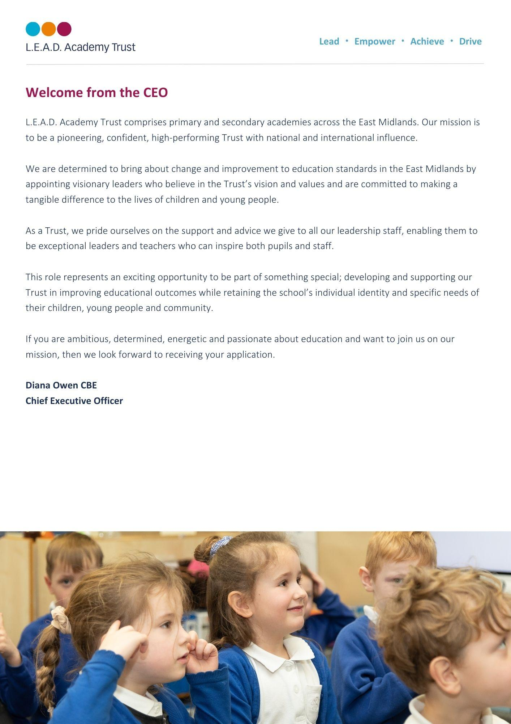
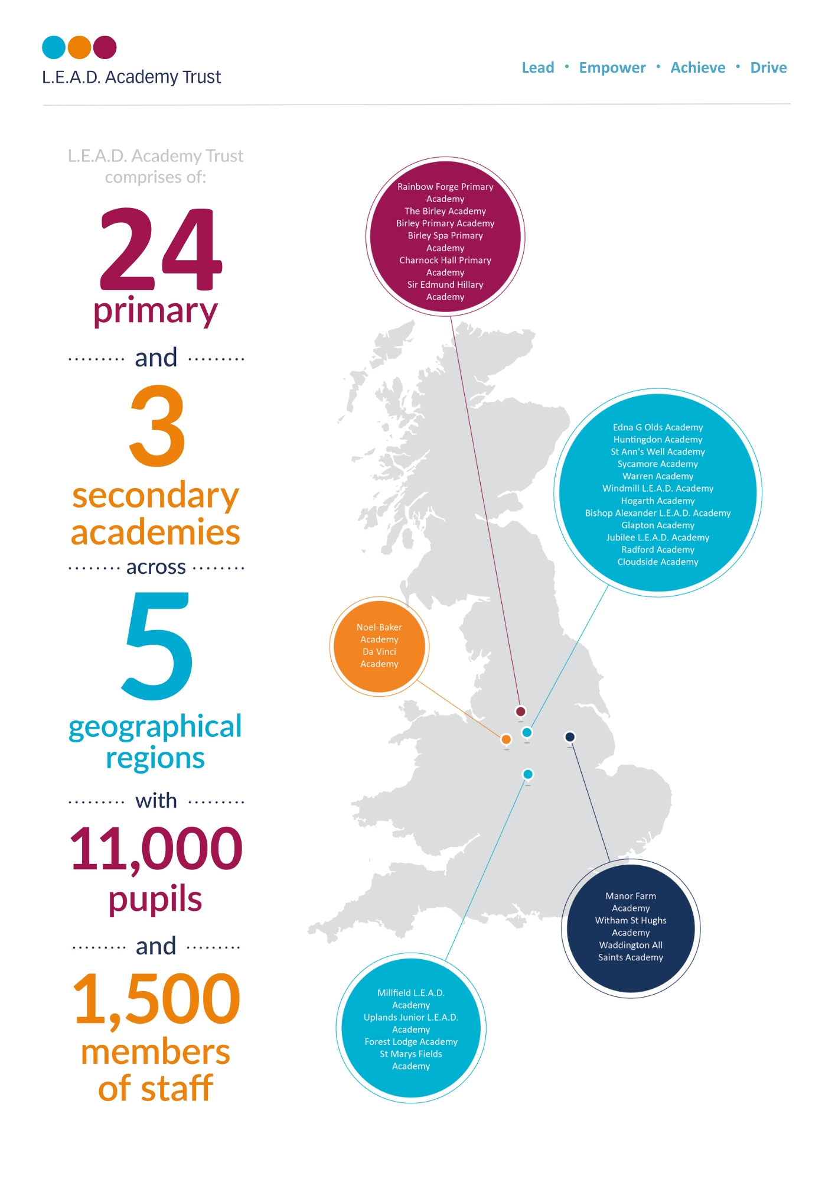
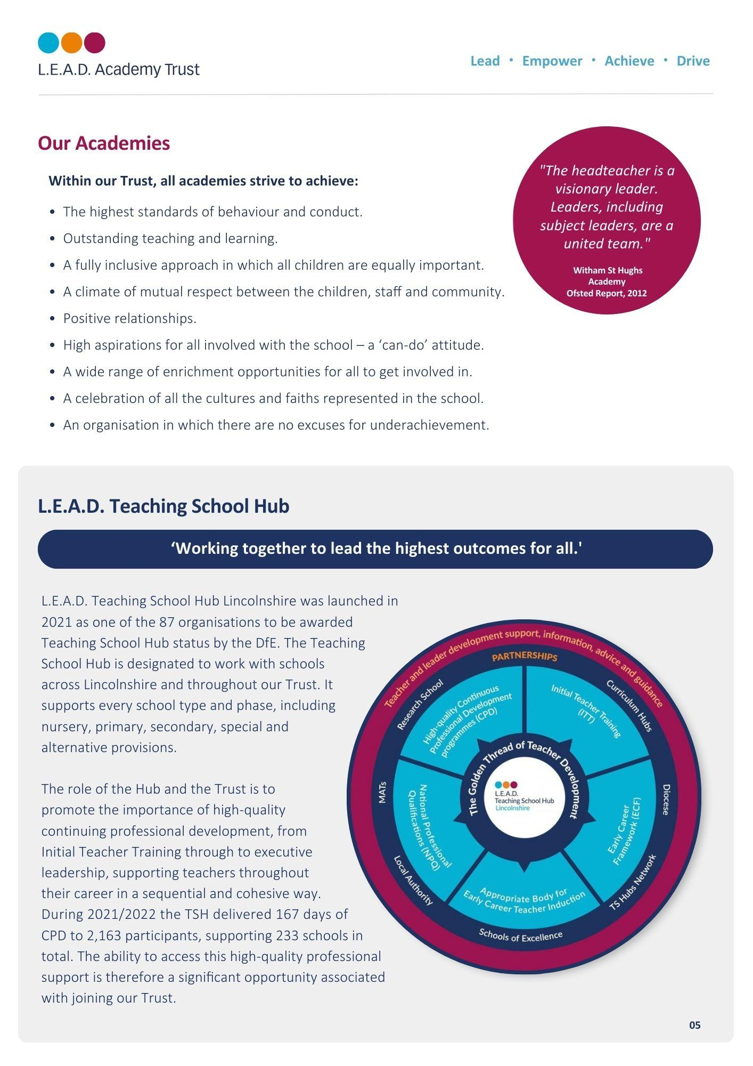

A message from the Headteacher
Thank you for your interest in this role.
I am proud to have been the Headteacher of Bishop Alexander Academy for 10 years, and consider myself lucky to work with remarkable pupils, dedicated staff and supportive families. The people are what makes this academy special!
The pupils are enthusiastic and committed to their learning and show resilience and aspiration in all they do. They understand the importance of making mistakes and recognise these as learning opportunities. They show care for each other, but also for other members of the community. We firmly believe that this school belongs to the pupils’, and their voice plays an essential part in the development of the academy. Pupils also undertake roles of responsibility such as Subject Ambassadors, Lunchtime Leaders Headteacher Mrs Nicky Spencelayh
and Active Citizens.

We have a highly committed team of staff, who inspire and care for our pupils. Our parents say, ‘they are approachable staff’ and provide a place in which ‘their children flourish’. All staff are proud to be members of the Bishop Alexander team.
We believe that our pupils deserve the best education possible, and this is only possible through talented and well trained staff. They have a wealth of CPD opportunities both within the academy and through L.E.A.D Teaching School Hub. Staff say they value these opportunities to develop.
The school is fortunate to have a strong and supportive Governing Body, who share our commitment to further strengthen teaching and learning and ensure that all children reach their full potential. They also share a keen interest in the staff and their welfare.
I strongly encourage you to visit the academy, and see our caring, yet challenging, ethos in practice.

About Bishop Alexander Academy
We are a one-form entry academy with 220 pupils, which consists of a modern school building with extensive grounds. There is a diverse community, with 13 different home languages spoken, and pupils come from a range of backgrounds. We are passionate about pupils being able to ‘see’ themselves in our curriculum, and we pride ourselves on our inclusive ethos.
Our curriculum follows a two year cycle and starts literally ‘on our doorstep’, in that it is about our local community and Newark itself. We feel that the children need a sense of belonging and pride in where they live, before they learn and appreciate the wider world. Our curriculum themes are carefully chosen and
reflect the needs of our pupils. The whole school follow the same theme and come together
at the end for a common purpose.

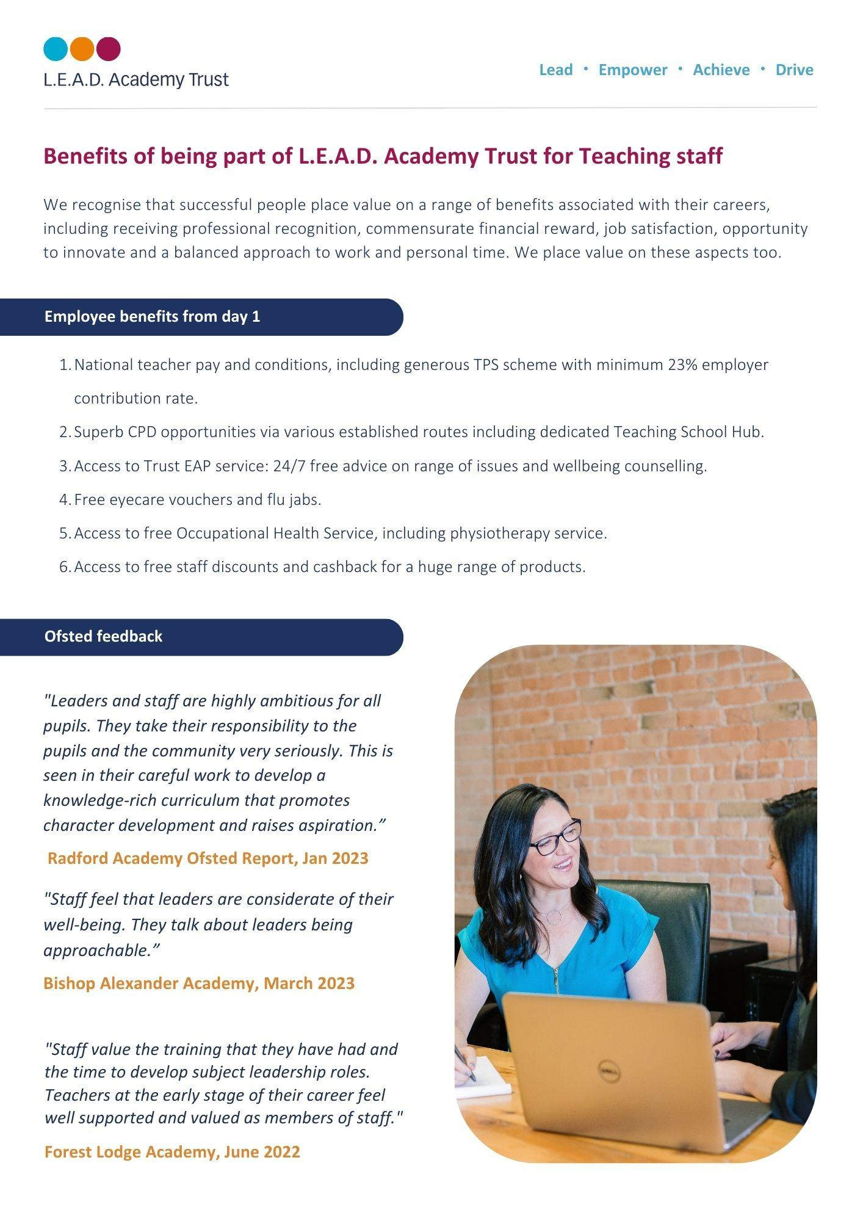

OFSTED March 2024:

“Pupils feel happy and safe at school”.
“Parents who share a view described a welcoming environment,
approachable staff and a place in which their children flourish”.

How to apply
Please send a completed application form and covering letter explaining your interest in the role and how you meet the person specification to : sallyh28@bishopalexanderacademy.co.uk
CLOSING DATE: Monday 8th July 2024

Applications will be reviewed upon receipt, therefore shortlisted candidates may be contacted in advance of the closing date.
L.E.A.D. Academy Trust is committed to safeguarding and promoting the welfare of children and young people and we can expect all staff and volunteers to share this commitment. This post is subject to an enhanced DBS check.
For an informal, confidential discussion about this opportunity, please email: Mrs Sally Hade on sallyh28@bishopalexanderacademy.co.uk
Job description
Key responsibilities and accountabilities
Cover Supervisor
This role is particularly suitable for candidates considering a future career in teaching.

Start date – September 2024

Working hours – Full Time

Pay – Scale U2 (£22,960)

Job purpose:
To support teachers and students as directed and ensure that classes are taught effectively during times of absence, or to be responsible for the delivery of cover lessons during planned development work.
Duties and Responsibilities:
- To work with teachers to prepare appropriate lessons / resources when absence is known in advance
- To compile appropriate lesson activities / resources in liaison with other teachers when absence is not known in advance
- To undertake classroom activities as directed by teachers to support teaching and learning process
- To assist in the preparation of resources and display
- To mark students’ work in accordance with Academy policies and teacher instructions
- To undertake administrative duties as requested by teachers
- To cover classes as and when needed
- To input data to support Academy policies in Assessment, Recording and Reporting
- To maintain student records in accordance with statutory procedures, Academy policies and as directed by Senior Leaders
- To manage the behaviour of pupils to ensure a constructive environment is maintained, by using a range of strategies
- Attend all meetings and functions necessary to support the work in this job description

As job descriptions cannot be exhaustive, the post-holder may be required to undertake other duties which are broadly in line with above key responsibilities.

The Trust is committed to safeguarding and promoting the welfare of children and young people and expects all staff and volunteers to share this commitment and individually take responsibility for doing so.
At L.E.A.D we have a strong vision and four core principles, to lead, empower, achieve and drive, which you will be expected to demonstrate in your working practices.
Person specification
The person specification listed below outlines the competences, knowledge and behaviour of candidates who would be suitable for this role. The two right-hand columns provide guidance as to whether these items are essential (E) or desirable (D) criteria.
Qualifications and Attainments | - Studied to a minimum standard of GCSE (grade A*-C), or equivalent, in English and Maths  - Level 3 qualification  - A degree or post graduate qualification | E  E | D
Skills and Knowledge | - Ability to contribute to the delivery of lessons  - High level of oral and written communication skills  - Ability to work as part of a team  - Able to work to tight deadlines, managing and prioritising time effectively  - Self-starter, with the ability to work independently and use own initiative to overcome obstacles | E  E  E  E  E
Experience | - Previous paid or voluntary work with young people  - An understanding of Keeping Children Safe in Education  - An understanding basic school organisation  - A basic knowledge of the work of a school  - Experience working with children with Special Educational Needs | E  E  E  E | D
Personal Attributes | - Have an openness to learning and change  - Have a positive attitude to personal development and training  - Be able to work in ways that promote equality of opportunity, participation, diversity and responsibility | E  E  E
Additional Requirements | - This role is subject to an enhanced DBS  - May be required to work out of school hours to support the academy | E  E

Email address:
office2@bishopalexanderacademy.co.uk
Phone number:
01636 680040

