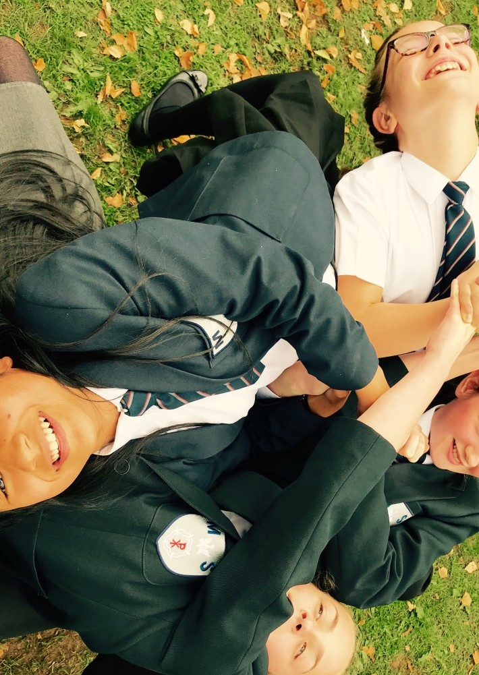

The
M.
McAULEY
Catholic High School and Sixth Form DONCASTER

Candidate Pack Cover Supervisor
1

M. Spring 2022
Dear Candidate,
Thank you for showing interest in this post.

If successful, you will be joining McAuley, the biggest school in Doncaster and the biggest Catholic school in Hallam Diocese at a very exciting time.

In mid-November 2017 we had a long overdue visit from OFSTED. The visit left us with no surprises and indeed confirmed many of the areas that had already been identified as priorities. The progress that we have made since then was recognised in the latest OFSTED of February 2020 but we have more to do.

As Head, I am totally committed to staff welfare and well-being and see my role as removing those obstacles that prevent staff being brilliant. As such I am totally convinced that shared and distributed leadership focussed on improving teaching is the best way to improve a school.

I am committed to bring the very best people to work at McAuley to join a community of Learners committed to the values and vision of the school and dedicated to making
a difference to the children we teach.mongst the details of the post you will find in this pack a Vision Statement. This was written in October 2017 at a conference involving over 200 people including all staff, Governors, parish priests and parents. This vision statement is a central document to explaining the type of school that we as a community want to create and work in.

The role that teaching and support staff play in the school is central to moving us further forward and if successful, you will be part of a team that have a strong determination and commitment to make a significant contribution to McAuley.

We aren’t there yet but we are definitely on the journey to being great. If you want to be part of something genuinely unique then we want to hear from you.

John Rooney, Headteacher

Job Profile | Cover Supervisor
To contribute to the teaching and learning of students in the school by supervising and instructing students when teachers are on short term absence. At other times supporting curriculum areas in administration and other tasks

- Key Duties/Areas of Responsibility

- To liaise with teachers regarding work set and distribute this to the appropriate students

- To take the registration of each class in line with school policy and cover form classes when required

- To be responsible for a class of students in lesson time and to facilitate the learning of students in relation to the work allocated by the subject teacher for the duration of the lesson and ensure students remain on task with the work they have been set

- To ensure students are provided with the necessary resources to facilitate learning

- To appropriately manage the behaviour of students, using the school’s behaviour policy whilst they are undertaking this work to ensure a constructive environment both in and out of the classroom

- Dealing with any immediate problems or emergencies in line with the school’s policies and procedures.

- Making sure completed work is returned to the appropriate teacher/department along alongside communicating any issues or problems that may have arisen during the lesson

- To maintain appropriate records and to provide relevant, accurate and up to date information for the school’s Management information systems, ie registering pupils accurately and timely following the best behaviour expectations for students as well as recording behaviour points and using the school child protection systems to log any safeguarding issues

- To carry out tasks within a specific Curriculum Area as directed by the Curriculum Leader

- Assist in lunchtime supervision and/or bus duties as directed

- To ensure the health and safety of students at all times

- To attend training sessions as required and be committed to continuous professional development

- Act as a First Aider in School

- Be aware of and support difference and ensure equal opportunities for all.

- Contribute to the overall ethos/work/aims of the school

- Appreciate and support the role of other professionals

- Participate in training and other learning activities, CPD and performance development as required

- Any other reasonable duties deemed appropriate and commensurate with the role and salary grade

Job Specific Notes
Salary Grade 7 (NJC)
Hours 35 per week
Term time plus 3 days

At The McAuley Catholic High School we are absolutely committed to keeping our young people safe by working together to safeguard and promote the welfare of children. Recruitment processes in our school comply with ‘Keeping Children Safe in Education’ and we would expect the successful candidate to share our commitment protect children. All newly appointed colleagues will undergo an enhanced DBS as well as strict recruitment and employment checks.

McAuley provides a distinctive Catholic education based upon Gospel Values with Christ at the Centre of all we do. It is a vibrant worshipping, sacramental community open to people of all faiths and those still exploring. Our faith is celebrated through our actions.
It is the first choice for Catholic families and an employer of first choice for staff. The school is a leading light in 11-19 education in Doncaster. Academic standards reflect the fact that, whatever their starting points, young people make brilliant progress throughout their time at the school. The academic is only one part of a focus which allows all God-given gifts and talents to be spotted and nurtured. Children feel good about themselves and proud to say they come to this school. They are listened to*. The wider community especially our local parishes actively promote the school and want to be involved in it. The school actively seeks out that involvement. The Family of schools work closely together to support and share in this vision and to give students the best possible start.
Throughout the school day there is a sense of calm and purpose because everybody has a clear sense of the expectations on behaviour and attitudes to learning. Children feel safe, secure, loved and happy in school. Day to day organization is routine and unfussy. Physical space and the care of that space matters. The environment which the children and staff enter each day is attractive, bright and clean. It is safe and welcoming and is obviously child-centred by the celebration of work in the corridors and classrooms.
Time is used well. The curriculum in all its aspects motivates the children and meets their needs. The result is work which they can be justly proud. They are intellectually curious and ask deep questions of themselves, take risks in their learning and work well together. This approach helps everyone to make progress in their own unique way with a special emphasis on the well- being of the most vulnerable in our school community. In their seven years in the school each child is valued and understood as an individual; academically, intellectually, socially, emotionally and spiritually. A strong moral compass prepares them well to be caring stewards in a rapidly changing world.
Parents, as valuable partners take an active part in supporting the school and know and trust that their children are in loving hands and are nurtured as they would nurture them. Open and swift two-way communication is the basis for tutor-based Pastoral care which is based upon peace, justice and reconciliation.
Those who lead the school are optimistic, approachable and in clear, quiet command. This approach is supported by a committed and active Governing body. The leadership philosophy is marked by simplicity and strength and a well-founded trust in colleagues. Passing fads or fashions are resisted, confident in the tried and tested practices for the community of learners it serves. Leaders ensure that staff are well looked after so the trademark of the school is staff continuity and where ambition is encouraged. The Leadership of the school is distributed. There is a no blame culture.
Staff know at all times that they are the servants of the school. Their instincts are always asking what can they do to make the school better. Those that choose to leave do so for good reason and are warmly thanked for the service they have given.
This embedded culture of thinking, doing and believing is a characteristic of all staff in every job that they do whether in the classroom, the reception desk, the pastoral office, the dining room, the caretaker’s room, the chaplaincy space.
McAuley staff challenge and support each other and never talk the hopes and aspirations of the school down. They do so every day the school is open and as much again when it is not. They have a passion to be the best they can be. They strive to be expert in as many ways as
they can be in nurturing all members of the school community; not some of the time but all of the time.
Staff will always go the extra mile for the children in their care. Staff care, risk, dream and believe and expect more than others think possible; whatever barriers are presented in the way of a child thriving the McAuley family will find a way.

*The McAuley Student Vision Statement 2018

