Cover Supervisor
Application pack and
information for candidates

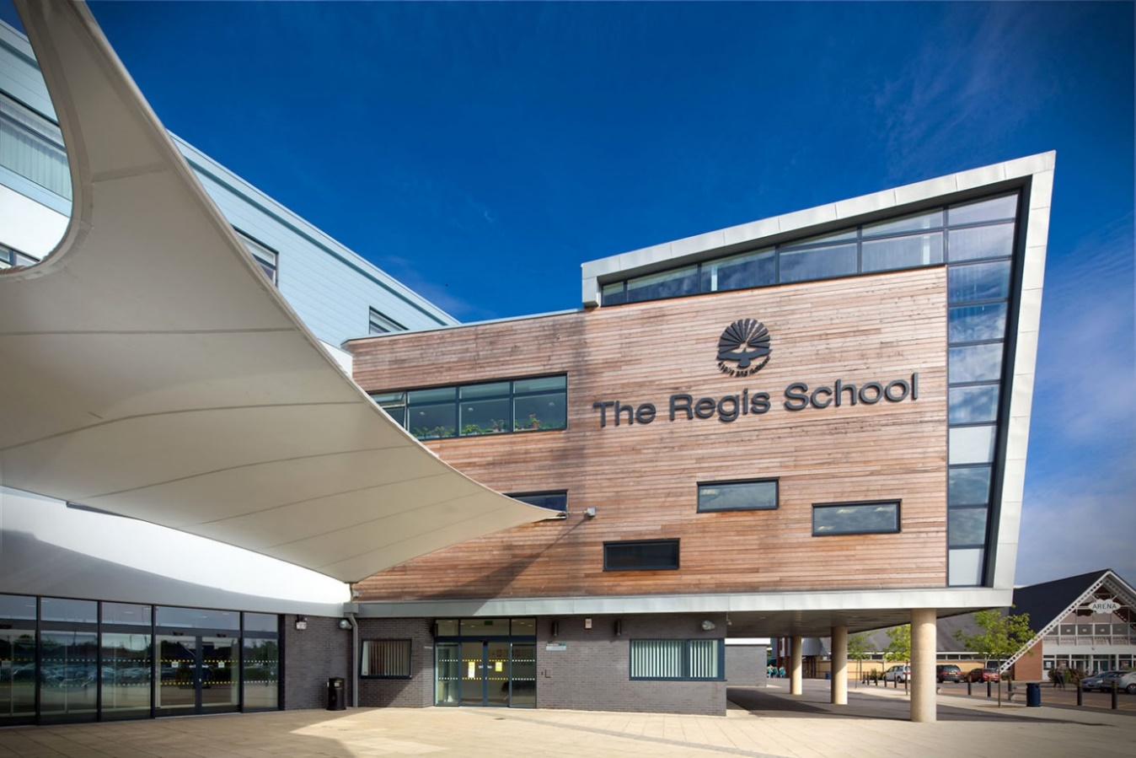

Thank you for your interest in this vacancy. I feel privileged to be leading The Regis School and I am resolute in my determination to deliver a high performing fully inclusive school, that provides a first-class education for the community it serves.
The staff here share that ambition, and you would be joining a highly qualified, motivated, and dedicated team, who are passionate about ensuring they bring out the best in everyone. We have high expectations of the students and a shared purpose; to ensure that when they leave us, they will be motivated lifelong learners, kind citizens and productive young adults. This is achieved through delivering an ambitious curriculum that equips students with powerful knowledge, maximising their cognitive development, and drawing out and building on their talents. Our curriculum is broad and balanced, not just our academic curriculum but also in terms of Character Education, where we are fully committed to our co-curricular provision, and the ‘hidden curriculum’ of the school - intended to spark curiosity and to nourish the head and the heart.

Our ethos is centred around ‘the best in everyone’ and therefore we expect the best from everyone, constantly challenging the students and ourselves. As a hardworking and passionate Headteacher I believe in many things including: high professional standards (of ourselves and our work); in personal responsibility and the value of discipline; that all students deserve disruption free learning; in kindness and good manners; in inclusion; in smiling; in being respectful and most importantly in showing limitless ambition, setting goals high.

I am proud of the commitment shown daily from our staff and the students to ensure The Regis School is a centre of educational excellence. This permeates out into the community, where parents’ confidence in our ability to do so is shown in The Regis School being the school of choice for the community we serve. We are delighted to have been oversubscribed for the third consecutive year this September and early indications predict this trend will continue with our new Year 6 intake in September 2022.

If the above aligns to your values and educational beliefs and feel excited that The Regis School could be the right school for you, we would welcome your application. There is more information in your pack and on our website about our school, and we hope you enjoy finding out more about us. We recognise that moving to a new school is a significant decision and therefore offer an open invite to prospective candidates to meet with myself (face to face or virtually) and visit the school in person. I very much look forward to meeting you.

Best wishes
Dave Oakes
Principal

Cover Supervisor
£15,517.89 pa (£21,500 FTE)
(32 hours per week). Hours 8.00 am to 3.15 pm daily (inclusive of a 30-minute break)
Term Time Only plus 2 INSET days (or equivalent for CPD)

We are seeking to appoint a proactive and enthusiastic individual to support teaching and learning within our school. The role involves supervising lessons in the absence of a class teacher, to ensure that students continue to learn new knowledge and or have opportunities to revisit prior knowledge, so that they continue to progress through the curriculum.

This post is ideal for those who are considering a career in teaching and are thinking of applying for a PGCE, Teach First or School Direct course, OR you could be an experienced teacher looking for a more flexible way of working OR have a passion for working with young people, and a love of learning who are looking for a new rewarding career pathway.

The key responsibilities of the role will include:
- Supervising students to complete their learning, delivering pre prepared resources when a teacher is absent, promoting engagement and supporting progress of students.
- Creating a calm and purposeful environment in which students can complete work set productively
- Setting and maintaining high expectations and standards.
- Following the school’s systems to ensure a disruptive free learning environment for all pupils.
- Establishing purposeful and positive relationships with students.

The role involves you being in front of a class of students (across the secondary age range), supervising a lesson. You would be sharing pre prepared resources with students across multiple subjects, rather than one subject, ensuring students complete the work that has been set. The key purpose in your role, is to secure continuity of learning in the teacher’s absence. Thus enabling students to continue to progress through the curriculum, master new knowledge and skills or consolidating ones they have already learned.

Those with the right temperament will find the work incredibly rewarding and by possessing the following skills and qualities, it is likely that you will be highly skilled and successful in this role

- Highly adaptable, responsive, and flexible in how you work
- Have excellent communication skills
- A calm, fair, positive, and warm manner, as well as being firm and assertive when needed
- A love of learning and working with young people

We hope that you see this as an exciting opportunity and if the above captures you, we look forward to hearing from you. We recognise that taking on any new role can be exciting and can raise questions so please do not hesitate to get in touch.

Closing date: Friday 7th January 2022 at 9am
Interview Date: to be confirmed

We reserve the right to close this vacancy early should we receive an overwhelming response. Interviews will be arranged on the receipt of positive applications.

Job Description

There are various reasons why teachers may need cover for their lessons. Your skills will allow students to continue to learn and enjoy their time in school while their regular teacher is engaged elsewhere.

As a member of our staff you will be able to offer a quality of support and continuity for our students.

A Cover Supervisor is vital in maintaining the stability of the school, ensuring that the students are able to access their learning in a supportive environment with your feedback and guidance to help them to complete their learning. You will build relationships with the students and colleagues in the school so that students come to learn that your expectations reflect those in the usual lesson environment.

Main responsibilities:
Although you will not teach, your role in the classroom will be varied, demanding and creative. You will need to think on your feet, have plenty of energy and patience and maintain an energising presence in order to motivate a class.

You will also be a Tutor for a tutor group for 25 mins each morning (training to be given, this could be in any of the year groups 7-11)

You will need to be aware of policies and procedures relating to child protection, health, safety and security, confidentiality and data protection and reporting all concerns to an appropriate person.

A typical cover supervision lesson:
- Greet the class at the door. Line them up for entry to the room, blazers on. Settle the class in the room, conduct a starter activity such as: write a sentence to summarise what you learned last lesson; copy down date and title.

- Introduce the work set today by asking a question to stimulate the class about the topic. Put up a schedule of activities. Set the class to work for a period of time (10-15minutes). Take the register while they are quiet and focussed.

- Move around the room, talk to pupils, provide feedback, support them, check they are on task.

- After 15-20 minutes into the lesson see what progress has been made and encourage the class to share answers and responses to the work. Distribute stickers to those who have done well.

- Set the class to work again for 15-20 minutes. Continue to circulate around the room, providing feedback and praise. Check pupils are on task and making the expected progress against the tasks set.

- During this time take five minutes, if you can, to make a note of some keywords and or questions from the subject material set to use in a plenary at the end.

- Approximately 10-15minutes before the end of the lesson check progress, get pupils to share what they have learned. Use your plenary questions to check the learning from the lesson. This might be a question and answer session about the subject content, a quick quiz based on the lesson or a true/false traffic light exercise

- Allow yourself 5 minutes to pack up in an orderly manner, check the room is tidy, all resources are collected, and check that there is nothing on the floor. Ensure the class are settled with blazers on. When the bell goes dismiss them calmly, by row or table, ensure they put their chair under, and then thank them for a positive lesson.

What you will gain from this role in education

- A pathway into teacher training through PGCE, United Teaching or Schools Direct route
- A pathway into student support and working in the pastoral system
- A pathway into being a Teaching Assistant
- Confidence about being in the classroom with older students

The Regis School is committed to safeguarding and promoting the welfare of children and young people and expects all who work at the school to share this commitment. All positions are subject to an enhanced disclosure through the Disclosure and Barring Service (DBS).

Person Specification

It is anticipated that evidence of meeting these criteria will be gathered from scrutinising the candidate’s application and observing the various aspects during the interview process.

Person Specification | Essential | Desirable

Qualification & Professional Membership
- A good general educational background
- Relevant Level 3 or equivalent qualification or experience

Experience
- Experience working with children of relevant age
- Expertise and recent experience of behaviour management
- Previous experience of working with children in an educational environment

Knowledge
- Working knowledge of national curriculum and other relevant learning programmes
- Understanding of how students learn and in particular barriers to learning
- Knowledge of Child Safeguarding procedures

Skills/Attributes
- Effective interpersonal skills
- Excellent communication and presentation skills
- Work constructively as part of a team as well as take initiative and work independently
- Ability to manage and monitor a student’s learning/behaviour choices

Personal Qualities
- Initiative to respond to and cope with unexpected problems and situations positively
- Self motivated

What makes The Regis School a great place to work?

You will:
- Be working for the biggest Multi Academy Trust in the UK, you will have access to first class professional developmental opportunities, and a collaborative and supportive national network of highly effective senior leaders and lead subject practitioners with a common purpose to bring out the best in everyone and continuous drive for improvement.
- Work in a disruption-free learning environment, enabling teachers to teach and students to learn.
- Work with teachers and leaders who are supportive, vibrant and ambitious, who all share a passion and love of teaching.
- Work in a school culture where feedback is central to improving the quality of teaching, supported by instructional coaching and deliberate practice.
- Be working in a state-of-the-art school where the teaching environment is of a very high quality e.g. well-equipped spacious classrooms, kitted with IWBs, visualisers and the necessary equipment/tools needed facilitate teaching.
- You will have own team space conducive to day-to-day professional conversations
- Be able to access excellent professional learning and career opportunities each year both within the school and the wider trust, including experience and skills needed to move into teaching if desired.
- Be able to access numerous employment benefits such as: a car leasing scheme, access to ‘Perkbox’ offering discounts in weekly shopping, high street stores and flights and holidays.
- Have access to reduced Gym Membership (50% off standard anytime membership) in a state of the art gym facility on campus.
- Have access to 10% discount on nursery place at Stepping Stones on-site nursery.

United Learning Child Protection Statement

United Learning is fully committed to the safeguarding of children – ensuring the well being of the child is paramount. For students to feel that they are able to do their best and achieve their true potential, it is important that they feel safe and supported in the school environment.

Everyone working within our schools and academies, whatever their role, is acutely aware that issues to do with the protection of children are of the highest possible importance. Trust underpins everything that we do in schools. The parents of our students entrust the care of their children to us and together we are all responsible for their well-being.

In relation to safeguarding, United Learning aims to ‘prevent’, ‘protect’ and ‘support’ all its students by addressing child protection in the curriculum, pastoral activities and in the management of the school, and by empowering and enabling staff to be vigilant for vulnerable students through training and information dissemination.

All United Learning schools have policies which deal with safeguarding, child protection and safer recruitment, which are in accordance with the relevant local authority procedures and which comply with the DFE’s safeguarding children and safer recruitment statutory guidance. The individual school policies are available via each school’s website or by contacting your school directly.

How to Apply
To apply and see more details please visit our website: www.theregisschool.co.uk/working-for-us/vacancies.

If you have any questions, please email vicky.ovens@theregisschool.co.uk

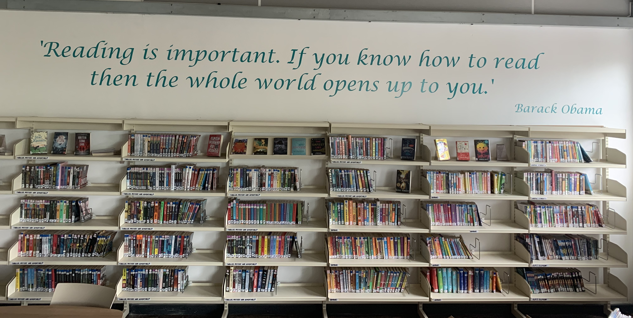

The Regis School

The Regis School is part of United Learning, a unique group of independent and state schools working together to achieve the best in everyone.

Our vision is to provide an excellent education so that all young people are able to make a success of their lives and, if we are to realise this vision, we need to make sure we attract, develop and reward the key ingredient, our high quality, hardworking staff.

The Regis is a school that we all feel proud of and our teachers are passionate about their work. We know that teaching can be a challenging profession, but with the support we offer and a commitment to seeing the best in each other, we work tirelessly to find creative ways to educate. We have access to a Group-wide curriculum, an intranet platform that enables sharing of resources and opportunities for work shadowing and mentorship.

The Regis School is a secondary 11-18 school with over 1600 students on roll. We are an inclusive comprehensive school that aims to achieve the best for every student. This philosophy is reflected in the successful Sixth Form of 160+ students who are offered a broad range of academic and vocational programmes. Over 70% of our students progress to Higher Education each year.

The Regis School has a well-qualified, dedicated supportive and enthusiastic staff team. We have approximately 200 staff, all of whom are committed to providing the best possible education for our students. As one of the biggest employers in Bognor Regis, we emphasise the learning of adults and young people. Staff are involved in further study, research projects and in the training of teachers in partnership with local universities.

The school boasts superb facilities in all subject areas. Each teaching area has audio-video facilities and a range of ICT suites throughout the school provides access to specialist equipment. All teachers have a laptop provided, to support teaching and administration.

The Regis School aspires to be an outstanding centre of learning, serving its community and transforming lives. We seek to equip our students for a changing world through building confidence, encouraging creativity and fostering enquiry to achieve excellence. These qualities will allow our students to flourish as leaders of the future and to take their place as caring, ambitious and responsible citizens in their communities.

Academic achievement is at the heart of what we do, ensuring students leave with the highest qualifications that enable them to be competitive in the global economy. We have a strict behaviour policy that enables teachers to teach in classrooms that are mainly free from disruption. Students who prevent others from learning are given a single warning, then learn elsewhere in the school under the supervision of senior staff.

The Regis School is part of the United Learning group. United Learning is a large, and growing, group of schools aiming to offer a life-changing education to children and young people across England.

United Learning schools work as a team and achieve more by sharing than any single school could. On our intranet site United Hub, for example, we share lesson plans and many other resources, helping to simplify work processes and manage workloads for an improved work-life balance.

As a group, we reward our staff better: with good career opportunities, better pay, benefits, and ultimately, the satisfaction of helping children to succeed.

We greatly value our staff and want them to know it. Starting with financial rewards and solid career progression, we believe in leading the industry with better remuneration packages. As such, you can expect to earn more at United Learning than if you took a role in the maintained sector, with up to 5% better pay for new teachers. In addition, our benefits options are undoubtedly competitive, with every member of staff being entitled to a core benefits and lifestyle package.

Your wellbeing is a priority. It is vital for us to have healthy and happy members of staff, which in turn ensures you are providing the best education for our children. We offer great benefits to support the health and wellbeing of colleagues, such as discounted gym memberships, Cycle2Work schemes and free counselling. We also provide you with more time to think and prepare for the term ahead, with a minimum of eight INSET days a year – with at least three dedicated to planning.
Further information about United Learning is available at www.unitedlearning.org.uk

