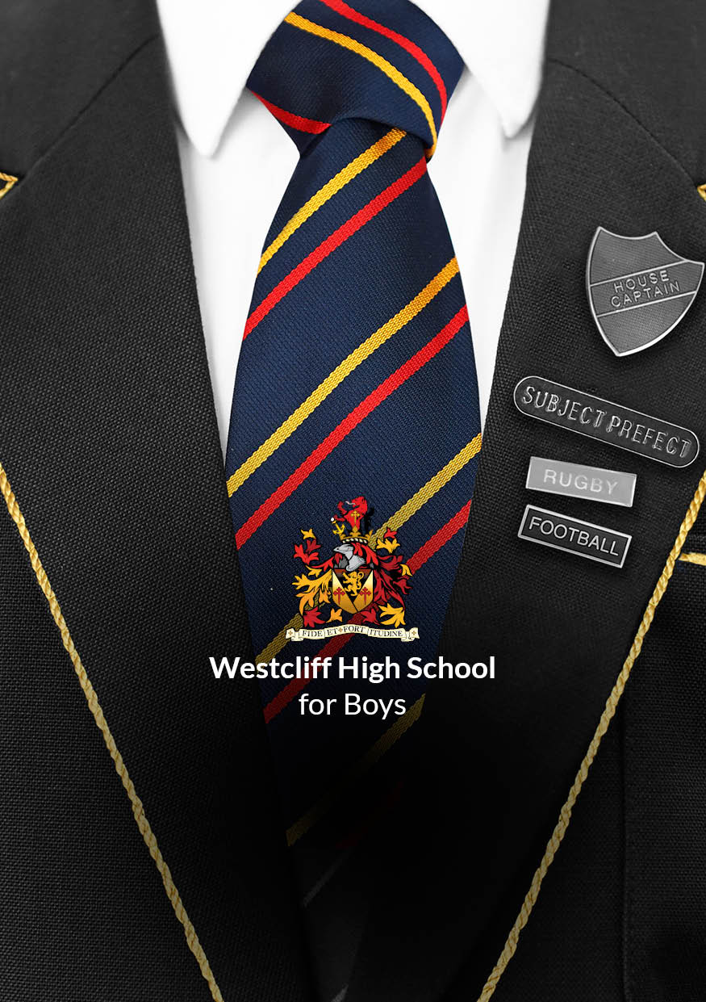

JOB DESCRIPTION
Cover Supervisor

Introduction

INTRODUCTION
Every School has its own traditions, its own ethos, its own identity, and its own purpose. The purpose of Westcliff High School for Boys (WHSB) is to provide an excellent education for our pupils, supporting them in their journey to adulthood by developing character and intellect within a safe, happy and scholarly community.
To this end, WHSB provides exceptional teaching and a wealth of extra-curricular activities to develop the Learner Profile attributes in our pupils through a unique education filled with exciting, challenging, and enjoyable experiences. Today, we continue our proud tradition as a Grammar School serving pupils within the local community and actively promoting the wonderful opportunities we can offer to local children and their families.

SUMMARY JOB DESCRIPTION
The role of the Cover Supervisor is to supervise whole classes during the absence of Teaching Staff. You will be expected to give instructions for the lesson as provided by a Teacher and have the ability to maintain good order to keep students on task.
The Cover Supervisor will normally be based on the School site, but may be required to work elsewhere from time to time in order to fulfil his/her responsibilities.

DURATION
The working pattern is 37.5 hours per week from 8.00 am to 4.00 pm Monday to Friday, 38 weeks term time only.

SALARY, HOLIDAY ENTITLEMENT, and Pension
Salary is paid at Point 7 Full Time Equivalent (FTE) £26,403, Actual Salary £22,951. There are 25 days holiday (rising to 28 days after 5 years service) plus statutory public holidays paid per annum which are included within the salary. Holiday is deemed to be taken within the School closure period. Support Staff at Westcliff High School for Boys are automatically enrolled in the Essex Pension Fund (Local Government Scheme).
LINE OF RESPONSIBILITY

The Cover Supervisor will be directly responsible to the Lesson Cover Manager.

Duties and responsibilities
The main duties and responsibilities are indicated below. Other duties of an appropriate level and nature may also be required, as directed by the Headmaster.

JOB SPECIFICATION:
Operational

- Establish and maintain good relationships with all staff, students, parents/carers, and other professionals.
- Supervise a class of students when the timetabled member of the teaching staff is absent, as per statutory regulations.
- Understand and implement the School’s behaviour policy and code of conduct, including the issuing of rewards and sanctions within the School’s guidelines to ensure a constructive environment.
- Ensure the good order and safety of the students being supervised, including an orderly start and finish to the lesson.
- Keep accurate attendance records of students in supervised lessons.
- Provide students with clear information and instructions regarding the work to be completed by them.
- Respond to any questions from students about the work set, processes and procedures.
- Help students with the organisation of the work set and the materials and resources provided.
- Leave the classroom in good order and secure at the end of the lesson.
- Return work completed in lessons and information, such as the class register, textbooks and equipment, to the appropriate teacher.
- Report as required any incidents of unacceptable behaviour or issues of concern to the appropriate member of staff.
- Use ICT effectively to support learning activities.
- Liaise with the appropriate staff, such as Heads of Department, with regard to the work that has been set so that requirements are fully understood.
- Provide support to students, including those with special educational needs and English as a second language, under the direction of the Class Teacher and SEND Co-ordinator.
- Deal with any immediate problems or emergencies according to the School’s policies and procedures.
- Put up and maintain appropriate classroom and corridor displays within the School and undertake other Teaching Assistant and Learning Support work as required.
- Supervise registration periods in the absence of the Form Tutor, completing required documentation/data entry.
- Provide supervision during break times as required.

Administrative

- Ensure that all administrative duties, checks and documentation are completed to the required level of accuracy.
- Carry out administrative work to support student’s learning, including photocopying.

General

- Invigilate School and Public Examinations and tests as required.
- Assist in escorting students on educational visits and participating in extra-curricular activities as required.
- Attend relevant meetings and training sessions.

Desirable Aptitudes
- Excellent communication skills.
- Outgoing and confident manner.
- Good standard of numeracy, literacy and ICT skills.

All staff are responsible for promoting and safeguarding the welfare of students at Westcliff High School for Boys by ensuring compliance with the School’s Safeguarding and Child Protection Policy at all times. It is a requirement of all staff to report any actual or potential risks to the safety or welfare of students to the Designated Safeguarding Lead.

This document summarises the main responsibilities of the post. All staff are required to undertake whatever else may reasonably be requested by the Headmaster. All staff are expected to uphold, support and realise the ethos of the School, as outlined in the Mission Statement and Learner Profile. Job Descriptions are subject to annual review.

Applicants should send a completed Support Staff Application Form to vacancies@whsb.essex.sch.uk.

Should we receive sufficient suitable applications for this position at an earlier point in the process, we reserve the right to close the advertisement early.


