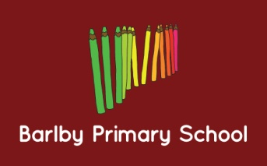
Job Description: Main Scale Teacher – cover role
EYFS and Key stage One
Status of Position: This is a main scale position within the school. The post holder is accountable to the Headteacher.
Main Purpose of the Position: This Job Description is to be performed in accordance with the provision of the School Teachers’ Pay and Conditions Document and within the range of teachers’ duties set out in that document.
Key Responsibilities for this role include:
- To work under the direction of the class teacher and leadership team, following established school policies and procedures
- To adhere to the school’s Teaching and Learning Policy and to strive for outstanding lesson delivery
- To be familiar with the EYFS curriculum and Key Stage One National Curriculum and expectations
- To challenge and support pupils in all aspects of school life
- To provide a stimulating and secure learning environment for pupils
- To follow the school’s policy on Equal Opportunities
- To follow planning procedures
- To follow assessment procedures
- To deliver a broad and enriching curriculum
- To establish good working relationships with pupils, colleagues and all stakeholders
- To maintain high standards of behaviour and to adhere to the school’s Behaviour Policy
- To maintain self-discipline; high expectations of self and to adhere to the school’s guidelines on professional conduct
- To adhere to the school’s Health and Safety Policy
- To adhere to all Safeguarding policies
- To adhere to GDPR regulations
- To carry out further tasks as the discretion of the Headteacher
This job description will be reviewed as deemed necessary by the Headteacher.

