Job Description – Northampton International Academy
Job title: | Curriculum Leader: Humanities
Responsible to: | Senior Leadership Team
Liaising with: | SLT, curriculum leaders, Heads of subjects, faculty teachers, parents/carers, trust central team, relevant support staff
Pay range: | Leadership Spine
Contract terms: | Permanent

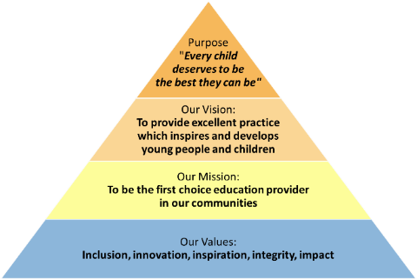

All staff should be committed to the school and East Midlands Academy Trust’s purpose to provide a relentless focus on great leadership and management and outstanding teaching. East Midlands Academy Trust is committed to support the school leaders, teachers and support staff to be the best they can be.

Role of the Curriculum Leader: Humanities

This senior middle leader post has responsibility for:

- ensuring that Humanities faculty is a hub of excellent practice
- leading, managing and developing the faculty team
- ensuring that staff appraisals are fair, challenging and compliant with policy
- implementing and delivering an appropriately broad, balanced, challenging, inspiring and effectively sequenced curriculum
- monitoring and supporting the overall progress and development of all learners, ensuring that teachers are skilled at supporting the needs of all
- modelling outstanding classroom practice in accordance with school policy and set high standards for the teaching team
- undertaking and managing quality assurance processes as directed by SLT
- liaising with EMAT central team when required
- contributing to the wider life of the school, including extra-curricular and enrichment activities
- meeting Key Performance Indicators identified in the Faculty Improvement Plan
- undertaking accurate Self-Evaluation and maintaining a culture of self-reflection and implement effective strategies for improvement
- undertaking the role of Form Tutor and advocating the House system
- contributing to all-through planning for humanities knowledge and skills development in the primary phase
- supporting the academy's behaviour policy and rewards system
- promoting the academy’s House system and character drivers
- adhering to Teacher Standards and Trust policies

Additional duties

Whilst every effort has been made to explain the main duties and responsibilities please note that this is illustrative of the general nature and level of responsibility of the work to be undertaken, commensurate with the grade. It is not a comprehensive list of all tasks that the post holder will carry out.
Employees will be expected to comply with any reasonable request from a manager to undertake work of a similar level that is not specified in this job description.

N.B. The post holder will carry out his/her responsibilities in accordance with the Trust’s equal opportunities policy.

This job description is provided to assist the post holder to know what his/her duties are. It may be amended from time to time without change to the level of responsibility appropriate to the grade of the post.

Health and Safety
So far as is reasonably practical, the post holder must ensure that safe working practices are adopted by employees, and in premises/work areas for which the post holder is responsible, to maintain a safe working environment for employees and learners.

Safeguarding
EMAT is committed to the safeguarding of its young persons and expects all staff, volunteers and adults to work within the parameters of the policies and procedures as agreed by the Board of Trustees to ensure the safety of all young persons within its care.

Equal Opportunities
It is the policy of EMAT to provide equal opportunities for all individuals; to prohibit discrimination in employment on any basis protected by applicable law, including but not limited to race, colour, religious creed, marital status, sex, sexual orientation, ancestry, national origin, age, medical condition or disability. EMAT promotes equal employment opportunities in all aspects of employment through positive employment policies and practice.

If any special requirements are needed to attend an interview, please inform the trust.

Compiled by: HR | Revision Number: vX
Approved by Headteacher: | Revision Date ___/___/___
Approved by HRBP: | Date: ___/___/___
Agreed by Headteacher: | Date: ___/___/___
Agreed and signed by post holder: | Date: ___/___/___

East Midlands Academy Trust is committed to safeguarding and promoting the welfare of children and young people and expects all staff and volunteers to share this commitment.
All appointments are subject to safer recruitment requirements.
This post is subject to an Enhanced DBS Disclosure

Person Specification
 | Essential | Desirable
Education and Qualifications
Qualified teacher status | ✓
Good Honours Degree | ✓
Professional development in preparation for leadership role | ✓
Interest in further professional development (e.g. NPML) |  | ✓
Experience
Proven pedagogical excellence | ✓
Budget management |  | ✓
Quality assurance | ✓
Student data analysis |  | ✓
Knowledge and understanding
Ability to teach up to A level standard | ✓
Understanding of curriculum intent, implementation and impact | ✓
Role of faculty subjects within school accountability measures |  | ✓
Exam board marking |  | ✓
Skills and Attributes
Strategic planning | ✓
Outstanding pedagogical practice | ✓
Prioritisation to support quality assurance procedures |  | ✓
Policy compliance | ✓
Ability to hold staff to account |  | ✓
Personal Qualities
High professional standards | ✓
High expectations of learners and staff | ✓
Collegiate and supportive | ✓
Strategic and horizon-scanning | ✓
Further requirements

