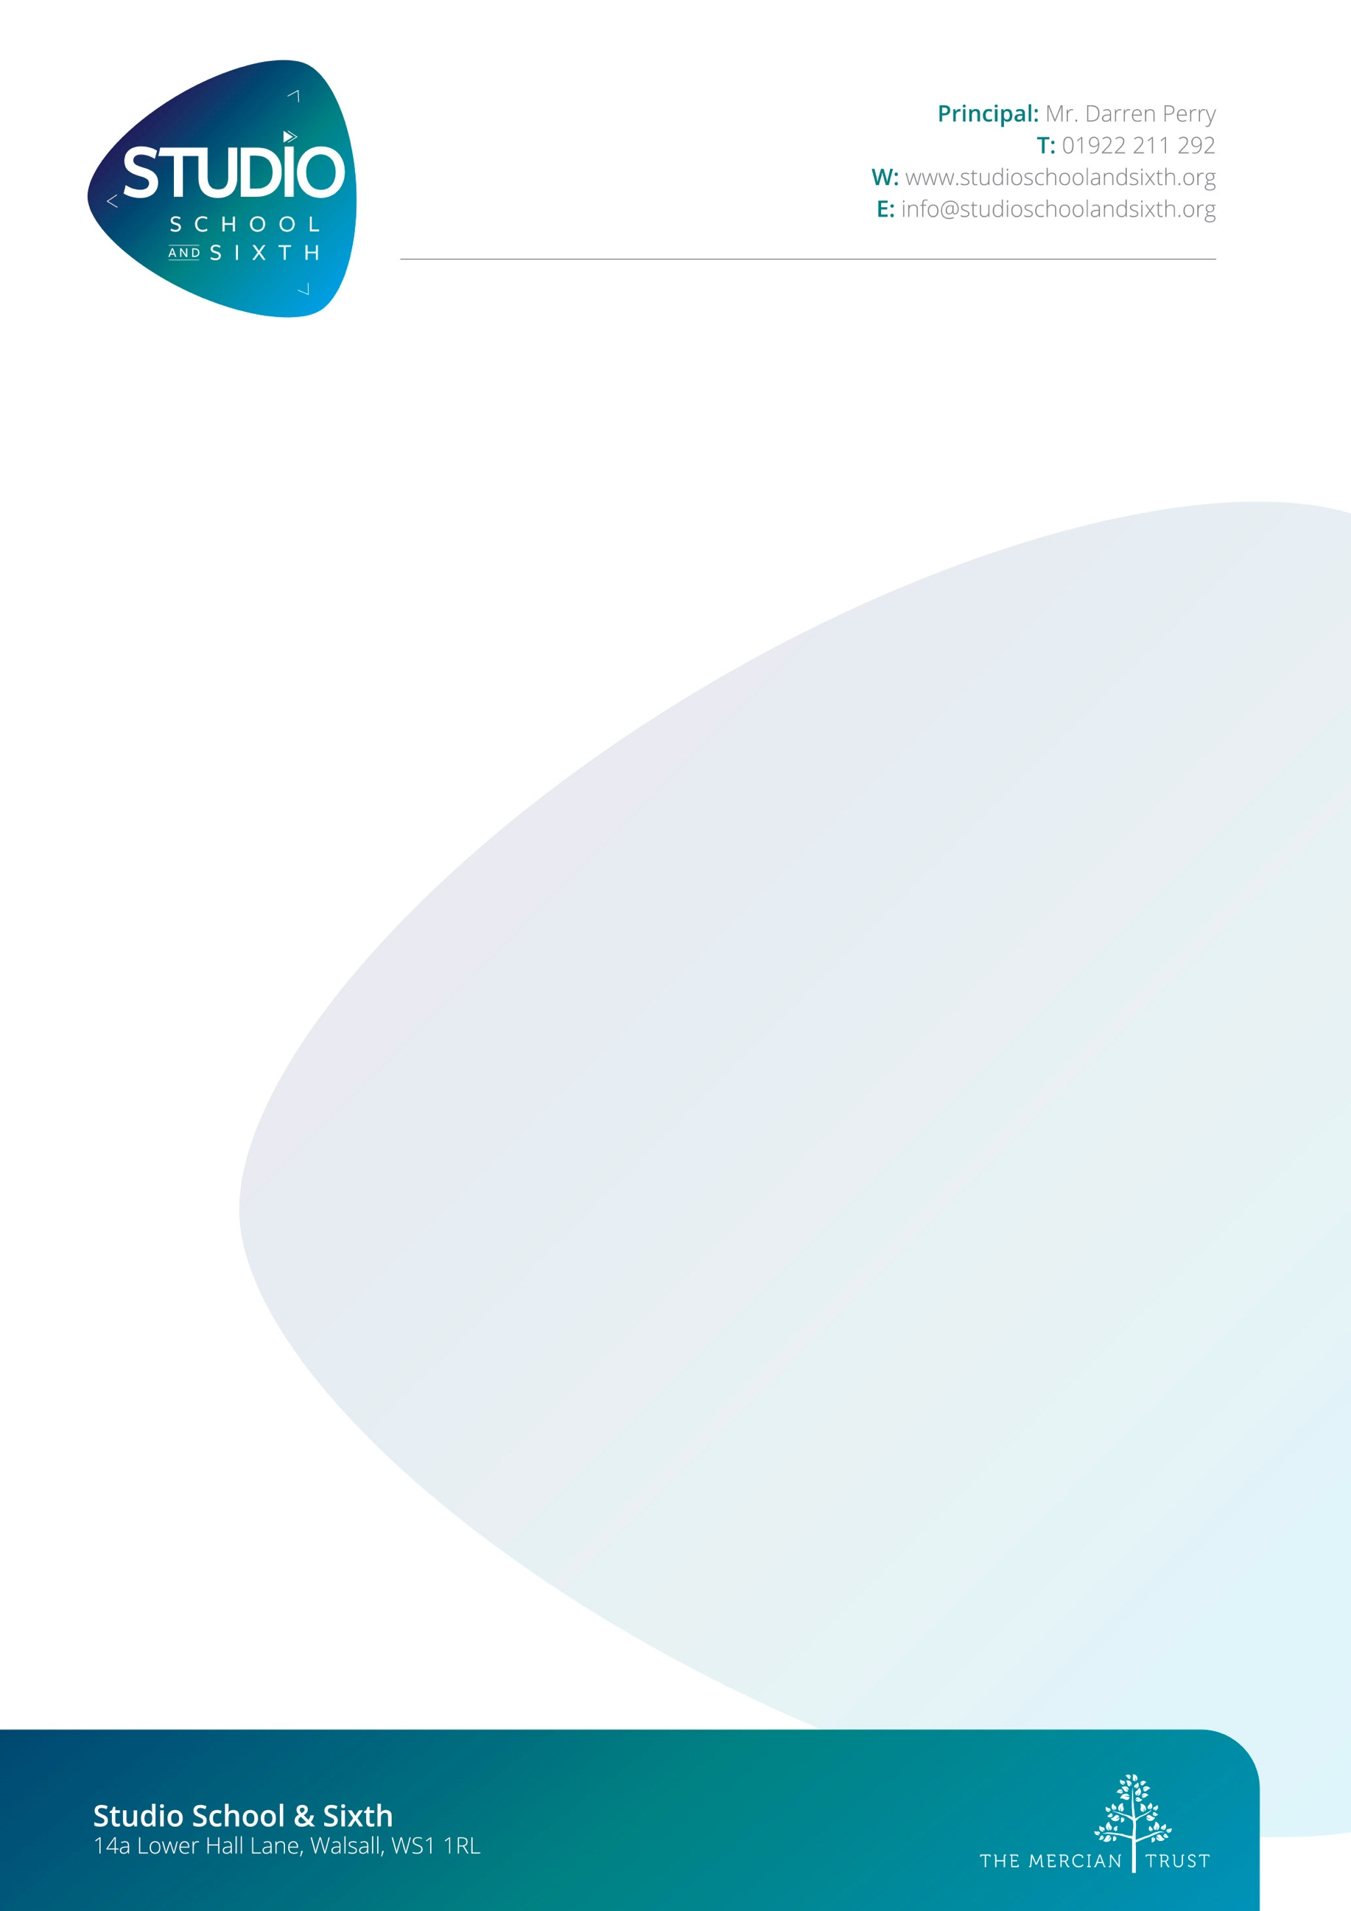
T

Curriculum Lead - Music
Advert
Job Title: | Curriculum Lead - Music
Start Date: | September 2024
Grade/ Salary: | MPR/UPR plus IIA Allowance - £5,500
Contract | Full-Time Permanent
Studio School & Sixth is looking to recruit an enthusiastic, hardworking teacher to lead our music curriculum.
About Studio School & Sixth
Studio School & Sixth is a specialist 14-19 non-selective school and founding member of The Mercian Trust.
Located in the heart of Walsall town centre, our unique small school and sixth form offers an immersive professional experience; supporting academic, vocational and personal excellence for students starting Year 10 or Year 12 who seek a creative curriculum.
Vocational learning is important here, but it would be wrong to think that this means our students focus purely on practical work. There’s plenty of theory to learn and we strike a good balance between the academic and the vocational. Above all, we challenge our students to be the very best they can be in their chosen fields.
Back in the Renaissance, more than 400 years ago, ‘apprentices’ studied under the guidance of ‘masters’ and it’s this model that has influenced the way Studio Schools operate today. Of course, much has changed, and now, thankfully, those ‘masters’ and ‘apprentices’ are just as likely to be women and girls, as they are men and boys.
Studio School & Sixth has almost 300 such ‘apprentices’. It’s one of only a handful of Studio Schools in the country and opened its doors in 2013. Its students go on to universities, conservatoires and high-quality apprenticeships. The school focuses on creative industries, specifically music, performing arts and media.
Join our team
- Do you want to work in a school that champions creative industries?
- Are you looking for a new and exciting opportunity to develop a specialist music curriculum?
- Are you ready to pass on your technical and specialist knowledge/ skills to the next generation of budding musicians?
Whether you have experience of teaching Key Stage 4 and 5 (Level 2 and 3 qualifications, or you are completing your Postgraduate Certificate of Education (or equivalent teaching qualification) in secondary education, we are looking for people like you to join our highly successful team.

If you wish to learn more about the school and this post, please get in touch via: d.perry@studio.merciantrust.org.uk
Applications should be made using the The Mercian Trust’s application form and you are required to provide two referees on your application. CVs will not be accepted.
Studio School & Sixth is committed to safeguarding and promoting the welfare of children and young people/vulnerable adults and expects all staff and volunteers to share this commitment. A copy of the ‘Safeguarding Policy’ is available to view or download by logging onto the School website: https://walsallstudio.school/
This position is subject to an Enhanced Disclosure & Barring Service check (formerly CRB) under the Rehabilitation of Offenders Act 1974. Further details regarding this check are available from the school or by visiting www.crb.gov.uk.

