
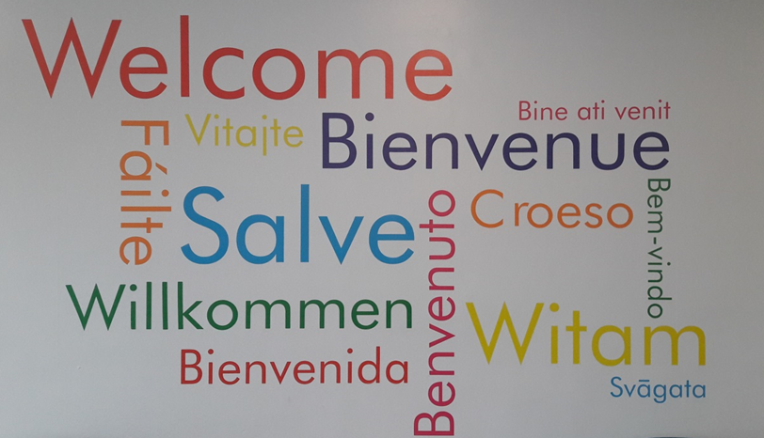
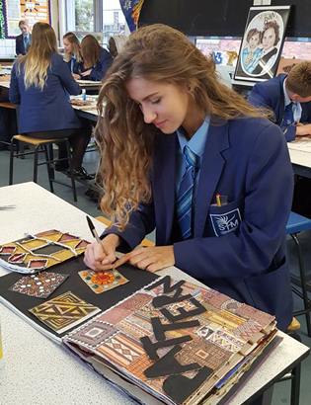
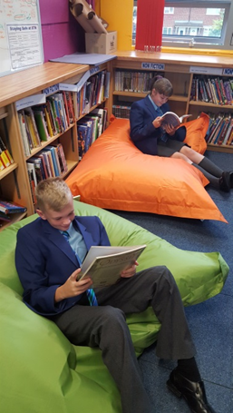
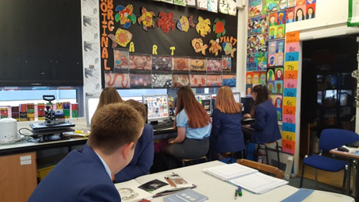


Recruitment Pack for the Position of:
CURRICULUM LEADER FOR LANGUAGES
Welcome to St Thomas More Catholic High School

Thank for taking time to consider the post of Curriculum Leader for English here at St Thomas More Catholic High School. The role is a vitally important one in our school and will impact directly on our continued success and future development.

Our OFSTED inspections of September 2007, April 2012, January 2016, March 2020 and November 2024, together with our pupils’ examination results at Key Stage 4 establish our wider reputation as a school with excellent results and pupil progress. The Diocese of Shrewsbury graded the school outstanding in December 2023

I hope that in finding out more about the school and its secure basis on Gospel Values you will feel motivated to apply for the post of Curriculum Leader for English. I would encourage you to visit the school and meet our exceptional pupils. Please do not hesitate to contact the school if you have specific questions. However do look at our website if you would like more information about our school.

Your application form and covering letter, including referees should be returned by the advertised closing date.

The application form and covering letter can be emailed to:
recruitment@st-thomasmore.cheshire.sch.uk

Kind regards
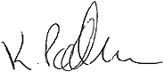

Mrs Katherine Packham
Headteacher




St Thomas More Catholic High School
Keeping Faith in Education

St Thomas More Catholic High School is a high performing, oversubscribed, 11-16 school in the South Cheshire Catholic Multi Academy Trust in the Diocese of Shrewsbury which was once again rated Good by Ofsted in 2016. Our most recent inspection by Shrewsbury Diocese rated us as an Outstanding Catholic school.

We have a well-deserved reputation for academic excellence balanced by outstanding pastoral care and support which allows our pupils to flourish and develop as rounded individuals.

During 2024-25 we continue with our focus on the quality of teaching to support excellent results for pupils, very high expectations of behaviour to create a calm and happy school, a strong good pastoral system to care for pupils and their needs, and a range of enrichment activities to engage and motivate pupils to contribute to their wider education to ensure that St Thomas More Catholic High School provides an outstanding education for all pupils.

Every school in the country with high ambitions for its young people would probably say the same, but we have a distinctive foundation or inspiration for our pursuit of excellence: our Catholic Christian values, based on the Gospel of Jesus Christ, which regards every person as a unique creation of God with an ‘original gift’ to offer the world. Our aim is to help pupils to discover the person they are called to be.

In the day to day life of the school, Gospel and British values are evident in the culture of respect and the strong ‘family’ atmosphere which all our visitors comment on and our staff and pupils value highly. Our values and common purpose has enabled us to create a thriving community who experience a full and balanced education which prepares them to live a fulfilling life and able to grasp all job, career, high education and leisure opportunities which the world offers.

What is special about a Catholic School?

 Form prayers each day |  Links with Global Schools
 Assemblies |  Caring ethos
 Retreats |  Inclusion for all
 Liturgical events |  Wellbeing Days
 Faith in Action |  Curriculum Core RE
 Equality and Respect of all |  Supporting the Church Catechetical Programmes
 Relationship and Sex Education |  Chaplaincy Team

KEY FACTS
LOCATION: Crewe, Cheshire
DENOMINATION: Roman Catholic
DIOCESE: Shrewsbury
AGE RANGE: 11 - 16
NO OF PUPILS: 647
NUMBER OF STAFF: 97
% OF PUPILS ON FREE SCHOOL MEALS: 19.17%

ACADEMIC ACHIEVEMENTS:
2024 GCSE Exam Results:
Progress 8: + 0.26
Attainment 8: 47.9
Achieving Grade 5 and above inc English & Maths: 42%
EBACC (Average Point Score) 4.35
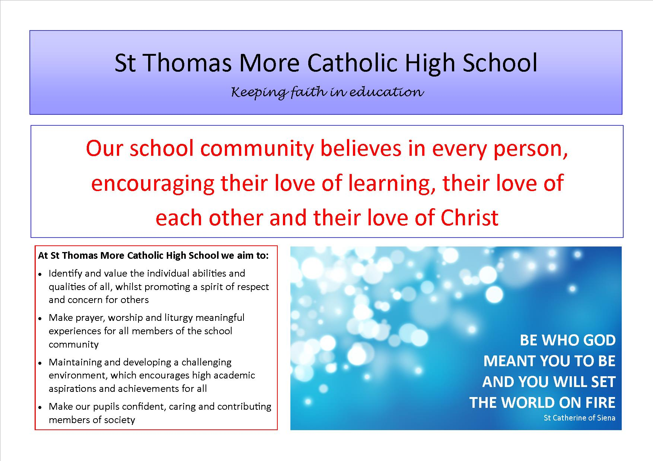

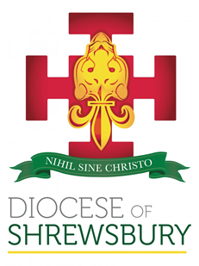
Crewe is an established town in Cheshire with a population of approximately 84,000. Crewe is known for its large railway junction and its history of manufacturing and overhauling locomotives. Crewe was also the home of Rolls-Royce Motors from 1946 until 2002. The Pyms Lane factory now produces Bentley Motor Cars exclusively.

St Thomas More Catholic High School is located within the parish of St Mary’s the Immaculate, Crewe, under the Diocese of Shrewsbury. We work closely with our partner feeder primary schools, St Mary’s Catholic Primary School, Crewe; St Anne’s Catholic Primary School, Nantwich and St Gabriel’s Catholic High School, Alsager. With a PAN of 128 and approximately 650 pupils on roll the school is increasingly oversubscribed.

St Thomas More Catholic High School has an excellent reputation within the Catholic and local community. We are a successful and popular school. Examination results and Levels of Progress are above local and national averages across Key Stage 3 and 4.

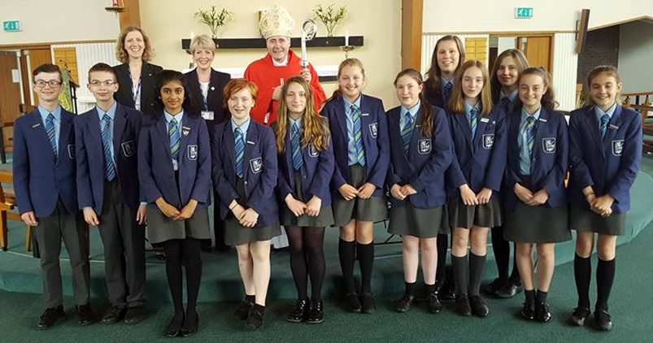

Welcome from the Languages Department
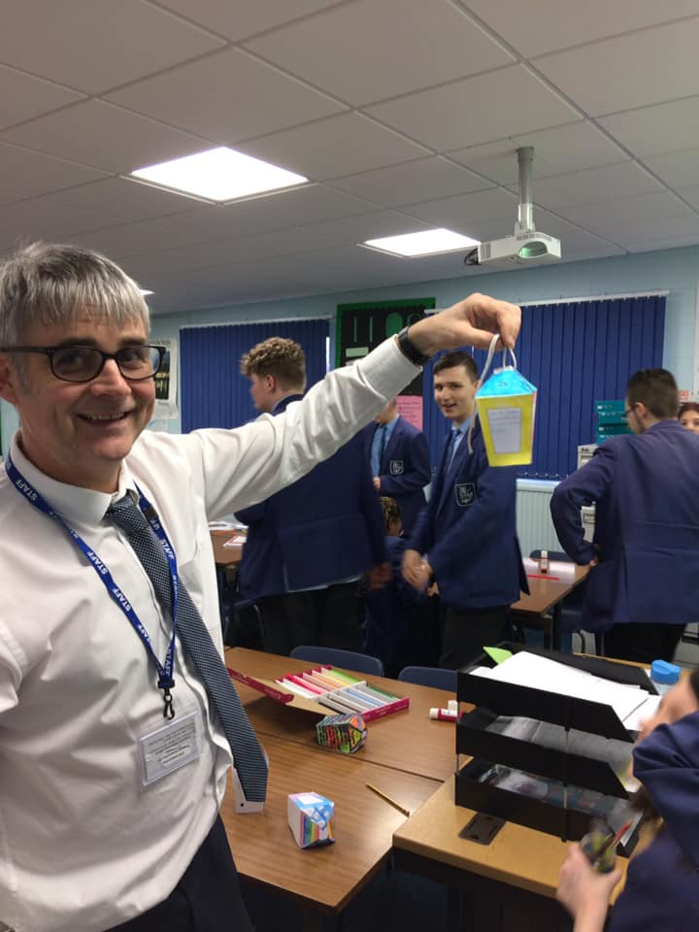
The Languages Department aims to provide pupils with a love for learning languages with a view to having as many students as possible choosing to study two Languages to GCSE Level. All pupils study at least one language to GCSE and we have increasing numbers of pupils studying both French and German. The whole cohort study French in Year 7 and the top two sets also study German. In Year 8, when pupils make their options, pupils either continue with French and the top two sets decide between French, German or both.

The Department is situated in a series of specialist classrooms all with interactive whiteboards and good sound / speakers for listening work. We are well resourced and follow a Conti based curriculum which is newly resourced. Ofsted were really delighted with our curriculum.

Our GCSE begins in Year 10 and we follow the Edexcel specification.

Attainment, progress, behaviour and levels of enjoyment in the department are good. We are a friendly, welcoming team who work well together to provide the best outcomes for all pupils. Quality Assurance within the faculty includes learning walks, book reviews, homework checks, behaviour reviews and formal observations all with an aim to share best practice and continually raise standards. Student voice also forms part of our systems.


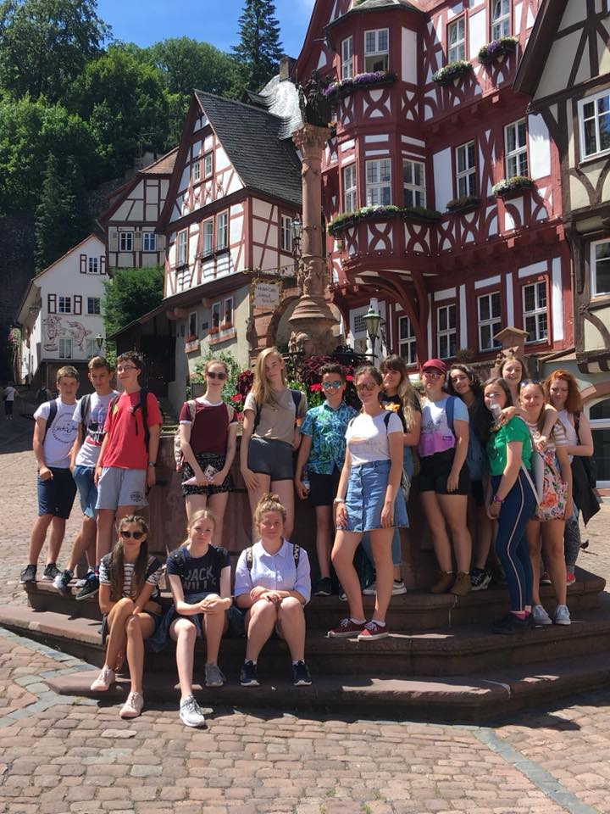

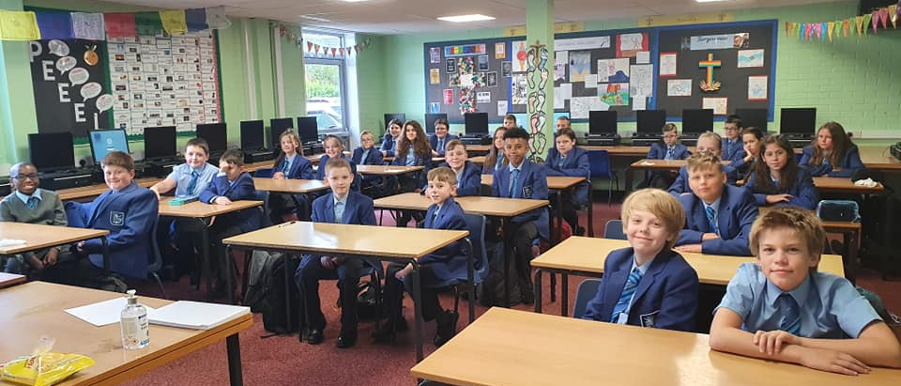

.

Job Description: Curriculum Leader for Languages

Reports to: Assistant Headteacher

This Job Description reflects the national standards which set out the professional knowledge, understanding, skills and attributes necessary to carry out effectively the key tasks of the role of Languages Curriculum Leader.

This school is a Catholic school. Each and every member of staff must accept and acknowledge their role in contributing to, and helping to generate, the overall ethos of the school as outlined in the Mission Statement.

Strategic direction and development of the subject
Within the context of the school's aims and policies, the Languages Curriculum Leader develops and implements subject policies, plans, targets and practices by:

- developing and implementing policies and practices for the Languages Department which reflect the school's commitment to high achievement, effective teaching and learning;
- create a climate which enables other staff to develop and maintain positive attitudes towards the Languages Department and confidence in teaching it;
- establish a clear, shared understanding of the importance and role of Languages in contributing to pupils' spiritual, moral, cultural, and social development, and in preparing pupils for the opportunities, responsibilities and experiences of adult life;
- use data effectively to identify pupils who are underachieving in Languages and, where necessary, create and implement effective plans of action to support those pupils;
- analyse and interpret the relevant national, local and school data, plus research and inspection evidence, to inform policies, practices, expectations, targets and teaching methods;
- establish, with the involvement of relevant staff, short, medium and long term plans for the development and resourcing of Languages which:
- contribute to whole-school aims, policies and practices, including those in relation to behaviour, discipline, bullying and racial harassment;
- are based on a range of comparative information and evidence, including in relation to the attainment of pupils;
- identify realistic and challenging targets for improvement in Languages;
- are understood by all those involved in putting the plans into practice;
- are clear about action to be taken, timescales and criteria for success;
- monitor the progress made in achieving Languages plans and targets, evaluate the effects on teaching and learning, and use this analysis to guide further improvement.

Teaching and Learning
The Curriculum Leader secures and sustains effective teaching of Languages, evaluates the quality of teaching and standards of pupils' achievements and sets targets for improvement by:

- ensuring curriculum coverage, continuity and progression in Languages for all pupils, including those of high ability and those with special educational or linguistic needs;
- ensure that teachers are clear about the teaching objectives in lessons, understand the sequence of teaching and learning in Languages, and communicate such information to pupils;
- provide guidance on the choice of appropriate teaching and learning methods to meet the needs of Languages and of different pupils;
- ensure effective development of pupils' literacy, numeracy and information technology skills through Languages
- establish and implement clear policies and practices for assessing, recording and reporting on pupil achievement, and for using this information to recognise achievement and to assist pupils in setting targets for further improvement;
- ensure that information about pupils' achievements in previous classes and schools is used effectively to secure good progress in Languages;
- set expectations and targets for staff and pupils in relation to standards of pupil achievement, and evaluate progress and achievement in Languages by all pupils, including those with special educational and linguistic needs;
- evaluate the teaching of Languages in the school, use this analysis to identify effective practice and areas for improvement, and take action to improve further the quality of teaching;
- ensure effective development of pupils' individual and collaborative study skills necessary for them to become increasingly independent in their work and to complete tasks independently when out of school;
- ensure that teachers of Languages know how to recognise and deal with discrimination of any kind;
- establish a partnership with parents to involve them in their child's learning of Languages, as well as providing information about curriculum, attainment, progress and targets;
- develop effective links with the local community, including business and industry, in order to extend the subject curriculum, enhance teaching and to develop pupils' wider understanding.

Leading and Managing Staff
The Curriculum Leader provides to all those with involvement in the teaching or support of Languages, the support, challenge, information and development necessary to sustain motivation and secure improvement in teaching by:

- helping staff to achieve constructive working relationships with pupils;
- establish clear expectations and constructive working relationships among staff involved with Languages, including through team working and mutual support; developing responsibilities and delegating tasks, as appropriate;
- sustain their own motivation and, where possible, that of other staff involved in Languages;
- appraise staff as required by the school policy and use the process to develop the personal and professional effectiveness of the appraisee(s);
- audit training needs of Languages staff;

- lead professional development of Languages staff through example and support, and co- ordinate the provision of high quality professional development by methods such as coaching, drawing on other sources of expertise as necessary, for example, higher education, LAs, subject associations;
- ensure that trainee and newly qualified teachers are appropriately trained, monitored, supported and assessed in relation to standards for the award of Qualified Teacher Status, the Career Entry Profiles and standards for induction;
- enable teachers to achieve expertise in their Languages teaching;
- work with the SENCO and any other staff with special educational needs expertise, to ensure that individual education plans are used to set Language-specific targets and match work well to pupils' needs;
- ensure that the Headteacher, senior managers and governors are well informed about Languages policies, plans and priorities, the success in meeting objectives and targets, and Languages-related professional development plans.

Person Specification : Curriculum Leader for Languages

Catholic Ethos:
► Willingness to support the ethos of a Catholic School.
► DESIRABLE: Practising Catholic.
► DESIRABLE: Experience of working in a Catholic school.

Qualifications:
► A suitably qualified graduate.
► An up-to-date knowledge of the KS3 and KS4 curriculum.
► Evidence of relevant and ongoing CPD.
► Any further relevant qualifications.

Skills:
► Strong teaching ability to GCSE level.
► Thorough knowledge and understanding of current developments in teaching, learning, school culture and the curriculum.
► Enthusiasm and vision for Languages.
► Ability to use data to identify strengths and address underachievement.
► Good analytical and strategic thinking skills.
► The ability to lead and implement new initiatives.
► Able to form good working relationships with students, parents and colleagues.
► Adaptability.
► Able to support colleagues.
► Excellent organisation, communication and decision making skills.
► Excellent time and classroom management skills.
► ICT competence.

Interpersonal Skills:
► Be able to build significant relationships with all in the school community and with others outside.
► Be open, approachable, friendly and sensitive.
► Be tactful and diplomatic when necessary and observe confidentiality when appropriate.
► Cheerfulness and resilience.
► Able to promote the image of the school through an articulate and confident approach.
► To be systematic, efficient, meet deadlines and priorities.

Attitude Values and Personal Qualities:
► A genuine love of and enthusiasm for Languages
► An interest in extra-curricular activities.
► Willing to play an active role and lead by example.
► A passion to succeed.
► The desire for further career development.
► An eagerness and capacity to want to contribute towards the School’s Senior Leadership Team.
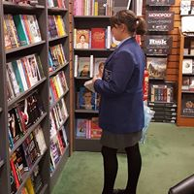
► A willingness to bring new ideas to the department.
► Hardworking.

ENHANCED DISCLOSURE

Thank you for interest in St Thomas More Catholic High School. The post you are applying for involves working with young people. It is therefore exempt from the Rehabilitation of Offenders Act and any offer of employment will be subject to an Enhanced Disclosure.

As this post is exempt from the Rehabilitation of Offenders Act, you must declare any convictions, including pending convictions, cautions, reprimands and warning which would otherwise be regarded as “spent” under this Act. Further details will be sought prior to appointment.

An Enhanced Disclosure is carried out by the Disclosure and Barring Service and will check criminal records for information on any convictions, cautions, reprimands and warnings held on Police National Computer and on local Police records.

All information on criminal records provided both by you and within the Enhanced Disclosure will be used, stored and disposed of in confidence and in line with the Disclosure and Barring Service Code of Practice of Disclosure Information.

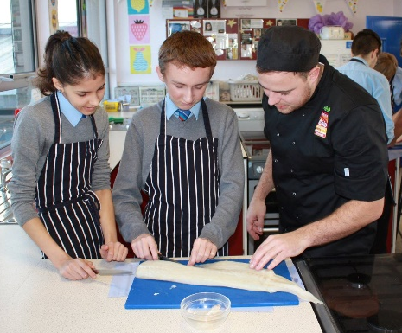
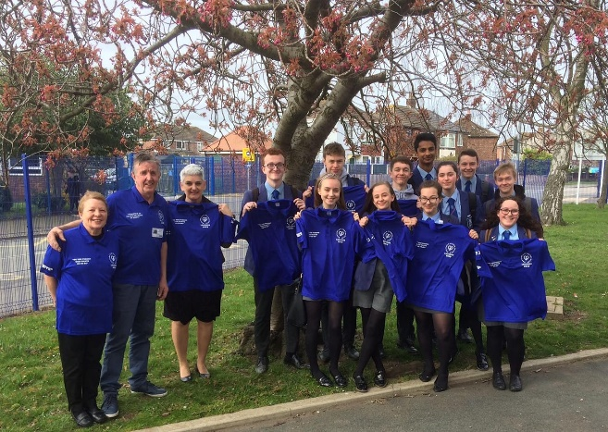
If your application is successful, you will receive further information on how to complete the Enhanced Disclosure.



