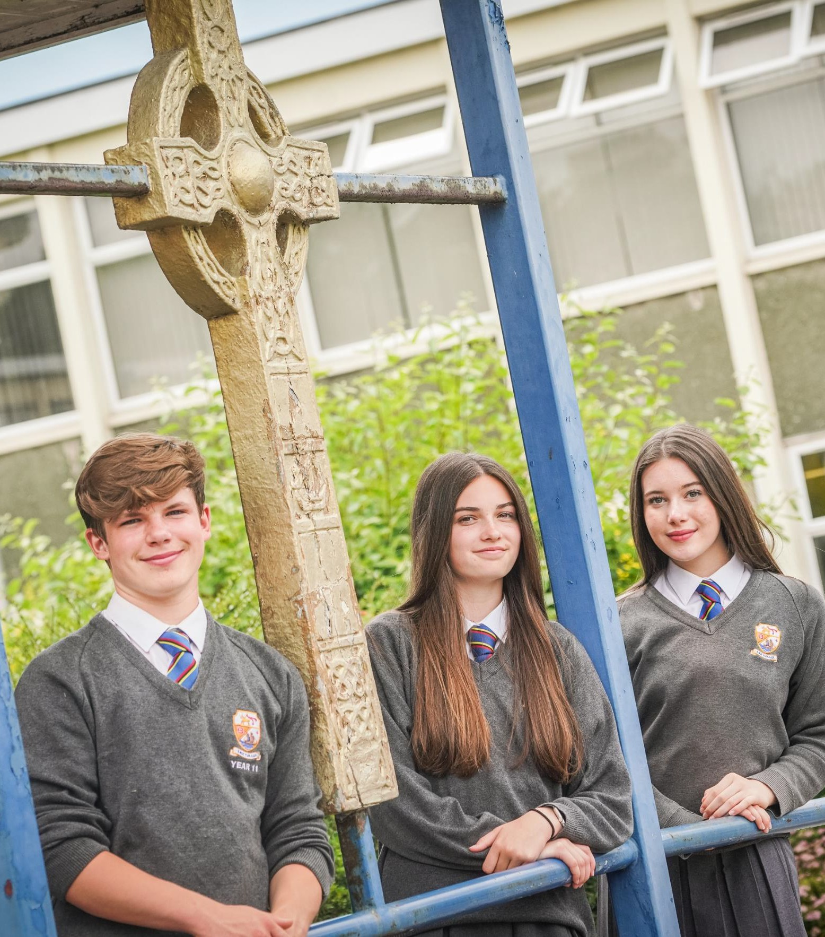

CLOSING DATE FOR APPLICATIONS: Monday 23rd February @ 9am INTERVIEW DATE: Tuesday 3rd March
Curriculum Leader of Religious Education

St Bede’s Catholic High School
St Bede’s Catholic High School, St Anne’s Road, Ormskirk, L394TA
/ƒ ©

“We are striving to provide a transformative Catholic Education ensuring that our pupils are empowered to serve the common good, by living the values of Faith, Hope and Love.”
1


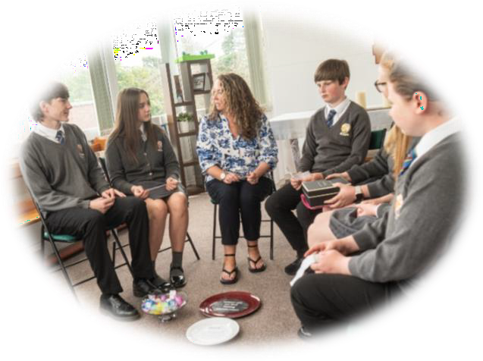
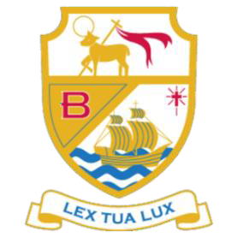
Contents Page

Page Number | Title
3 - 4 | Welcome – Mr D Morgan, Headteacher
5 | School Ethos
6 - 9 | Job Description
10 - 11 | Person Specification
12 | Application Process

Welcome from our Headteacher

January 2026

Dear Colleague,
In the first instance, may I thank you for showing an interest in joining St Bede’s Catholic High School as Curriculum Leader of Religious Education. We are seeking an outstanding and committed practitioner who is passionate about Catholic education, child-centred in their approach, and eager to play a leading role in nurturing the faith, formation and academic excellence of our pupils.
This is a school with a genuine ambition to fulfil its vision of becoming an institution that provides:
“…a Transformative Catholic Education ensuring that our pupils are empowered to serve the common good by living the values of Faith, Hope and Love”.
We are a part of the West Lancashire schools’ network, Catholic Schools Direct, Endeavour Learning School Alliance and of course, the Archdiocese of Liverpool. All of these networks and communities allow us to be a forward thinking and outward looking school which is at the forefront of educational development, locally and nationally.
Before committing to completing an application, I would encourage you to visit our school to undertake a tour of the site. I am convinced that upon arrival you will receive our customary welcome and that you will be captivated by both our distinctive Catholic ethos and learning culture. Please contact our Assistant School Business Manager, Miss Julie Taylor recruitment@sbchs.co.uk , to arrange your visit.
The Governors seek to appoint an excellent and inspirational classroom practitioner to play a leading role in the life of the school. This post offers an exciting opportunity for a committed middle leader to shape and contribute to the strategic direction of St Bede’s, supporting our mission to deliver high-quality Catholic education rooted in faith, service and academic excellence.
Religious Education is a highly valued and thriving subject at St Bede’s, led by a supportive and committed team. Our fully embedded RED curriculum, exceptional GCSE outcomes and rich programme of enrichment and prayer and liturgy ensure that Religious Education plays a central role in the Catholic life of the school. This was recognised in our most recent CSI inspection, where St Bede’s was judged Outstanding in all areas. The successful applicant will be an outstanding teacher of Religious Education with a proven track record of securing excellent outcomes, and a deep commitment to supporting the faith formation and spiritual development of young people within a Catholic community.
St Bede’s Catholic High School is a thriving, oversubscribed community rooted in a proud tradition of Catholic education and service to Ormskirk and the surrounding areas. Guided by our mission, we are committed to nurturing young people to grow academically, spiritually and personally, so that they may flourish as courageous and compassionate individuals.
We remain steadfast in our commitment to the education of the whole child, combining strong academic outcomes with exceptional pastoral care and spiritual formation. Our pupils are known for their resilience, kindness and enthusiasm for contributing fully to school life. We value a close partnership between home and school, working together to nurture the faith, character, and the academic growth of every pupil.
If appointed, you will work with a committed and highly skilled Governing Body, which consistently supports the school and drives its ongoing improvement. Our dedicated staff, both teaching and support, are passionate about enhancing the life chances of our pupils and work tirelessly to ensure every student can flourish. While our school building was built in the 1957, significant recent upgrades have created a bright, safe, and modern environment that supports high quality teaching and learning and a vast offer of enrichment activities.
If you are successful in your application, I am confident that you will be inspired by the opportunity to lead Religious Education at the heart of our Catholic school, you will play a central role in leading Religious Education at the heart of our Catholic school, nurturing pupils’ relationship with God, their moral development, and their love of learning. I hope that you will give careful consideration to applying for this post and joining a school with a proud history, a thriving Catholic community, and a bright future.

Should you choose to apply I would like to wish you every success with your application.

Yours sincerely,



Mr D Morgan

School Ethos

At St Bede’s Catholic High School, our vision, mission and virtues are at the heart of everything we do. Rooted in the Gospel message and inspired by our call to ‘Bear Fruit’, we strive to provide a transformative Catholic education that nurtures the whole person. Guided by the virtues of Courage, Wisdom, Respect and Humility, we seek to empower our pupils to flourish as individuals and to serve the Common Good within our school, our Church and the wider community.

School Vision

“To provide a transformative Catholic education ensuring that our pupils are empowered to serve the
common good by living the values of Love, Faith and Hope”

Mission

“I am the vine, you are the branches. Whoever remains in me, with me in them, bears fruit in plenty”
John 15:5
School Virtues
Courage, Wisdom, Respect and Humility

At St Bede's we believe that we are part of God's creative process,
providing the opportunity for each individual to flourish, in order to serve the Common Good
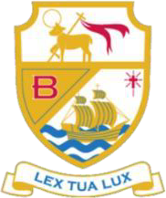



Job Description

Curriculum Leader of Religious Education Post

St Bede’s Catholic High School, Ormskirk
Job description

Employment details

Job title: | Curriculum Leader of Religious Education
Reports to (job title): | SLT Line Manager
Responsible for: | Teaching staff and other relevant personnel within the department.
Term: | 1.0 FTE
Liaising with: | Headteacher, SLT Line Manager, School Chaplain, Parish Priest, other Curriculum Leaders, Pastoral Teams and relevant staff with cross-school responsibilities, relevant non-teaching support staff, LA staff, and parents.
Level and scale point: | MPR/UPR Plus TLR 1.1

Purpose: | - To raise standards of student attainment and achievement within Religious Education and to monitor and support student  progress.  - To be accountable for student progress and development within the subject area.  - To develop and enhance the teaching practice of others  - To ensure the provision of an appropriately broad, balanced, relevant and differentiated curriculum for students studying in the  department, in accordance with the aims of the school and the policies determined by the Governing Body and Headteacher of the school  - To be accountable for leading, managing and developing the subject/curriculum area  - To manage effectively and deploy teaching/support staff,  - financial and physical resources within the department to support the designated curriculum portfolio  - To take a lead role in the promotion of the catholic ethos, mission and vision of the school  - To provide a lead in the Catholic life of the school together with the SLT member appointed to lead Catholic life of the school  - To support the Chaplaincy provision to enhance the Catholic life of the school  - To organise the liturgy and worship in conjunction with the lay chaplain and SLT lead for the Catholic life in school  - To provide strategic leadership for the Religious Education strand of the Catholic Schools Inspectorate, working collaboratively with the Headteacher, SLT member and School Chaplain to ensure excellence in Catholic life, curriculum provision, and inspection readiness

- To develop and ensure implementation of a whole-school policy for RSHE in line with the aims and policy for RSHE in line with the aims and policies of the school
- To use Diocesan, national, local and school management data effectively, and to monitor standards of achievement across the school in Religious Education
- To be involved in the liturgical experience and spiritual life of the school, both curricular and extra in conjunction with SLT and school chaplain
- To be involved in the extra-curricular life of the school, both Religious Education and other enrichment events and activities, eg: Faith in Action, Sacramental programmes and retreat days
- To plan and deliver Celebration of the Word assemblies to provide all pupils with the opportunity to
- To plan, arrange school visitors and visits to enhance the Religious Education curriculum and Catholic life of the school
MAIN DUTIES
Operational/Strategic Planning | - To lead the development of appropriate curriculum, resources, schemes of work, assessment and teaching and learning strategies in the department  - The day-to-day management, control and operation of course  provision within the department, including effective deployment  of staff and resources  - To monitor and follow up student progress.  - To implement School Policies and Procedures, e.g. Equal  Opportunities, Health and Safety  - To work with colleagues to formulate aims, objectives and strategic plans for the department via the departmental development plan with reference to the needs of students and to the aims, objectives and strategic plans of the school  - To establish the process of the setting of targets within the department and to work towards their achievement  - To develop the effectiveness of teaching and learning within the Department  - To contribute to the school procedures for lesson observation  - To implement school quality procedures and to ensure adherence to those within the department  - To monitor and evaluate the department in line with agreed quality assurance procedures.  - School procedures including evaluation against quality standards and performance criteria
Management Information: | - To ensure the maintenance of accurate and up-to-date information concerning the department on the management information system (SIMS)  - To make use of analysis and evaluate performance data provided  - To identify and take appropriate action on issues arising from data, systems and reports; setting deadlines where necessary and reviewing progress on the action taken  - To produce reports on examination performance, including the analysis of data and relevant intervention strategies.  - To provide the SLT and Governing Body with relevant information relating to the department’s performance and development

Communication: | - To ensure that all members of the department are familiar with its aims and objectives  - To ensure effective communication/consultation as appropriate with the parents of students  - To liaise with partner schools, local parishes, higher education, examination boards, awarding bodies and other relevant external bodies  - To represent the department’s views and interests at Curriculum Leader meetings  - To lead the development of effective subject links with partner schools and the community, attendance where necessary at liaison events in partner schools and the effective promotion of subjects at Open Days/Evenings and other events  - To promote the development of effective subject links with external agencies
Management of Resources: | - To manage the available resources of space, staff, money and  equipment efficiently within the limits, guidelines and procedures laid down; including deploying the department’s budget, acting as a cost centre holder, requisitioning, organising and maintaining equipment and stock, and keeping appropriate records  - To foster and implement application of ICT in Religious Education including the development of materials for learning  - To ensure that Health and Safety policies and practices, including Risk Assessments, throughout the department are in line with national requirements and are updated where necessary, therefore liaising with the school’s Health and Safety Manager
Curriculum: | - To liaise with the Deputy Head to ensure the delivery of an appropriate, comprehensive, high quality and cost-effective curriculum  - To keep up to date with national developments in the subject area and teaching practice and methodology  - To actively monitor and respond to curriculum development and initiatives at national, regional and local levels  - To liaise with the Deputy Head to maintain accreditation with the relevant examination and validating bodies  - To ensure that the development of Religious Education is in line with diocesan guidelines and national developments  - To follow the requirements of the exam board, and meet with requirements of the Religious Education Directory  - To ensure curriculum coverage, continuity and progression in Religious Education throughout the school  - To ensure 10% curriculum is Religious Education for KS3/4  - To be aware of the need to take responsibility for your own professional development, and ensure attendance at Diocesan inset provision
Staffing: | - To undertake Appraisal Reviews and to act as reviewer for a group of staff within the department  - To work with the Assistant Headteacher to ensure that staff development needs are identified and that appropriate  programmes are designed to meet such needs

- To make appropriate arrangements for classes when staff are absent, liaising with the relevant staff to secure appropriate cover within the department
- To participate in the interview process for teaching posts when
required and to ensure effective induction of new staff in line with school procedures
- To promote teamwork and to motivate staff to ensure effective working relations
- To participate in the school’s ITT programme as appropriate
- To be responsible for the day-to-day management of staff within the designated department and act as a positive role model
Quality Assurance: | - To ensure the effective operation of quality control systems  - To undertake regular work scrutiny with members of the department to ensure that the Marking Policy is being used correctly
Pastoral System: | - To monitor and support the overall progress and development of students within the department  - To act as a Form Tutor and to carry out the duties associated with that role.  - To plan and deliver RSHE lessons as part of the Personal Development curriculum.  - To ensure the Behaviour Management system is implemented in the department so that effective learning can take place
Teaching: | - To undertake an appropriate programme of teaching in accordance with the duties of a standard scale teacher
Other Specific Duties:
To continue personal, professional development.
To engage actively in the appraisal process.
To undertake any other duty as specified by STPCD not mentioned in the above.
Whilst every effort has been made to explain the main duties and responsibilities of the post, each individual task undertaken may not be identified. Employees will be expected to comply with any reasonable request from a manager to undertake work of a similar level that is not specified in this job description.
Employees are expected to be courteous to colleagues and provide a welcoming environment to visitors and telephone callers.

The school will endeavour to make any necessary reasonable adjustments to the job and the working environment to enable access to employment opportunities for disabled job applicants or continued employment for any employee who develops a disabling condition.
This job description is current at the date shown, but, in consultation with you, may be changed by the Headteacher to reflect or anticipate changes in the job commensurate with the grade and job title.

Person Specification

 | ESSENTIAL | DESIRABLE | EVIDENCE  A – Application I –Interview  R- Reference
Qualifications
- Qualified teacher status | ✓ |  | A
- Degree | ✓ |  | A
- Catholic Certificate in Religious Studies |  | ✓ | A
Faith Commitment
- Must be a practising Catholic who can inspire and live the teachings of the Faith | ✓ |  | A/I/R
- The passion to share Faith with others in teaching and leading prayer and worship. | ✓ |  | A/I/R
- Evidence of participation in faith life of the community | ✓ |  | A/I/R
Professional Experience
- Qualified Teacher who has undertaken appropriate training and has the necessary knowledge to undertake the duties of the post | ✓ |  | A
- The ability to devise and teach appropriate courses throughout the school | ✓ |  | A /I
- The ability to develop strategies for supporting pupils’ individual  needs in and beyond the classroom | ✓ |  | A /I
- A commitment to pastoral care as a positive support to learning | ✓ |  | A /I
- The ability to establish successful relationships at all levels and can work as a member of a team | ✓ |  | A, I/R
- Excellent classroom practitioner | ✓ |  | I/R
- Management experience |  | ✓ | A/I/R
- Experience of teaching RE in a Catholic school | ✓ |  | A/I
- A sound knowledge of RE programmes of study | ✓ |  | A/I
- A keen interest in the ongoing development in Religious Education | ✓ |  | A/I
- Ability to assess the strengths and weaknesses of RE programmes  of study |  | ✓ | A/I
- Coordination and delivery of PHSE, RSHE and Citizenship |  | ✓ | A/I
Professional Development
- Has demonstrated a commitment to own development | ✓ |  | A/I/R
- Has the potential for further development | ✓ |  | A/I/R
- Evidence of potential to lead and manage an area of the RE curriculum and staff | ✓ |  | A/I
- Recent in-service training in leadership and management |  | ✓ | A/I
- Evidence of leading/managing an initiative | ✓ |  | A/I
- Ability to demonstrate an impact of CPD across the RE department |  | ✓ | A/I
Strategic Leadership
- Ability to share a vision of our Catholic Secondary Education | ✓ |  | A/I
- Successful evidence of motivating staff | ✓ |  | A/I
- Evidence of leading a development within RE department and the successful outcome | ✓ |  | A/I
- Ability to demonstrate analysis of data and ability to articulate how to monitor and evaluate RE curriculum and development plans | ✓ |  | A/I

- Evidence of managing curriculum changes | ✓ |  | A/I
- Demonstrate understanding of requirements of Section 48 | ✓ |  | A/I
- Demonstrate knowledge of Safeguarding, Health and Safety and GDPR |  | ✓ | A/I
Teaching and Learning
- Proven track record of successful teaching and learning leading to positive improvement | ✓ |  | A/I
- A secure understanding of the requirement of the Curriculum Directory for Religious Education | ✓ |  | A/I
- Knowledge or experience of a range of successful teaching and learning strategies to meet the need of students | ✓ |  | A/I
- A secure understanding of assessment strategies and the use of assessment to inform next stage learning in all key stages | ✓ |  | A/I
- Experience of effective monitoring and evaluation of teaching and learning and feedback |  | ✓ | A/I
- Experience of characteristics of effective learning environments and key elements of successful behaviour management | ✓ |  | A/I
Leading and Managing Staff
- Evidence of leading events in RE department | ✓ |  | A/I/R
- Demonstrate understanding of the purpose of performance management and professional development | ✓ |  | A/I/R
- Understanding of finance and resource management |  | ✓ | A/I/R
Accountability
- Ability to communicate effectively, orally and in writing to a range of audiences | ✓ |  | A/I
- Evidence of use of data for self-evaluation and improvement strategies | ✓ |  | A/I
- Demonstrate an awareness of managing underperformance | ✓ |  | A/I
- Understanding of the criteria of evaluation of Catholic school | ✓ |  | A/I
- Lead sessions to develop knowledge of staff |  | ✓ | A/I
Skills, Qualities and Abilities
- Strong commitment to the mission of a Catholic school | ✓ |  | A/I
- Commitment to their own spiritual formation and that of pupils and staff | ✓ |  | A/I
- High expectation of pupils’ learning and attainment | ✓ |  | A/I
- Strong commitment to school improvement and raising achievement for all | ✓ |  | A/I
- Ability to build and maintain good relationships | ✓ |  | A/I
- Ability to remain enthusiastic when working under pressure | ✓ |  | A/I
Other
- An understanding of and an ability to contribute to the daily mission of the school | ✓ |  | A/I
- The capacity to contribute to the wider life of the school | ✓ |  | A/I
- Willingness to undertake First Aid Training | ✓ |  | I

Application Process

Application
If you wish to apply, please email your completed CES Application form to Miss J Taylor, Assistant School Business Manager, at Recruitment@sbchs.co.uk, or alternatively post your completed forms and address to Miss J Taylor, St Bede’s Catholic High school, St Annes Road, Ormskirk, L394TA. Please note that only Catholic Education Service Leadership application forms will be accepted and that you should not enclose a Curriculum Vitae.

School visits
Prospective candidates are encouraged to visit the school to see for themselves the high standards that we expect of both pupils and staff. If this is what you wish to do, please contact Miss J Taylor, Assistant School Business Manager, at Recruitment@sbchs.co.uk or Call 01695 570335

Closing date
Please ensure that your completed application form arrives by Monday 23rd February @9am

Shortlisting

Shortlisted candidates will be informed by telephone.

Selection process & Interview dates
Interview will be week commencing 2nd March - proposed date Tuesday 3rd March

This school is committed to safeguarding and promoting the welfare of children and young people and expects all staff and volunteers to share this commitment. Applicants will be required to undertake an Enhanced DBS check

“I am the vine, you are the branches. Whoever remains in me, with me in them, bears fruit in plenty”

John 15:5

