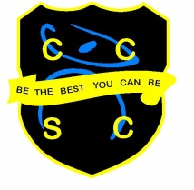
D&T Technician

Chesterton Community Sports College is an exciting school to work in with a dynamic, enthusiastic team. We are the lead school of the Collective Vision Trust and have an excellent reputation in the area.

We are an oversubscribed school with a record of excellent progress and results. We have a warm and friendly learning environment with a hard-working ethos and both staff and pupils strive, ‘To be the best they can be.’

We are looking for a D&T Technician to join our Technology department team at Chesterton Community Sports College.

Main Roles and Responsibilities
- Working under the guidance of the class teacher to support practical lessons
- Health and safety checks throughout the technology classrooms and workshop
- Monitoring of equipment and stock
- Ensure the department is kept clean and tidy

Essential Skills
- Good knowledge of wood and metal work
- Able to manage own time
- Good basic understanding of practical tasks
- Able to drive

Desirable Skills
- Welding
- Metal lathe work

The post will be advertised on our website http://www.ccsc.staffs.sch.uk
with the closing date Wednesday 8th June and interview date on Tuesday 21st June.

You are welcome to come and visit, prior to interview, to see our wonderful school.

This position is subject to an Enhanced Disclosure check under the Rehabilitation of Offenders Act 1974. Further details regarding this check are available from the school or by visiting www.dbs.gov.uk

This school is committed to safeguarding and promoting the welfare of children and young people/vulnerable adults and expect all staff and volunteers to share this commitment.

