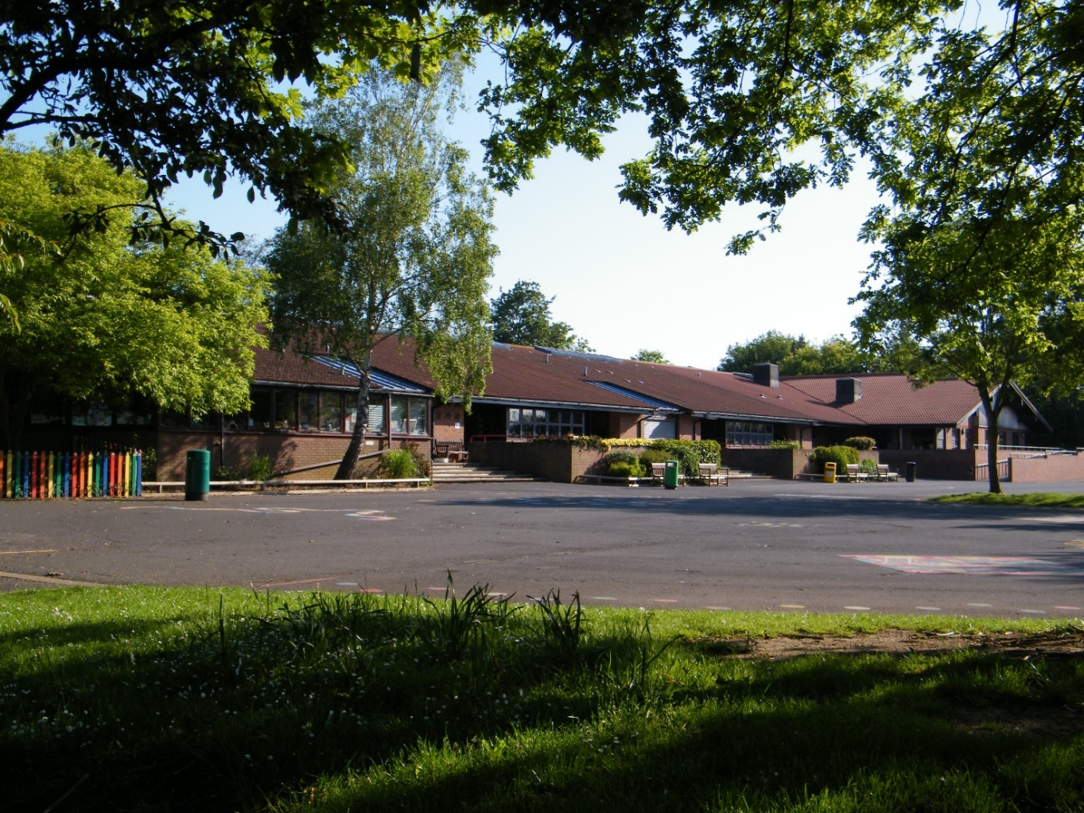

Deputy/Assistant Headteacher
Recruitment Pack
September 2021

About Preston Primary Academy Trust

Preston Primary Academy Trust is located in Yeovil, Somerset and currently has nine schools:

- Preston Church of England Primary School
- Kingfisher Primary School
- Manor Court Community Primary School
- Countess Gytha Primary School
- North Cadbury Church of England Primary School
- Huish Episcopi Primary School
- Hambridge Primary School
- Middlezoy Primary School
- Othery Village School

We are committed to providing an excellent education for all children. As a trust we work collaboratively with many schools in the Somerset and Dorset area to support school improvement.

Outstanding leadership, excellent continuing professional development and high-quality learning environments are at the heart of everything we do. With a strong focus on developing each school's unique identity, we aim to serve the needs of the local community and provide the very best education for all children in the trust.

Expertise will be shared across the Trust ensuring that all schools have access to outstanding practice.
Vision and Values
At Preston Primary Academy Trust Staff and Governors will provide the highest academic standards in a safe and caring environment. We will develop a love of learning to last our children throughout their lives. Our exciting curriculum and extra-curricular activities will broaden our children's horizons, giving them a greater sense of themselves and the importance of others.

We are committed to a strong partnership between home and school, secondary schools, the local community and industry, to become centres of excellence. Such excellence not only applies to academic studies, but also sporting and creative pursuits and the recruitment of high-quality staff at all levels.

Our children will be known for their high standards of behaviour and their sense of citizenship within the community.

Our Key Values and Aims are to:
Ensure outstanding teaching and a culture of high expectations and high attainment, where all individuals reach their full potential and take pride in their achievements.
- Create a safe and stimulating environment, providing lifelong learning experiences which meet individual needs.
- Promote and develop spiritual, moral and cultural growth.
- Provide good examples that children will use as a reference for positive behaviour.
- Encourage all to care for and respect themselves, the local community and others.

Our Trust will be recognised for:
- Its welcoming, positive ethos where all are happy and thrive.
- High academic standards.
- Artistic and sporting achievement.
- Consideration towards others and their needs throughout the world.

Features of our Trust schools:
- The Trust employs Headteachers (rather than Heads of school) to maintain the individual nature of the school and to secure its success through day-to-day decision making. ​
- Strong local governance to support the leadership of the school.
- Each school’s budget allocation is used only for the intended school.
- Each school’s accrued reserves remain within that school for its own use.

Our children will:
- Feel cared for and secure in school.
- Be proud of their school and their personal contributions to its success and the wider community.
- Have good self-esteem and confidence in their individual strengths.
- Be aware of their role in the wider community.

School Data:
Age range | 4 - 11
Location | Yeovil, Somerset
Number on roll | 438
Ofsted rating | Outstanding – January 2012

Job Description

Job Title: | Deputy/Assistant Headteacher
Salary: | L2-L10
Reports To: | Headteacher
Main Purpose
The Deputy/Assistant Headteacher under the direction of the Headteacher, will take a major role in:

- Formulating the aims and objectives of the school.
- Establishing policies for achieving these aims and objectives.
- Managing staff and resources to that end.
- Monitoring progress towards the achievement of the school’s aims and objectives.

If the Headteacher is absent, the Deputy/Assistant Headteacher will deputise, as directed by the governing board.

The Deputy/Assistant Headteacher will also be expected to fulfil the professional responsibilities of a Headteacher, as set out in the School Teachers’ Pay and Conditions Document (STPCD).
Qualities
The Deputy/Assistant Headteacher will:
- Uphold public trust in school leadership and maintain high standards of ethics, behaviour and professional conduct.
- Build positive and respectful relationships across the school community.
- Serve in the best interests of the school’s pupils.
Duties and responsibilities
School culture and behaviour
Under the direction of the Headteacher, the Deputy/Assistant Headteacher will:
- Create a culture where pupils experience a positive and enriching school life.
- Uphold educational standards in order to prepare pupils from all backgrounds for their next phase of education and life.
- Ensure a culture of staff professionalism.
- Encourage high standards of behaviour from pupils, built on rules and routines that are understood by staff and pupils and clearly demonstrated by all adults in school.
- Use consistent and fair approaches to managing behaviour, in line with the school’s behaviour policy.

Teaching, curriculum and assessment
Under the direction of the Headteacher, the Deputy/Assistant Headteacher will:
- Establish and sustain high-quality teaching across subjects and phases, based on evidence.
- Ensure the teaching is underpinned by subject expertise.
- Effectively use formative assessment to inform strategy and decisions.
- Ensure the teaching of a broad, structured and coherent curriculum.
- Establish curriculum leadership, including subject leaders with relevant expertise and access to professional networks and communities.
- Use valid, reliable and proportionate approaches to assessing pupils; knowledge and understanding of the curriculum.
- Ensure the use of evidence-informed approaches to reading so that all pupils are taught to read.

Additional and special educational needs and disabilities
Under the direction of the Headteacher, the Deputy/Assistant Headteacher will:
- Promote a culture and practices that enables all pupils to access the curriculum.
- Have ambitious expectations for all pupils with SEN and disabilities.
- Make sure the school works effectively with parents, carers and professionals to identify additional needs and provide support and adaptation where appropriate.
- Make sure the school fulfils statutory duties regarding the SEND Code of Practice.

Organisational management and school improvement
Under the direction of the Headteacher, the Deputy/Assistant Headteacher will:
- Establish and sustain the school’s ethos and strategic direction together with the governing board and through consultation with the school community.
- Establish and oversee systems, processes and policies so the school can operate effectively.
- Ensure staff and pupils’ safety and welfare through effective approaches to safeguarding, as part of duty of care.
- Manage staff well with due attention to workload.
- Ensure rigorous approaches to identifying, managing and mitigating risk.
- Allocate financial resources appropriately, efficiently and effectively.
- Identify problems and barriers to school effectiveness, and develop strategies for school improvement that are realistic, timely and suited to the school’s context.
- Make sure these school improvement strategies are effectively implemented.

Professional development
Under the direction of the Headteacher, the Deputy/Assistant Headteacher will:
- Ensure staff have access to appropriate, high standard professional development opportunities.
- Keep up to date with developments in education.
- Seek training and continuing professional development to meet needs.

Governance, accountability and working in partnership
- Under the direction of the Headteacher, the Deputy/Assistant Headteacher will:
- Understand and welcome the role of effective governance, including accepting responsibility.
- Ensure that staff understand their professional responsibilities and are held to account.
- Ensure the school effectively and efficiently operates within the required regulatory frameworks and meets all statutory duties.
- Work successfully with other schools and organisations.
- Maintain working relationships with fellow professionals and colleagues to improve educational outcomes for all pupils.
- Work successfully with other schools and organisations.
- Maintain working relationships with fellow professionals and colleagues to improve educational outcomes for all pupils.

Safeguarding
- Ensure all the statutory duties with regards to safeguarding are embedded and sustain a culture of vigilance.
- Continue to promote the school’s excellent reputation for safeguarding and strengthen provision for children with additional needs, children looked after and vulnerable pupils and their families.
- Ensure the safety and security of pupils, staff and visitors and the school site.
- Create a school environment and ethos which promotes equality and challenges discrimination.
- Ensure all statutory duties are met with regard to the SEN code of practice and children looked after and promote the health and wellbeing of all pupils.

This job description does not define in detail all the duties/responsibilities of the post. It will be reviewed at least once a year and may be subject to modification or amendment after consultation and agreement with the postholder.

Person Specification

criteria | qualities
Qualifications  and training | - Qualified teacher status  - Degree
Experience | - Successful leadership and management experience in a school  - Teaching experience with the primary phase  - Involvement in school self-evaluation and development planning.  - Demonstrable experience of successful line management and staff development.
Skills and knowledge | - Data analysis skills, and the ability to use data to set targets and identify weaknesses.  - Understanding of high-quality teaching, and the ability to model this for others and support others to improve.  - Understanding of school finances and financial management.  - Effective communication and interpersonal skills.  - Ability to communicate a vision and inspire others.  - Ability to build effective working relationships.
Personal qualities | - A commitment to getting the best outcomes for all pupils and promoting the ethos and values of the school.  - Ability to work under pressure and prioritise effectively.  - Commitment to maintaining confidentiality at all times.  - Commitment to safeguarding and equality, ensuring that personal beliefs are not expressed in ways that exploit the position.

How to Apply
Completed application forms and covering letter should be submitted to the School Office. Applications can be emailed to office@preston.ppat365.org posted to:
Mrs D Bessell
School Office, Preston C of E Primary School, The Toose, Abbey Manor Park, Yeovil, Somerset, BA21 3SN
The application form can be found at: https://www.prestoncofeprimary.co.uk/
Names and contact details of two referees must also be given, one of whom should be your current or most recent employer. Referees will be contacted in advance of interview.
The Headteacher will be happy to show interested candidates around the school. Please contact the school office to make an appointment for an informal chat about the position on 01935 474538.
Application Deadline
Application deadline | 19th April 2021
Interview | W/C 26th April 2021

The school is committed to equal opportunities and safer recruitment practice, pre-employment checks including criminal background check via the disclosure procedure will be undertaken before any post is confirmed.

