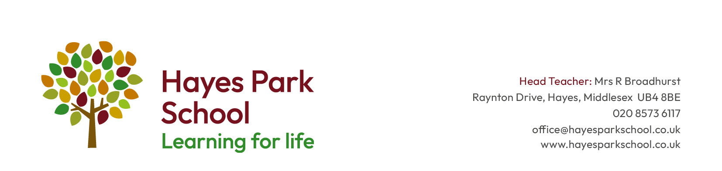
Person Specification for Deputy Head – Inclusion
 | Assessed through Application (A) or Interview (I) | Essential or desirable
Professional qualifications and experience  - Qualified Teacher Status  - At least 5 years successful teaching experience, with a SEND focus (preferably including SRP/DU)  - Trained to DSL level with recent safeguarding experience  - Recognised SENCO qualification  - Evidence of recent professional development relevant to the post  - Significant and successful leadership in SEND resulting in school improvement  - Evidence of outstanding practice in SEND teaching, preferable including an SRP/DU | A  A  A  A  A & I  A & I  A & I | E  E  E  E  D  E  E
Skills and Knowledge  - Good knowledge of the primary and curriculum and experience of adapted curriculums for alternative pathways  - An excellent understanding of theory and best practice in teaching and learning, particularly as it relates to achieving high rates of pupil progress for pupils with additional needs  - A track record of implementing successful strategies to raise achievement  - Good ICT skills  - An understanding of the role of parents and community in school improvement and how this can be promoted  - A good understanding of effective strategies for gaining and maintaining high standards of behaviour at whole school level  - Experience of interpreting and using assessment data to raise achievement  - Ability to form and maintain excellent relationships with children which enhance their learning and mental health and emotional wellbeing | A & I  A & I  A & I  A  A & I  A & I  A & I  A | E  D  E  D  E  E  E  E
Leadership and Management  - Experience of delegating, supporting and monitoring the work of others  - Experience of managing substantial change across a subject/ area or whole school  - Successful experience of observing and evaluating inclusive teaching, providing effective feedback and implementing support  - Ability to work effectively in partnership with the Headteacher  - Experience of leading the professional development of staff within the context of school improvement  - Success at promoting inclusive practice across a school that leads to high expectations for all learners  - Experience of acting as an outstanding model of inclusive teaching for others | A & I  A & I  A & I  A & I  A & I  A & I  A & I | E  E  E  E  E  E  D
Personal Qualities  - Ability to lead and motivate others  - Ability to work collaboratively  - Excellent interpersonal skills  - Ability to communicate clearly and work effectively with all stakeholders  - Ability to work on own initiative, make decisions and solve problems  - Excellent resilience and organisational skills and the ability to work effectively under pressure, prioritise appropriately and meet deadlines | A & I  A & I  A & I  A & I  A & I  A & I | E  E  E  E  E  E

