

Deputy Head of Academy
Discovery Special Academy
Job Ref: DSA393

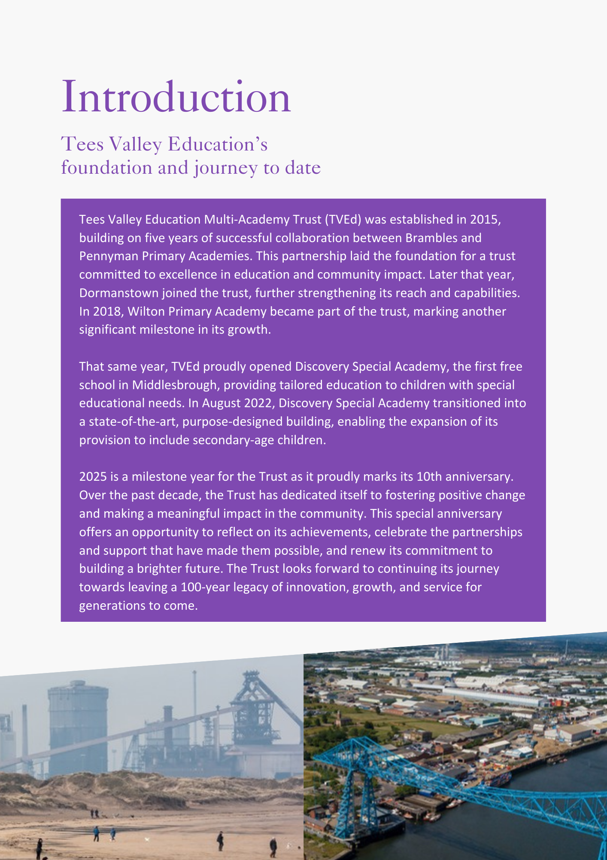

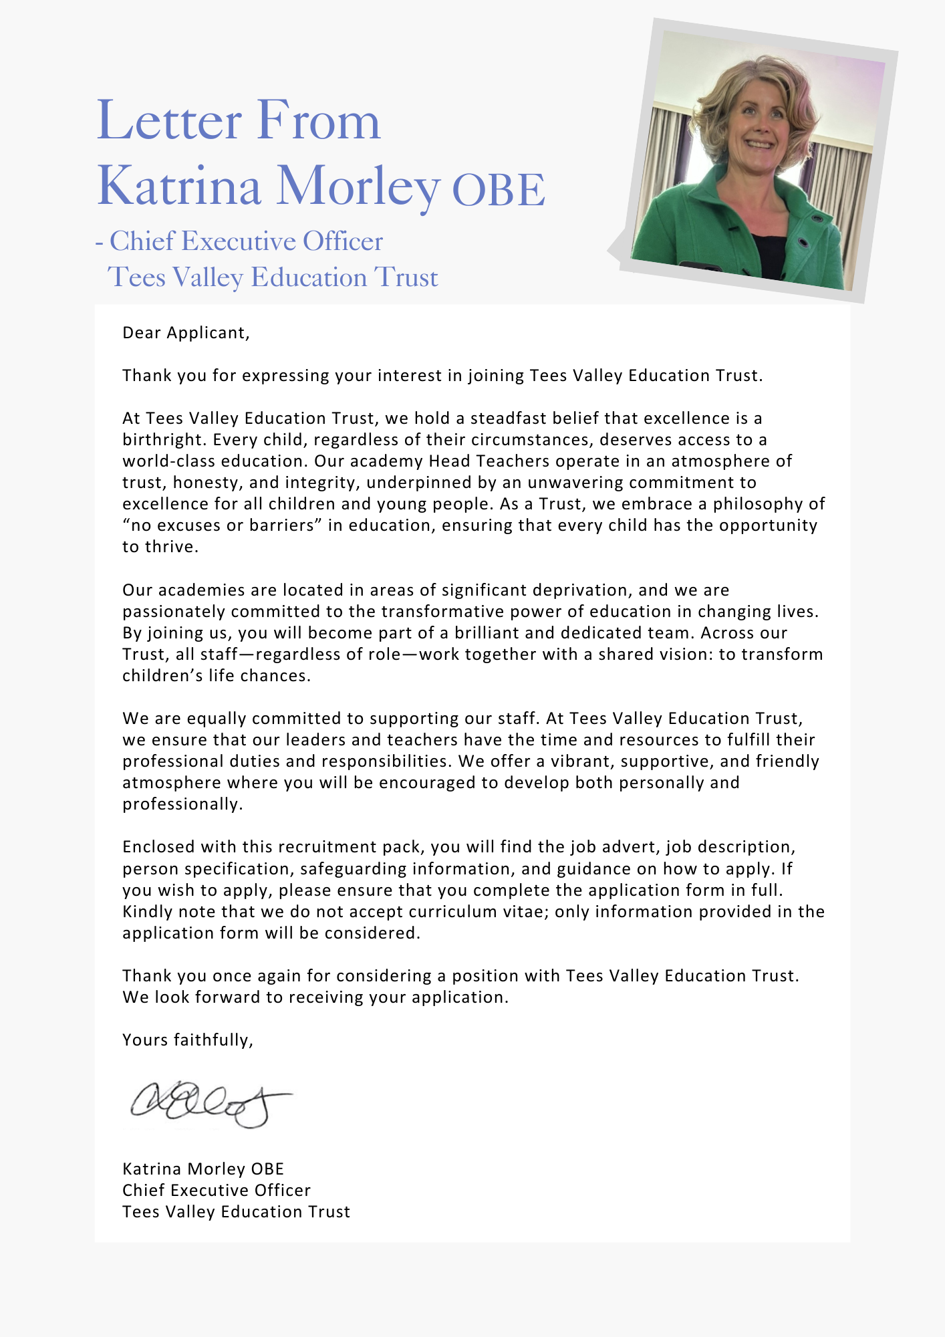

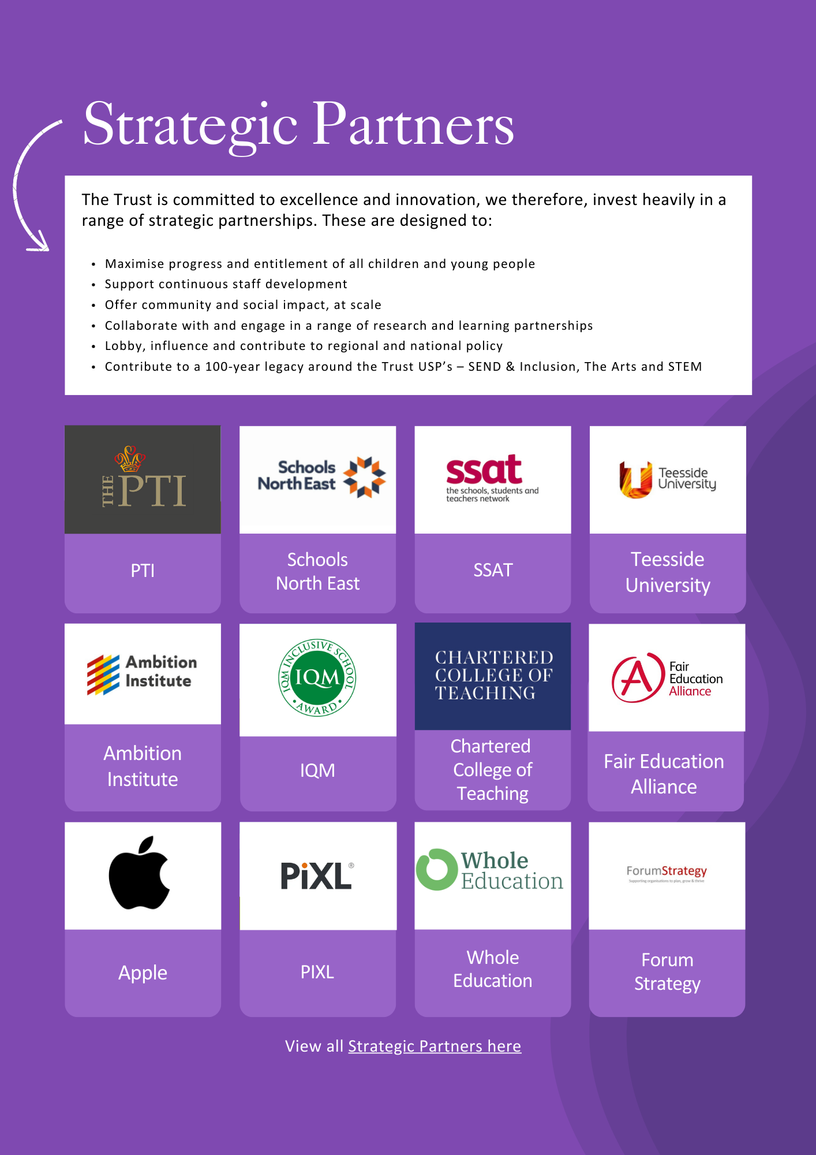

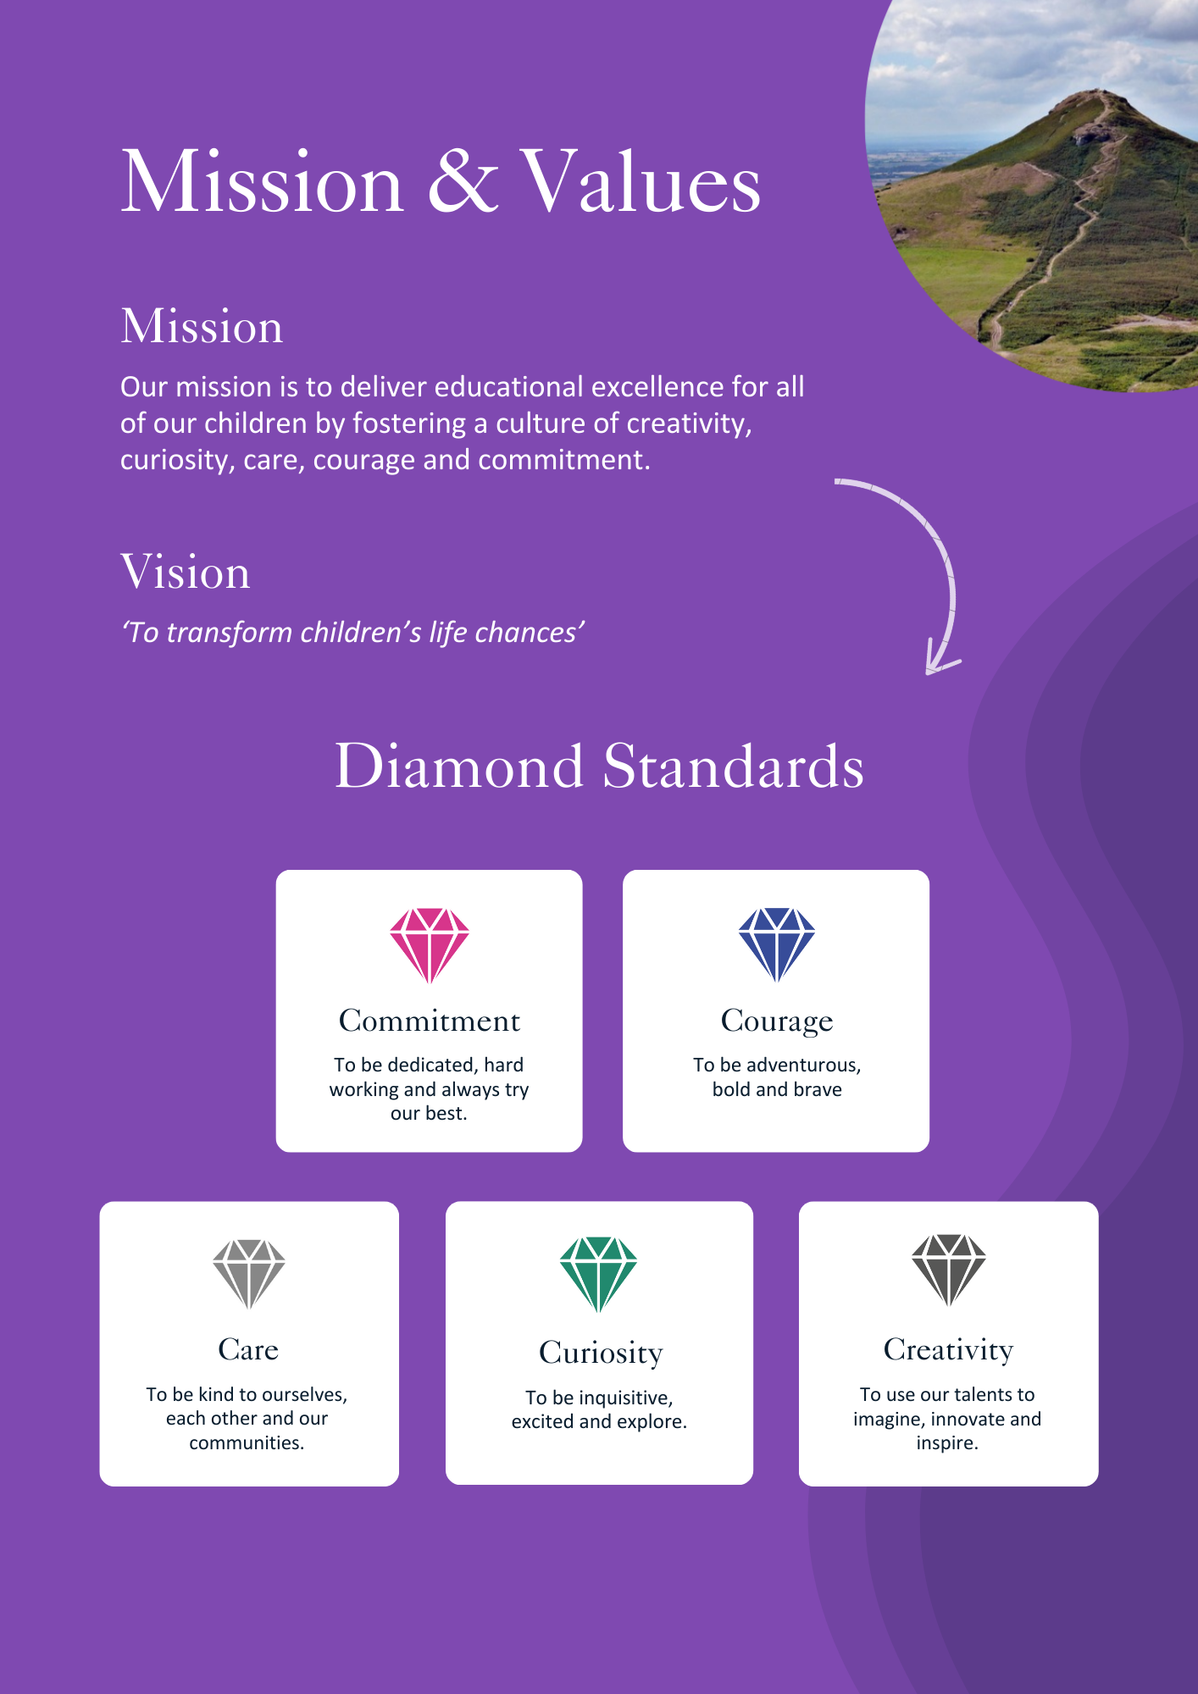

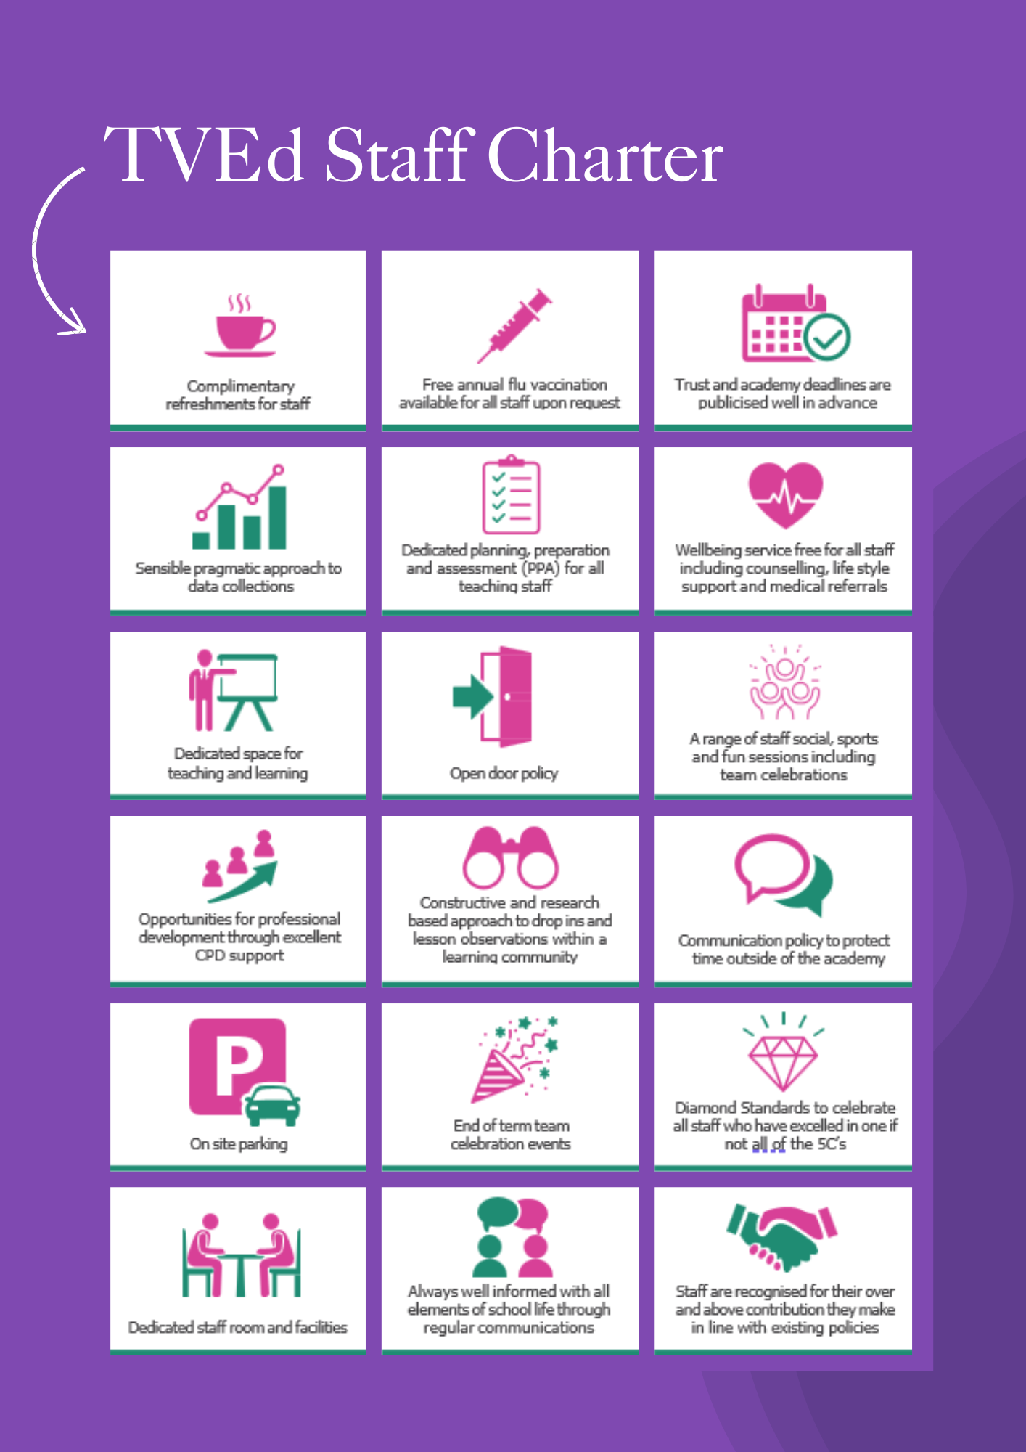

ADVERTISEMENT

Status: Permanent
Required: 1.1.2027 (or sooner)
Salary: L11-L15 £66,368 - £73,105
Hours: 32.5 hours
Reporting to: Executive Headteacher
Academy: Discovery Special Academy
About the role we are looking to appoint:
Tees Valley Education is an inclusive learning community that educates 1,243 pupils, from two-year-olds, through to secondary. Discovery Special Academy, part of Tees Valley Education Trust (TVEd), is seeking an ambitious and forward-thinking Deputy Head of Academy to drive excellence in teaching, curriculum development, and assessment in our secondary phase.
In this key leadership role, you will play a pivotal part in raising standards by enhancing the quality of teaching and learning. Through best practices, coaching, and mentoring, you will empower staff to deliver high-impact lessons while ensuring that assessment methods accurately reflect pupil progress.
Curriculum development, including development of our careers programme and accreditation offer, is central to this role, requiring innovation and strategic thinking. Discovery Special Academy’s broad and balanced curriculum supports not only academic achievement but also the social, emotional, and physical development of all pupils. As Deputy Head of Academy, you will collaborate with subject leaders across the academy and Trust to refine and adapt learning strategies, tailoring them to meet the needs of all pupils.
Furthermore, the Deputy Head will be instrumental in data-driven decision making at academy and trust level, using assessment data to identify areas where children may be underperforming and developing interventions to address these gaps. A focus on continual professional development (CPD) is also key to this role, providing staff with the necessary tools and training to meet ambitious performance targets, and equipping them with the skills to deliver a curriculum that fosters deep learning and sustained improvement.
At the heart of this position is TVEd’s commitment to raising aspirations and creating an environment where all pupils strive to be their best. By promoting evidence-based strategies and ongoing reflection on teaching practices, the Deputy Head of Academy will not only drive improvements in educational outcomes but also contribute to the academies and Trust’s broader vision. With children’s learning and well-being at the centre of all decision-making, you will play a crucial role in shaping a future where every pupil has the opportunity to succeed.
Applications are invited from prospective candidates who demonstrate that they are able to meet the essential criteria set out in the person specification and who have the vision, values and tenacity to join an outstanding team and help continue the journey towards excellence.

JOB DESCRIPTION
To play a major role, under the direction of the Executive Headteacher and in conjunction with other members of senior staff, in implementing the vision, aims and objectives of the academy and Trust as well as establishing the policies and procedures through which they are achieved. The post holder will be responsible for standards and curriculum across the secondary phase of the academy and for an area across the Trust. To undertake such duties as are delegated. To work alongside the senior leadership team to proactively manage staff and resources. Take responsibility for promoting good behaviour and be the strategic lead for behaviour across the academy. Carry out the duties of a school teacher and Deputy Head of Academy as set out in the School Teachers’ Pay and Conditions Document. The Deputy Head of Academy for standards and curriculum will have delegated responsibilities which are both academy and Trust wide.
Strategic Direction and Development
- Work in partnership with other academy leaders in managing the academy through strategic planning and the formulation of policy and delivery of strategy, ensuring management decisions are implemented effectively and in a timely manner
- To ensure the vision for the academy is clearly articulated, shared, understood and acted upon effectively by all
- Demonstrate the vision in your everyday work and practice
- Motivate and work with others to create a shared culture and positive learning climate
- Ensure that strategic planning takes account of the diversity and experience of the academy and community
- Take a leading role across the whole academy, in the light of new and emerging research, to enhance and extend the learning experience of pupils
- Be aware of current and proposed educational developments at an academy, Trust, local and national level and ensure the academy is prepared for these
- Set a high professional standard and support and challenge other staff to do the same
- With the Head of Academy, manage and organise the day-to-day use of the building and grounds so they meet curriculum and health and safety requirements
- Work proactively and strategically as a member of the academy and Trust
- Promote a culture of inclusion within the academy community where all views are valued and taken into account
- Be responsible for own and others’ CPD within the academy and the Trust
- Manage staff (including performance management and sickness absence management) and resources to fulfil the aims and objectives of the academy
- Review the status and progress of the academy through analysis of performance information, creating review and development plans (RAD) and overseeing their successful implementation, reporting to Trust governance meetings
- Model outstanding pedagogical and leadership practice as well as having an expert knowledge base of special education
- Lead on assessment and data analysis across the secondary phase of the academy in order to improve the outcomes for all groups of pupils
- Promote and protect the health and safety of pupils, staff and visitors to the academy
- Demonstrate consistent application of all school policies and provide an exemplar model of the application of policies in your practice where appropriate

Leading Standards and Curriculum:
- Research and lead creative and imaginative ways of anticipating and solving problems and identifying opportunities that will enhance the quality of education across the academy
- Demonstrate a culture and ethos of challenge and support where all pupils can achieve success and become engaged in their own learning
- Monitor, evaluate and review classroom practice throughout the academy and promote improvement
- Challenge underperformance at all levels and provide support to improve performance
- Support the academy priorities through monitoring activities, lesson observations, pupil dialogues and work scrutinises
- Work with other academy leaders to raise standards through staff performance appraisal and pupil progress meetings
- Be an excellent classroom practitioner, coaching, mentoring and leading learning in the secondary phase where necessary
- Monitor the academy’s performance data, sharing this with staff as appropriate and ensuring at least good rates of progress through non accredited and accredited courses
- Lead on the production and analysis of academy data, identifying vulnerable learners and underperformance, and implementing effective strategies to raise attainment
- Monitor the impact of resource deployment on educational outcomes and collaborate with the Executive Headteacher and Head of Academy to suggest adjustments, ensuring that spending decisions are aligned with the academy’s priorities
- Play a leading role in the development and review of all aspects of the secondary curriculum across the academy and Trust

Leading and Managing Staff:
- Support the Executive Head teacher and SLT to develop positive working relationships and sustain motivation, with and between all staff and the community
- On a day-to-day basis, provide guidance and leadership to ensure the highest possible standard of pupil care, record keeping and communication
- Take a role in managing pupil behaviour across the academy and consistently modelling and implementing the agreed policy for pupil behaviour
- Treat people fairly, equitably and with dignity and respect to create and maintain a positive school culture
- Support by ensuring effective planning, allocation, support and evaluation of work is undertaken by teams and individuals, ensuring clear delegation of tasks and devolution of responsibilities
- Acknowledge the responsibilities and celebrate the achievements of individuals and teams
- Develop and maintain a culture of high expectations for self and for others and take appropriate action when performance is unsatisfactory
- Regularly review own practice, set personal targets and take responsibility for your own personal development
- Work with other leaders at academy and Trust level to develop an ethos, which enables everyone to work collaboratively, share knowledge and understanding, celebrate success and accept responsibility for outcomes
- Work with other leaders developing appropriate programmess of professional development for all staff including quality coaching and mentoring, in line with the RAD plan and performance management system, whilst enabling excellence and outstanding ability to flourish

Accountability:
- Attend Senior Leadership Team Meetings and Trust Challenge Boards, when required, to provide information and advice regarding your specific areas of responsibility
- Support in the development of, and present, a coherent, understandable and accurate account of the academy’s performance to a range of audiences including trustees, parents and carers
- Reflect on personal contribution to academy achievements and take account of feedback from others
- Fulfil all commitments arising from contractual accountability

Managing the Organisation:
- Help all staff to understand and fulfil their statutory responsibilities through observation, feedback, support and modelling
- Line-manage and act as Performance Management reviewer for staff identified by the Executive Head Teacher
- Support the staff and set an example of high professional standards and leadership
- Support the Executive Head Teacher to ensure that the range, quality and use of all available resources is monitored, evaluated and reviewed to improve the quality of education for all
- Communicate relevant information to all staff in a timely and organised manner
- Undertake other reasonable duties related to the day-to-day administration of the school as requested by the Executive Head Teacher

The job holder may be required to undertake additional duties, as could be reasonably
required in exceptional or emergency situations.

The job holder may be required to work across the academy group, including for Trust-wide
initiatives. The job holder may be required to undertake additional training e.g. first aid,
Positive Handling.
This job description will be reviewed annually and may be subject to amendment or modification at any time after consultation with the post holder. It is not a comprehensive statement of procedures and tasks but sets out the main expectations of the Trust in relation to the post holder’s professional responsibilities and duties.

Elements of this job description and changes to it may be negotiated at the request of either the line manager, Deputy CEO or CEO.

Safeguarding requirements for the role:
Tees Valley Education Multi Academy Trust is committed to safeguarding and promoting
the welfare of children. All appointments will be subject to a satisfactory enhanced DBS
check.
This post is exempt from the Rehabilitation of Offenders Act 1974 and, therefore, all
convictions, cautions and bind-overs, including those regarded as “spent” must be
declared. The Trust’s Recruitment of Ex-Offender policy can be requested or visit the
Trust’s website.

PERSON SPECIFICATION
QUALIFICATIONS | A,I,R | E/D
Degree of relevant qualification and  experience | A | E
Qualified Teacher Status | A | E
Evidence of further professional  development | A,I,R | E
Qualifications or experience in pedagogy and child development | A | D
Experience of skills outside teaching | A,I,R | D
Evidence of leadership development courses / or a willingness to undertake them | A,I | D
Positive Handling trained or a willingness to undertake it | A,I | D
EXPERIENCE
An outstanding understanding of Assessment for Learning (AfL) and the impact it has on progress | A,I,R | E
Sustained experience and or in depth knowledge of teaching in a range of year groups with experience in secondary an essential consideration | A,I,R | E
Experience of training, coaching and  mentoring colleagues across school, Trust and/or LA | A,I,R | E
Previous experience in a leadership role (preferably but not exclusive to a current AHT or DHT/HoA in a smaller school / academy) | A,I,R | E
Evidence of developing, monitoring and evaluating a key aspect of academy provision including the identification of SEF and academy priorities. | A,I,R | E
A secure understanding of school wide data and data analysis systems which could include SIMS, data dashboard, FFT. | A,I,R | E
Experience of teaching and impact in benchmark years, including accredited/examined courses | A,I,R | D
Creative approach to problem solving | A,I,R | D
KNOWLEDGE, ABILITIES AND SKILLS
A proven track record as an outstanding teacher. | A | E
Ability to drive forward improvements. | A,I,R | E
Able to talk about characteristics of effective SEND teaching and learning strategies used to raise pupil attainment and achievement. | A,I,R | E
A broad understanding of the core curriculum and creative opportunities for cross curricular learning. | A,I,R | E
A sound understanding of strategies to support all children’s learning. | A,I,R | E
Highly successful experience of leading and managing whole academy developments in a number of areas regarding teaching & learning and raising standards of attainment and achievement across the academy. | A,I,R | E
Outstanding organisational skills with the ability to self-direct as well as work successfully within a team. | A,I,R | E
A commitment to further professional development. | A,I | E
The ability to work productively and positively with a range of colleagues both internally and externally. | A,I,R | E
Experience of conducting staff induction, mentoring and performance management. | A | D
Excellent interpersonal skills. A team player. | I,R | E
Flexible, personable and adaptable. | A,I,R | E
Ability to inspire and motivate all children to learn and reach their full potential. | A,I,R | E
Ability/willingness to contribute to the whole academy context (including INSET) | A,I,R | E
Tenacity, enthusiasm and drive. | A,I,R | E
LEADING AND MANAGING STAFF
Leadership and management experience. | A,R | E
Experience of planning for change, development and improvement | I | E
The ability to set high and clear expectations, to hold others accountable for performance and the contributions they make to the academy community. | A,I | E
Proven ability to set & meet challenging targets, for pupils and the academy, including self-review and evaluation, and to enable others to do this. | A,I,R | E
Proven ability to analyse, prioritise and meet deadlines. | I,R | E
Able to demonstrate leadership qualities and people management skills. | A,I,R | E
Able to motivate, promote good relationships and effectively communicate with all stake holders. | A,I,R | E
Commitment to safeguarding and promoting the welfare of children. | A,I,R | E
Work with other leaders to develop an ethos which enables everyone to work collaboratively, share knowledge and understanding, celebrate success and accept responsibility for outcomes. | A,I,R | E
Be an excellent role model for both staff and pupils in terms of being reflective and demonstrating a desire to improve and learn. Modelling practice, procedures and protocols. | A,I,R | E

AM (Assessment Method), A- Application Form, I – Interview, R – Reference,
E – Essential, D - Desirable
Important: In the first instance, applications are assessed against the criteria listed above, in addition to overall presentation, use of standard English and grammatical accuracy.

Where applications do not meet the expected standard, they will be rejected before being matched to the person specification.

HOW TO APPLY AND EXPLANATORY NOTES OF THE PROCESS

Please submit a letter outlining your suitability for the post and your relevant experience. Letters
should be addressed to Miss Jennifer Duncan and returned to Discovery Special Academy.

Shortlisting Process
After the closing date, short listing will be conducted by a panel, who will match your
skills/experience against the criteria in the Person Specification. You will be selected for interview entirely on the contents of your application form, so please read the Job Description and Person Specification carefully before you complete your form.

Shortlisted candidates will receive:
- Letter confirming interview details.
- Details of original ID documentation is required to confirm candidates. Photocopies or certified copies are not accepted.
- Criminal Record Self-Declaration Form, which must be brought on the day of the interview in the sealed envelope provided.

Interview process
In addition to candidates’ ability to perform the duties of the post, the interview will also explore
issues relating to safeguarding and promoting the welfare of children, including:

- Motivation to work with children and young people
- Ability to form and maintain appropriate relationships and personal boundaries with children and young people
- Emotional resilience in working with challenging behaviours
- Attitudes to use of authority and maintaining discipline
- Conditional Offer: Pre-Employment Checks
- Any offer to a successful candidate will be conditional upon:
- Verification of right to work in the UK
- Receipt of at least two satisfactory references (if these have not already been received)
- Verification of identity checks and qualifications
- Satisfactory enhanced DBS check
- Verification of professional status such e.g. QTS Status, NPQH (where required)
- Satisfactory completion of a Health Assessment
- Satisfactory completion of the probationary period (where relevant)
- Where the successful candidate has worked or been resident overseas in the previous five years, such checks and confirmations as may be required in accordance with statutory guidance.

For your information, the recruitment timetable is detailed below:

Closing date: 3rd July 2026
Shortlisting date: 3rd July 2026
Interview date: Friday 10th July 2026

EQUALITIES INFORMATION AND OBJECTIVES STATEMENT

As an academy we ensure that our vision, values and ethos meet the expectations of the equality and diversity guidelines and legislation set out by the Equality and Human Rights Commission. This includes the following 9 protected characteristics:
- Age
- Disability
- Gender Reassignment
- Marriage and Civil Partnerships
- Pregnancy and Maternity
- Race
- Religion or belief
- Sex
- Sexual Orientation

Objectives Statement
- To support children’s sensory, academic and communication skills to enable them to develop holistically.
- To ensure high expectations across all aspects of the academy (as outlined in objective 1) to ensure children make the best progress according to their individual starting points.
- To continue to monitor attendance of all groups of children in the academy.
- To review levels of parental and pupil engagement in learning and academy life, across all activities and ensure equality and fairness in access and engagement.
- To ensure the academy environment is as accessible as possible to pupils, staff and visitors.



