
Tenby Road Northampton
NN5 7DF
Tel: 01604 585219

Dear Applicant

Re: Deputy Head

Thank you for your enquiry about this important post at the Camrose Early Years Centre For Children & Families.

Enclosed you will find:
- a job description & person specification
- application form
- Information about Camrose
- Deputy Head Information
- Confidential Equality Monitoring Form
- Disclosure of Criminal Conviction Form

NB: the Camrose Centre follows Safer Recruitment Practices, therefore:

- do not send CV’s but use the application form, supporting statement section to illustrate how you fit the person specification
- this post will be subject to an enhanced Disclosure Barring Service check
- references will be taken up prior to interview for short listed candidates

Please contact me to discuss any concerns you may have about any of the above requests.

Closing date for applications is midday Monday 29th November 2021 and interviews will take place on week beginning Monday 6th December 2021. In an endeavour to keep our administrative costs down, you will only be contacted if we wish to pursue your application. Therefore if you have not heard from us within four weeks of the closing date then your application has not been successful on this occasion, however, if this is the case, we sincerely thank you for your interest in our vacancy.

If you have any queries regarding the vacancy please call Reception on 01604 585219. We look forward to receiving your application in due course.

Yours sincerely

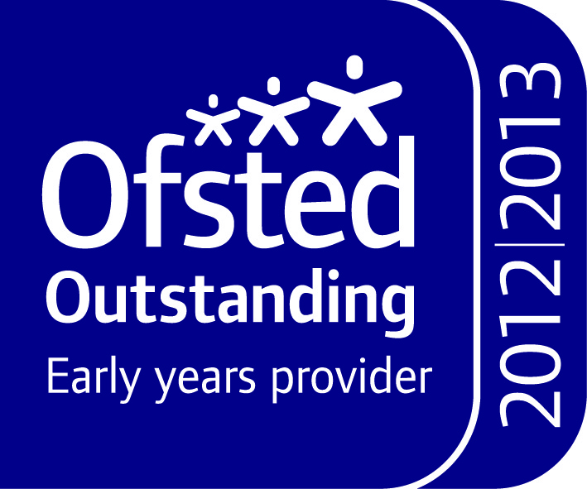
Lyndsey Barnett
Executive Headteacher

