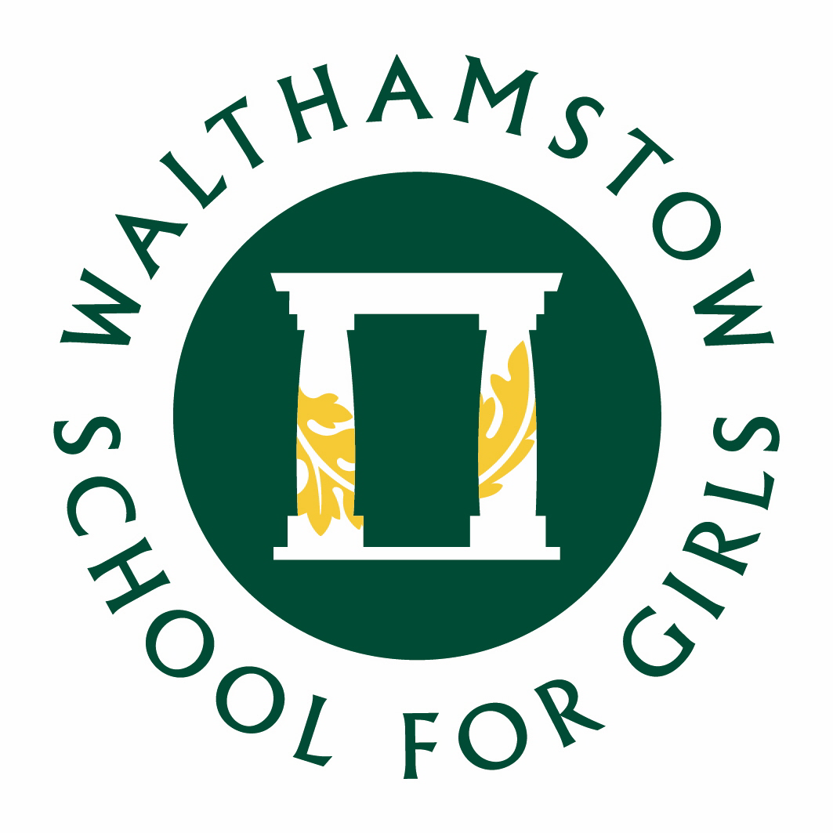

WALTHAMSTOW SCHOOL FOR GIRLS
English Faculty Information

The English Faculty is a dynamic and exciting one currently consisting of seven enthusiastic and committed English specialists and further English specialists from outside the faculty. The Faculty is a well-established team with a reputation for innovative curriculum development and effective and creative teaching and learning styles. The Faculty’s work is often modelled as good practice for other faculty areas. The Faculty adds value significantly in excess of national expectations across both Key Stages.
Classes are taught in mixed ability groups in both Key Stages where all lessons focus on quality first teaching strategies to cater for all our students’ needs. In-class support is provided by members of the Learning Support Department who also collaborate with English teachers and pre-teach key concepts and vocabulary. Classes in Key Stage 3 are taught in groups of 30; Key Stage 4 classes are between 22 and 26.
At Walthamstow School for Girls, English is an extremely popular area of the curriculum and emphasis is placed on development of the students’ skills and confidence in reading, writing, speaking and listening as well as the development of independent learners. The Faculty also encompasses GCSE Film Studies, a very popular options subject with growing industry connections. The Faculty electronically stores resources centrally for all to use and colleagues regularly contribute to this forum. All teaching rooms have interactive whiteboards and classroom teachers are issued their own iPad to further enhance teaching and learning. The Faculty is well stocked and texts are regularly updated.
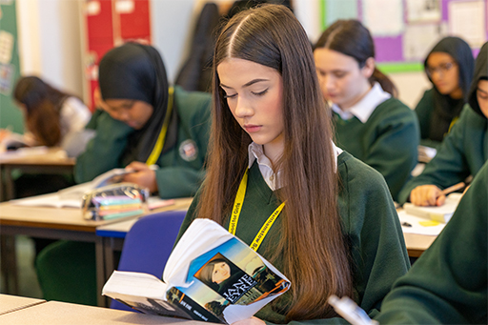
The Faculty has shared schemes of learning in place for both Key Stages which cover the requirements of the National Curriculum, ensure students’ steady progression of key skills, and ensures students have the skills and knowledge to be confident and successful in the GCSE syllabus. Schemes of learning consist of carefully devised sequences which respect students’ diversity, stimulate their interests and introduce them to challenges. The Faculty regularly updates and modifies schemes of learning to ensure students are developing the appropriate skills for lifelong learning and are continually being offered the appropriate level of challenge. The department works closely with the Librarian to promote reading for pleasure and host joint Library and English events.. The faculty further collaborates with the Librarian and Languages faculties to promote our Ancient Worlds curriculum, which combines literacy skills, Ancient Civilization curriculum, and Latin. We regularly facilitate writing competitions and a number of our students have had work published in creative writing anthologies.

At Key Stage 4 all students follow the WJEC Eduqas English Literature and AQA English Language GCSE courses. The Faculty has a strong tradition of excellent GCSE results and many students study English at post 16 level. The English faculty achieved excellent results in English in 2025, with 45% achieving a grade 7 - 9 and 92% achieving grade 4 – 9 in English Language. For English Literature, 51% of students achieved a grade 7 – 9 and 92% achieved a grade 4 – 9.
Ongoing curriculum development is at the core of the English Faculty’s work. We have made significant and exciting progress in many areas including; literature from diverse authors, critical thinking skills and oracy support materials.
The Faculty provides a range of quality extra curriculum events which support and reaffirm the schools’ ethos and engender a sense of the school as a community of readers and writers. These range from annual poetry and short story competitions, visiting workshops, International Women’s Day celebrations and in-house performances.
We have an energetic team, learn from each other and are dedicated to providing the best education for our students. We are keen to learn and experiment with new teaching and learning pedagogy and always rise to the challenge.
September 2025

