

**WALTHAMSTOW SCHOOL FOR GIRLS**

***“NEGLECT NOT THE GIFT THAT IS IN THEE”***

Candidate Information Pack

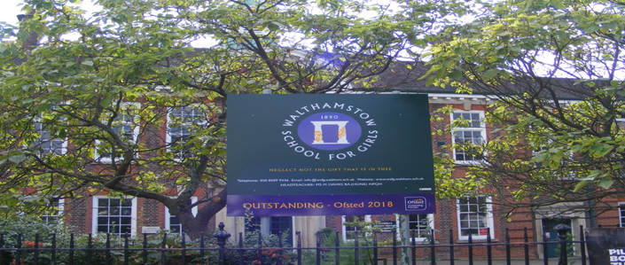

**Information for applicants for the post of**

**Deputy Head of Faculty Modern Foreign Languages / Head of French**

**Required for September 2023**

Contents of Applicant Pack

* Welcome letter from Helen Marriott – Headteacher
* Brief history of Walthamstow School for Girls
* Walthamstow School for Girls G.R.E.E.N. vision
* School Improvement Plan Summary
* What staff value about our school
* Applying for a job at Walthamstow School for Girls
* Pre-employment checks
* Job description and Person Specification
* Faculty Information (where applicable)
* Staff Benefits

**Candidates are encouraged to visit the school website for additional information:**

[www.wsfg.waltham.sch.uk](http://www.wsfg.waltham.sch.uk)

**Additional Information and Key Policies:**

Safeguarding: <https://www.wsfg.waltham.sch.uk/attachments/download.asp?file=2921&type=doc>

Keeping Children Safe in Education: <https://www.wsfg.waltham.sch.uk/attachments/download.asp?file=2756&type=pdf>

Policy statement on Recruiting Ex-Offenders and Safekeeping of Disclosure:

<https://www.wsfg.waltham.sch.uk/attachments/download.asp?file=2527&type=pdf>

Applicants Guide to Prevention of Illegal Working:

<https://www.wsfg.waltham.sch.uk/attachments/download.asp?file=2528&type=pdf>

LBWF Safer Recruitment Guidance

[**https://www.wsfg.waltham.sch.uk/attachments/download.asp?file=2730&type=doc**](https://www.wsfg.waltham.sch.uk/attachments/download.asp?file=2730&type=doc)

LBWF Equal Opportunities Policy Statement

[**https://www.wsfg.waltham.sch.uk/attachments/download.asp?file=2731&type=doc**](https://www.wsfg.waltham.sch.uk/attachments/download.asp?file=2731&type=doc)

# 

Welcome letter from Helen Marriott, Headteacher

# January 2023

Dear Applicant

I am delighted that you are considering applying for the role of Deputy Head of Faculty – Modern Foreign Languages / Head of French at Walthamstow School for Girls. I consider it a privilege to lead staff and students in this exceptional school where we are passionate about education being a vehicle for promoting equality for all and where our mission is to empower young women to become leaders of the future. We are a truly comprehensive school, proud of our diversity and committed to social justice. Although we are an Outstanding School (Ofsted, 2018), achieve exceptional outcomes and have consistently been in the top 20% of schools nationally for progress, our focus is on developing exceptional young women, not just on academic achievement. Our designation as a Teaching School Hub in February has given us the opportunity to work collaboratively with leaders and practitioners throughout Haringey, Redbridge and Waltham Forest to improve the life chances of young people in 239 schools across our area. There could not be a more exciting time to join the students and staff at WSfG!

We actively value staff and students: we are committed to their development and the contribution they make to shaping the future direction of the school. The new school SIP, created initially with middle leaders and then with a wider range of stakeholders, demonstrates our commitment to staff and student wellbeing, distributed leadership and creating robust systems, founded on evidence-informed practice. I have included a summary in this pack so that you have a ‘flavour’ of how our key priorities will be developed over the next few years.

We are committed to Safer Recruitment practices and procedures and shortlisted applicants will be questioned about their commitment to the safeguarding of young people. The successful candidate will be subject to an enhanced DBS clearance.

Having read the candidate information, I hope that you feel excited by both the role itself and the chance to be part of WSfG at a pivotal moment in its development. We welcome visits from prospective candidates and would be proud to show you round our wonderful school.

I look forward to hearing from you.

Helen Marriott

Headteacher MA NPQH



**History**

In January 1890, a circular stated that a “school for girls” was to be opened in Walthamstow. Miss Hewett was appointed as the first Headmistress and remained until she retired in 1924. There were 49 girls, whose ages ranged from 7-16 years. At this time there were only five teachers, two of whom were graduates.

Our original building was in West Avenue Road and when student numbers grew the school moved to Church Hill House, where a church now stands. It was in September 1913 that 243 girls came to the present building with the Greek Amphitheatre being added in the 1920s. In January 2010 our most recent refurbishment and rebuilding work was completed as part of the Building Schools for the Future Programme. This work has given us the unique blend of traditional and state of the art facilities that we currently enjoy at our school.

**Our school in 2022**

Walthamstow School for Girls is a high achieving, oversubscribed, diverse and inclusive school which is regularly in the top 20% nationally for progress, and is at the centre of the vibrant local community of Waltham Forest (the 2019 and first London Borough of Culture). Our most recent results can be found on our website. We are consistently among the top-performing non-selective schools in the country and the pupils take great pride in their school. In June 2018 we were awarded an ‘outstanding’ judgement in all categories.

Every one of our 900 students is valued equally as an individual with different gifts and talents, reflecting our commitment to the school motto “Neglect not the gift that is in thee”. We offer strong pastoral support and regular monitoring, target setting and dialogue with students and parents/carers.

Walthamstow School for Girls is proud be the lead school of the North East London Teaching School Hub. Working collaboratively across Haringey, Redbridge and Waltham Forest our aim is to ensure that every child has a great teacher who inspires and unlocks their potential. We aim to achieve this by providing exemplary training and development, for leaders and practitioners which meets the needs of all the schools in our area, so that every child has access to the highest quality education and develops a desire for lifelong learning..

*“Middle Leaders are exceptional and collaborate well to share best practice. They drive their teams with energy and enthusiasm. They share the strong moral purpose of the Headteacher to ensure that no pupil is left behind. As a result, outcomes for pupils are outstanding, giving them essential life chances.” Ofsted 2018.*

**Students and staff**

Our school is characterised by its sense of community and ‘family’, the commitment of staff to the welfare and progress of students and its inclusive and diverse nature. Our students are a delight: ambitious and hard-working, they embrace the full range of opportunities offered to them both during and beyond the school day. This is highlighted not only by our exceptional examination results but also by the maturity of the girls, their sense of responsibility, community and fun.

One of the school’s strengths is the quality of the staff we are able to attract and retain. Our teachers ensure lessons are stimulating and challenging. Students work with enthusiasm and interest in classrooms where there is a calm atmosphere suitable for learning. The broad and balanced curriculum ensures that all students are extremely well equipped to continue their education.

**Our environment**

We offer excellent facilities to both staff and students. Our acclaimed architect designed buildings and facilities make a stunning learning and working environment. Our £18 million rebuild project, completed in 2010, dramatically extended and enhanced our accommodation. We have state-of-the-art facilities in science, technology and performing arts, as well as a fantastic dining hall, two assembly halls and social areas.

Visitors often comment on the beautiful school grounds and are surprised to find them in an East London comprehensive school! We are fortunate to benefit from both a listed building and an architect designed site, surrounded by lawns and trees. We also have a Greek amphitheatre and an allotment where students to learn how to grow fruit and vegetables, some of which are then used by our chef.

The school is well-served by transport connections, being just ten minutes’ walk away from Walthamstow Central tube and rail station and five minutes’ walk from the popular Walthamstow ‘village’, creative and restaurant quarter. We pride ourselves on working hard to retain our role as an important part of the local community. Examples of this commitment can be seen in our weekly *Greensheets*. Our staff are inclusive and friendly, with regular social and wellbeing events as well as charity fundraising.

**Educating and empowering young women**

Our role is to empower young women become leaders of the future: confident and articulate, but also critical thinkers. Through a range of activities and opportunities, students are helped to develop their leadership qualities, their sense of community and global responsibility as citizens of the world in line with our G.R.E.E.N. values.

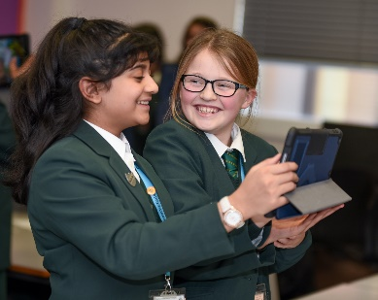

Our G.R.E.E.N. Vision

**The G.R.E.E.N. values**

| https://www.wsfg.waltham.sch.uk/_site/data/files/images/values/C52FA90503F596A26EE2DC7FE1E19642.png | The value **GROWTH**is based on the work by Carol Dweck on growth mindset.  Having a growth mindset encourages the belief that we can all improve at whatever we put our minds to with practice and perseverance.  It encourages learning, effort and stickability.  It also promotes the importance of reflection and criticism as tools to move us forward. |
| --- | --- |
| https://www.wsfg.waltham.sch.uk/_site/data/files/images/values/3FEE02382FB6B8CCE94E0DF659218767.png | The value **RESILIENCE** represents the notion that, on any learning journey, there will be obstacles.  With **RESILIENCE**and perseverance, these obstacles can be overcome and the final goal more rewarding.  The key is not to be fearful of these obstacles and to accept that mistakes and challenges are an important part of learning.  The learning line is an effective symbol for resilience and for assessment for learning. |
| https://www.wsfg.waltham.sch.uk/_site/data/files/images/values/38C6CD54B28E286D9A8410BF39911E01.png | The value **ENERGY**is the centre of our vision.  It encourages focus and enthusiasm from everyone.  This **ENERGY** could be represented in the attitude of students as well as in staff morale, parent and governor involvement.  It promotes positivity and supports all of the other G.R.E.E.N. values. |
| https://www.wsfg.waltham.sch.uk/_site/data/files/images/values/BC7D9BD0A310876A7B76D38599477A89.png | The value **EMPATHY**promotes community spirit in many dimensions.  It signifies self-awareness as well as respect for each other despite our differences.  In addition to this, it illustrates that none of us are alone on our learning journey and that, through collaboration, success can be greater. |
| https://www.wsfg.waltham.sch.uk/_site/data/files/images/values/AABBE9BC30E8511FD418D7E3A2E90E56.png | The value **NEWNESS** is vital in an ever changing world.  This encourages us to be open to new ideas, techniques, technologies and challenges.  It encourages us all to step out of our comfort zones as this is where the deepest learning and the greatest success can be achieved. |



Our vision: Where are we heading and what are we trying to achieve?

Our vision for WSFG is...

• A school where we value great learning and great teaching because we know that this is the key to unlock our students’ potential and inspire them on a journey of lifelong learning

• A school where all staff understand their role as agents of social change so that we focus on improving the life chances of all students, particularly the most vulnerable and disadvantaged

• A school where all of our girls feel safe and nurtured because of our robust support and safeguarding systems, where students understand how to improve their wellbeing, and where there is a culture of empathy and kindness

• A school where every student feels known, valued and listened to; students are empowered to become decision makers and have the confidence to undertake any role or profession, regardless of gender, sexual-orientation, race or ethnicity, knowing that in doing so, they are making the world a better and more equal place

• A school where there is distributed leadership; systems ensure that staff feel listened to and valued and effective communication enhances staff wellbeing

• A school which produces great leaders, both in its students and staff, and where there is a culture of female leaders being ‘10% braver’

• A school where students have broad horizons: physically, intellectually, culturally and emotionally

• An outstanding school where its evidence-based practice is shared, both nationally and internationally

• A school where the curriculum is broad and balanced, is used as a tool to develop critical thinking, where leaders understand its impact and where students feel the curriculum is both relevant and meets their needs

• A school which is enhanced by its leadership of the Teaching School Hub, seeing it as a mechanism for sharing and learning from the best teacher training and development practice in North East London and across the country.

**What is the purpose of the SIP?**

• The SIP acts as an ambitious medium and long-term plan for the school

• It creates an accurate baseline from which we can plan so that we have a clear idea of ‘where we are’ as a school, in terms of our priorities

• We need to ensure that we have a clear evidence base for any actions we take and our SIP actively encourages this process

• The ‘impact’ section allows us to see the journey we need to make, with clearly-defined, measurable outcomes

• The ‘actions’ should be what enables us to make that journey and should be carefully reviewed in order to ensure that they will have the desired impact, rather than actions for their own sake

• Since it is impact-driven, the SIP allows us to plan backwards and understand the actions we need to take from our current position.

**Who is it for?**

• The SIP has been created by a range of stakeholders: staff, governors and senior leaders. In June and July, students and parents will be consulted on these priorities and plans.

• The SIP is for the whole school community but will be used by governors to hold the school to account

**How will it be used?**

• This is an ‘organic’ document which will be constantly updated and reviewed by leaders and governors

• In the Autumn term, additional information for the baseline will necessitate changes in actions and intended outcomes

• The SLT will review the SIP actions and measure their impact against the intended outcomes at least every half-term

• Middle leaders will create their own faculty versions of the SIP so that their actions reflect those of the whole school and, in turn, feed into the process, forming part of the cycle of evaluation and review

**What are our priorities and why?**

• Our SIP priorities were proposed by a working group of middle leaders, led by the Headteacher, in February and March 2021. SLT at the SLT conference interrogated quantitative and qualitative information to ensure that these were the right priorities for the school. Staff and governors at our SIP day in April then explored the priorities further through a more detailed planning exercise and made decisions about which should be our most important priorities.

• There are four priorities so that we can focus on fewer priorities and more impact. These are our key priorities, which are all of equal importance: student wellbeing; staff wellbeing; pedagogy for achievement and progress; leadership and coaching development.

https://educationendowmentfoundation.org.uk/public/files/Publications/Implementation/EEF-Implementation-Recommendations-Poster.pdf

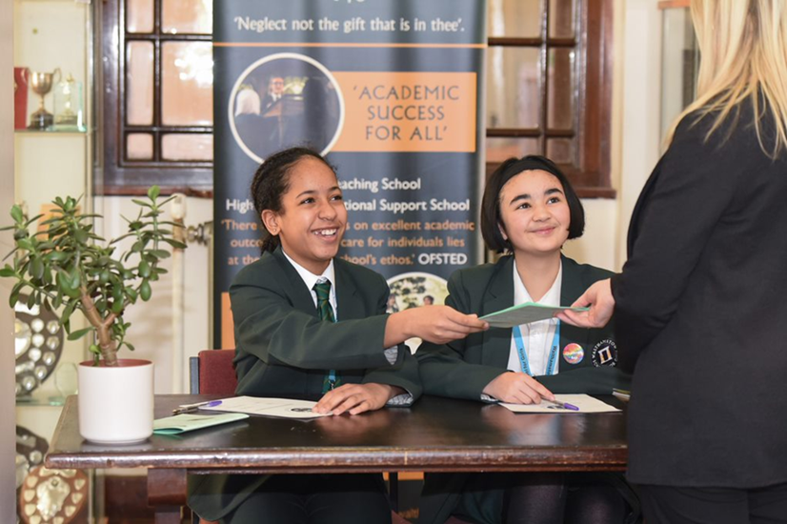

What staff value about the school

*“The school’s values of Growth, Resilience, Energy, Empathy and Newness (GREEN) are lived by staff and pupils in all aspects of the school’s work.” Ofsted 2018.*

* This school feels safe, kind and caring. We are not driven by results – we seem to be driven to produce fabulous young women
* Ethos of the school, supportive colleagues and strong management with compassion

*“There are very strong working relationships between staff and pupils based on mutual trust and respect.” Ofsted 2018*

* I value the ethos of hard work in the students and how the school promotes kindness, tolerance and maturity amongst the students
* Atmosphere of diversity, respect and inclusion
* Freedom to teach in a range of styles

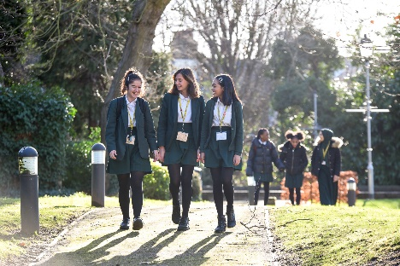



**What makes a good application?**

You need to make sure your application does you justice and provides you with the best possible chance of getting an interview. This means reading the job description and person specification and taking time over your application to demonstrate your skills and experience.

**The Application Form**

We do not accept CVs for any post in school, any CVs submitted will not be used for short listing purposes. It is essential that you complete all the sections on the application form. The “monitoring information” section will not be used for short-listing; it is used for administrative purposes only. You must provide full details in respect of two referees, one must be your current or last employer. If you are looking to join us from another school one of your referees must be your current Headteacher.

**Do you meet the requirements of the Person Specification?**

During the short-listing process we look at the information that you have provided and compare this against the person specification for the position that you are applying for. It is important, therefore, that you provide as much information as possible about how you meet the requirements of the post. You need to be able to demonstrate how you match the criteria, giving examples where possible. This will give you the best chance of being invited for an interview.

**Supporting Information**

The “general experience and information” section is your opportunity to sell yourself and demonstrate your suitability for the post, be concise but informative and highlight your skills and knowledge. Please include all your relevant experience whether gained at work or outside of the work place environment.

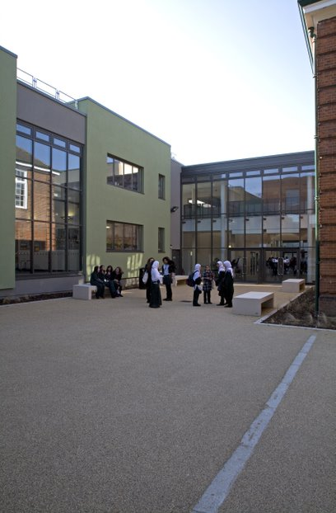



If you are successful at interview and are offered a post at Walthamstow School for Girls we will be required to carry out a number of pre-employment checks. All offers of employment are conditional on these checks being satisfactorily completed.

The checks completed are:

**Identification documents**

All staff are required to provide proof of their identity and that they have the right to work in the UK.

**Online / Social Media Checks**

As recommended in Keeping Children Safe in Education 2022, online searches are carried out on all shortlisted candidates at Walthamstow School for Girls. The searches are carried out to identify any issues or incidents that have happened, and are publicly available online, which the school might want to explore with the candidate at interview. If you are shortlisted you will be asked to complete a form to provide details of your social media platforms and the handles you use on each site.

**Criminal Record Checks (DBS)**

All offers of employment are subject to a satisfactory Enhanced Disclosure from the Disclosure and Barring Service DBS (formerly the Criminal Records Bureau CRB). Full information relating to this check and the Rehabilitation of Offenders Act 1974 is included in our New Starter Information Pack, issued with offer letters. Before completing the online DBS application you are advised to read the guidance information received with the email link.

Please note any information provided on your application form in the Disclosure and Criminal Background section will only be viewed by those who need to see it as part of the recruitment process. Any information disclosed will be treated in strictest confidence.

**Employment history and references**

On your application form it is important that you provide your full employment history including information regarding any gaps in your employment. References will be requested, prior to interview, from the information provided on your application form. We reserve the right to seek further references deemed appropriate and all references are verified on receipt.

We may ask you to help us to chase your referees to make sure that we receive your references as quickly as possible.

If you are currently employed in a school we will request a reference from your current Headteacher.

**Qualifications**

If your role requires you to hold a professional qualification you will be asked to provide evidence in the form of original certificates. Copies of these will be held on your Personnel file.

**NCTL Checks (Teaching staff only)**

All teachers are checked against the NCTL central register, this includes a Prohibition check.

**Pre-Employment Health Check**

All staff will be asked to complete a pre-employment health questionnaire. Any information that is disclosed as part of the health check will only be shared with relevant key members of staff and will be treated in the strictest of confidence.

**WALTHAMSTOW SCHOOL FOR GIRLS**

***“NEGLECT NOT THE GIFT THAT IS IN THEE”***

Job Description

**Job title: Deputy Head of Faculty** (non-core) (DHOF)

**Reporting to:** Head of Faculty (HOF)

**Responsible for:** Communication to the Head of Faculty the interests and needs of those he/she line manages

**Line management of:** Named members of the faculty, this may include support staff if appropriate

**Liaising with:** HOF, teaching and support staff in their faculty, relevant teaching and support staff with cross-school responsibilities, LEA personnel, governors and parents/carers

**Working time:** 195 days per year – full time. Attendance at identified calendared events during the school year

**Salary/TLR Allowance:** Classroom Teachers’ Pay Scale + TLR 2b

**Disclosure:** Enhanced

|  |  |
| --- | --- |
| **Core Purpose** | * To lead and manage a subject area * To be accountable for student progress and attainment in that subject area * To deputise for the HOF in his/her absence (along with the other DHOF, in line with written faculty policy) * To make appropriate cover arrangements for classes when staff are absent (in line with written faculty policy) |
| **Curriculum** | * To lead, manage and develop student attainment across one subject area in the faculty * To be accountable for the planning, delivery and assessment of the subject at that subject area including the development of syllabi, differentiated resources, Schemes of Work (SOW) and assessment strategies * To keep up to date with national, regional and local developments in the subject area and to actively monitor and respond to them, disseminating the knowledge to the relevant members of staff |
| **Strategic Leadership** | * To lead on the implementation and evaluation of one of the three faculty development plan targets |
| **Quality Assurance** | * To support the HOF in carrying out the twice-yearly self-evaluation activity as a means of informing faculty practice and identifying areas of development * To monitor student standards and attainment in the subject area against annual targets * To support the HOF in setting annual targets for the subject area * To quality control subject reports |
| **Resources** | * To support the HOF in overseeing an evaluating the subject budget allocation to ensure it is spent in line with faculty and SIP priorities and best value principals |
| **Staffing** | * To be Performance Manager for a small number of faculty members, carrying out performance management reviews in line with school policy and setting challenging objectives * To lead, develop and enhance the teaching practice of the staff delivering the subject * To participate in the recruitment and interview process for members of the faculty |
| **Management Information** | * To use data appropriately to set targets and expectations and to ensure effectively differentiated teaching of the subject |
| **Cross Faculty Responsibilities** | * To be faculty rep for Challenge, ICT or SEN |
| **Teaching** | * To undertake an appropriate programme of teaching on a ratio of 40/50 |
| **School Ethos** | * To contribute to the development of whole school policy * To represent the faculty at HOF meetings in the HOFs absence * To attend Forum meetings * To support the school ethos, aims and policies |
| **Whole School Contribution** | * To play a full part in the life of the school community, to support is distinctive aims and ethos and to encourage staff and students to follow this example * To continue professional development * To comply with the schools Health and Safety policy * To engage actively in the performance review process * To undertake any other duty as specified by STPCB not mentioned above |

This job description is carried out in accordance with provisions of the School Teachers’ Pay and Conditions document and within the range of teachers’ duties set out in that document.

The school will endeavour to make any necessary reasonable adjustments to the job and the working environment to enable access to employment opportunity for disabled job applicants or continued employment for any employee who develops a disabling condition.

Each DHOF may have specific duties on top of these generic ones.

This job description is current at the date shown but, in consultation with you, may be changed by the Headteacher to reflect or anticipate changes in the job commensurate with the grade and job title.

March 2020

*This school is committed to safeguarding and promoting the welfare of children and young people and expects all staff and volunteers to share this commitment.*

Person Specification

|  |  |  |  |  |  |  |
| --- | --- | --- | --- | --- | --- | --- |
|  | **Criteria** | Essential | Desirable |  | Assessed by application | Assessed by selection process |
|  | **Qualifications** | | | | | |
| 1 | A good honours degree or equivalent | / |  |  | / |  |
| 2 | Qualified Teacher Status (QTS) | / |  |  | / |  |
|  | **Professional experience and knowledge** | | | | | |
| 3 | Proven experience as an outstanding classroom practitioner teaching the full ability range 11-16 | / |  |  | / | / |
| 4 | Successful management experience | / |  |  | / | / |
| 5 | Evidence of recent relevant professional development activities | / |  |  | / |  |
| 6 | Considerable experience of curriculum development | / |  |  | / | / |
|  | **Knowledge and Understanding** | | | | | |
| 7 | An in-depth understanding of the nature of the French curriculum and its relationship to the curriculum as a whole | / |  |  | / |  |
| 8 | Secure knowledge of the statutory requirements for French and assessment, recording and reporting requirements in the subject | / |  |  | / | / |
| 9 | Good knowledge and understanding of the characteristics of high quality teaching in French and the main strategies for improving and sustaining high standards of teaching, learning and achievement for all students | / |  |  | / | / |
| 10 | A full appreciation of the contribution the subject can make to furthering the school’s aims and to its central priority of further raising achievement | / |  |  |  | / |
| 11 | A full knowledge and understanding of the contribution the subject can make to the school’s Equal Opportunities Policy and practice | / |  |  | / | / |
| 12 | Knowledge and understanding of how evidence from a variety of sources can be used to inform expectations, targets and teaching approaches in the faculty | / |  |  |  | / |
| 13 | Knowledge and understanding of the current use and future potential of information technology to aid teaching and learning of the subject and to assist with subject management | / |  |  | / | / |
|  | **Skills and Personal Qualities** | / |  |  |  |  |
| 14 | Ability to set high standards and provide a professional role model for staff in the teaching and learning of the subject | / |  |  | / | / |
| 15 | Ability to set clear aims, direction and purpose for the subject and to lead a team to achieve identified aims | / |  |  | / | / |
|  |  |  |  |  |  |  |
| 16 | First class communication skills (written and oral) for working with a variety of audiences | / |  |  | / |  |
| 17 | Energy and enthusiasm for all aspects of the post | / |  |  | / | / |
| 18 | Creative approach to curriculum development and school development | / |  |  | / | / |
| 19 | Strong commitment to maintaining and improving still further the quality of teaching and learning and standards achieved in the faculty | / |  |  |  | / |
| 20 | Ability to evaluate the quality of classroom experience | / |  |  |  | / |
| 21 | Ability to support, guide and motivate others | / |  |  |  | / |
| 22 | Ability to provide strong leadership and to work as a member of a team and to understand when these roles are appropriate | / |  |  |  | / |
| 23 | Ability to work under pressure, to meet challenging deadlines and to be adaptable | / |  |  |  | / |
| 24 | Good organisation and proven administrative abilities | / |  |  | / | / |
| 25 | Ability to devolve responsibilities and delegate tasks, as appropriate | / |  |  |  | / |
| 26 | Ability to identify professional development needs and encourage continuing professional development, plan and organise INSET | / |  |  |  | / |
| 27 | Ability to develop successful relationships with students and to employ a variety of strategies for behaviour management | / |  |  | / | / |

March 2020

*This school is committed to safeguarding and promoting the welfare of children and young people and expects all staff and volunteers to share this commitment.*



**Walthamstow School for Girls – The Languages Faculty**

The Languages Faculty at Walthamstow School for Girls is a very successful faculty. All Language staff are fully committed to ensuring our students really enjoy their language learning experience and achieve their full potential in this subject area. We strive to ensure that our students develop a real interest in the cultural aspects of the languages we teach which will enrich their lives and lead them to view language learning as something they will continue with in the future.

Our success as a faculty has been achieved principally by strong teamwork, effective planning, and the delivery of consistently high-quality teaching. We have very high expectations of our students in terms of motivation and effort. They respond extremely well to our teaching and have high expectations of themselves and of us.

We are very well supported by our Leadership Team and this has enabled us to be very well resourced with some of the best language teaching materials available. These include the Pearson Activelearn Studio for French as well as the Viva courses at KS3 and KS4. All students have access to Quizlet in order to support them in vocabulary acquisition both at home and at school.

All of our classrooms are fully equipped with interactive whiteboards enabling staff to fully utilise a range of teaching materials.

Students French or Spanish and there is an option to study Latin and Urdu later at GCSE. Able linguists are able to study both French and Spanish from Year 8. A very high percentage of our students opt to continue with their language to GCSE. Group sizes are usually between 20 and 25.

We are fortunate to have French and Spanish language assistants each year and our students benefit enormously from working with them. Many other extra-curricular activities are organised such as lunch-time language clubs and after-school lunch-time support.



Staff Benefits

Outlined below are some of the additional benefits available to staff working at Walthamstow School for Girls.

**Commitment to CPD**

The best CPD has a measurable impact on the progress of students. For this reason, we believe in giving our staff dedicated training time, delivered during twilights. We are developing a comprehensive CPD programme, where all staff follow long-term courses, including training as coaches by John Kane, an external provider. Staff then work in triads to coach each other, developing their practice through bespoke feedback training.



**Cycle 2 work scheme**

This benefit offers staff the opportunity to purchase a bike (from a range of providers) making a tax saving, whilst keeping fit at the same time.

**Eye Tests**

All staff using computer equipment should have eye and eyesight checks at regular intervals. Eyesight testing should also happen where staff experience visual difficulties, which may reasonably be considered to be caused by computer work. Staff working within schools in the London Borough of

Waltham Forest may be entitled to reimbursement of some costs associated with vision testing and the frames and lenses needed to enable them to work safely on display screen equipment.

**Staff Wellbeing**

Staff Wellbeing is one of our school SIP priorities. There is a staff wellbeing development group which examines both strategic and operational approaches to improving the wellbeing of all groups of staff in our school.

At Walthamstow School for Girls there are also a number of staff organised activities including a running club, Keep Fit and Boxfit exercise sessions and staff football matches.

**Workplace Options - Employee Assistance Provider**A confidential counselling, help and information service is provided for all those employed by Waltham Forest and is available free of charge 24 hours a day, every day of the year. This service can help with a range of problems from practical everyday matters to sensitive and emotional issues. For further information please call 0800 328 1437 or contact: [**www**.**employeeassistance.org.uk**](http://www.employeeassistance.org.uk)

**Non-meeting weeks**

There are designated Home and Family non-meeting weeks throughout the year to support with reduced workload and staff wellbeing.

**Staff Car Park**

There is parking available on site for all staff.





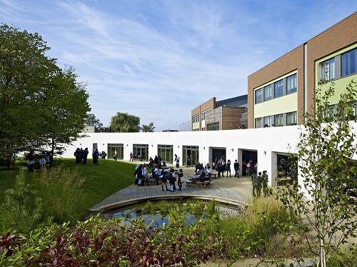

For further information about our school please visit our website: [**www.wsfg.waltham.sch.uk**](http://www.wsfg.waltham.sch.uk)