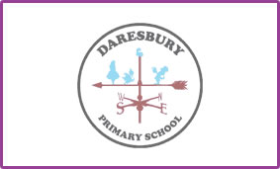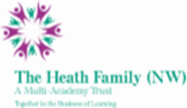

Dear Potential Candidate,

Thank you for showing interest in our current vacancy for a Deputy Head of School. This vacancy has arisen due to increasing numbers at the school as well as a recent leadership restructure.

Daresbury Primary School is a growing school with 183 children currently on roll, organised into 7 classes. The long term plans over the next 2 years have us increasing our numbers annually until we reach 210 on roll. These plans also include some new building at the school, so there are exciting times ahead.

You would be joining a staff of over 20 who all work together to help make Daresbury Primary School a happy and positive environment for all of our children, parents and wider community. Your role would involve taking responsibility for a class (year group to be confirmed at a later date) as well as leading on key aspects of the school including Behaviour and Attitudes and Personal Development.

We very much hope, having read all the information provided, that you decide to apply to become part of the staff team at Daresbury Primary School. If you require any further information please do not hesitate to get in touch via email or by telephone.

Kind regards

Paul Holloway

Executive Principal

Daresbury Primary School

