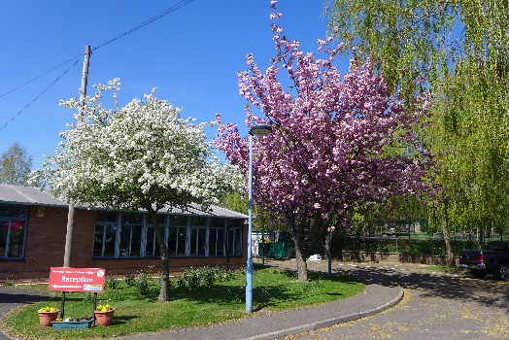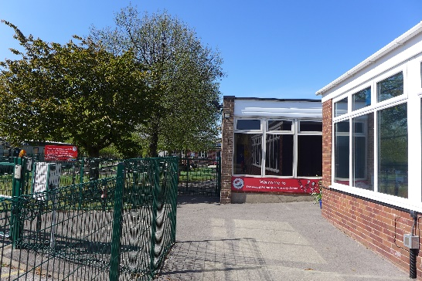

We are looking for an enthusiastic, energetic, experienced primary practitioner with vision and commitment to become one of our two Deputy Heads of School.

You must have a comprehensive understanding of primary practice from 3 to 11 years and be able to demonstrate the ability to lead and manage others to ensure our standards in all aspects of school life remain at the highest.

You would be joining a Leadership Group consisting of two Deputy Heads of School, our Head of School and our Executive Head Teacher. This Senior Team is supported by 5 Lead Practitioners.

We are a 5 form entry primary school serving a richly diverse community in Wollaton, a suburb of Nottingham City.

We are proud to be part of Nottingham City and Nottingham Schools Trust.

We have 1088 children on roll including our 52 place Nursery and 10 place Enhanced Provision. We have 3 buildings (to become 4 in September 2021) all on one site.

Although we are so large, we pride ourselves on having a Fernwood team ethos supporting one another in all we do. The Governing Body is an integral part of this team.

The children are always at the centre of our thoughts and developments, their safeguarding and well- being our priority. We put great emphasis on our inclusive approach which is held in high regard by our parents – ‘Excellence for All’.

Finally but most importantly our children will welcome you and delight you as a teacher with their creativity, independence and confidence. Please have a look at our Twitter page @Fernprimary and school website.

If you are interested in the position of Deputy Head of School, please make an appointment via either school office to be taken on a tour of the school by our Head of School, Lynne Orme or Executive Head Teacher, Mandy Austin.

Please read the job description and person specification below.

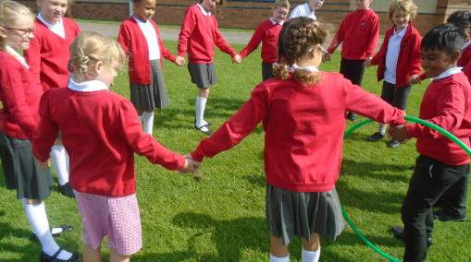

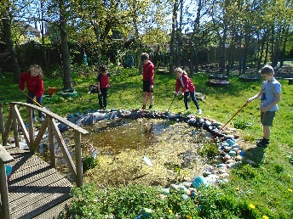



**Nottingham City Council**

**Deputy Head of School**

**Fernwood Primary & Nursery School**

**Job Description**



**Responsible to:** The Executive Head Teacher and Governing Body of Fernwood Primary & Nursery School

**Job Purpose:** To promote professional leadership and management within the school; to secure high quality teaching and provide a curriculum that promotes the highest standards of learning and achievement for all pupils

In addition to the job requirements set out in the School Teachers’ Pay and Conditions Document the Deputy Head of School will:-

* Support the Executive Head Teacher and Head of School in all areas of school life
* Work across the whole of the primary site supporting all teams and children (1088 + children, 160 + staff)
* Accept the day to day responsibilities of leading the school in the absence of the Head of School and Executive Head Teacher.

**In addition –**

**Key accountabilities**

1. **Creating the future of the school**

* Support the vision of Fernwood Primary & Nursery School
* Assist the Leadership Group in the development and implementation of the school’s annual action plan.

1. **Leading teaching and learning in the school to**

* Assist the Executive Head Teacher and Head of School to promote a high quality of teaching and learning
* Provide a role model of ‘good’/’outstanding’ teaching and learning throughout the primary phase; teach a class / groups as required annually
* Complete the duties of a Performance Management Team Leader / Appraiser
* Annually up-date the Whole School Curriculum Plan
* Thoroughly monitor teachers’ planning and give constructive feedback
* Plan and develop curricular initiatives.

1. **Standards/review and pupil progress**

* Assist the Executive Head Teacher and Head of School to track and analyse the progress and outcomes of individual pupils, identified groups of pupils, year groups and the whole school
* Assist senior staff in monitoring the annual reports of pupils’ progress
* Lead pupil progress interventions, including those of vulnerable groups, across the school.

1. **Promote positive behaviour**

* Lead the school in positive behaviour management, developing whole school behaviour initiatives, working with other staff to address specific interventions and maintaining appropriate records
* Promote and support good practice in behaviour management
* Encourage pupils to have a clear understanding of values, self-discipline, self-respect and respect for others
* Ensure good behaviour is maintained at all times during the school day particularly at lunchtime and whenever pupils are engaged in authorised school activities on or off school premises.

1. **Promote high levels of attendance**

* Assist other members of the Leadership Group to ensure that all children attend school daily
* Assist with the monitoring of persistent absence and take positive action where necessary.

1. **Develop self and others**

* Mentor, guide and advise new teachers to the school
* Support teaching staff who may need assistance to improve their knowledge, skills and practice in teaching and learning
* Develop, maintain and oversee the Continuous Professional Development of all Teaching Assistants.

1. **Managing the organisation**

* Produce an action plan for the school, for the year ahead, interpreting and disseminating the annual action plan and liaising with others to ensure that this is implemented across the school
* Work in close liaison with all members of the Fernwood Primary & Nursery School Leadership Group
* Liaise closely with all other senior staff particularly the other Deputy Head of School
* Assist the Head of School with routine procedures which ensure the smooth running of the school e.g. rotas, timetables, staff board, lunchtime responsibilities
* Lead on the line management, performance, deployment and CPD of individuals within the TA Team
* Lead and deploy the Midday Supervisors Team
* Regularly lead significant assemblies in both buildings
* Spend sufficient time in each building so that the staff, pupils and parents recognize you as a Primary Deputy Head of School
* Attend whole school meetings and events.

1. **Securing accountability**

* Contribute to, and articulate, a Fernwood Primary & Nursery School ethos which enables everyone to work collaboratively
* Support the Executive Head Teacher and Head of School to ensure that individual staff accountabilities are clearly defined, understood and agreed within the school
* Ensure, in conjunction with other members of the Leadership Group, that every child has access to high quality teaching and learning within the school
* Attend relevant Governing Body meetings and work with individual governors, or groups of governors, when required.

1. **Strengthening the community**

* Work closely with parents and members of the wider community to foster positive relationships, support pupils and encourage involvement in all aspects of school life
* To work closely with the Friends of Fernwood
* Collaborate with other agencies to ensure pupil and community needs are met
* Support and assist pupils in making a successful transition to each next phase of education.

1. **Premises**

* Assist the Head of School and Executive Head Teacher to manage the safety of the site, day to day security and effective supervision of the school buildings, their contents and of the school grounds
* Liaise with other site users as required.

1. **Safeguarding and promoting the welfare of children**

* Assume the responsibilities of a senior Designated Safeguarding Lead
* Assume the responsibilities of the Looked After Child Designated Teacher role with assistance from the Lead Professionals
* Promote and safeguard the welfare of children in the school
* Ensure that safeguarding procedures are followed closely by all staff
* Demonstrate commitment to pupils’ individual social and educational development and well-being.

1. **Health and Safety**

* Support the Head of School to ensure that the school complies with Health and Safety at Work legislation and related guidance and school procedures
* Update all risk assessment annually
* Take responsibility for the completion of all health and safety referrals and oversee all health and safety records.

1. **Other duties as considered appropriate**

* Daily and weekly duties to be agreed with the Head of School/Executive Head Teacher
* Undertake any other reasonable duties that may be required from time to time commensurate with the post of Deputy Head of School.

*This job description may be amended at any time after discussion with the Executive Head Teacher and annually when key tasks related to the schools’ priorities are determined.*

**'This school is committed to safeguarding and promoting the welfare of children and young people and expects all staff and volunteers to share this commitment'**

**Nottingham City Council**

**Deputy Head of School**

**Fernwood Primary & Nursery School**

**Person Specification**



|  |  |  |  |
| --- | --- | --- | --- |
|  | Application | Interview | Test |
| **CAREER EXPERIENCE AND QUALIFICATIONS** | X | X |  |
| * Degree level qualification | X | X |  |
| * Qualified Teacher Status | X | X |  |
| * Relevant recent professional development | X | X |  |
| * Record of successful class teaching with at least three years teaching experience in a primary school | X | X |  |
| * Has had a substantive leadership role in a school for 3 years | X | X |  |
| **LEADERSHIP SKILLS** |  |  |  |
| * A good understanding of school leadership | X | X |  |
| * Experience of overseeing the successful delivery of teaching and learning against agreed strategic plans and able to demonstrate a strong commitment to raising standards of achievement for all pupils | X | X |  |
| * Ability to lead by example, be highly driven, motivated and be able to motivate others | X | X |  |
| * Ability to promote the school’s vision and values to the pupils, staff, governors and parents at the school | X | X |  |
| * Ability to be flexible in a constantly changing work environment | X | X |  |
| * Ability to accept day to day responsibility for running a school | X | X |  |
| * Ability to work in close partnership with other education establishments and the Governing Body | X | X |  |
| * Experience of leading whole school developments and/or successfully managed projects | X | X |  |
| * Ability to use data, benchmarks and feedback to monitor progress of children’s learning | X | X | X |
| * Experience of managing and developing staff and carrying out performance reviews and monitoring outcomes and impact in line with the school’s strategic direction | X | X | X |
| * Commitment to the protection and safeguarding of children, with up-to-date knowledge of relevant legislation and training | X | X |  |
| * Ability to delegate responsibility and coach, mentor and develop others. | X | X |  |
| **OTHER SKILLS AND ABILITIES** |  |  |  |
| * Able to communicate clearly and effectively in written and spoken English in order to effectively engage with the school and local community | X | X |  |
| * Ability to apply analytical thinking to solve problems and/or resolve conflict | X | X | X |
| * Ability to provide a model of excellent teaching | X | X | X |
| * Able to lead the school in positive performance management and related initiatives, interventions and records | X | X |  |
| * Possess a thorough understanding of issues related to attainment and achievement of different groups of pupils within the school and able to analyse performance data and evaluate it in order to improve performance | X | X |  |
| * Ability to contribute to the design, implementation and review of the whole school curriculum | X | X |  |
| * Excellent ICT skills | X | X | X |
| * Ability to maintain positive behaviour management practices | X | X |  |
| * Can effectively manage time and priorities | X | X |  |
| * An understanding of working in an urban, culturally diverse community. | X | X |  |
| **PERSONAL QUALITIES** |  |  |  |
| * Ability to maintain a professional and confident manner and remain calm under pressure and demonstrate resilience | X | X | X |
| * Ability to inspire the respect and trust of all stakeholders | X | X |  |
| * Demonstrates warmth and empathy together with high expectations and rigour | X | X |  |
| * Can articulate a commitment to every child | X | X |  |
| * Displays self-confidence, a sense of humour and a positive approach at all times | X | X | X |
| * Is approachable by all members of the school community and is a good listener | X | X |  |
| * Demonstrates high standards of conduct and appearance. | X | X |  |

Please note that the elements of this person specification may be assessed via application, interview and/or test as indicated.

**‘This school is committed to safeguarding and promoting the welfare of children and young people and expects all staff and volunteers to share this commitment.’**