
Deputy Head of Science Faculty

Kirkby High School
Recruitment Pack



CONTENTS
Letter from Headteacher
About us
Coninuous Professional Development
Job Description
Person Specification
How to Apply
Application Form
Welcome
Dear Applicant,
Thank you for your interest in the deputy head of science faculty position at Kirkby High School.
Due to the promotion of the current postholder, we are seeking to appoint a dedicated and enthusiastic individual who is ambitious and has an excellent work ethic to commence January 2027.
Our vision is a community driven by high expectations and mutual respect providing all individuals with the belief and opportunities to succeed now and in the future.
To help you decide if the job would suit you, please find enclosed some details, which we hope will give you a flavour of what Kirkby High School and The Rowan Learning Trust are about.
If your values and ambitions mirror ours and you believe you can deliver that vision, then we would be delighted to receive an application from you.
Visits to the school our welcome. If you have any specific queries please or would like to arrange a visit please contact my PA, Jo Barrett j.barrett@kirkbyhighschool.net
We are committed to safeguarding all members of our community; therefore, all posts are subject to enhanced disclosure procedures and pre-employment checks.
Yours faithfully,
Mrs A Dobson
Headteacher, Kirkby High School


Kirkby High School
Kirkby High School is an 11-16 mixed comprehensive of around 1000 students where we continually strive to provide the highest standards for our whole school community. All staff at Kirkby High School fully embrace our mission: Maximising our Potential. Leading this wonderful school fills me with great pride.

Kirkby High School stands at the centre of our local community and we believe that we offer our young people guidance and aspiration to be the best they can be in all aspects of life. We want to provide all students with the opportunities to develop into well-rounded individuals, successfully both academically and personally. We are determined to ensure every child reaches their potential. Our vision is a community driven by high expectations and mutual respect providing all individuals with the belief and opportunities to succeed now and in the future.
We believe in building a culture of resilience, kindness, respect, aspiration and confidence in which our students can thrive. These are our

Kirkby Child values. These values are a set of core principles for our students and underpin the whole ethos of our school.

I hope you find all the information you need. If you wish to know more, or if you would like to arrange a school tour, please don’t hesitate to get in touch.

Mrs A Dobson
Headteacher

Confidence Kindness Aspiration Respect Resilience.


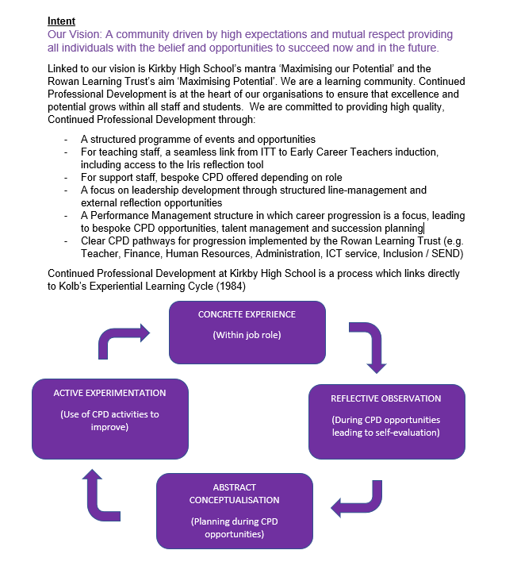
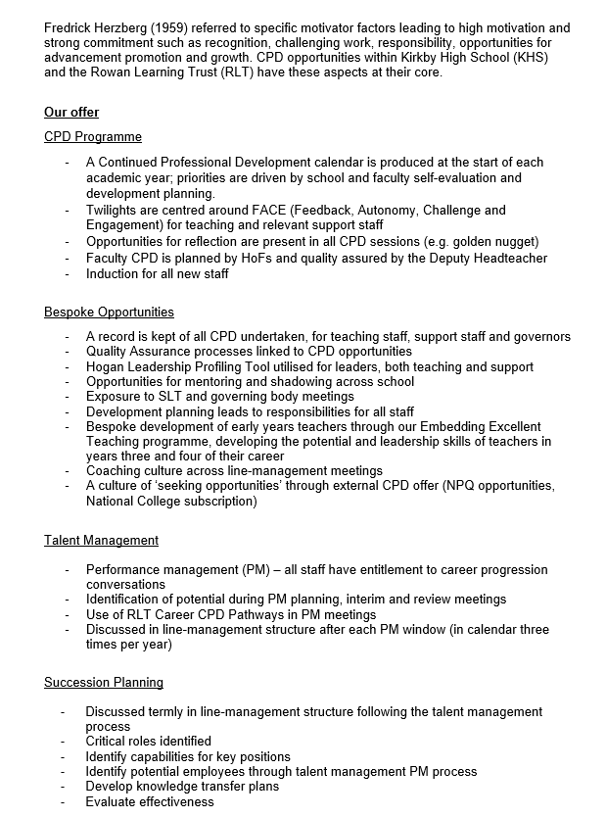
Continued Professional
Development Framework

Job Description

Overall purpose of post
- Carry out the professional duties of a school teacher as set out in the current School Teachers' Pay and Conditions Document (STPCD).
- Support the Head of Faculty and deputise when and where appropriate.
- Raise standards of student attainment and achievement within a specific area of the subject and monitor and support student progress.
- Be accountable for student progress and development within a specific area of the subject.
- Develop and enhance the teaching practice of others.
- Ensure the provision of an appropriately broad, balanced, relevant and differentiated curriculum for students studying in the department, in accordance with the school's aims and curricular policies.
- Be accountable for leading, managing and developing a specific area of the subject.
- Manage effectively and deploy teaching/support staff, financial and physical resources within a specific area of the subject.

Teaching
- Undertake an appropriate programme of teaching in accordance with the duties of a standard scale teacher

Strategic / Operational Planning
- Lead the development of appropriate syllabuses, resources, schemes of work, marking policies, assessment and teaching and learning strategies in a specific area of the subject.
- Be responsible for the day-to-day management, control and operation of course provision with the subject, including effective deployment of staff and physical resources.

- Monitor actively and follow up student progress to maximise value added attainment, including students with SEND.
- Implement school policies and procedures, e.g. equal opportunities, health and safety, COSHH, accommodation strategy, etc.
- Work with colleagues to formulate aims, objectives and strategic plans which have coherence and relevance to the needs of students and to the aims, objectives and strategic plans of the school.
- Lead and manage the planning function of the specific area of the subject, and to ensure that the planning activities of the department reflect the needs of students within the subject area, SDP/DDP and the aims and objectives of the school.
- Link with staff to ensure that the work in the curriculum area fully reflects the school's distinctive ethos and mission.
- Foster and oversee the application of I.C.T, including the development of materials to support the curriculum and students’ learning.
- Ensure that health and safety policies and practices, including risk assessments, throughout the department are in-line with national requirements and are updated where necessary, therefore liaising with the school's health and safety manager.

Curriculum Provision
- Liaise with the head of faculty to ensure the delivery of an appropriate, comprehensive, high quality and cost-effective curriculum programme which complements the school development plan.
- Be accountable for the development and delivery of a specific area in the subject.

Curriculum Development
- Lead curriculum development for a specific area of the subject.
- Keep up to date with national developments in the subject area and teaching practice and methodology.
- Actively monitor and respond to curriculum development and initiatives at national, regional and local levels.
- Liaise with the designated member of SLT to maintain accreditation with the relevant examination and validating bodies.
- Be responsible for the development of key skills within the curriculum area.
- Ensure that the development of a specific area of the subject is in line with the Rowan Learning Trusts policy and practice.

Staffing
- Work with the head of faculty and designated member of SLT to ensure that staff development needs are identified and that appropriate programmes are designed to meet such needs.
- Continue own professional development.

DEPUTY HEAD OF FACULTY – SCIENCE
Reports to: Head of Faculty
Location: Kirkby High School, Bracknell Avenue, Kirkby, L32 9PP
Salary: Classroom Teachers’ Pay Scale + TLR2B
Hours: Full time as specified within STPCD

Communications and Liaison
- Ensure that all members of the department are familiar with its aims and objectives.
- Ensure effective communication/consultation as appropriate with the parents of students.
- Liaise with partner schools, higher education, industry, examination boards, awarding bodies and other relevant external bodies, as appropriate.
- Represent the views and interests of a specific area of the subject.
- Contribute to the planning and delivery of school liaison activities.
- Lead the development of effective subject links with partner schools and the community, promoting the subject effectively at liaison events in school, partner schools and the wider community.
- Promote actively the development of effective subject links with external agencies.

Management of Resources
- Manage the available resources of space, staff, money and equipment efficiently within the limits, guidelines and procedures laid down; including deploying the department budget, acting as a cost centre holder, requisitioning, organising and maintaining equipment and stock, and keeping appropriate records, relevant to a specific area of the subject.
- Work with the head of faculty and designated member of SLT in order to ensure that the teaching commitments are effectively and efficiently time-tabled and roomed within the specific area of the subject.

Pastoral System
- Monitor and support the overall progress and development of students within a specific area of the subject.
- Monitor student attendance together with students' progress and performance in relation to targets set for each individual, ensuring that follow-up procedures are adhered to and that appropriate action is taken where necessary.
- Act as a form tutor and to carry out the duties associated with that role as outlined in the generic job description/staff handbook.
- Contribute to the personal development programme according to school policy.
- Ensure the behaviour management policy is implemented in the department so that effective learning can take place.

School Ethos
- Play a full part in the life of the school community, to support its distinctive mission and ethos and to encourage and ensure staff and students to follow this example
- Support the school in meeting its legal requirements for worship.
- Promote actively the school’s corporate policies.
- Comply with the school's health and safety policy and undertake risk assessments as appropriate.

- Be responsible for the efficient and effective deployment of support staff in a specific area of the subject.
- Undertake performance management review(s) and to act as reviewer for a group of staff within the department.
- Make appropriate arrangements for classes when staff are absent, ensuring appropriate cover within a specific area of the subject.
- Participate in the interview process for teaching posts when required and ensure effective induction of new staff in line with school procedures.
- Promote teamwork and motivate staff to ensure effective working relations.
- Participate in the school’s ITT and induction programme, as required.
- Be responsible for the day-to-day management of staff within a specific area of the subject and act as a positive role model.

Quality Assurance
- Ensure the effective operation of quality control systems.
- Establish the process of the setting of targets within a specific area of the subject and to work towards their achievement.
- Establish common standards of practice within a specific area of the subject and develop the effectiveness of teaching and learning in line with school policy and practice.
- Contribute to the school procedures for lesson observation and feedback.
- Implement school quality procedures and ensure adherence to those within a specific area of the subject.
- Monitor and evaluate the curriculum area in line with agreed school procedures including evaluation against quality standards and performance criteria.
- Seek/implement modification and improvement where required.
- Ensure that the department's quality procedures meet the requirements of The Rowan Learning Trusts self-evaluation process.

Management Information
- Ensure the maintenance of accurate and up-to-date information concerning a specific area of the subject on the management information system.
- Make use of analysis and evaluate performance data provided.
- Identify and take appropriate action on issues arising from data, systems and reports; setting deadlines where necessary and reviewing progress on the action taken.
- Produce reports within the quality assurance cycle for a specific area of the subject.
- Produce reports on examination performance, including the use of value-added data.
- Manage the collection of relevant data for a specific area of the subject.
- Provide relevant information relating to the department performance and development for a range of audiences, including the governing body.

Please submit the enclosed application form and a supporting statement of no more than two sides of A4 outlining why you are interested in the opportunity and how your application addresses the requirements for the role.
Applications should be returned electronically to j.barrett@kirkbyhighschool.net
Alternatively, send a hard copy to:
Mrs A Dobson
Headteacher
Kirkby High School
Bracknell Avenue
Kirkby
L32 9PP

Closing date for applications: 12 noon, Friday 25th September 2026
Person Specification
Essential

- An ability to teach science up to KS4

- A consistently good or better classroom teaching standard

- A track record of high value added scores with respect to student progress

- An excellent record of attendance and punctuality

- The ability to develop effective working relationships with students

- A high degree of self-management and organisation

- An enthusiasm and passion for the teaching of science

- A thorough knowledge of the National Curriculum and awareness of KS3 and KS4 curriculum changes

- A commitment to continuing professional development

- The ability to command the respect of staff and students

- A willingness to take part in extra-curricular activities

- A willingness to share best practice and to learn from others

- The ability to work as a supportive team member

- Excellent ICT skills to aid the delivery of the curriculum

- A desire and willingness to explore innovative methods of curriculum delivery to capture the imagination of the students

- The potential and desire to become a head of faculty in the future


How to Apply


The Trust will make any necessary reasonable adjustments to the job and the working environment to enable access to employment opportunities for disabled job applicants or continued employment for any employee who develops a disabling condition.
All appointments are subject to satisfactory references, proof of qualifications and eligibility to work in the UK.
The Trust is committed to safeguarding and promoting the welfare of all children and young people and expects all staff to share this commitment. An enhanced DBS check will be required.

The Trust will make any necessary reasonable adjustments to the job and the working environment to enable access to employment opportunities for disabled job applicants or continued employment for any employee who develops a disabling condition.
All appointments are subject to satisfactory references and eligibility to work in the UK.
The Trust is committed to safeguarding and promoting the welfare of all children and young people and expects all staff to share this commitment. An enhanced DBS check will be required.


The Rowan Learning Trust
Registered Office: 18 Beecham Court, Goose Green, Wigan, WN3 6PR
Company Number 8010464



KIRKBY HIGH SCHOOL

JOB APPLICATION FORM FOR TEACHING STAFF IN SCHOOLS

The School and Governing Body are committed to equal opportunities in employment and welcome applications from all sections of the community.

BRACKNELL AVENUE,

KIRKBY, MERSEYSIDE, L32 9PP

TELEPHONE: 0151 477 8710

FACSIMILE: 0151 477 8715

EMAIL: admin@kirkbyhighschool.net

- POST APPLIED FOR

Post Applied For:
School: | Kirkby High School
As advertised in: |  | On date:

2. PERSONAL DETAILS

SURNAME: |  | FORENAME:
TITLE:  (Optional) |  | Date of Birth:  (Optional)
Address:
POSTCODE: |  | Email:
Telephone No: |  | Mobile No:
Email: |  | DfE No:

3. CURRENT POST
SCHOOL/SERVICE:
LOCAL EDUCATION AUTHORITY:
JOB TITLE:
DATE OF APPOINTMENT: |  |  | SALARY:
TLR/ Recruitment and Retention Allowance (please specify as applicable)
MAIN DUTIES AND RESPONSIBILITIES
Reason for this application

4. EMPLOYMENT HISTORY
Post | Dates |  | Employer | Grade/Salary | Reason for Leaving
 | From | To

5. GENERAL EDUCATION
School | From | To | Qualifications – Grades, awarding bodies and dates

6. FURTHER AND HIGHER EDUCATION
Name of College/ University | From | To | Qualifications – Grades, awarding bodies & dates

7. ANY OTHER RELEVANT QUALIFICATIONS
Please give details of any other relevant qualifications you have for this post.

8. ADDITIONAL INFORMATION
Are you related to, or a close friend of, any member of the Trust or of the Governing Committee of the school? (If yes, please state relationship) | Yes / No
Have you left any previous job for the reason of redundancy or are you in receipt of an occupational pension?  (If yes, please give details) | Yes / No
Have you ever been dismissed from any previous employment on the grounds of misconduct or incapability?  (If yes, please give details) | Yes / No
Do you hold a current and valid driving licence?  (if yes, please state the category) | Yes / No
The Rowan Learning Trust is committed to providing equal opportunities and supporting all applicants. If you require any reasonable adjustments to allow you to participate in the application process, please let us know.
Do you require any reasonable adjustments? YES/NO

9. CRIMINAL CONVICTIONS OR CAUTIONS
You should note that the disclosure of any offence will not necessarily prevent the Rowan Learning Trust from employing you, but we reserve the right to consider its significance in relation to working with children.

Work at the school is exempt under the Rehabilitation of Offender Act 1974. Any offer of appointment will be dependent upon the successful completion of the Disclosure and Barring Service (DBS) check at the Enhanced level.

Where serious concerns as to an individual’s suitability to work with children are expressed, the facts will be reported to the relevant authorities.
In line with Keeping Children Safe in Education (KCSIE) guidance, are you currently subject to any criminal investigation, police enquiry, arrest, charge, caution, conviction, or other matter that may be relevant to your suitability to work with children and young people?  If yes, please forward details (date, offence and sentence) with a covering letter, in a sealed envelope marked “Addressee Only – Headteacher”. | Yes / No
Do you have any adult cautions (simple or conditional) or spent convictions that are not protected as defined by the Rehabilitation of Offenders Act 1974 (Exceptions) Order 1975 (Amendment) (England and Wales) Order 2020? | Yes / No
In line with Keeping Children Safe in Education, The Rowan Learning Trust will undertake general online searches for all shortlisted candidates which may include social media and video platforms. Online searches will only examine data which is publicly available, and the aim is to identify any incidents or issues. Any areas of concern will be discussed during the interview process.
10. REFERENCES
Please state the names and addresses and telephone numbers of two persons from whom references may be obtained. One must be your current or most recent employer. In the absence of previous employment experience, a reference from your last place of full-time education will be a suitable alternative.
REFEREE 1 |  |  |  |  | REFEREE 2
TELEPHONE NO: |  |  |  |  | TELEPHONE NO:
EMAIL: |  |  |  |  | EMAIL:
Reference Type:  (Please circle) | Employer |  | Education | Character | Reference Type:  (Please circle) | Employer |  | Education | Character
Please note that we will contact these referees if you are short-listed for this post and seek references before interview.

11. FURTHER INFORMATION FOR CANDIDATES
- You will receive no further communication unless selected for interview. If you have therefore not been contacted within three weeks of the closing date for applications, you should conclude that, unfortunately, you have been unsuccessful on this occasion.
- In the interests of the protection of children, all posts are subject to enhanced criminal record and other relevant disclosures through the Disclosure & Barring Service (DBS). A criminal record will not necessarily prevent you from obtaining a position.
- Under the Data Protection Act, the Trust and the Governing Body will use the information given for the purpose of recruitment and selection. Strict confidentiality will be observed and if you become an employee, the information will be used for personnel, pay and pensions administrative purposes only.
- To comply with the Asylum and Immigration Act 1996 (as amended by S.147 of the Nationality, Immigration and Asylum Act 2002), all prospective employees will be required to supply evidence of eligibility to work in the UK. If you are appointed to the post you will be provided with further information detailing what documents will be required.

THANK YOU FOR YOUR INTEREST SHOWN IN THIS APPOINTMENT

12. DECLARATION
To the best of my knowledge and belief all the particulars I have given are true. I understand that any false statements may disqualify me from employment or render me liable for dismissal. I also understand that no offer of employment made to me will be binding unless confirmed in writing.
I also understand that this post is subject to a satisfactory enhanced Disclosure and Barring Service (DBS) check and to satisfactory medical clearance and the provision of documentary evidence (e.g. NI Number) that shows I am entitled to work in the U.K.

Signature:……………………………………………………………………………Date:………………

