DEPUTY HEAD OF SCIENCE
Maternity Cover
MPS/UPS + TLR
Required As Soon As Possible

Candidate Pack

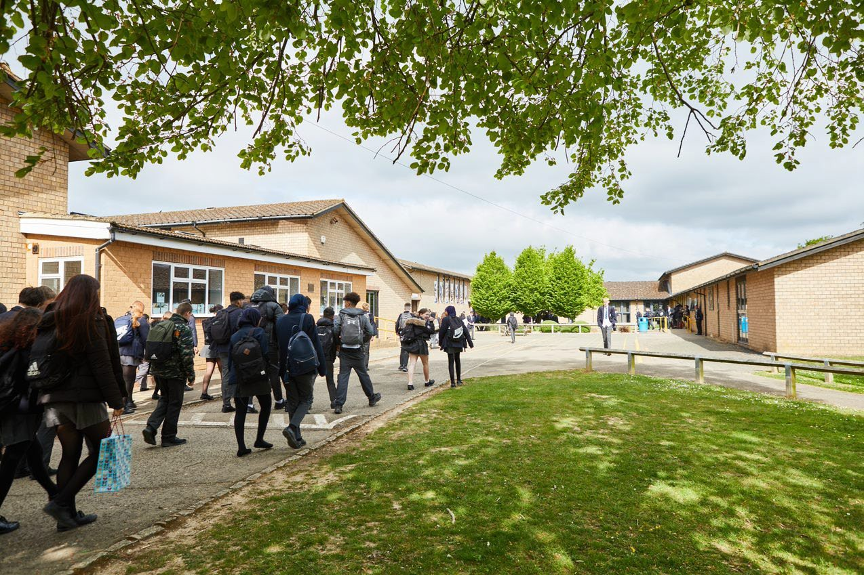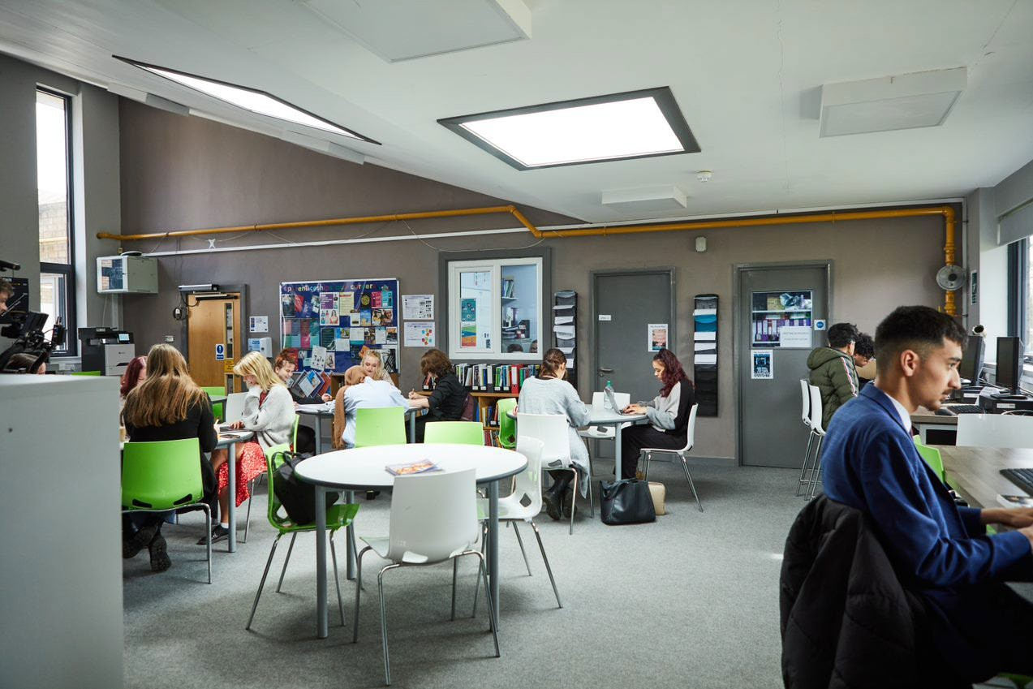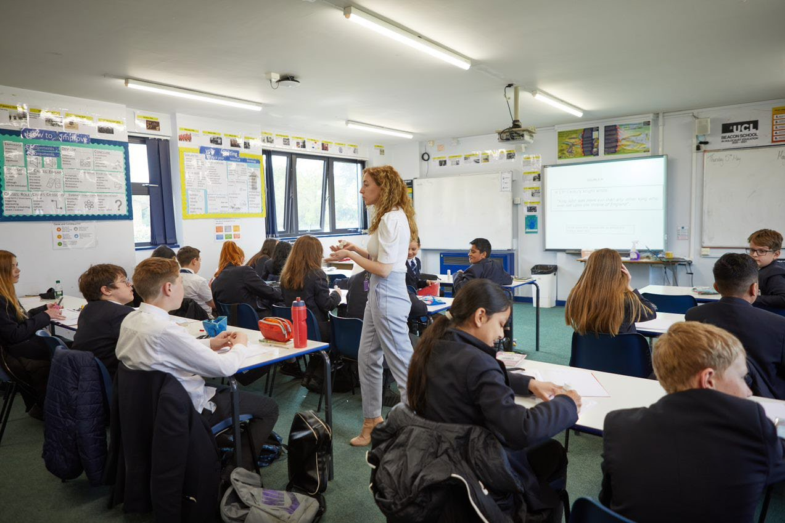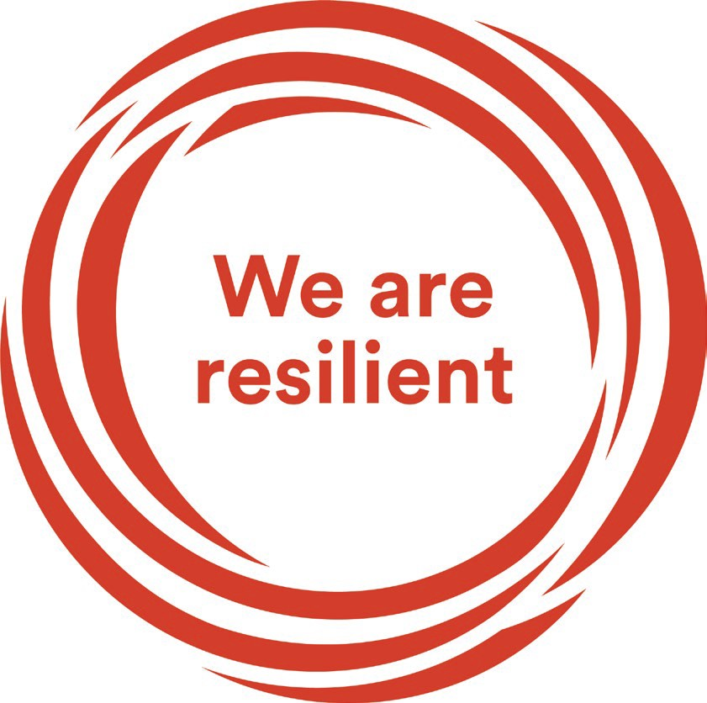
Welcome letter from the Headteacher

Dear Prospective Candidate,

Thank you for your interest in the position of Deputy Head of Science at Sir William Ramsay School.

I joined Sir William Ramsay School as the new Headteacher in May and am committed to getting the school back to ‘Good’ as quickly as possible. Clarity, consistency and rigour are central to our plans to ensure that all students enjoy learning and make good progress. Our plans include significant developments in high quality teaching and learning, the introduction of ambitious targets, a focus on developing excellent teaching, meaningful homework and improvements in behaviour for learning. We are also rolling out a digital learning 'One to One Device' strategy across the school to ensure that students can receive innovative teaching and access state of the art resources at both home and school.

We are seeking to appoint a dynamic and inspirational Deputy Head of Science who is well qualified and enthusiastic about teaching and learning. The successful candidate will be forward thinking with a focus on developing exciting and engaging learning experiences.

The ideal candidate will have a belief in the ability of all students to achieve and a passion for raising student achievement. You will have a desire to strive for continuous school improvement and a commitment to team work as well as a sense of fun.

If you would like to find out more about the role or to arrange a conversation with the Head of Faculty, please contact PBrown@swr.school

I will hope to meet you in the near future.

Yours faithfully

Paul Ramsey
Headteacher

Vision and Values at Sir William Ramsay School

Empowering Everyone to Achieve

Vision
A community where every voice counts, where talent and creativity are brought to life, where students grow in confidence, build resilience and are prepared for the rest of their lives.

Values
- We are respectful – we always treat people, property and the environment with kindness and consideration
- We are ambitious – we ask for help when we need it and strive to be the best we can be
- We are reliable – we do what is asked of us and deliver on our commitments
- We are resilient – we prepare for the future and adapt and grow from challenges

Mission
We aim to achieve our vision by:
- Raising students above the ordinary by developing and delivering lifelong learning which transforms lives
- Ensuring every person feels valued, safe and happy
- Enabling students to feel proud of themselves, and to take pride in the success of others
- Promoting a culture of mutual respect where everyone is treated as a valued member of the school community
- Encouraging positive communication so that words and actions are thoughtful, supportive and motivational
- Placing parents and carers at the heart of the life of the school
- Having highly dedicated and well-qualified staff who are committed to continuous professional development
- Adopting an ethos of continuous improvement within all aspects of school life

Equality
Sir William Ramsay is an inclusive and diverse community. We work to eliminate all forms of discrimination on the grounds of ethnic origin, religion, sexual orientation, gender, disability or ability. This is achieved via the following principles:
- Ensure that students have the opportunity to reach their potential in all areas of school life
- Ensure that parents and students can make choices free from prejudice and stereotyping
- Oppose any form of racism, sexism, disability discrimination, homophobia or any other form of discrimination
- Value every student’s language and cultural background

JOB DESCRIPTION

 | Job Title: | Deputy Head of Science Faculty (Maternity)
 | Grade: | Main or Upper Pay Range plus TLR 2b
 | Reports to: | Head of Science Faculty
 | Responsible for: | And accountable for the learning, teaching, achievement, behaviour, well-being and personal development of all students in Years 10 and 11 Triple Science, post-16 courses in the Faculty ensuring equality’s of opportunity for all.  And accountable for the learning, teaching, achievement, behaviour, well-being and personal development of the more able and disadvantaged students in Science across the Faculty ensuring equality of opportunity for all.  And being accountable for achieving the highest possible standards in work and conduct.

Purpose of the job
- To lead the development of curriculum in line with the whole school Curriculum Intent of Years 10 and 11 Triple Science, all Years 12 and 13 courses in the Faculty.
- To lead on the development and implementation of resources, schemes of work, policies, assessment, teaching, learning and behaviour strategies across the Faculty in Years 10 and 11 Triple Science and all Years 12 and 13 courses.
- To monitor progress, learning, interventions, behaviour and teaching in the Faculty of Years 10 and 11 Triple Science and all Years 12 and 13 courses, the more able and disadvantaged students and use this information to improve the quality of provision.
- To support the Head of Faculty with the implementation of up to date Health and Safety policy, practice and monitoring across the Faculty.
- To deputise for the Head of Faculty.
- To act as a positive role model and to lead by example.
- To create and deliver engaging lessons to diverse groups of students at all levels.
- To promote and inspire enthusiasm for learning and for subjects.
- To promote high standards of student behaviour.

Main Responsibilities as a Deputy Head of Faculty
- To support the writing and monitoring of Faculty Improvement Plan.
- To support the writing and implementation of a Faculty Handbook.
- To lead curriculum development in Years 10 and 11 Triple Science, all Years 12 and 13 courses.
- To actively monitor and respond to curriculum development and initiatives at a school, local and national level.
- To keep up to date with national developments in the subject area and teaching practice and methodology.
- To support the establishment of common standards of practice within the Faculty and support the development of effective teaching and learning across the Faculty.

- To monitor student progress, learning and teaching in the department and use this information to improve the quality of provision and student outcomes in Years 10 and 11 Triple Science, all Years 12 and 13 courses and of the more able and disadvantaged students.
- To ensure timely and effective interventions are in place to address student progress issues of Years 10 and 11 Triple Science, all Years 12 and 13 courses and of the more able and disadvantaged students.
- To ensure the school and Faculty behaviour policy is implemented consistently in Years 10 and 11 Triple Science, all Years 12 and 13 courses and of the more able and disadvantaged students so that effective learning can take place.
- To be responsible with recruitment of Triple and KS5 students in Science, via open evenings, parental communication and liaising with the Sixth Form Team.
- To ensure the maintenance of accurate and up-to-date information in the school’s management information system.
- To ensure staff within the Faculty keep up to date records of marks/assessments.
- To analyse and evaluate performance data provided.
- To identify and take appropriate action on issues arising from data systems and reports and to set deadlines where necessary and review progress on the action taken.
- To produce reports on examination performance, including the use of value-added data.
- To ensure effective communication/consultation as appropriate with the parents of students.
- To line manage, challenge and support any teachers or Support Staff as required in the school’s structure.
- To work with the Head of Faculty to make appropriate arrangements for classes when staff are absent, ensuring appropriate cover within the Faculty liaising with the Lead Cover Supervisor/relevant staff to secure appropriate cover within the department
- Working with the Professional Tutor to assist/support the development of staff within initiatives such as NQT, OTT and PGCE.
- To develop effective subject links with partner schools and the community, attendance where necessary at liaison events in partner schools and the effective promotion of subjects at Open Days/Evenings and other events such as Awards Evenings.

Main Responsibilities as a classroom teacher
- To prepare and deliver high quality, engaging and challenging lessons to a range of classes of different abilities and ages, differentiating work as required, considering prior knowledge and incorporating literacy and numeracy.
- To incorporate the strategies in place for students, for example from Student Passports, into planning so individual needs are met.
- To monitor student progress and put in place appropriate intervention strategies as required.
- To mark work, give appropriate feedback and maintain records of students’ progress and development.
- To be accountable for the students taught attainment, progress and outcomes.
- To maintain accurate and up-to-date electronic management information as required by the school such as safeguarding, progress data, test scores, student behaviours and achievements, notes of meetings with parents, interventions in place etc.

- To maintain up to date subject knowledge.
- To devise and write new curriculum materials for the team as required by the Head of Faculty.
- To select and use a range of different learning resources, ICT and equipment.
- To liaise with Learning Support Assistants (LSAs) or other professionals in the classroom to ensure that they know the teacher’s expectations for students they are supporting.
- To prepare students for qualifications and external examinations.
- To manage student behaviour in the classroom and on the school premises, and appropriate, consistent and effective measures in cases of misbehaviour.
- To undertake pastoral duties, such as being a Form Tutor, and supporting students on an individual basis through academic and personal difficulties.
- To communicate in a professional manner with parents/carers about their child’s progress.
- To support other colleagues.
- To promote positive self-esteem amongst students.
- To encourage positive attitudes and good behaviour amongst students.
- To develop social and emotional skills amongst students.

Other Responsibilities
- To promote the School’s vision, values and aims.
- To be aware of and comply with the codes of conduct, regulations, policies, procedures.
- To work as part of a team.
- To be generally responsible for safeguarding and promoting the welfare of students.
- To be responsible for own and team health and safety including well-being.
- To meet the Teacher Standards at a level relevant to the post-holder’s career stage.
- To actively participate in the School’s appraisal system.
- To do Continued Professional Learning as agreed with the Line Manager.

This job description is current but, in consultation with the postholder, it may be changed by the Headteacher to reflect or anticipate changes in the post commensurate with the grade or job title.

The Science Department

Teacher of Science
Team members share a commitment to raising standards of student achievement. We are keen to promote a department which accommodates a broad range of interests and abilities, whilst ensuring that every student is encouraged to reach their maximum potential. If you are enthusiastic, flexible, enjoy challenges and are committed to help us offer excellence in Science, then you are the person to join our progressive and forward-thinking team, which has rapidly raised the profile of Science and STEM at the school.

The Science Curriculum
At KS3, students study a broad curriculum that offers breadth of activity to allow students to experience many different aspects of Science, whilst offering enough depth to enable students to excel in a range of activities. Students are taught following the Kerboodle Activate scheme of work ranging from electricity to the skeleton.

In KS4 Core Science students follow the AQA Trilogy or Separate Sciences. This takes them into very difficult aspects of Science that allow them to work out which areas of Science may be for them in the future.

At KS4 we also offer BTEC Health & Social Care a coursework subject that has had some of the best results in the school over the last couple of years.

Students in the 6th form also have the option to study Biology, Physics or BTEC Health & Social Care.

Science Facilities
We have 3 new labs and 10 in total. Each teacher has their own lab where they will be based for all their lessons. One of the labs is used as a 6th Form Science study room. We have two Technicians and a large prep room that is fully stocked with chemicals and practical equipment to help teach excellent Science lessons.

Extra-Curricular Activities
We offer a STEM Science club that follows the Crest Award and we are open to more clubs and events being run by members of the team throughout the year.

How to Apply

If you wish to discover more about this exciting opportunity, need any further information or you wish to have an informal discussion, please contact Patrick Brown: PBrown@swr.school or 01494 815211.

Please email your completed application form to: jointheteam@swr.school

Closing Date: 9am, Monday 30th January 2023
Interviews: TBC

Sir William Ramsay School is committed to safeguarding and promoting the welfare of children and young people and expects all staff and volunteers to share this commitment. We will ensure that all our recruitment and selection practices reflect this commitment.

All successful candidates will be subject to DBS checks along with other relevant pre-employment checks.

