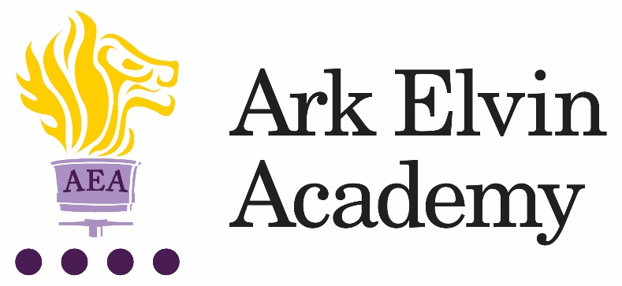

Deputy Head of Year (Non-Teaching)

At Ark Elvin Academy we are working hard to provide all our pupils with an excellent education and are looking for committed teachers and support staff to join us at this exciting stage in our school improvement journey. Our team of enthusiastic, high expectations staff have transformed our school and we are just as excited about the next step in our school improvement journey as we work together to deliver the outstanding education our community need and deserve. We are deeply committed to our mission:
“To ensure that every pupil leaves Elvin confident, articulate, and culturally aware; able to pursue careers they are passionate about, contribute to society and live happy, healthy and fulfilled lives.”
In our last OFSTED inspection (October 2019) it was recognised that at Ark Elvin Academy:
“Pupils, parents and staff all agree that Ark Elvin Academy has improved out of all recognition. Pupils are proud of the school.”
“The headteacher and leaders have very high expectations…… Staff want all pupils to succeed in every area of their lives, not just academically.”
“The school is a calm, safe and supportive place for pupils. Pupils behave very well in lessons. They get on well with one another and with adults.”
We are a large non-selective secondary school in the London borough of Brent, with excellent transport links to central London. We are committed to ensuring teachers can focus on teaching and have the opportunity to refine and develop their practice in the classroom and develop their leadership skills, we have:
- twice as many training days as is standard
- weekly professional development for all staff.
In recruiting our Deputy Head of Year, we are seeking the following from applicants:
- A growth mindset
- High standards of professionalism
- Courteousness
- The potential to be an exceptional leader

We passionately believe in our six pillars and they drive all our thinking and our school improvement at Elvin:

Strong Discipline
Calm, purpose and order are established through the consistency of expectations and explicit teaching of discipline.

High Quality Teaching
Teachers are subject experts with an excellent understanding of the intellectual journey they are taking their pupils on and have mastery in effective teaching skills.

Mastery Curriculum
Our curriculum design enables pupils to make rapid progress and develop a framework of knowledge and understanding in each subject area that provides a solid foundation for further study.

Raising aspirations and enrichment
Pupils understand the opportunities that a school and university education will afford them in terms of careers and quality of life. Pupils develop their passions and interests through an Our extensive enrichment programme.

Character development
Pupils develop the characteristics that support their academic achievement, create thoughtful citizens and allow them to make reflective choices over their personal lives.

Developing leaders
All members of staff see themselves as leaders within an aligned community of professionals and are systematically trained in best practice. We create high performing teams to drive our school improvement.

Ark Elvin is on an exciting improvement journey – join us and be part of that change.
We encourage and welcome you to visit our school; to arrange a visit, please contact our HR Advisor, Chantel Mutongole c.mutongole@arkelvinacademy.org or 020 8902 6362.

Closing date:  Interview: | Wednesday 20th October, 9am  TBC
Start date: | ASAP
Salary: | Ark Support salary band 6, Point 8 – 19, £23,517.42- £28,618.65 pro rata (actual salary £24,715 - £30,076 per annum)
Ark is committed to safeguarding children; successful candidates will be subject to an enhanced DBS check

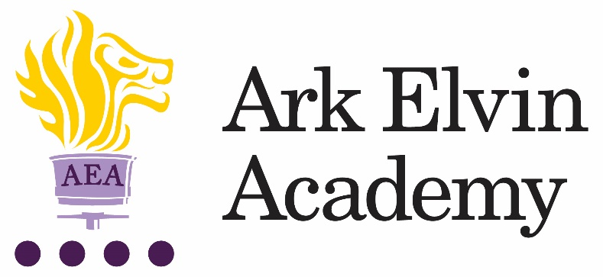
Job description: Deputy Head of Year (Non-Teaching)

Reporting to: Head of Year
Start date: ASAP
Location: Ark Elvin Academy
Contract: Full-time, permanent (40 hours per week) – working
hours to be agreed with line manager.
Salary: Ark Support salary band 6, point 8 – 19 £23,517.42-£28,618.65 pro rata (Actual salary £24,715- £30,076 per annum)

The role
At Ark Elvin Academy, we believe that ensuring an orderly and purposeful environment is key to supporting every child to work hard and make progress and we know that this is established through the consistency of expectations and explicit teaching of discipline. The role of the Deputy Head of Year is essential to supporting this.

The Deputy Head of Year supports strong discipline, character and raising aspirations, and by these actions, excellent teaching. The Deputy Head of Year supports the Head of Year in setting and maintaining the culture of the year group. They will model and lead by example the setting of high expectations of effort, achievement and conduct, raising pupil aspirations, developing good character and habits, offering encouragement and guidance and creating a year group environment that is mutually supportive, purposeful and stimulating. The Deputy Head of Year will support the Head of Year in leading year group activities such as assemblies, lunch and break time duties.

Key responsibilities
- To support the Head of Year in ensuring that all pupils are successfully inducted in the school’s values, policies and routines, and that these are understood and maintained throughout the year.
- To communicate the highest expectations of behaviour and consistently and effectively implement the Academy’s behaviour policy and procedures.
- To analyse and track behaviour data and support the Head of Year as required with the necessary pupil interventions.
- To take a lead role in supporting the Academy to reach its target of 97% attendance across all year groups by following up on all absences and implementing attendance interventions for pupils.
- To establish and communicate the highest expectations of attendance and punctuality for all pupils. To rigorously follow up any lateness to school.
- To work closely with relevant colleagues to ensure that pupils demonstrate positive behaviour and that teams are fostering the right culture.
- To facilitate restorative conversations between staff and pupils.
- To be a role model for pupils.
- To contribute to assemblies, pastoral initiatives and enrichment/intervention programmes.
- To take responsibility for following up on all behaviour incidents which occur.
- To contribute to raising pupils’ aspirations through implementing systems for praise and recognition in conjunction with the Head of Year.
- To communicate effectively and regularly with parents/carers as required and directed by the Head of Year.
- To carry out duties throughout the school day.

Other
- Undertake other various responsibilities as directed by the Principal.

This job description sets out the main duties of the post at the time of drafting. It cannot be read as an exhaustive list. These responsibilities will be discussed annually as part of the postholder’s annual performance review and are subject to change. However, it may be altered at any time subject to need in consultation with the postholder subject to the Principal’s approval.

Person Specification: Deputy Head of House (Non-Teaching)

Qualifications

- Right to work in the UK
- GCSE qualification or equivalent
- Degree level qualification is desirable

Knowledge, Skills and Experience
- Experience of establishing successful learning relationships with a variety of children at the relevant age
- Experience and/or understanding of the role of a learning support assistant
- Relentless drive to do whatever it takes to ensure all pupils succeed.
- Embody our core values – integrity, courage, community and mastery – in all aspects of work and conduct.
- The belief that with the right environment all of our pupils are able to excel at university, or in a meaningful alternative.
- The courage and conviction to make a difference.
- The ability to listen and communicate effectively.
- Empathy and the ability to understand the needs, aspirations and motivation of diverse individuals and groups.
- The ability to influence and motivate others.
- Develop and communicate a shared vision.
- Model desired behaviour and values.
- Empower, support and coach others.
- Hold others to account for high standards of performance.
- Understand and resolve conflict.
- Identify, analyse and resolve problems and issues.
- Develop plans with concrete outcomes and effective solutions.
- Evaluate results and identify necessary actions.
- Make fact-based decisions.
- IT Skills

Personal Characteristics
- Sustain energy, optimism and motivation in the face of pressure and setbacks.
- Stay calm in difficult situations and maintain clarity of vision.
- Be adaptable in the face of adversity.
- Awareness of own strengths and limits.
- Commitment to ongoing improvement and learning.
- A passion for own role and that of others.
- Focus on achieving challenging goals and results.
- Resourcefulness and flexibility in delivering outcomes.
- Effective team worker and leader.
- Demonstrates resilience, motivation and commitment to driving up standards of achievement.
- Acts as a role model to staff and students.
- Vision aligned with Elvin’s high aspirations, high expectations of self and others.

Other
- Commitment to equality of opportunity and the safeguarding and welfare of all students
- This post is subject to an enhanced DBS check.

Ark is committed to safeguarding and promoting the welfare of children and young people in our academies. To meet this responsibility, we follow a rigorous selection process, details of which can be provided if requested. All successful candidates will be subject to an enhanced Disclosure and Barring Service check.

