Cofton Primary School

DEPUTY HEAD TEACHER
COFTON PRIMARY SCHOOL
WOOTTON ROAD
BIRMINGHAM
B31 4ST.
0121 475 3374
www.cofton.bham.sch.uk

Leadership Spine: 11-15 (£56,796 - £62,561 - dependent upon experience)

Due to the promotion of our current Deputy Head Teacher, we are looking for an outstanding practitioner and leader, who will make a significant contribution to our ‘happy and successful’ school.
We can offer:
- 410 well-motivated, well-behaved and engaged learners;
- a vibrant, happy, popular school with a real sense of community;
- the opportunity to become part of a dynamic leadership team, who support and encourage professional development and staff well-being;
- an active Governing Body and supportive parent/carer community;
- spacious grounds and premises with further potential.
We are looking for a candidate who:
- is an exemplary role model;
- nurtures, inspires and raises aspirations of all children, understanding how they learn best and never gives up on them;
- has the passion, drive, vision, energy and resilience to further raise standards;
- is an excellent and highly literate communicator and ‘people person’, capable of building positive relationships and working effectively in partnership with children, families, staff, governors and the wider community;
- has a proven track record of being an outstanding, imaginative, innovative, resourceful and decisive practitioner;
- has proven leadership qualities, including the experience of successful leadership of a core area and/or aspect and/or phase, with the ability to challenge, support, inspire and motivate colleagues to do their best.

For more information, to request an application pack or to book a visit, please contact our Senior Office Manager, John Shattock, on: 0121 475 3374 or j.shattock@cofton.bham.sch.uk .
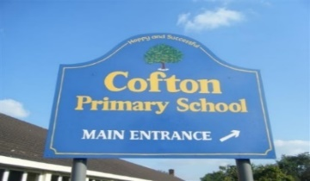
Please apply by noon, Monday 20th March, 2023.

Interviews: Thursday 30th March, 2023.

Job Commences: September 1st, 2023.

